Vim commands:

1. :w command :-

Used to save the file

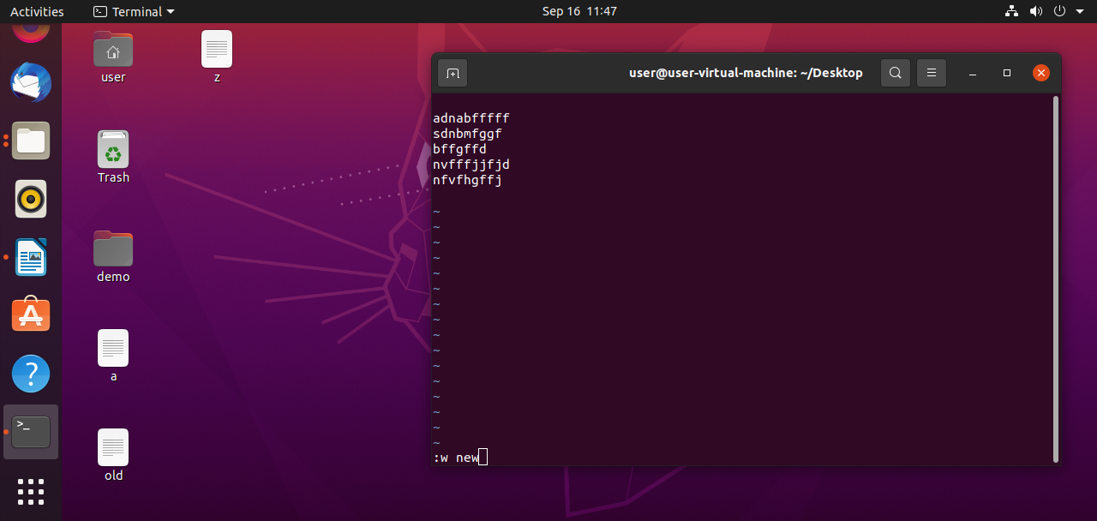
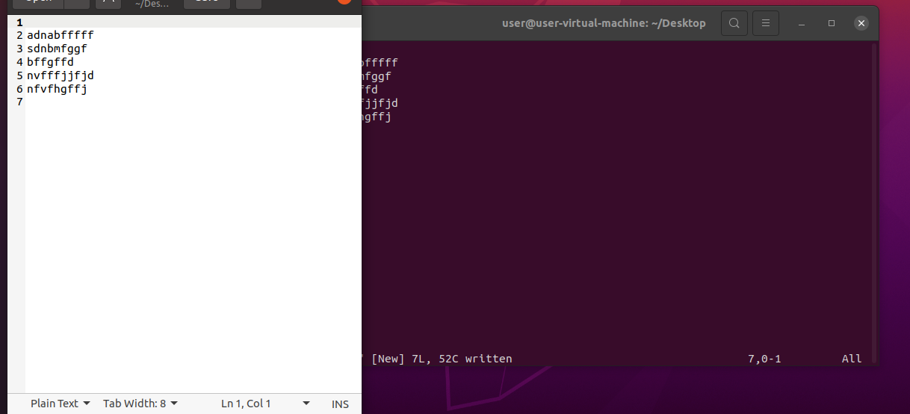
2. :q command :-
used to exit .

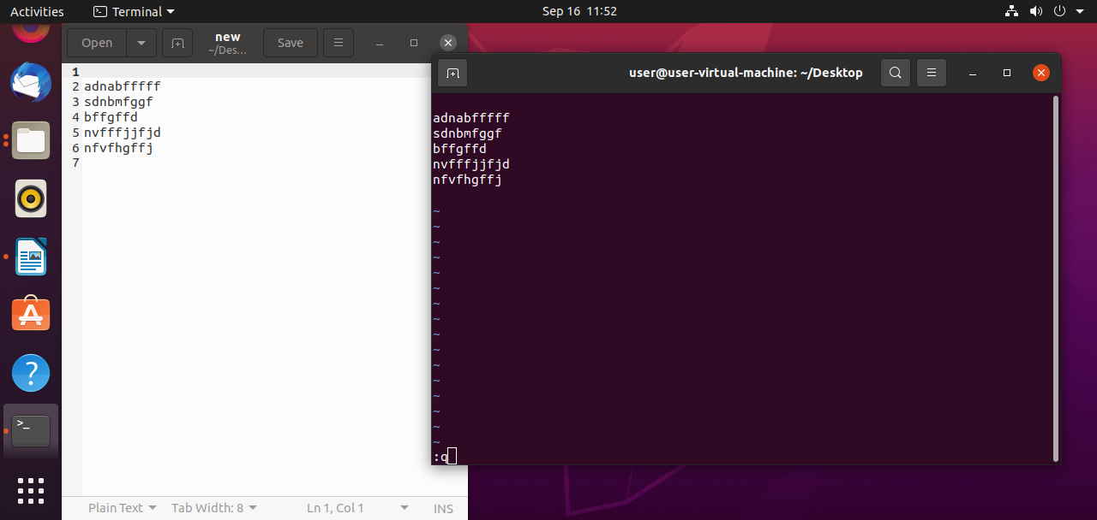

3. :q! Command :-

used to exit the terminal without saving.

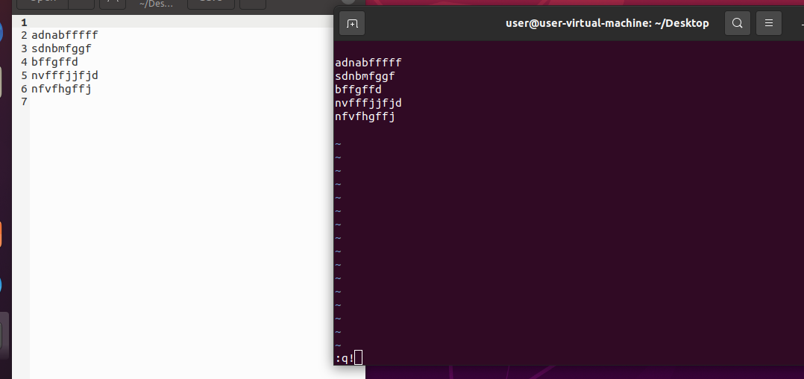

4. :d command:-

Used to line by line.

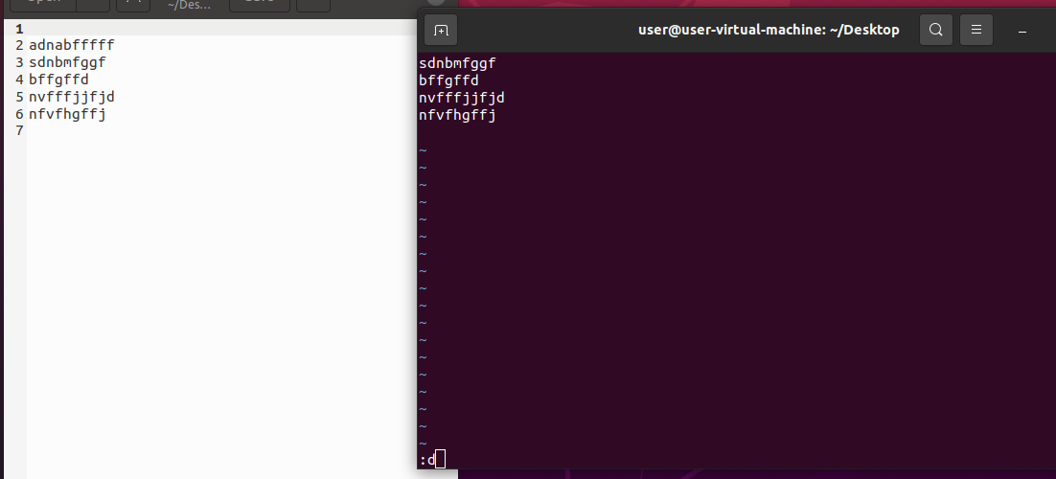

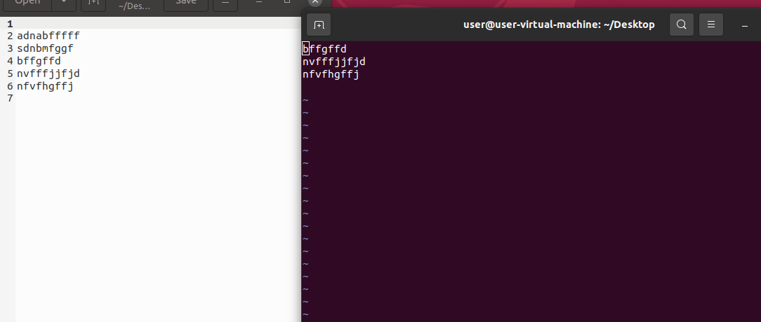

5. :u command:-
Used to undo.

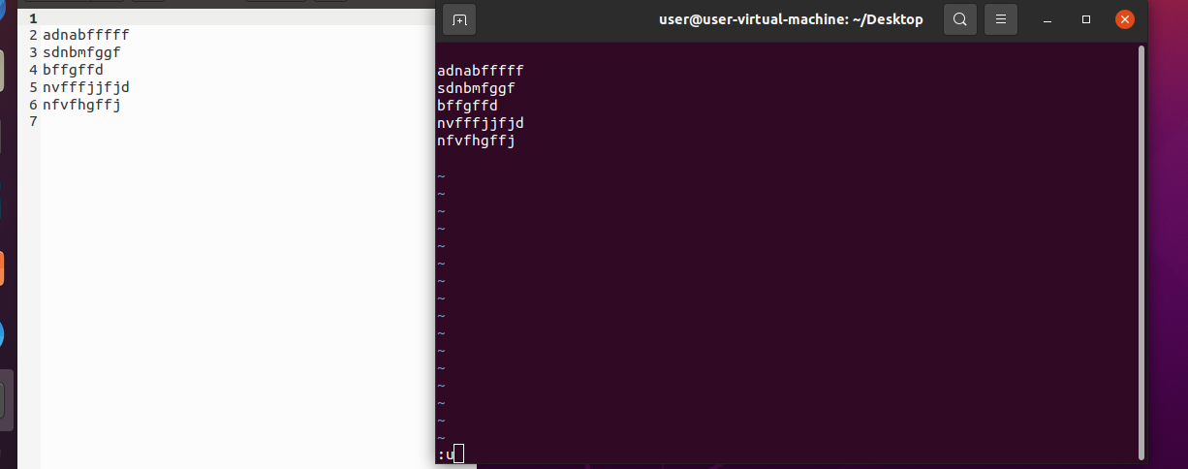

6. :x command:-

Used to delete word by word.

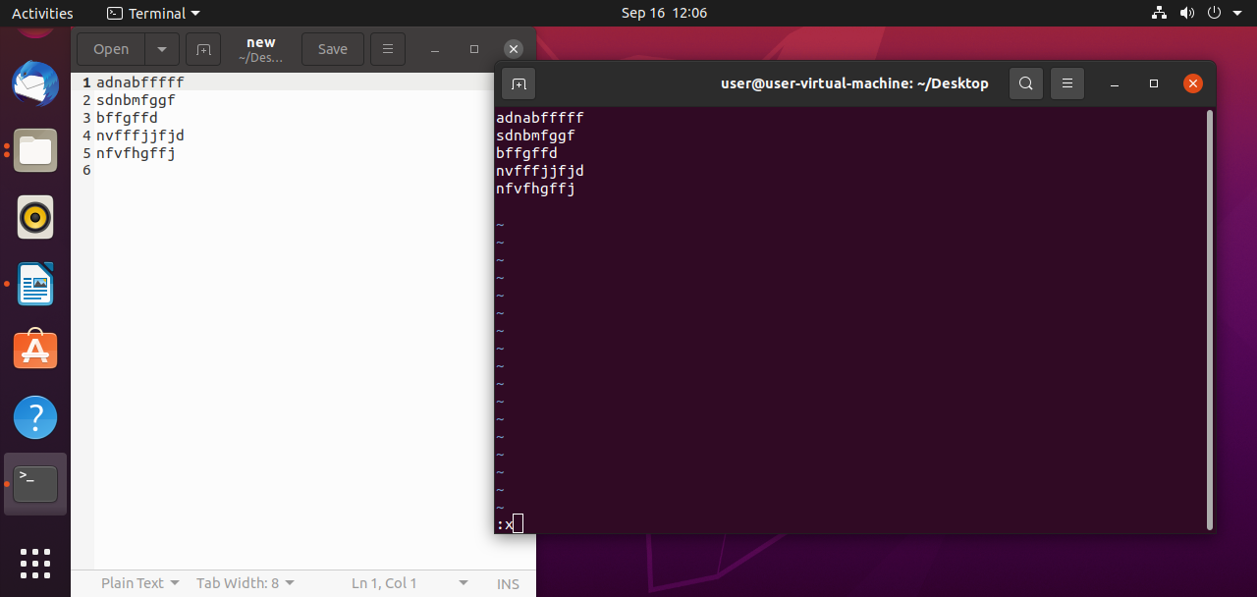
7. :r filename:-

Used to open data in file.

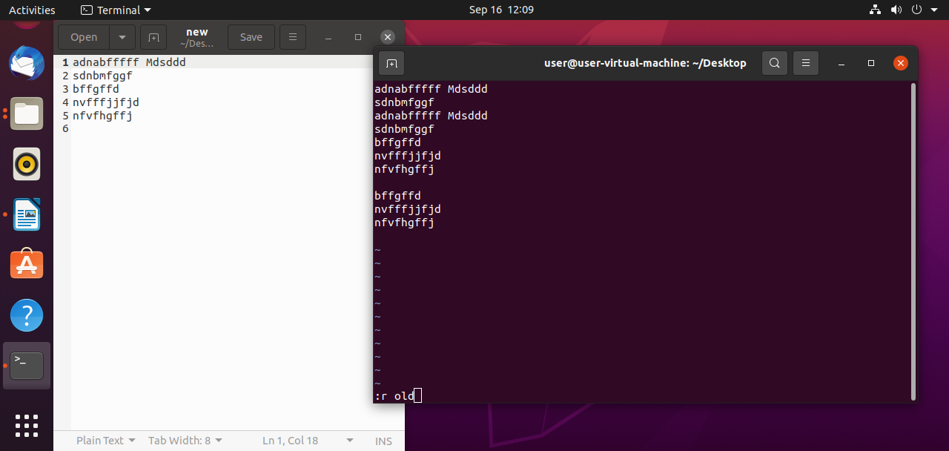

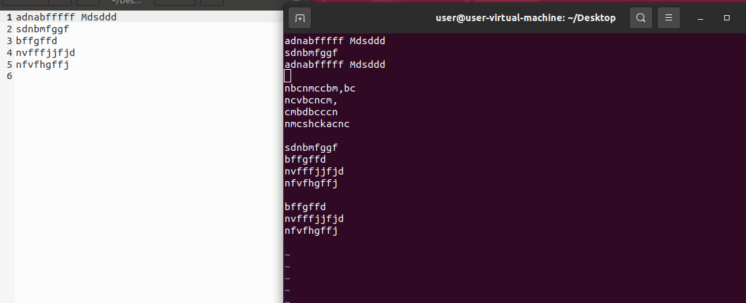

8. :wq command :-

Used to write and quit.

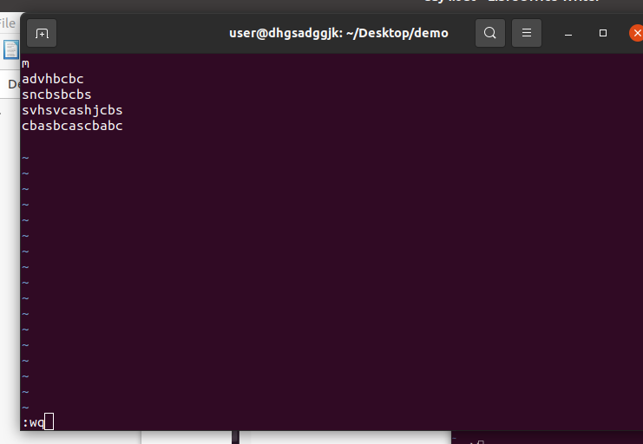

Less commands:

1. less a:

It can be used to read the contents of a text file in one page.

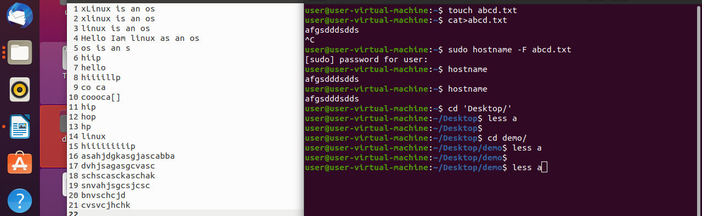

2. less -p ‘hip’ a:

The above command tells less to start at first occurance of pattern ‘hip’ in the file.

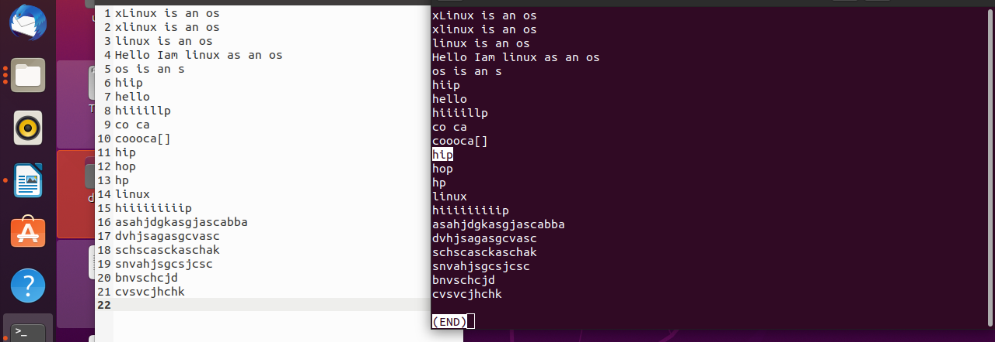

3. less -N a:

It displays the number of paragraphs.

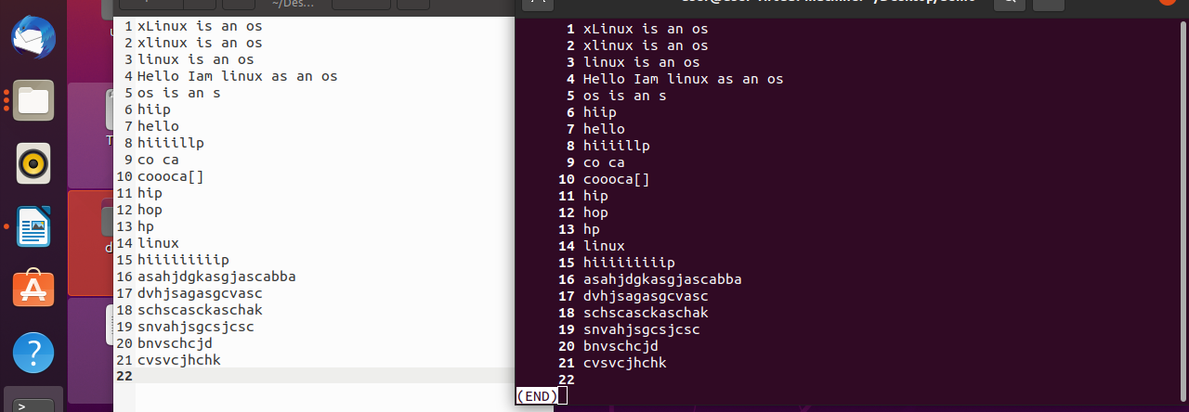

find command:

find . - type a:

Used to find files and directories in ‘a’ file.
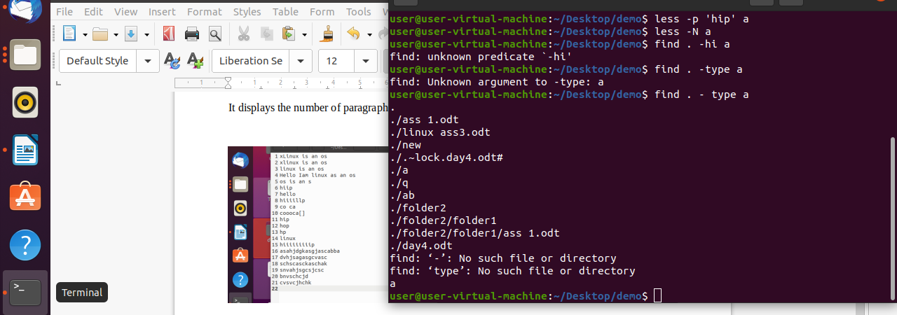

Head command:

head filename:

Used to print first 10 lines of a file.

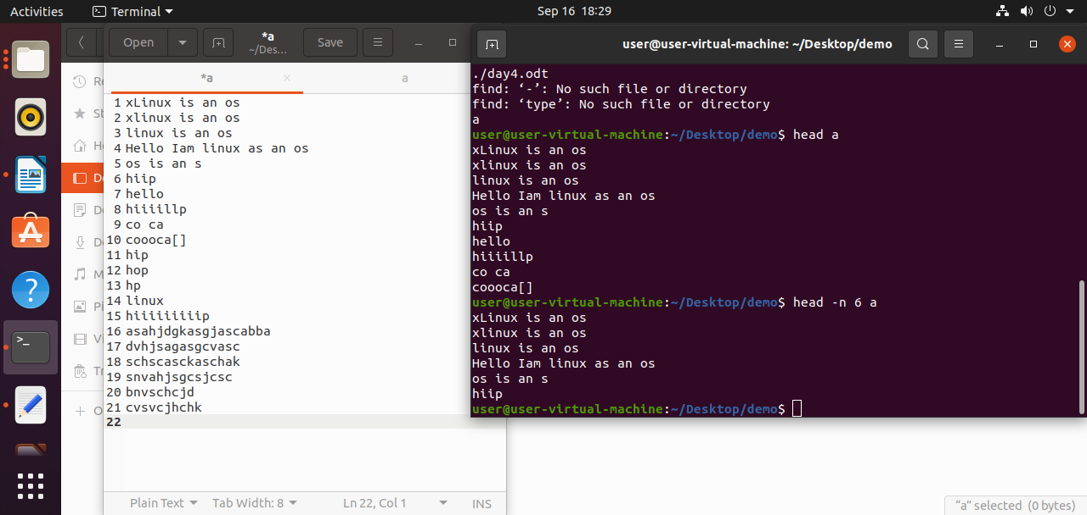

head -n 6 filename:

Used to print first 6 lines of a file.

head -v filename:

It will print text with filename also.

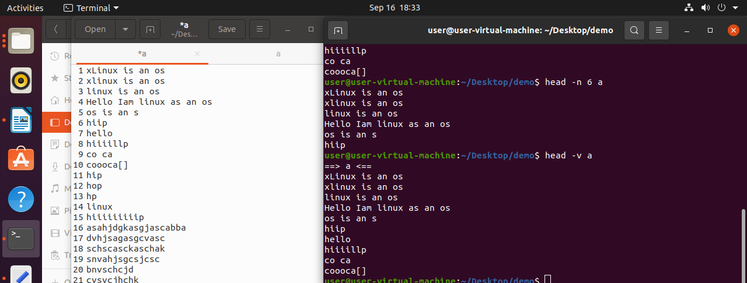
head -c 6 filename:
Used to print only 6 letters of a file.

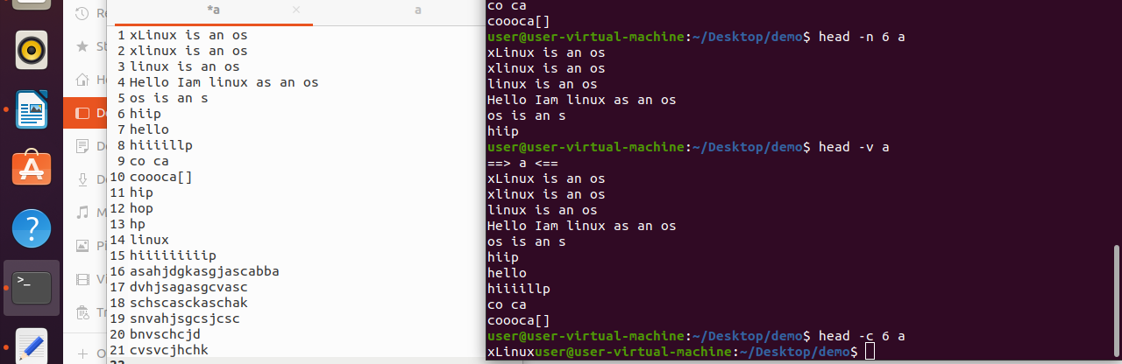

tail command:

tail filename:

Used to print last 10 lines of the file.
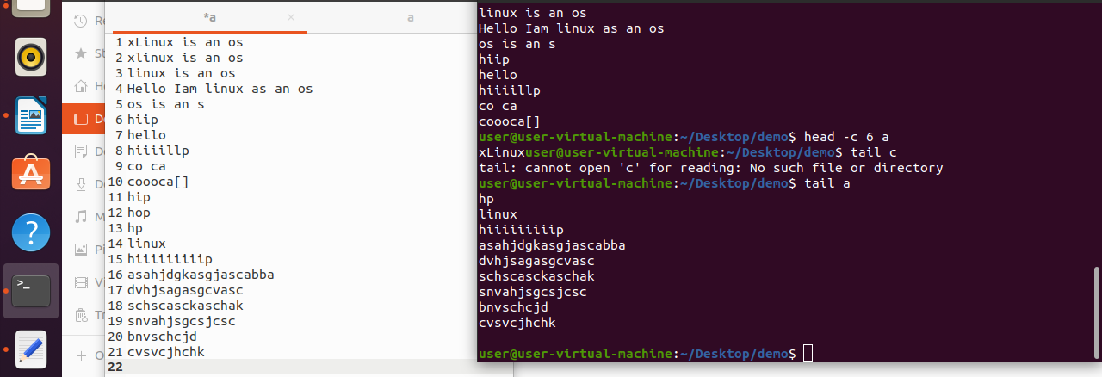

tail -n 5 filename| sort -r:

Used to sort the last 5 lines of the file in reverse order.

