INVENTORY MANAGEMENT DATABASE DESIGN

Objectives
The objective of the Inventory Management System is to provide a centralised platform for managing inventory requests, inventory allocation, stock tracking, and approval workflows within an organisation. The system is designed to maintain inventory records, manage employees and departments, support role-based access control, track request approvals, and record all inventory transactions for auditing purposes.

Requirement Analysis
The Inventory Management System was developed to address critical functional requirements such as User Management for storing employee details and designations; Department Management to organize personnel and requests by organizational units; Role Management to implement role-based authorization for various user levels; Product Management to track inventory details and stock levels; Request Management for the creation and submission of inventory requests; Request Item Management to maintain records of requested and issued product quantities; Request Status Management to track approval workflows with timestamps and remarks; and Stock Transaction Management to record inventory movements and stock additions, ensuring accountability and data consistency throughout the inventory lifecycle.

ER Model Using Min Max Representation

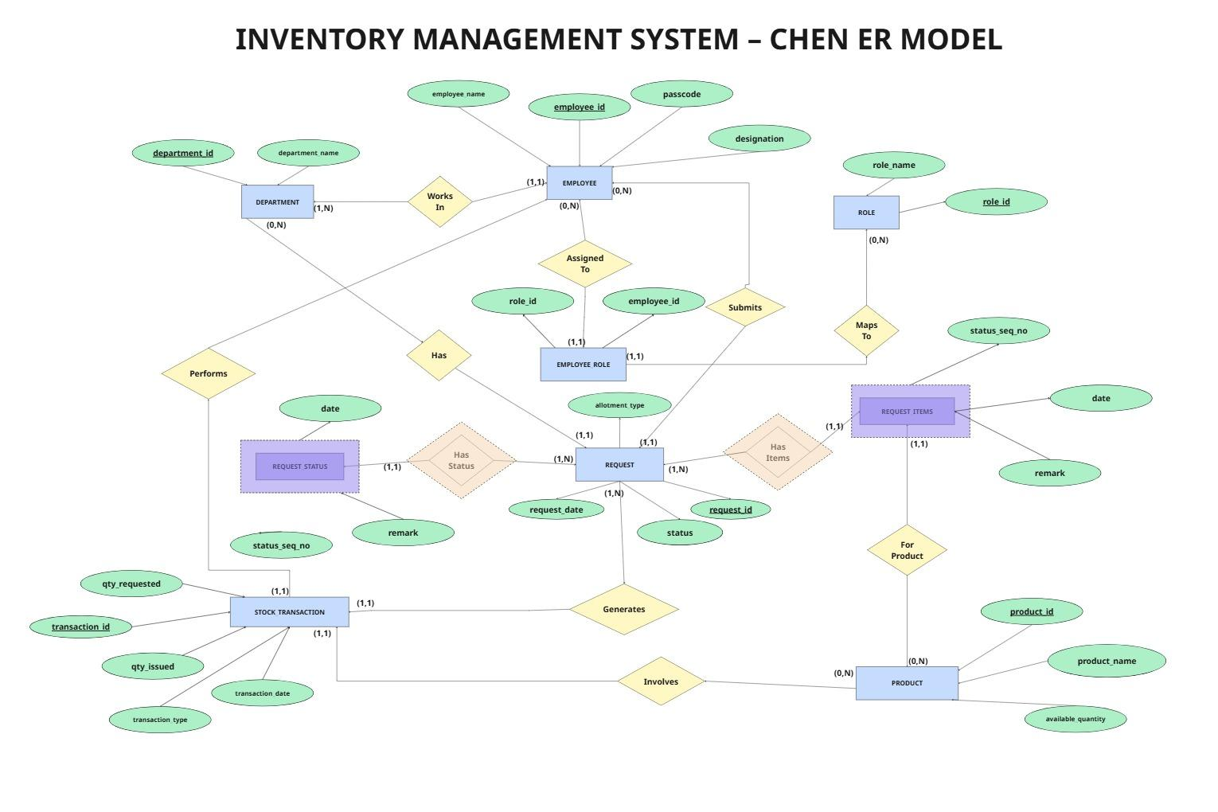

Relational Analysis

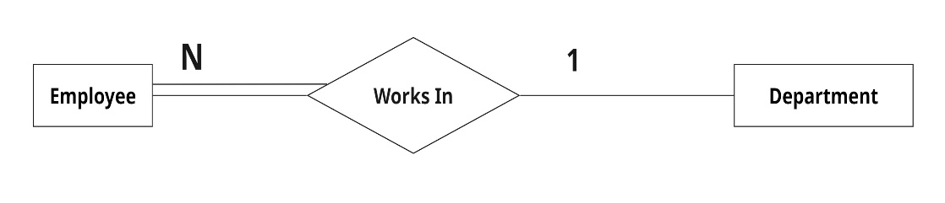
Employee – Department Relationship
One department contains many employees. One employee belongs to one department.
Cardinality: Employee (1)
Department (N)

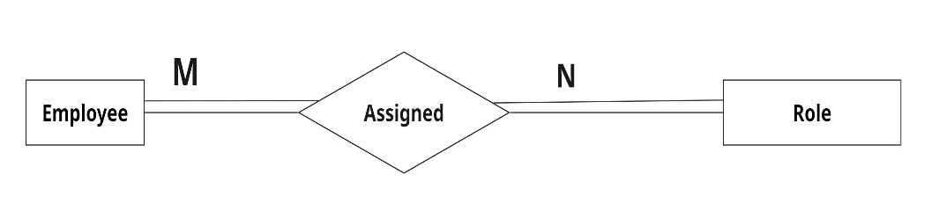
Employee – Role Relationship:
One employee can have multiple roles. One role can be assigned to multiple employees.
Cardinality: Employee (N)
Role (M)
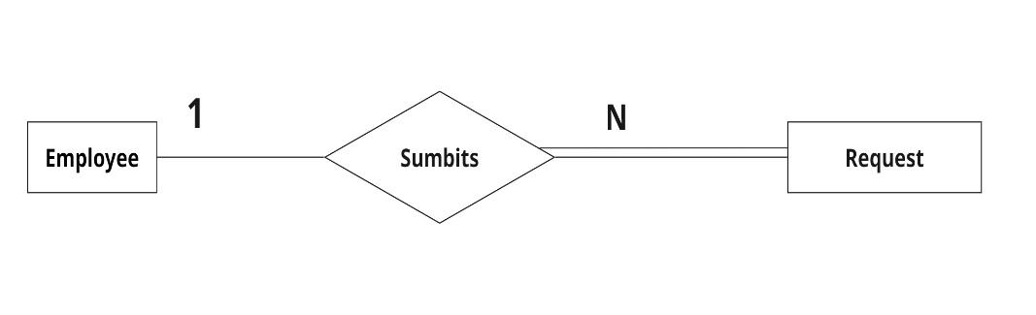
Employee – Request Relationship:
One employee can create multiple requests. One request belongs to one employee.
Cardinality: Employee (N)
Request (1)
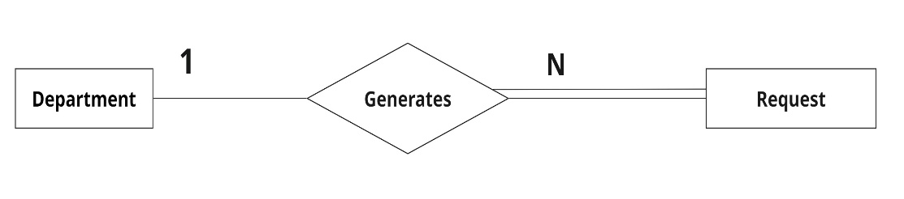
Department – Request Relationship:
One department can generate multiple requests.
Cardinality: Department (N)
Request (1)
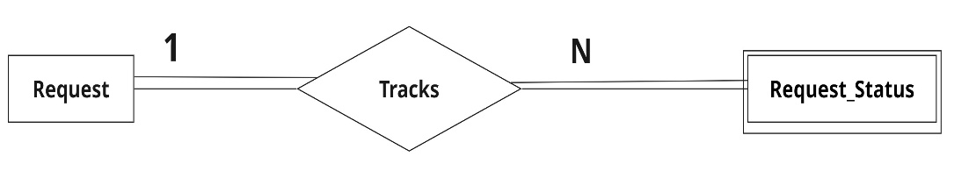
Request – Request_Status Relationship:
One request can have multiple status updates.
Cardinality: Request (N)
Request_Status (1)
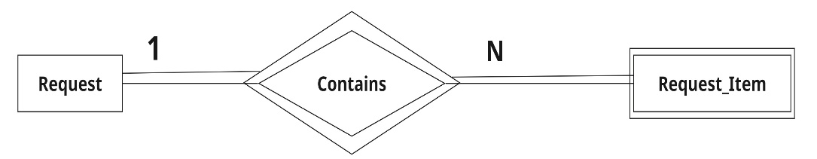
Request – Request_Item Relationship:
One request contains multiple requested products.
Cardinality: Request (N)
Request_Item (1)

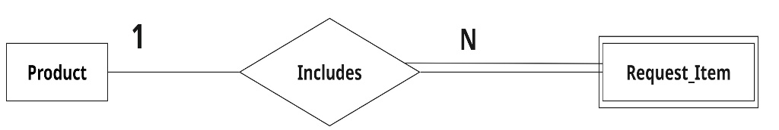
Product – Request_Item Relationship:
One product may appear in multiple request records.
Cardinality: Product (N)
Request_Item (1)
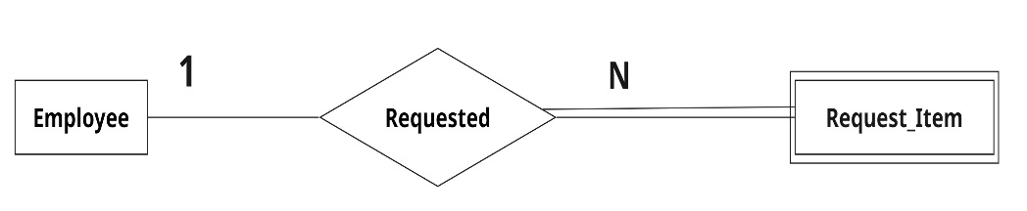
Employee – Request_Item Relationship
An individual employee can be linked to several request item records.
Every request item is assigned to a single employee.
Cardinality: Employee (N)
Request_Item (1)
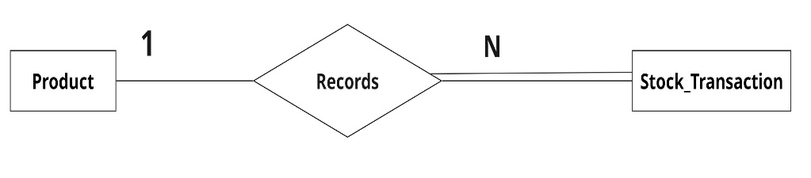
Product – Stock_Transaction Relationship:
One product may participate in multiple stock transactions.
Cardinality: Product (N)
Stock_Transaction (1)
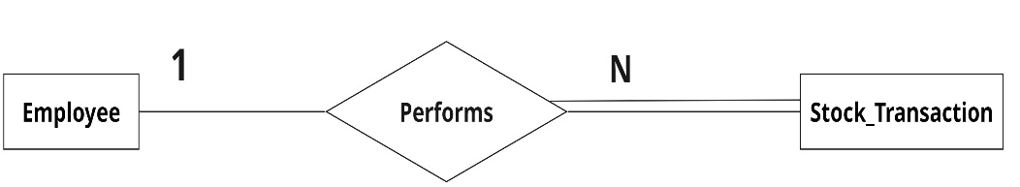
Employee – Stock_Transaction Relationship
One employee can perform multiple inventory transactions.
Cardinality: Employee (N)
Stock_Transaction (1)
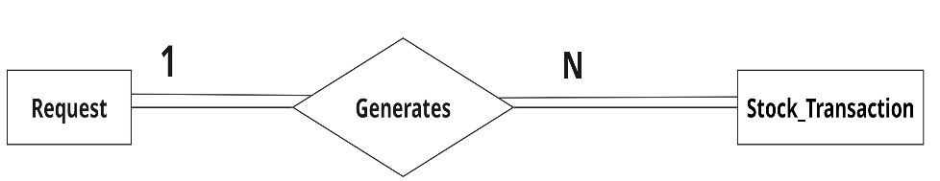
Request – Stock_Transaction Relationship
One request may generate multiple stock issue transactions.
Cardinality: Request (N)
Stock_Transaction (1)

Table Descriptions

1.Employee Table

Stores employee information.

employ_id (Primary Key) – INT

employ_name – VARCHAR(50)

passcode – VARCHAR(50)

designation – VARCHAR(50)

emp_dept_id (Foreign Key) – INT

Purpose: Stores employee records, authentication information, designation details, and department associations.
2.Department Table
Stores department information.
- dept_id (Primary Key) – INT
- dept_name – VARCHAR(50)
Purpose: Maintains organisational departments and serves as a reference for employees, requests, request status records, and request items.
3.Role Table
Stores available system roles.
- role_id (Primary Key) – INT
- role_name – VARCHAR(50)
Examples:• staff • department_head • admin • stock_manager
Purpose: Defines the roles available within the system for authorisation and workflow management.
4.Employee_Role Table
Associative entity between Employee and Role.
- employ_table_employ_id (Foreign Key) – INT
- role_table_role_id (Foreign Key) – INT
Purpose: Resolves the many-to-many relationship between employees and roles. An employee can have multiple roles, and a role can be assigned to multiple employees.
5.Request Table
Stores inventory requests raised by employees.
- request_id (Primary Key) – INT
- request_date – DATETIME
- Status_current – ENUM ('Pending_Department_head','Rejected_department_head','Forwarded', 'Approved_and_issued', 'closed')
- allotment_type – ENUM('processing', 'partial', 'total')
- requested_by_employ_id (Foreign Key) – INT
- requested_by_department_id (Foreign Key) – INT
Purpose: Acts as the primary transaction entity for inventory requests and stores the current status and allotment information.
6.Request_Status Table
Stores request status tracking information.
- request_status_id – INT
- present_status – ENUM ('Pending_Department_head', 'Rejected_department_head', 'Forwarded_to_stock_manager', 'Approved_and_issued', 'closed')
- recent_up_date – DATETIME
- remark – VARCHAR(100)
- request_status_request_id (Foreign Key) – INT
- request_status_department_id (Foreign Key) – INT
Purpose: Maintains the complete history of request approvals, rejections, forwarding actions, and status updates.
Weak Entity Justification: Request_Status is considered a weak entity because it cannot exist independently without a corresponding Request. Every status record must be associated with an existing request.
7.Request_Item Table
Stores products associated with a request.
- requested_items_id – INT
- quantity_requested – INT
- request_id_of_requested_items (Foreign Key) – INT
- department_id_of_requested_items (Foreign Key) – INT
- product_id_of_requested_items (Foreign Key) – INT
- employ_id_of_requested_items (Foreign Key) – INT
Purpose: Stores detailed information about products requested under each inventory request, including requested and issued quantities.
Weak Entity Justification: Request_Items is considered a weak entity because it depends on the existence of a Request. A request may contain multiple requested products, but a Request_Items record cannot exist without a parent request.
8.Product Table
Stores inventory product information.
- product_id (Primary Key) – INT
- product_name – VARCHAR(100)
- available_quantity – INT
Purpose: Maintains inventory stock information and available quantities of products
9.Stock_Transaction Table
Stores inventory movement records.
- transaction_id (Primary Key) – INT
- transaction_date – DATETIME
- quantity_requested – INT
- quantity_issued – INT
- transaction_type – ENUM ('OUT', 'NULL')
- request_id_of_stock_transaction (Foreign Key) – INT
- product_id_of_stock_transaction (Foreign Key) – INT
- employ_id_of_stock_transaction (Foreign Key) – INT
Purpose: Maintains inventory issue records and provides an audit trail for stock movement associated with requests.

Syntax of create table statements

-- CREATES TABLE BY NAME Department
CREATE TABLE Department (
dept_id INT UNSIGNED PRIMARY KEY,
dept_name VARCHAR(50) NOT NULL
);

-- CREATES TABLE BY NAME Employ
CREATE TABLE Employ (
employ_id INT UNSIGNED PRIMARY KEY ,
employ_name VARCHAR(50) NOT NULL,
passcode VARCHAR(50) NOT NULL UNIQUE,
designation VARCHAR(50) NOT NULL,
emp_dept_id INT UNSIGNED NOT NULL,
FOREIGN KEY (emp_dept_id) REFERENCES Department(dept_id)
);

-- CREATES TABLE BY NAME Role_Play
CREATE TABLE Role(
role_id INT UNSIGNED PRIMARY KEY ,
role_name VARCHAR(50) NOT NULL

);
/*this table has created because of many to many relationship between employ table and role table*/
-- CREATES TABLE BY NAME Emloy_Has_Role
CREATE TABLE Emloy_Table_Has_Role (
employ_table_employ_id INT UNSIGNED NOT NULL ,
role_table_role_id INT UNSIGNED NOT NULL ,
FOREIGN KEY (employ_table_employ_id) REFERENCES Employ (employ_id),
FOREIGN KEY (role_table_role_id) REFERENCES Role(role_id)
);

-- CREATES TABLE BY NAME --Request
CREATE TABLE Request (
request_id INT UNSIGNED AUTO_INCREMENT PRIMARY KEY , -- this is auto increment update later // done update
request_date DATETIME NOT NULL ,
status_current ENUM('Pending_Department _head', 'Rejected_department_head', 'Forwarded', 'Approved_and_issued', 'closed')
NOT NULL
DEFAULT 'Pending_Department _head',
allotment_type ENUM('processing','partial','total') DEFAULT 'processing',
requested_by_employ_id INT UNSIGNED NOT NULL,
requested_by_department_id INT UNSIGNED NOT NULL,
FOREIGN KEY (requested_by_employ_id) REFERENCES Employ (employ_id),
FOREIGN KEY (requested_by_department_id) REFERENCES Department(dept_id)
);

-- CREATES TABLE BY NAME Product
CREATE TABLE Product(
product_id INT UNSIGNED PRIMARY KEY,
product_name VARCHAR(100) NOT NULL,
available_quantity INT UNSIGNED DEFAULT 0
);

-- CREATES TABLE BY NAME Request_Status
CREATE TABLE Request_Status (
request_status_id INT UNSIGNED AUTO_INCREMENT UNIQUE NOT NULL,
present_status ENUM('Pending_Department _head', 'Rejected_department_head', 'Forwarded_to_stock_manager', 'Approved_and_issued', 'closed')
NOT NULL
DEFAULT 'Pending_Department _head',
recent_up_date DATETIME NOT NULL ,
remark VARCHAR(100) DEFAULT 'no remarks',
request_status_request_id INT UNSIGNED NOT NULL ,
request_status_department_id INT UNSIGNED NOT NULL,
FOREIGN KEY (request_status_request_id) REFERENCES Request(request_id),
FOREIGN KEY (request_status_department_id) REFERENCES Department(dept_id)
);

-- CREATES TABLE BY NAME Request_Items
CREATE TABLE Request_Items (
requested_items_id INT UNSIGNED AUTO_INCREMENT UNIQUE NOT NULL,
quantity_requested INT UNSIGNED NOT NULL,
request_id_of_requested_items INT UNSIGNED NOT NULL ,
department_id_of_requested_items INT UNSIGNED NOT NULL ,
product_id_of_requested_items INT UNSIGNED NOT NULL ,
employ_id_of_requested_items INT UNSIGNED NOT NULL ,
FOREIGN KEY (request_id_of_requested_items ) REFERENCES Request(request_id),
FOREIGN KEY (department_id_of_requested_items) REFERENCES Department(dept_id),
FOREIGN KEY (product_id_of_requested_items ) REFERENCES Product(product_id),
FOREIGN KEY (employ_id_of_requested_items) REFERENCES Employ(employ_id)
);

-- CREATES TABLE BY NAME Stock_Transaction
CREATE TABLE Stock_Transaction (
transaction_id INT UNSIGNED AUTO_INCREMENT PRIMARY KEY ,
transaction_date DATETIME NOT NULL,
quantity_requested INT UNSIGNED NOT NULL,
quantity_issued INT UNSIGNED NOT NULL ,
transaction_type ENUM('IN','OUT','NULL') NOT NULL DEFAULT 'NULL', -- there is no IN here since we are not tracking the products that are coming inside the stock {future scope of the project}
request_id_of_requested_items INT UNSIGNED NOT NULL ,
request_id_of_stock_transaction INT UNSIGNED NOT NULL ,
product_id_of_stock_transaction INT UNSIGNED NOT NULL ,
employ_id_of_stock_transaction INT UNSIGNED NOT NULL ,
FOREIGN KEY (request_id_of_stock_transaction ) REFERENCES Request(request_id),
FOREIGN KEY ( product_id_of_stock_transaction ) REFERENCES Product(product_id),
FOREIGN KEY (employ_id_of_stock_transaction) REFERENCES Employ(employ_id)
);
-- removed coumn request_id_of_requested_items from Stock_Transaction table
ALTER TABLE Stock_Transaction
DROP COLUMN request_id_of_requested_items ;
-- updatation is done to transaction_type from transaction_type ENUM('IN','OUT','NULL') NOT NULL DEFAULT 'NULL', to transaction_type ENUM('OUT','NULL') NOT NULL DEFAULT 'NULL';
ALTER TABLE Stock_Transaction
MODIFY COLUMN transaction_type ENUM('OUT','NULL') NOT NULL DEFAULT 'NULL';

Conclusion
The Inventory Management System database has been designed using Entity Relationship Modelling principles and relational database concepts. The system successfully manages employees, departments, roles, requests, products, request tracking, and stock transactions while maintaining data consistency and inventory accountability. The database structure supports organisational inventory workflows and provides a scalable foundation for future enhancements.

