RedHat Enterprise Virtualization
Table of Contents
RedHat Enterprise Virtualization 1
Data Center 2
Create a Data center 2
Remove a Data Center 2
Force remove a data center 3
Clusters 4
Creating a cluster 4
Delete a cluster 5
Hosts 5
Add Hosts to the Cluster 5
Delete a Hosts in a cluster 6
Storage 8
Preparing and nfs storage 8
Delete a Storage Domain 12
Uploading iso files to RHEV 13
Virtual Machine 14
Creating a Virtual Machine 14
Clone a Virtual Machine 22
Deleting a virtual Machine 23

Data Center
Create a Data center
Click on the Data Center in the resource tab and then click new

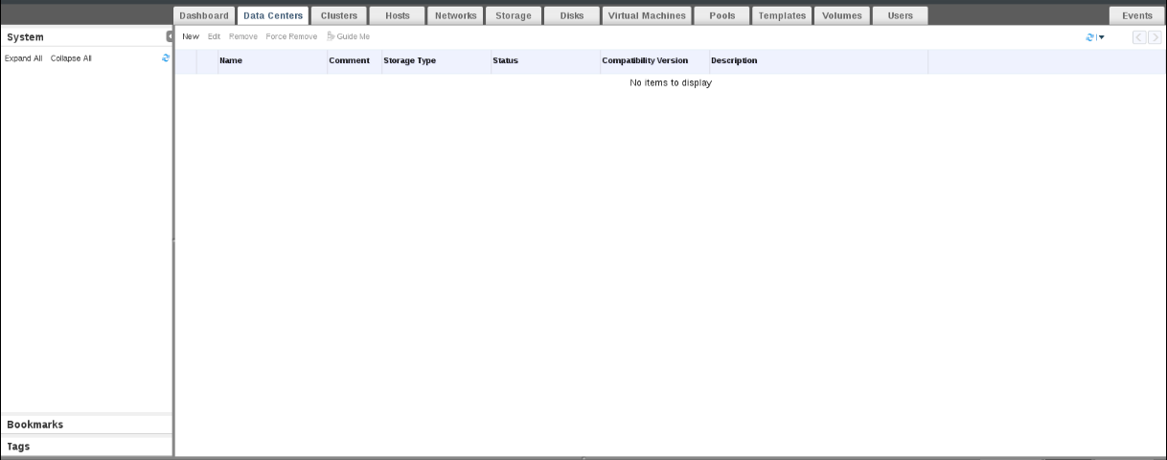
Enter the name of the data center in the New Data Center tab. Select the Storage Type, Compatibility version, Quota Mode and click Ok. Click on the configure later.

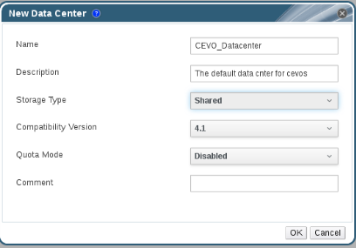

Remove a Data Center
Select the Data centers in the resource tab. Select the appropriate data center which you want to delete. Click on the Remove and click Ok.

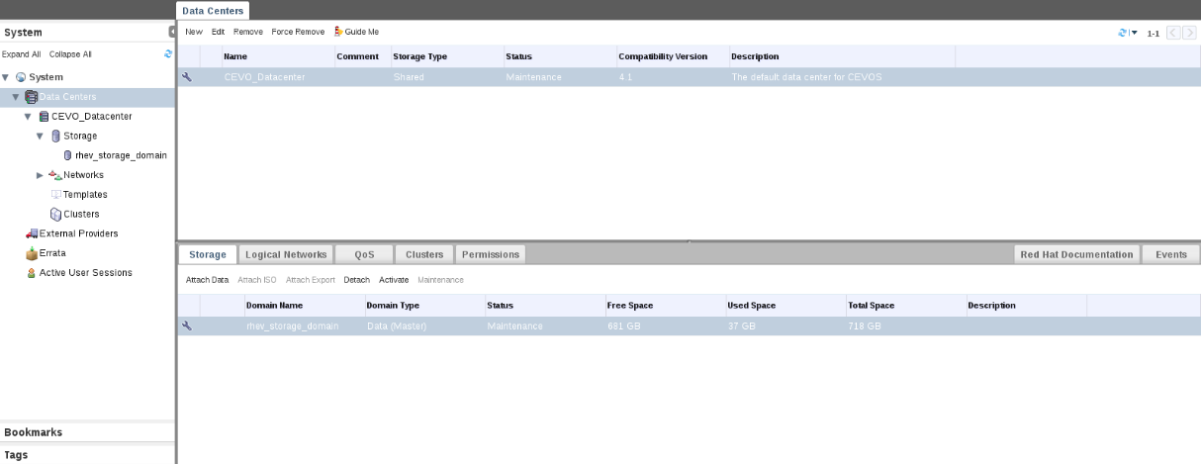

Force remove a data center
Select the Data Center in the resource and select the Data Center which you want to delete. Click the Force Remove and In Force Remove Data Center tab, select Approve operation and click Ok.

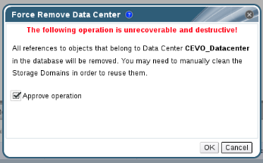

Clusters
Creating a cluster
Select the Clusters in the resource tab and click on New.
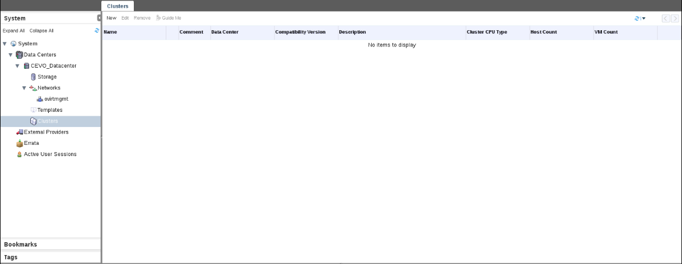
Enter the Name,Description and comment of the cluster in the New Cluster tab. Select the Management Network, CPU Architecture, CPU Type, Compatibility Version, Switch type and select the option according to your requirement and then click okay.

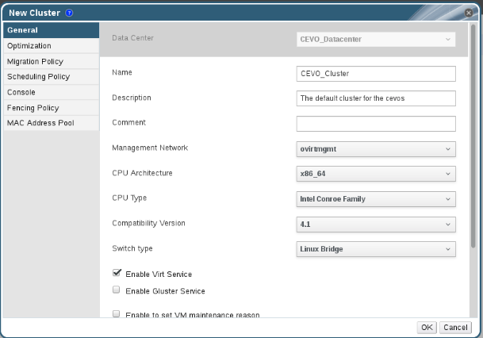

Delete a cluster
To delete a cluster, we have to delete the hosts in the cluster and then click on the Clusters in the resource tab and then click on the Remove and then click Ok.

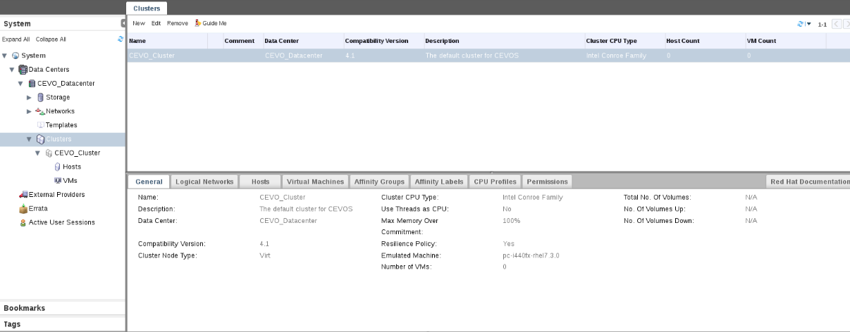

Hosts
Add Hosts to the Cluster
Select the Hosts in the resource tab under the drop down of Clusters and click New.

Enter the Name, Comment, Address and password and click Ok.

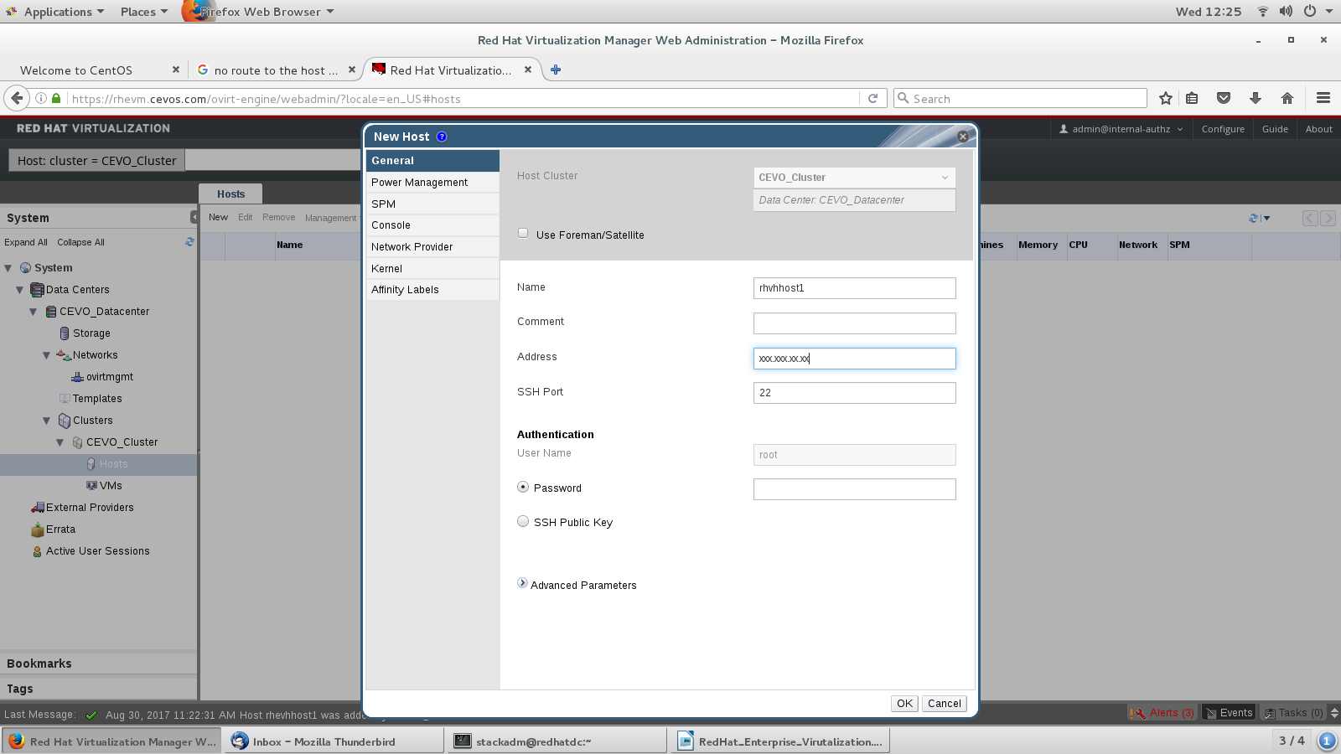

Storage
A storage domain is a collection of images which have a common interface. A storage domain contains a virtual machine images and iso files. A storage domain can be either be and block devices or NFS (network file system). You should create a data domain to storage virtual machine data and an ISO domain to store an iso image files to boot virtual machine. To create a storage, we have to configure NFS Storage.
Delete a Hosts in a cluster
In the admin portal click on the hosts in the resource tab and select the host which you want to delete.
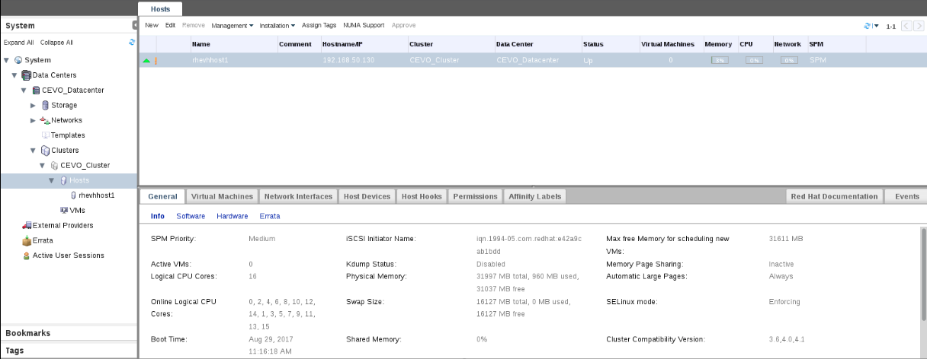

To delete a host, you have to place the host in the Maintenance mode and make no virtual machines are running on that host. To place the host in the maintenance mode click in the Management and then click on the Maintenance and then click Ok.

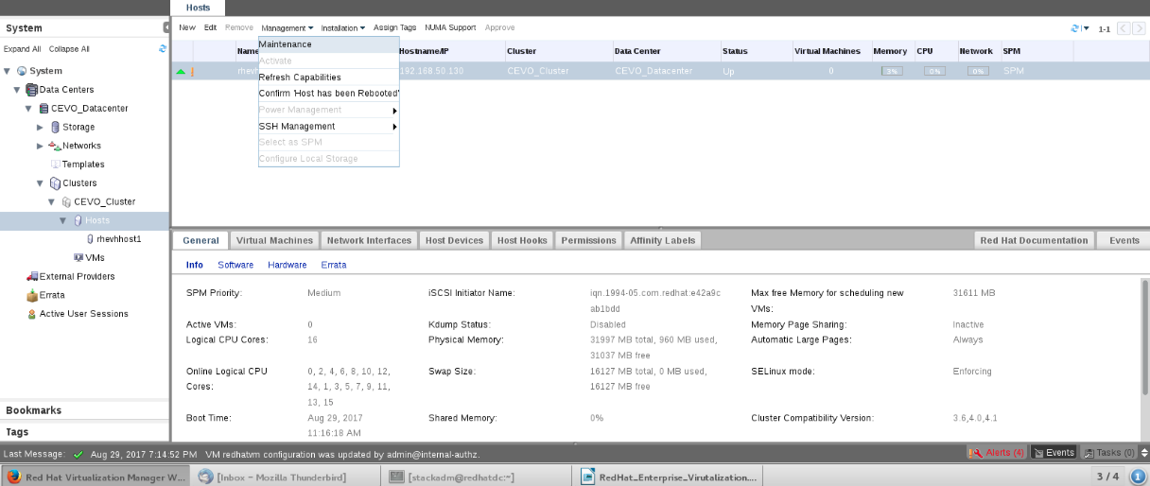
Once the host is in the maintenance mode then click on the Remove button and click Ok.

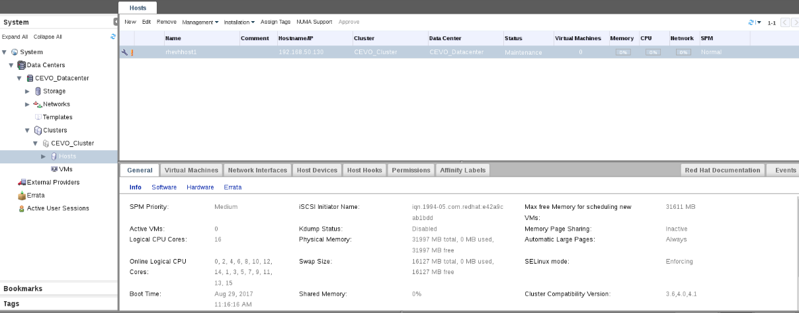

Storage
Preparing and nfs storage

NFS server will serve as a data domain in the redhat enterprise virtualization. You don't need to setup a ISO domain if you set up while installing RedHat Virutal Manager. Configure the system user vdsm and group kvm in the nfs server because RHEV communcaite with each other using vdsm.

Creating a logical disk using Logical Volume Manager
- identify the empty disk using below command
# more /proc/partitions
- create physical volume
# pvcreate /dev/sdb

Give full access to kvm and vdsm to have access to those folder
1. Create a group kvm
# groupadd kvm -g 36

2. create a user vdsm in the group kvm
# useradd vdsm -u 36 -g 36

3. set the ownership of the nfs exported directories to vdsm:kvm
# chown -R vdsm:kvm /ISO
# chown -R vdsm:kvm /storage

4. change the permissions of the directories so that user should read write and execute granted to the owner. Read and execute permissions to the group and other users.

# chmod 0755 /ISO
# chmod 0755 /storage
Creating a storage domain
Attach a nfs storage to the data center in redhat virtualization environment. First we have to create a data domain function to store the virtual machine data and then we have to create ISO domain to store the iso files to boot the virtual machine.

Select the storage in the resource tab and then click on the new domain.

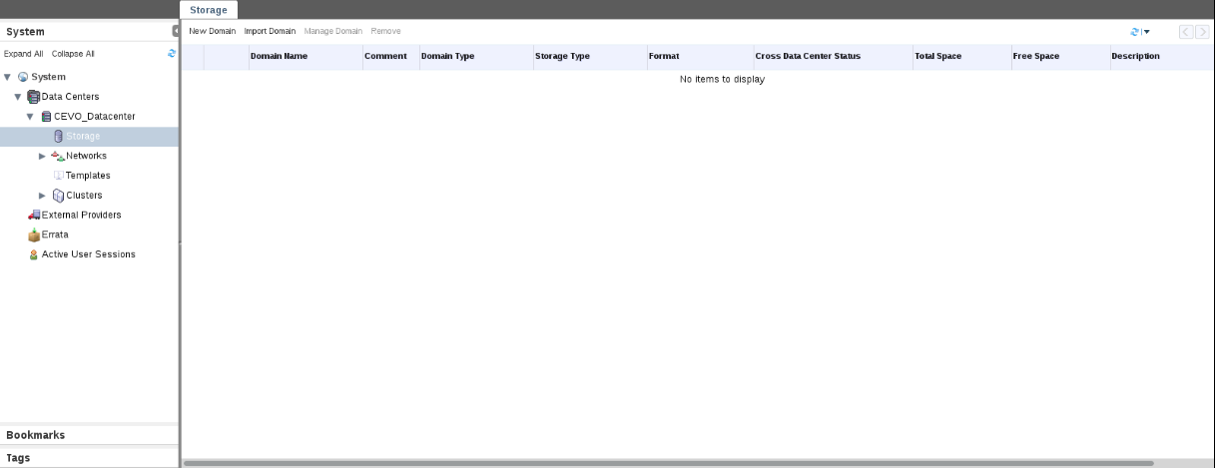

Enter the Name, Description and Comment in the New Domain tab. Select Data Center where you want to create a storage, Domain Function as Data, Storage Type as NFS and select the host. Enter the export path of the NFS drive and click Ok.

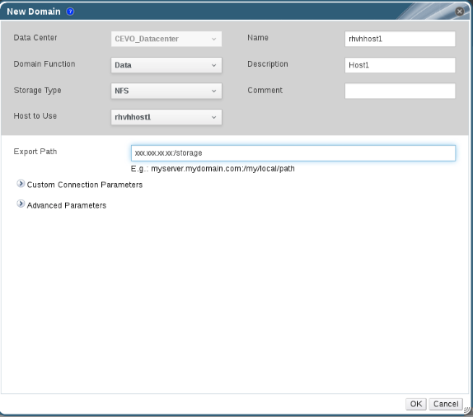

After creating a storage data domain, we have created an iso domain. So, click on the New Domain. Select the Data Center where you want to store, Domain Function as Export, Storage Type as NFS, Host to Use as hostname. Enter the Name, Description, Comment and Export Path of the nfs exported drive and click Ok.

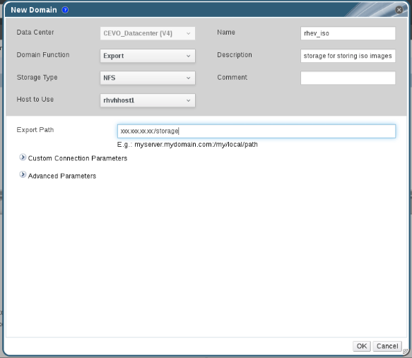

Delete a Storage Domain
To delete a storage domain, click on the Storage in the resource tab and click on storage domain which you would like to delete.

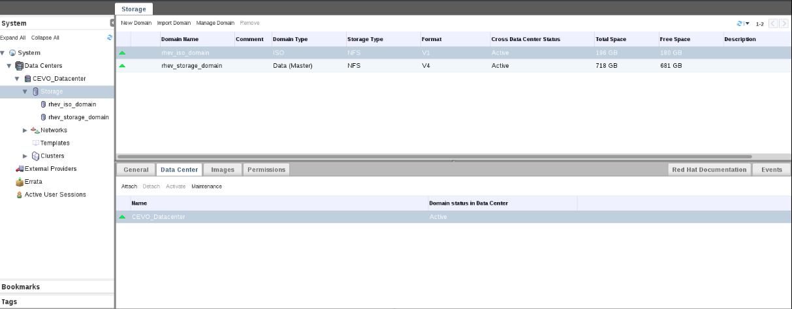

Click on the Data Center tab below and then click on the Maintenance and click Ok. To delete a storage domain, it must be in the maintenance mode.

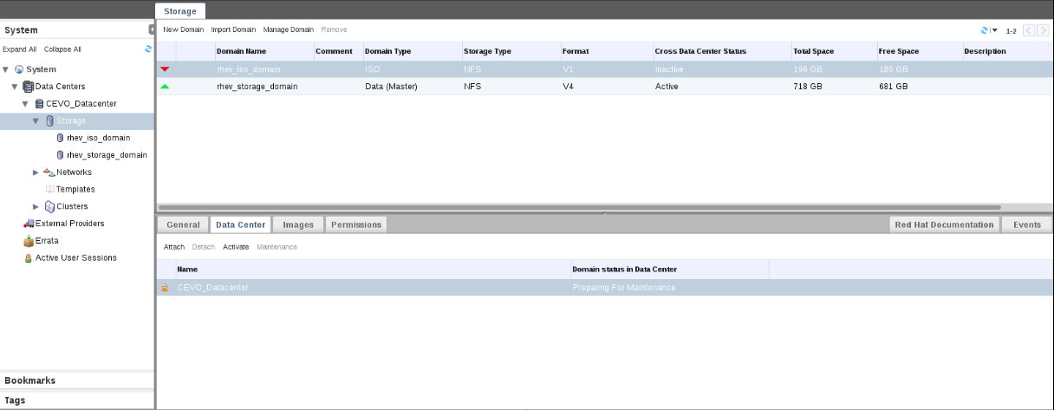

Once the storage domain is in the maintenance mode then click on the Detach and click Ok. Select the storage domain, right click on it and click on Remove to permanently delete the Storage Domain.

Uploading iso files to RHEV
To upload files to the RHEV we have use the redhat tool called engine-iso-uploader. Use below command to upload the iso files into ISO Domain. Replace the values of iso_domain as iso domain name and iso_file_name as iso file name.

# engine-iso-uploader upload -i iso_domain iso_file_name

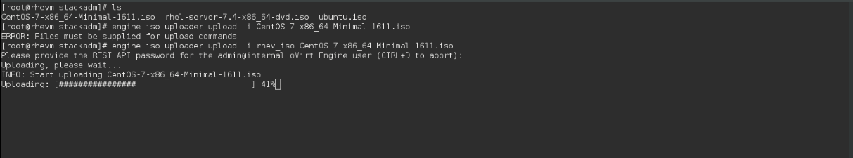

Once the is uploaded verify the upload in the admin portal. Select the Storage in the resource tab and click on the Images. You should the uploaded image.

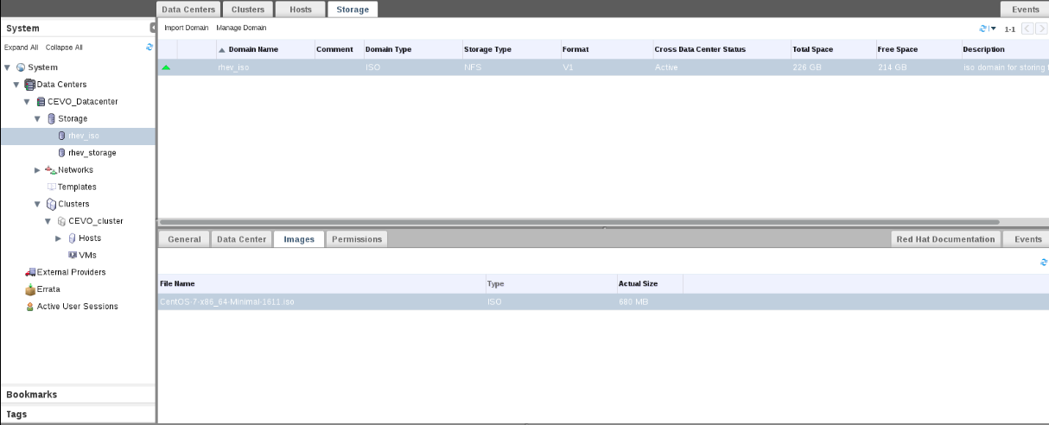

Virtual Machine
Creating a Virtual Machine

Select VMs in the resource tab in the drop down of the Clusters and click on New VM

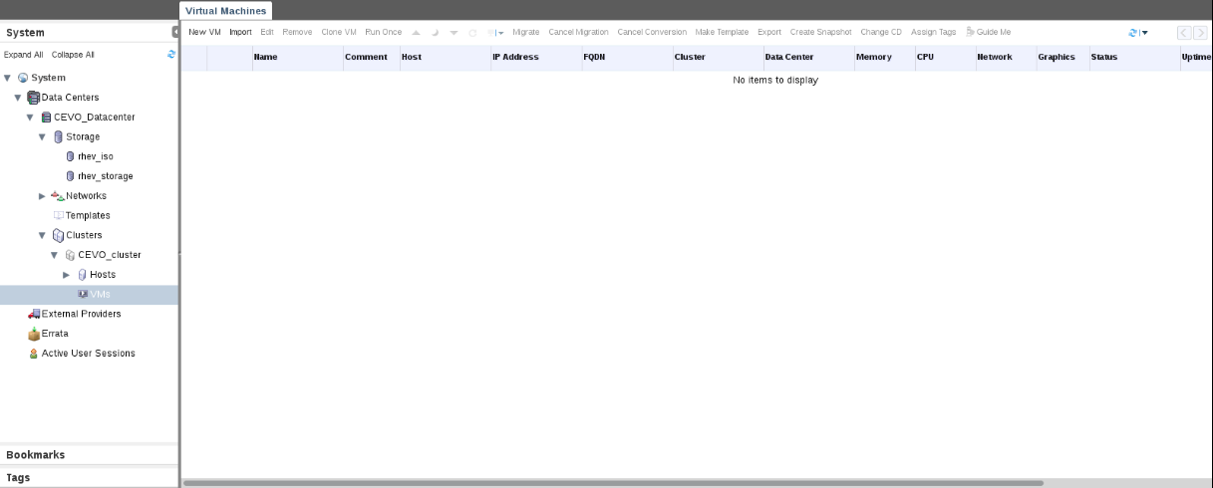

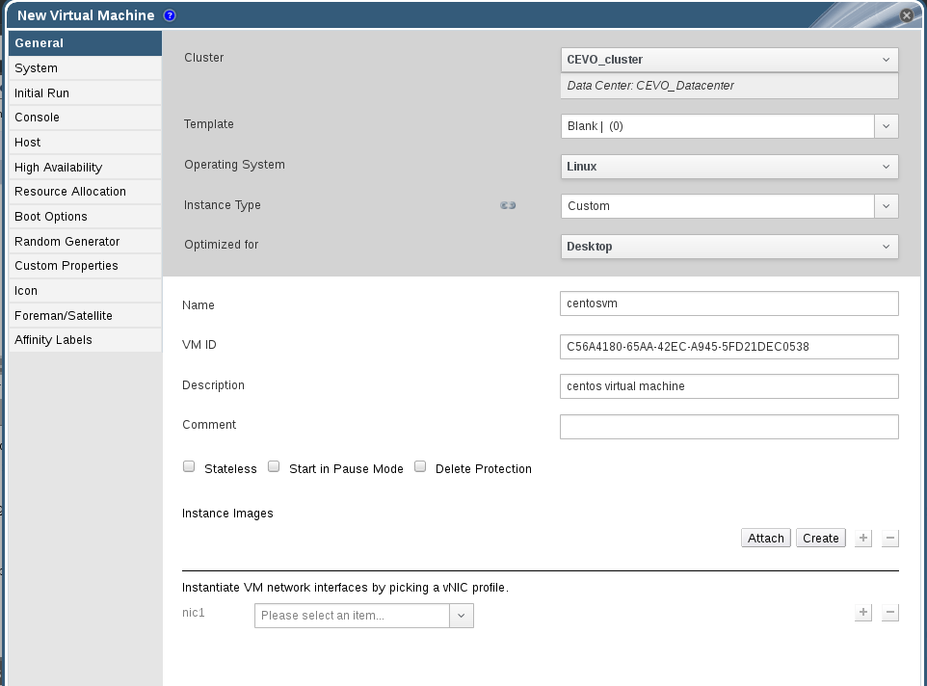
Enter the Name, VM ID, Description of the virtual machine. Make sure VM ID should be in guid format verify guid before you proceed. In Instance Images tab click on Create. Enter the Size(GB) as desired, Description for the virtual machine, select the interface, Storage Domain, Allocation policy, Disk Profile in the drop-down list according to your requirement click
OK

Click on the Show Advanced Options then click on the Boot Options and then select the Frist Device as CD-ROM, Second Device as Hard Disk. Select the option Attach CD and select the iso image.

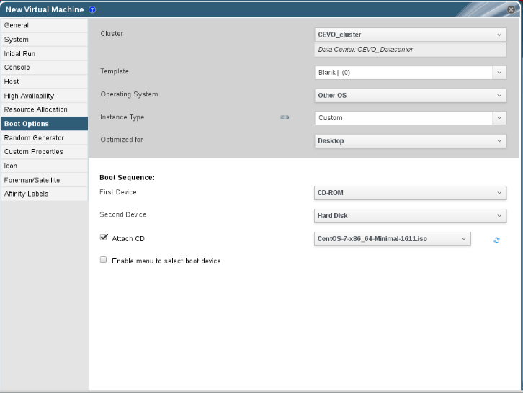

Click on the Console, In the Video Type select VGA in the drop down list and click Ok.

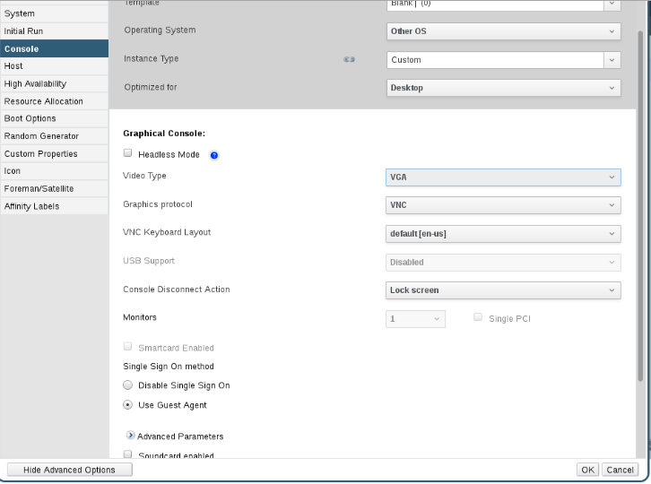

Once everything is configured power the virtual machines. Make sure you install virt-viewer to see the vm console. To install virt-viewer use below command
# yum install virt-viewer

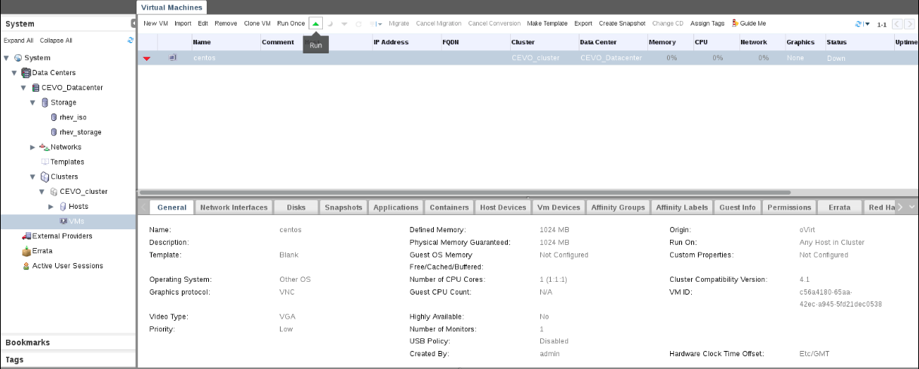

Click on the console and open with virt-viewer to see the console.

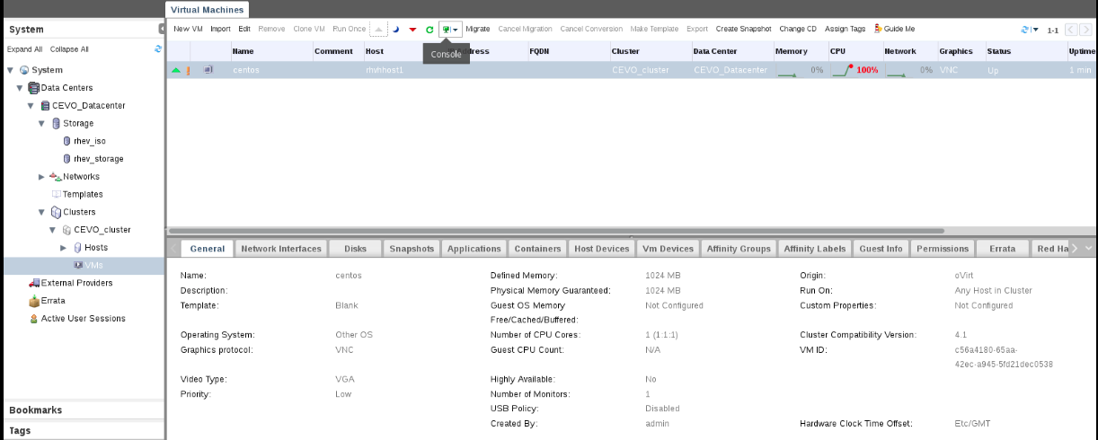

Configure the virtual Machine according to your requirement and Begin Installation.

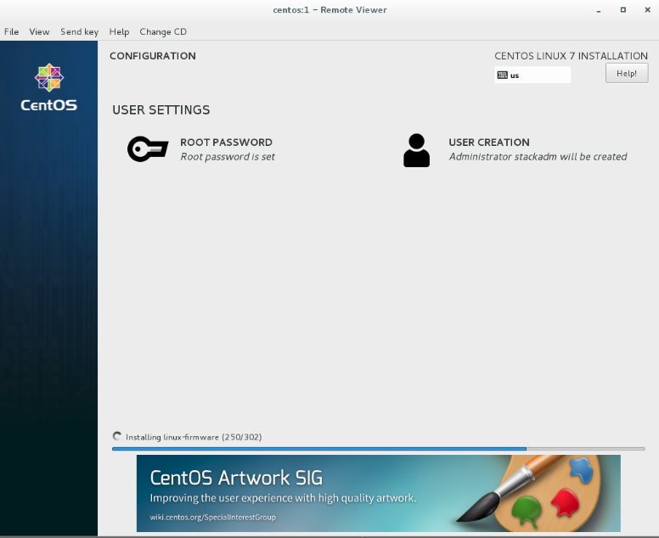

Once the boot process is completed change the boot order by clicking the edit option in VMs resource tab. In Edit Virtual Machine tab click on the Boot Options and select the First Device as Hard Disk and click Ok. Restart the Virtual Machine.

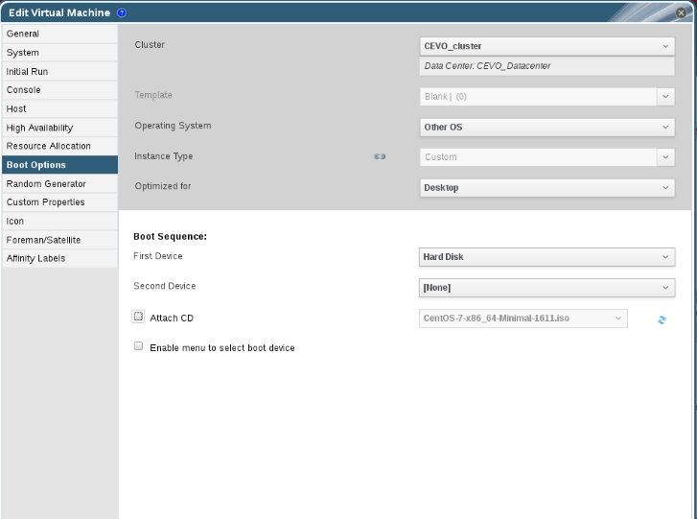

After the rebooting the Virtual Machine, your VM is ready to use. Login wih the credentials you created installing Operating system.

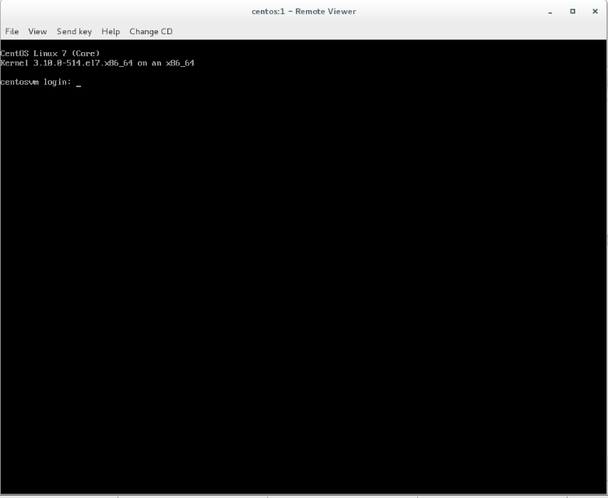

Clone a Virtual Machine
To clone a virtual machine, the virtual machine must be in shutdown state. Once the virtual machine is in shutdown state you will get an option to clone virtual machine.

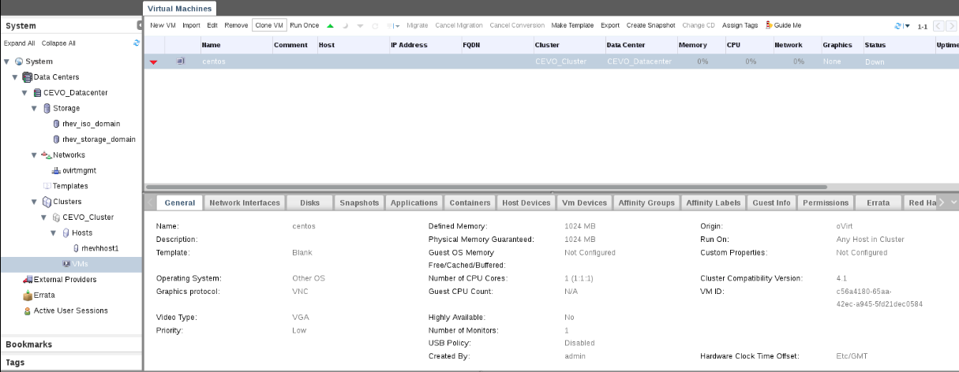

Once you click on the clone virtual machine you will get another window Clone Virtual Machine. Provide a name new virtual machine and click Ok.

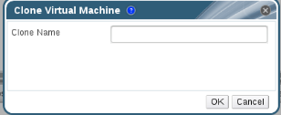
Deleting a virtual Machine

To delete a virtual machine, we should shut down the virtual machine. To shut down the virtual machine you have click the red button as shown in the figure below.

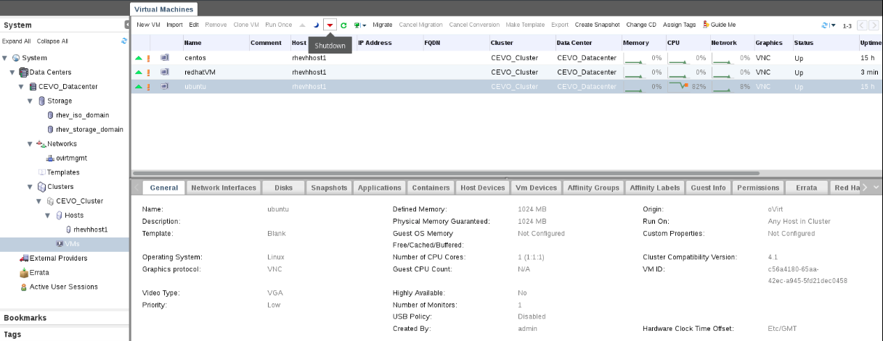
Once the virtual Machine is in shutdown state you will get an option to remove a virtual machine from the cluster.

