Airbnb Data Analysis

***Wireframe Documentation***

As per the problem statement, we have done the analysis and all the interpretations can be represented in the form of various graphs as follows: -

# TOP 10 PROPERTIES EARNING MOST IN TERMS OF PRICE

# 

**2**. **BOTTOM 10 PROPERTIES EARNING MOST IN TERMS OF PRICE**

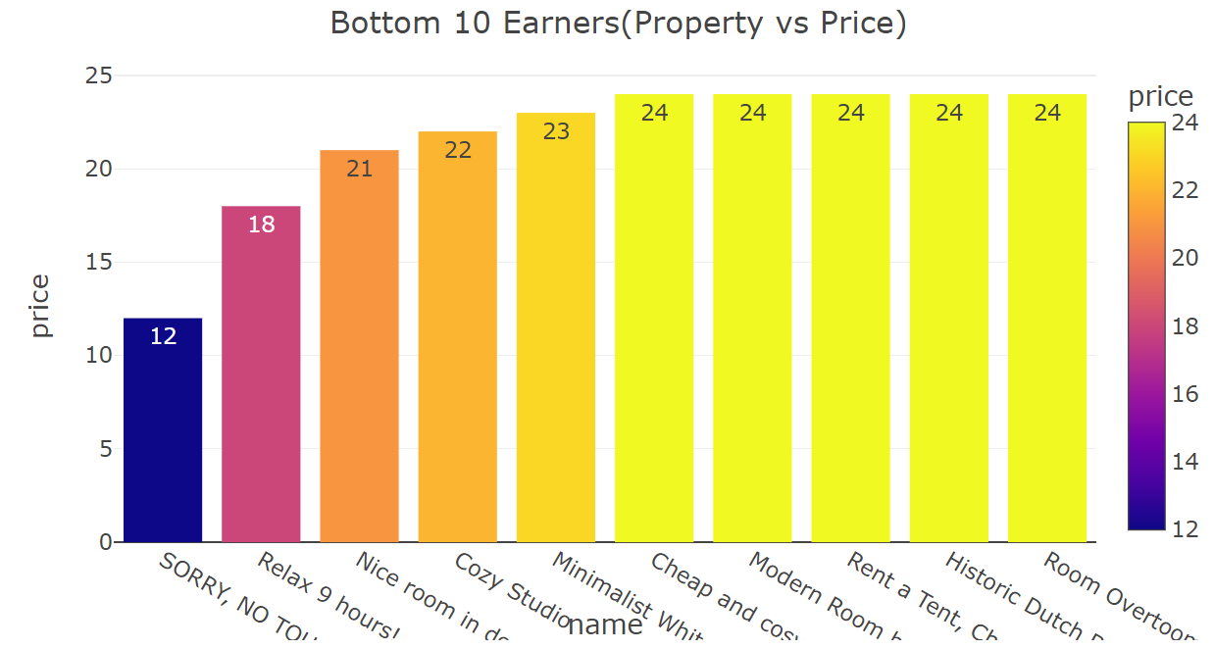

**3. TOP LOCATIONS WITH HIGHEST NUMBER OF BOOKINGS**

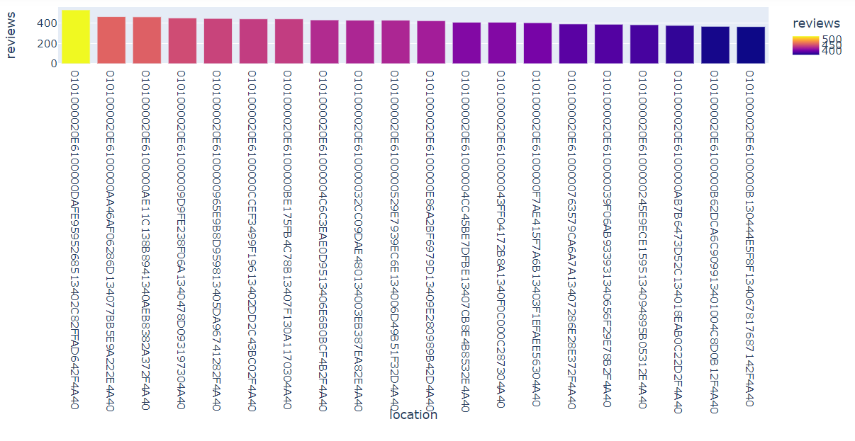

**4. TOP PROPERTY NAMES WITH HIGHEST NUMBER OF BOOKINGS**

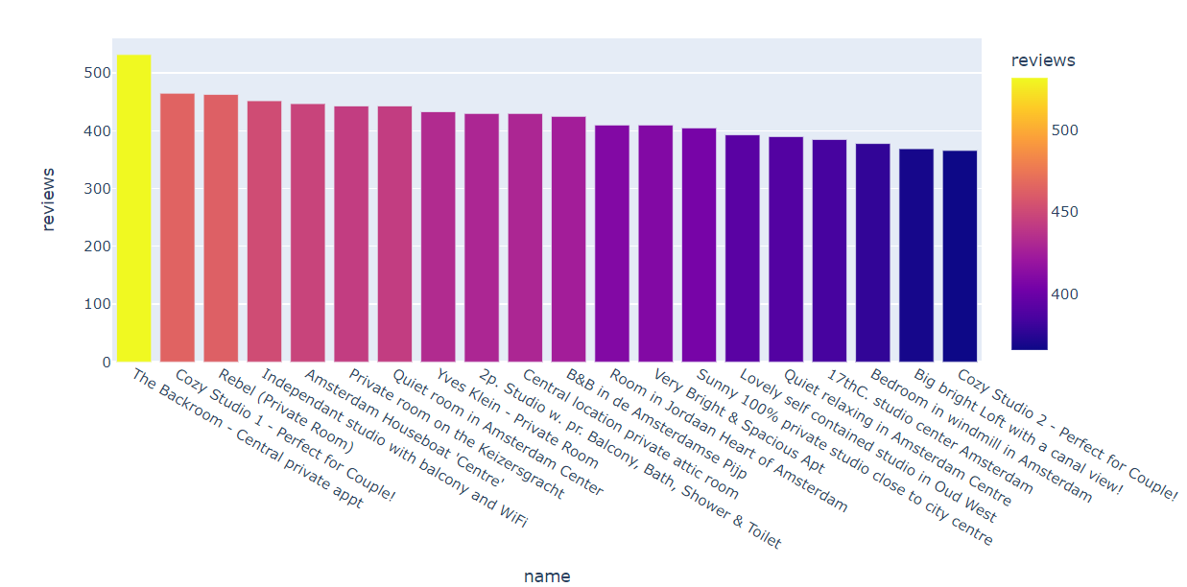

**5. PRICE WITH RESPECT TO LOCATION**

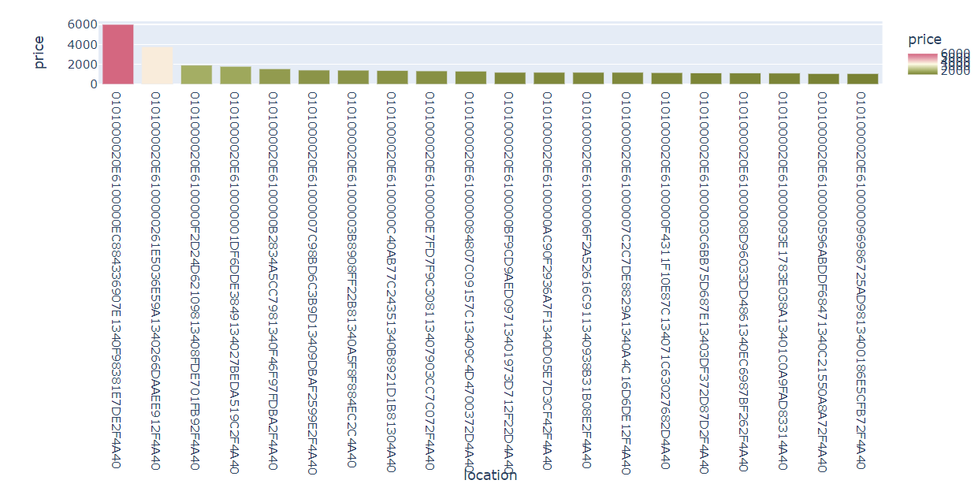

**6. NEIGHBOURHOOD NAMES WITH THEIR AVERAGE PRICE**

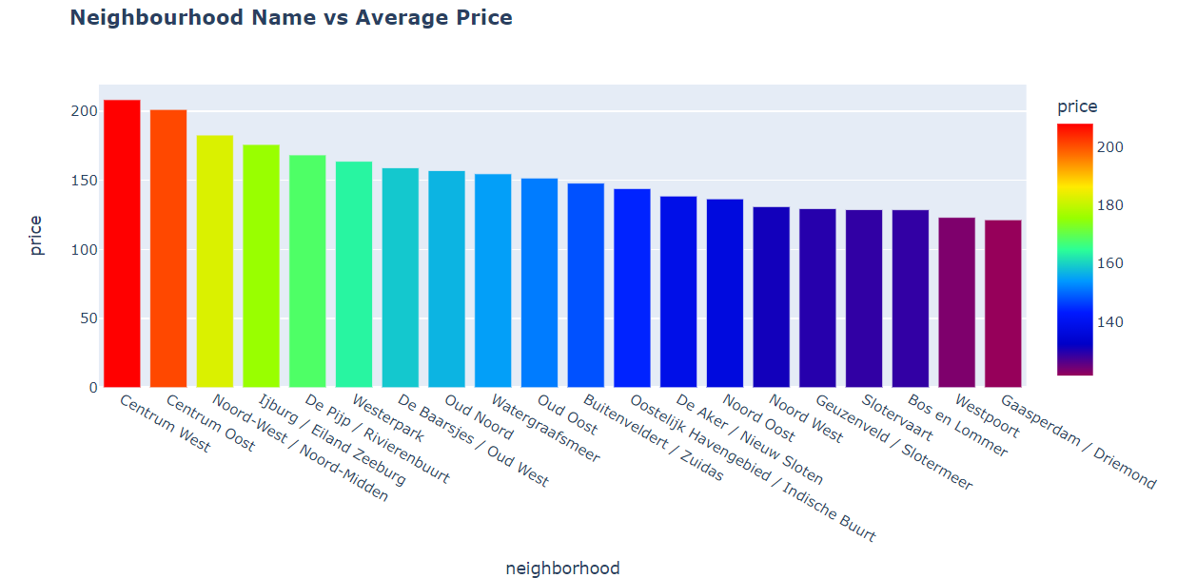

**7. RELATIONSHIP BETWEEN QUALITY AND PRICE**

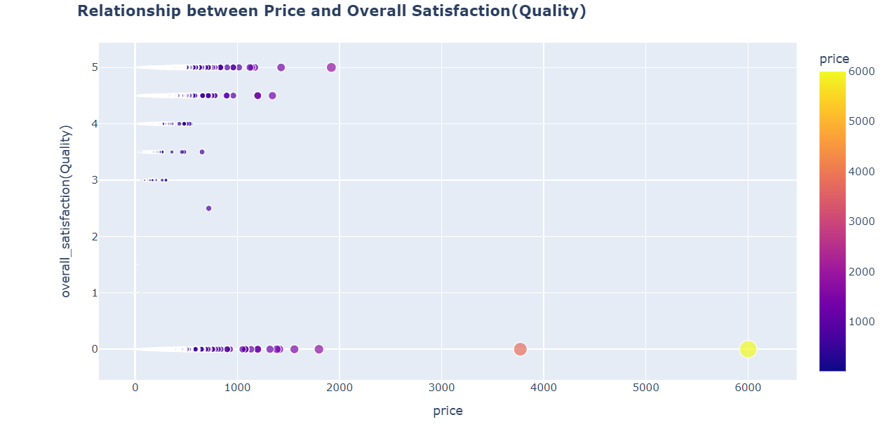

**8. RELATIONSHIP BETWEEN PRICE AND PEOPLE ACCOMMODATED**

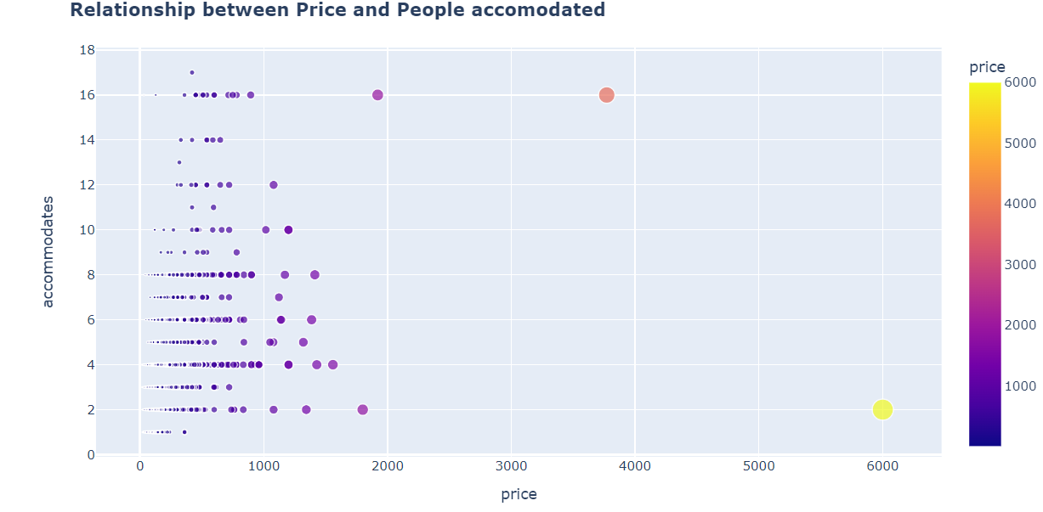

**9. NEIGHBOURHOOD NAME VS TOTAL PRICE (OR REVENUE GENERATED)**

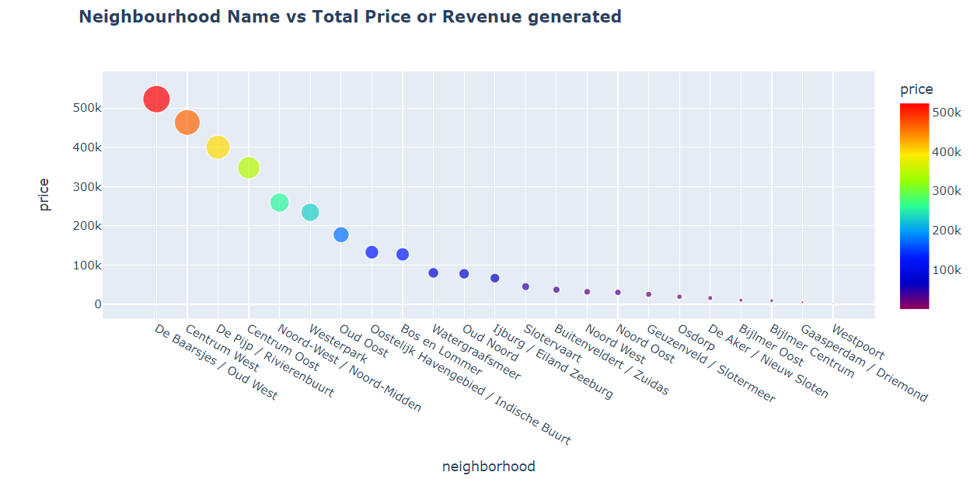

**10. NEIGHBOURHOOD NAME VS TOTAL PRICE (OR REVENUE GENERATED) IN PIE CHART TO SHOW PERCENTAGE SHARE IN REVENUE BY EACH NEIGHBOURHOOD**

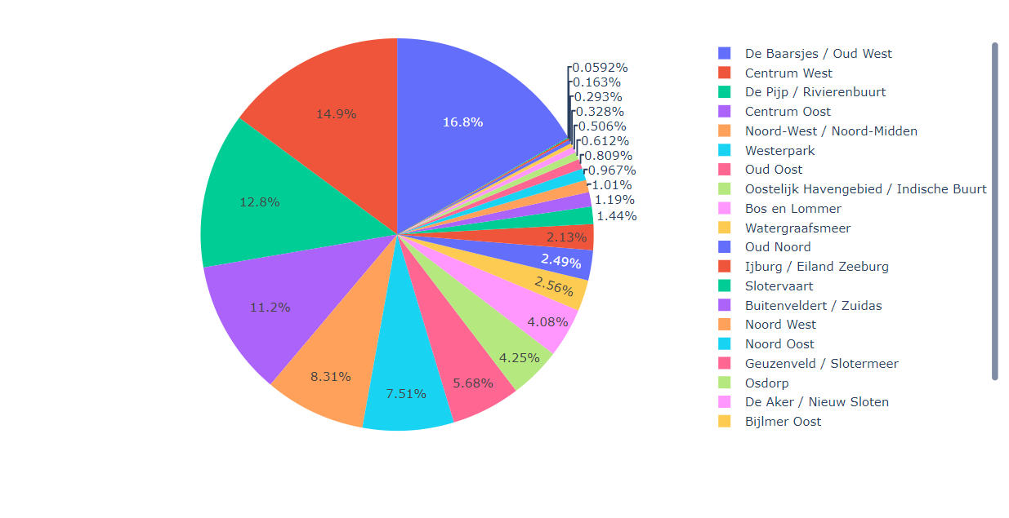

**11. NUMBER OF PROPERTIES WITH RESPECT TO ROOM TYPE**

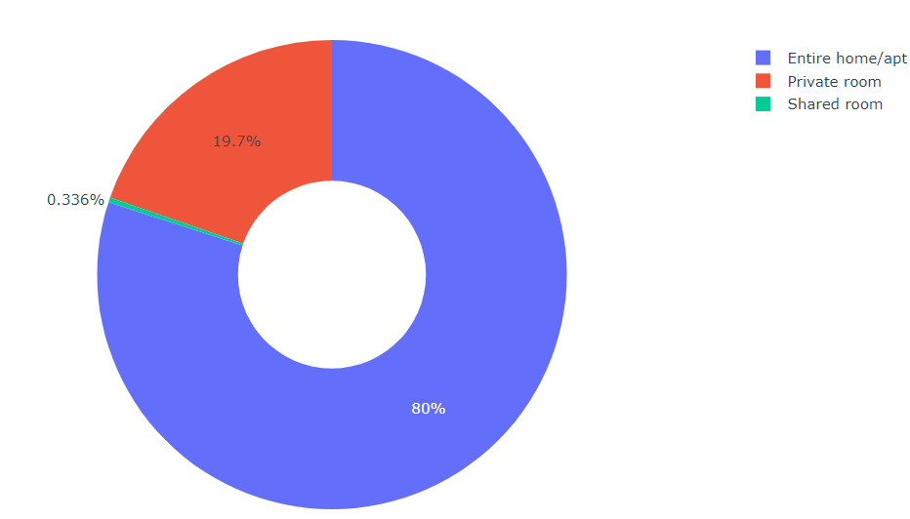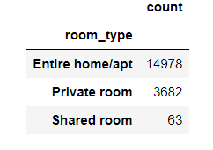

**12. AVERAGE NEIGHBOURHOOD PRICE BY ROOM TYPE**



**13. TOP 5 NEIGHBOURHOODS WITH MAXIMUM NUMBER OF BOOKINGS**

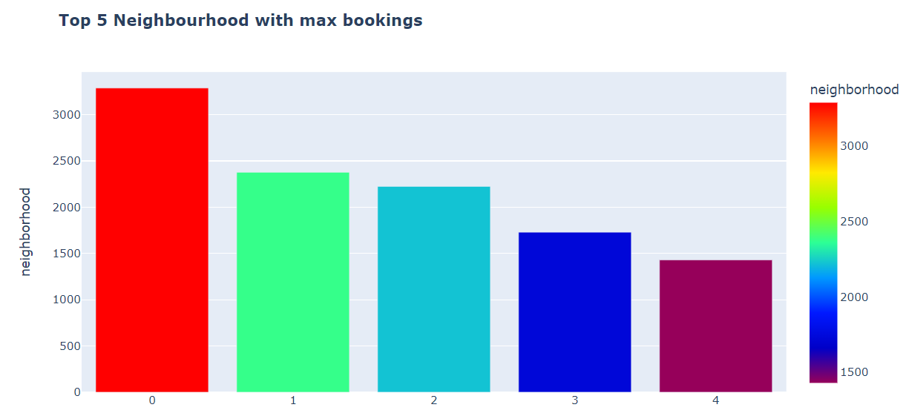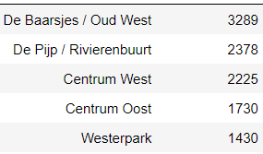

**14. LOCATION OF ALL THE AIRBNB PROPERTIES ON AMSTERDAM MAP**

