1. **INTRODUCTION**

**1.1 ABSTRACT**

This project surely saves he time of world .this project has been designed purely to reduce the time taken to find an item to purchase .it will also consumes less time in calculation of grand total of purchased items. Consumer can easily know the monthly investment on market with the help of previous records Consumer can make selected List of items at any time from any where with the help of previous records Consumer can make selected list of items at any time from anywhere with the help of this application .we design this project as a platform independent application so that it can be accessed easily using any smart phone ,tablet from anywhere with mobile network coverage.

The application consists of following modules:

1. Administrator
2. Consumer

**Module 1: Administrator** **Module:**

Administrator takes care of secure registration and profile management of the consumers Administrator handles updating the market items with their price and quantity. Administrator facilitates options like search for an item , adding items to the list and removing items from selected list .

**Module 2: Student Module:**

Consumer need to register to the application with unique id and password. After getting logged in the user can participate the activities like add item to selected list and also can remove item if not necessary . Consumer can know the grand total of the selected listitems

1. **PROBLEM DEFINITION**

The project will be used by the supermarkets to make the things among easier. Here different list of items will get stored. Here the members have unique id and password, the authentication is not secured. As anyone can access the shared information, sharing of large amount of information is difficult and not secured. When user searches regarding any item they may be delayed to get the reply from the administrator . This may also delay their planned schedule.

Sometimes the absence of items may also delay in providing the information or the material that is required by the user. The searching, viewing and deleting of items is also difficult due to storage of access amount of information in the records.

Hence to overcome the above problems a system is being developed. This system is based on Role Based Access Control. The admin has full access to the database and manages the information. The user that has registered is valid or not is checked by the admin. Here every user is provided with a unique login id and password. The users also will not be delayed in getting the information or the items required by them and they can go according to their wish.Searching, adding and deleting of items is easy.

1. **SYSTEM ANALYSIS**

**4.1 EXISTING SYSTEM:**

In existing system learning resources like study materials cannot be updated due to insufficient collaboration between virtual universities. Students are dissatisfied with their collaboration regarding access and updating study materials. Students find it difficult to coordinate their schedule when a study material provided by the university is postponed. The staff cannot reduce their work by assigning to other person who is working in any one of the university which is a partner of virtual universities.

**Disadvantages:**

Sharing of large amount of information is difficult.

Though the members have unique id and password the authentication is not secured as anyone can access the shared information.

Absence of staff may delay in providing the required information for the students.

Searching, uploading and downloading of materials is difficult.

The staff cannot assign work to another person.

**4.2 PROPOSED SYSTEM:**

The effective collaboration with information sharing in virtual universities is based on role-based access control management. There are four users- admin, management, student and staff. Each user has respective unique id and password. Admin is responsible for adding or deleting universities, viewing the universities, their respective staff and students.

**Advantages:**

Large amount of information can be shared easily.

As only authenticated persons can access the system, more security is maintained.

There is no delay in providing updates and replying to the queries of the students.

The staff can assign work to other person, hence they can reduce their work.

Searching of information, uploading and downloading of materials is easy.

1. **FEASIBILITY STUDY**

A feasibility study is an evaluation of the proposal is to determine the difficulty in carry out a task. Generally a feasibility study precedes technical development and project implementation in other words, a feasibility study is a evaluation (or) analysis of the potential impact of the proposed project.

**5.1 TYPES OF FEASIBILITY:**

1. **TECHNOLOGY FEASIBILITY:**

The assessment is based the outline design of system required in terms of input processes, output, fields, programs and procedures. This can be quantified in terms of volumes of data trends, frequency of updating etc in order to estimate whether the new system will perform adequately or not. Technology feasibility is carried to determine whether the company has capability in terms of software, hardware, personal and expertise the completion of project.

1. **ECONOMIC FEASIBILITY:**

Economic feasibility analysis is the most frequently used method for evaluating the effectiveness of new system, commonly cost of benefit analysis. The procedure is to determine the benefits outweigh cost then the decision is made to design and implemented the system entrepreneur must accurately weigh the cost is a benefit before taking an action.

1. **LEGAL FEASIBILITY:**

Determines whether the proposed system conflicts with legal requirements eg-a data processing system comply with a local protection acts.

1. **OPERATING FEASIBILITY:**

It is a measure how we are proposed system solves the problems and takes advantages of the opportunity identify during scope definition and how it satisfies the requirements identified the requirements analysis phase of system development.

1. **SCHEDULE FEASIBILITY:**

A project will fail if it takes too long to be completion before it is used. Typically this means estimating how long the system will take to develop and if it can be completed in a given time period using so many methods like payback period. Schedule feasibility is a measure how the responsible the project timetable is.

1. **PROJECT OVERVIEW**

**6.1 PROJECT MODULES:**

This project surely saves he time of world .This project has been designed purely to reduce the time taken to find an item to purchase .it will also consumes less time in calculation of grand total of purchased items. Consumer can easily know the monthly investment on market with the help of previous records Consumer can make selected List of items at any time from any where with the help of previous records Consumer can make selected list of items at any time from anywhere with the help of this application .we design this project as a platform independent application so that it can be accessed easily using any smart phone ,tablet from anywhere with mobile network coverage.

This application consists of following modules:

1. Administrator
2. Consumer

**Module 1: Administrator** **Module:**

Administrator takes care of secure registration and profile management of the consumers Administrator handles updating the market items with their price and quantity. Administrator facilitates options like search for an item , adding items to the list and removing items from selected list .

**Module 2: Student Module:**

Consumer need to register to the application with unique id and password. After getting logged in the user can participate the activities like add item to selected list and also can remove item if not necessary . Consumer can know the grand total of the selected list items.

1. **DEFINITION, ACRONYMS AND ABBREVATIONS**

**ABBREVATIONS:**

JVM : Java Virtual Machine

SQL : Structured Query Language

XML : Extensible Mark up Language

JSP : Java Server Pages

JDBC : Java Database Connectivity

JDK : Java Development Kit

CSS : Cascading Style Sheets

RBAC : Role Based Access Control

**DEFINITIONS:**

JVM :

A Java virtual machine (JVM) is a [process virtual machine](http://en.wikipedia.org/wiki/Virtual_machine%2523Process_virtual_machines) that can execute [Java bytecode](http://en.wikipedia.org/wiki/Java_bytecode). It is the code execution component of the [Java platform](http://en.wikipedia.org/wiki/Java_platform).

SQL SERVER:

It is a software product whose primary function is to store and retrieve data as requested by other software applications, be it those on same computer or those running on another computer across network (including the Internet).

JSP:

Java Server Pages (JSP) is a technology that helps [software developers](http://en.wikipedia.org/wiki/Software_developer) create [dynamically generated web pages](http://en.wikipedia.org/wiki/Dynamic_web_page) based on [HTML](http://en.wikipedia.org/wiki/HTML), [XML](http://en.wikipedia.org/wiki/XML), or other document types.

JDBC:

JDBC is a Java-based data access technology (Java Standard Edition platform) from [Oracle Corporation](http://en.wikipedia.org/wiki/Oracle_Corporation). This technology is an [API](http://en.wikipedia.org/wiki/Application_programming_interface) for the [Java programming language](http://en.wikipedia.org/wiki/Java_(programming_language)) that defines how a client may access a [database](http://en.wikipedia.org/wiki/Database).

ROLE BASED ACCESS CONTROL:

Role Based Access Control is a database through which the data is accessed according the roles of the users who are accessing the database to retrieve the data.

1. **SYSTEM REQUIREMENTS**

**SOFTWARE REQUIREMENTS:**

Operating system : Windows 7

Technology : Java/J2EE(Servlets, JSP, JDBC)

Web Technologies : Html, JavaScript, CSS, Jsp

Web Server : Tomcat 6.0 or above

Database : Oracle 10g Express Edition

Software’s : JDK 1.6 and above

**HARDWARE REQUIREMENTS:**

Hardware : Pentium based systems with a minimum of P4

RAM : 1 GB (minimum)

**9. TECHNOLOGIES**

**9.1 INTRODUCTION TO JAVA**

Java is a set of several [computer software](http://en.wikipedia.org/wiki/Computer_software) products and specifications from [Oracle Corporation](http://en.wikipedia.org/wiki/Oracle_Corporation) that provides a system for developing [application software](http://en.wikipedia.org/wiki/Application_software) and deploying it in a [cross-platform](http://en.wikipedia.org/wiki/Cross-platform) computing environment.

Java is used in a wide variety of [computing platforms](http://en.wikipedia.org/wiki/Computing_platform) from [embedded devices](http://en.wikipedia.org/wiki/Embedded_device)  and [mobile phones](http://en.wikipedia.org/wiki/Mobile_phone)  on the low end, to [enterprise servers](http://en.wikipedia.org/wiki/Enterprise_server) and [supercomputers](http://en.wikipedia.org/wiki/Supercomputer) on the high end. While less common, [Java applets](http://en.wikipedia.org/wiki/Java_applet) are sometimes used to provide improved and secure functions while browsing the [World Wide Web](http://en.wikipedia.org/wiki/World_Wide_Web) on [desktop computers](http://en.wikipedia.org/wiki/Desktop_computer).

**9.1.1 HISTORY OF JAVA**

Java history is interesting to know. Java team members (also known as Green Team), initiated a revolutionary task to develop a language for digital devices such as set-top boxes, televisions etc.For the green team members, it was an advance concept at that time. But, it was suited for internet programming. Later, Java technology as incorporated by Netscape. Currently, Java is used in internet programming, mobile devices, games, e-business solutions etc. There are given the major points that describes the history of java. 1) James Gosling, Mike Sheridan, and Patrick Naughton initiated the Java language project in June 1991. The small team of sun engineers called Green Team. 2) Originally designed for small, embedded systems in electronic appliances like set-top boxes. 3) Firstly, it was called "Greentalk" by James Gosling and file extension was .gt. 4) After that, it was called Oak and was developed as a part of the Green project. 5) Why Oak? Oak is a symbol of strength and choosen as a national tree of many countries like U.S.A., France, Germany, Romania etc. 6) In 1995, Oak was renamed as "Java" because it was already a trademark by Oak Technologies. 7) Why they choosed java name for java language? The team gathered to choose a new name. The suggested words were "dynamic", "revolutionary", "Silk", "jolt", "DNA" etc. They wanted something that reflected the essence of the technology: revolutionary, dynamic, lively, cool, unique, and easy to spell and fun to say. According to James Gosling "Java was one of the top choices along with Silk". Since java was so unique, most of the team members preferred java. 8) Java is an island of Indonesia where first coffee was produced (called java coffee). 9) Notice that Java is just a name not an acronym.

10) Originally developed by James Gosling at Sun Microsystems (which is now a subsidiary of Oracle Corporation) and released in 1995. 11) In 1995, Time magazine called Java one of the Ten Best Products of 1995. 12) JDK 1.0 released in(January 23, 1996).

**9.1.2 FEATURES OF JAVA**

There is given many features of java. They are also known as java buzzwords.

1. Simple
2. Object-Oriented
3. Platform independent
4. Secured
5. Robust
6. Architecture neutral
7. Portable
8. Dynamic
9. Interpreted
10. High Performance
11. Multithreaded
12. Distributed

**Simple :**

According to Sun, Java language is simple because, syntax is based on C++ (so easier for programmers to learn it after C++). removed many confusing and/or rarely-used features e.g., explicit pointers, operator overloading etc. No need to remove unreferenced objects because there is Automatic Garbage Collection in java.

### Object-oriented:

Object-oriented means we organize our software as a combination of different types of objects that incorporates both data and behaviour. Object-oriented programming(OOPs) is a methodology that simplify software development and maintenance by providing some rules. Basic concepts of OOPs are:

* Object
* Class
* Inheritance
* Polymorphism
* Abstraction
* Encapsulation

### Platform Independent:

A platform is the hardware or software environment in which a program runs. There are twotypes of platforms software-based and hardware-based. Java provides software-based platform. The Java platform differs from most other platforms in the sense that it's a software- based platform that runs on top of other hardware-based platforms. It has two components: Runtime Environment API(Application Programming Interface)

### Secured: Java is secured because:

* No explicit pointer
* Programs run inside virtual machine sandbox.
* Classloader- adds security by separating the package for the classes of the local file system from those that are imported from network sources.
* Byte code Verifier- checks the code fragments for illegal code that can violate access right to objects. Security Manager- determines what resources a class can access such as reading and writing to the local disk. These security are provided by java language. Some security can also be provided by application developer through SSL ,JAAS, cryptography etc.

### Robust:

Robust simply means strong. Java uses strong memory management. There are lack of pointers that avoids security problem. There is automatic garbage collection in java. There is exception handling and type checking mechanism in java. All these points makes java robust.

### Architecture-neutral and Portable:

There is no implementation dependent features e.g. size of primitive types is set. We may carry the java byte code to any platform.

### High-performance:

Java is faster than traditional interpretation since byte code is "close" to native code still somewhat slower than a compiled language (e.g., C++)

### Distributed:

We can create distributed applications in java. RMI and EJB are used for creating distributed applications. We may access files by calling the methods from any machine on the internet.

**Multi-threaded:** A thread is like a separate program, executing concurrently. We can write Java programs that deal with many tasks at once by defining multiple threads. The main advantage of multi-threading is that it shares the same memory. Threads are important for multi-media, Web applications etc.

**9.1.3 .JAVA CLASS LIBRARY** Java the platform contains around 4,000 classes/interfaces

* Data Structures
* Networking, Files
* Graphical User Interfaces
* Security and Encryption
* Image Processing
* Multimedia authoring/playback And more...

**9.1.4 .JAVA FRAMEWORK ARCHITECTURE** The following figure illustrates the architecture of the Silk Performer Java Framework. The figure is divided into three main sections:

* The upper box illustrates supported technologies and test types.
* The middle box illustrates layers of Java Framework code.
* The lower box illustrates available tools.

*Supported Technologies and Test Types* (upper box in figure) In one dimension, the upper box shows some of the supported technologies. The second dimension illustrates the areas of testing in which Java Framework can be used.

*Layers of Java Framework Code* (middle box in figure) The middle box shows the layers of Java Framework code and its connection to various client APIs. The Java Framework API is the “membrane” between BDL code and Java code, symbolized by arrows in the figure. Some of the arrows point in one direction (see “Runtime-to-Java Communication”). Some of the arrows show that communication is possible from Java to the runtime (i.e., Java-to-Runtime communication ).

*Available Tools* (lower box in figure below) In one dimension, the lower box shows Silk Performer tools for generating Java Framework code. The second dimension indicates if code generation is done with the help of Silk Performer tools or 3rd party tools.

**9.1.5. WEB SERVICES** Web Services provide data and services to other applications. Future applications will access Web Services via standard Web Formats (HTTP,HTML,XML and SOAP), with no need to know how the Web Service itself is implemented. Web Services are main building blocks in the Microsoft .NET programming model.

**9.1.6 APPLICATIONS OF JAVA**

* Since Java has inbuilt networking features so it is widely used for developing network related programs and softwares. Socket programming using JAVA is very simple and efficient and simple  and efficient and simple as compared to c.
* It is widely used for creating web applications and it can also generate static HTML content like php and JavaScript so it is used in website designing too.
* In application software development Java is widely used because it is a fully Object Oriented Programming language
* Creating Graphical User Interface(GUI) in Java is very simple and efficient as compared to c and c++. So it is also used in creating GUI for applications.
* That’s all.. if you have any more idea or my points seems wrong.. then you may write a comment.

**9.1.7 CHALLENGES OF JAVA**

Java is unique - it's a mainstream programming language that works like no other. Its rules aren't well understood yet by many application developers. Part of the reason for this is that its capabilities and limitations haven't been fully explored.

As a result, while many of the problems may be similar, recognizing them and knowing what to do when you find them remains challenging, even to experienced Java developers. What follows are just a few of the development issues and what they mean for Java.

***Performance***   
Performance is a concern of applications written in any language. Most programmers are familiar with common performance issues using a conventional language such as C with a stand-alone or even a client/server application. Such issues often involve improper allocation, deallocation of memory and poor use of system APIs.

These aren't even characteristics of the Java language. For example, relating Java code to how the JVM manages memory is difficult and error-prone. However, it's vital to improve Java performance because its execution model has additional overhead that tends to degrade performance more than native applications do.

In addition to typical performance requirements and issues surrounding traditional stand-alone applications, distributed Java applications must contend with problems surrounding the interactions between components running on different systems. Performance problems may manifest themselves in unexpected ways or appear to be caused by different parts of the code other than the actual problem area. Identifying and locating performance bottlenecks rapidly is a significant challenge in distributed application development.

***Reliability***   
Enterprise Java applications, especially distributed ones, are often mission-critical in nature: all aspects of the application must work perfectly at all times. Developers and development managers must be able to gauge the reliability of their applications accurately. While the characteristics of the language tend to make Java applications less error-prone, there are still plenty of ways to introduce runtime errors.

With distributed Java applications the reliability equation is even more difficult. It means assessing not only the individual applications but also the components as they interact. Java also makes it possible to write highly threaded applications that make sense in a distributed environment. But using threads means that problems with resource contention and deadlock are much greater.

***Testing***   
Java applications face the same testing problems as traditional ones. They must be tested as thoroughly as possible before fielded, and developers should have a good idea of the extent of the test coverage before certifying an application. Distributed software systems written in Java, however, are extraordinarily difficult to test and debug. Because components reside on different computers and must work together perfectly for the application to work properly, all components must be tested simultaneously.

***Memory Management***   
Since JVMs perform all the memory management tasks for applications, understanding the memory usage of the underlying platform and influencing memory allocation and use to affect performance is difficult to do and not intuitive. That's especially true because developers have no easy way of determining the relationship between code and the underlying memory use.

**9.1.10 BENEFITS**

1.Simple 2.Platform independent 3.Secure 4.Reliable 5.Multi Tasking 6.Dynamic 7.Economical

1) **Simple:** This particular program is specially designed to be very user-friendly. If compared with other programming languages, Java is easier to write, compile, debug and learn. This is because it uses automatic memory management and garbage collection. unique learners can apply it easily within a short period of time.

2) **Platform-independent:**The best thing about Java is its ability to go easily from one computer system to another without creating any predicament. “Write once, speed anywhere” best describes Java. It can urge independently at both the source and binary levels. The same program can be race smoothly on different systems. This special feature is extremely well-known to World Wide Web software which needs a lot of flexibility.

3) **Secure:** If security is your main exertion, Java will be your best choice. It places security as its top priority. Its language, compiler, interpreter and runtime environment are customized with security in mind. Its platform allows users to download unknown code over a network and speed it in a find environment without causing hurt to the systems. The host system will not be infected by virus at all. This capability alone has made the Java platform recent.

4) **Reliable:** Honestly speaking, it is indeed hard to glimpse for programming languages which are truly robust. However, Java has assign a lot of inconvenience on early checking for possible errors. Java compilers are able to detect many problems at the initial stage of execution. Hence, it is considered the most friendly programming by the developers.

5) **Multiple Tasking:**  
Java has the capability to make several tasks simultaneously. Multithreaded programming has been smoothly integrated into it. It works best in visual and network programming. At the same time, its stable standards serve the developers to manufacture multilevel applications with a component based near.

6) **Dynamic:** Java code is organized in modular object-oriented units. These units are known as classes. They are stored in separate files and are loaded into the Java interpreter only when required. In this state, a program is able to extend itself dynamically by loading which classes it needs to expand its functionality.

7) **Economical:**  
How noteworthy do you need to invest on Java programming? It is an launch source. Hence, you don’t need to struggle with heavy license fees annually.

**9. 2 INTRODUCTION TO SQL SERVER**

Microsoft SQL server is a relational data base server, developed by Microsoft: It is a software product whose primary function to store and retrieve data a s requested by other software applications, be it those on the same computer or those on running on other computers across the network (including the internet). These are at least a dozen different editions of Microsoft SQL server aimed at different audiences and for different workloads (ranging from small applications that store and retrieve data on the same computer, to the millions of users and computers that access huge amount of data from the internet at the same time).

**9.3 DATA STORAGE**

The main unit of data storage is a data base, which is a collection of tables with typed columns. SQL server supports different data types, including primary types such as integer, float, decimal, char (including characters strings), Varchar (variable character strings), binary (for unstructured blobs of data), text (for textual data) among others. The rounding of floats to integers uses either symmetric arithmetic rounding or symmetric round down (fix) depending on arguments: SELECT Round (2.5,0) gives 3.

Microsoft SQL server also allows user define composite types to be defined and used. It also makes server statistics available as virtual cables and views. In addition to tables, a data base can also contain other objects including views, stored procedures, indexes and constraints along with transaction log.

**9.4 DATA RETRIEVAL**

The main mode of retrieving data from an SQL Server database is querying for it. He query is expressed using a variant of SQL called T-SQL, a dialect Microsoft SQL Server share with with Sybase SQL Server due to its legacy. The query declaratively specifies what is to be retrieved. It is processed by the by the query processor, which figures out the sequence of steps that will be necessary to retrieve the requested data. The sequence of actions necessary to execute a query is called a query plan. There might be multiple ways to process the same query. For example, for a query that contains a join statement and a select statement, executing join on both the tables and then executing select on the results would give the same result as selecting from each table and then executing the join, but result in different execution plans. In such case, SQL Server chooses the plan that is expected to yeeld the results in the shortest possible time. This is called query optimization and is performed by the query processor itself.

SQL Server also allows stored procedures to be defined. Stored procedures are parameterized T-SQL queries, that are stored in the serve itself (and not issued by the client application as is the case with general queries). Stored procedures can accept values sent by the client as input parameters, and send back results as output parameters. They can call defined function, and other stored procedures, including the same stored procedure (up to a set number of times). They can be selectively provided access to. Unlike other queries, stored procedures have an associate nam, which is used at runtime to resolve into the actual queries. Also because the code need not be sent from the client every time (as it can be accessed by name), it reduces network traffic and some what improves performance. Execution plans for stored procedures are also cached as necessary.

1. **SCREENS**

**HOME PAGE**

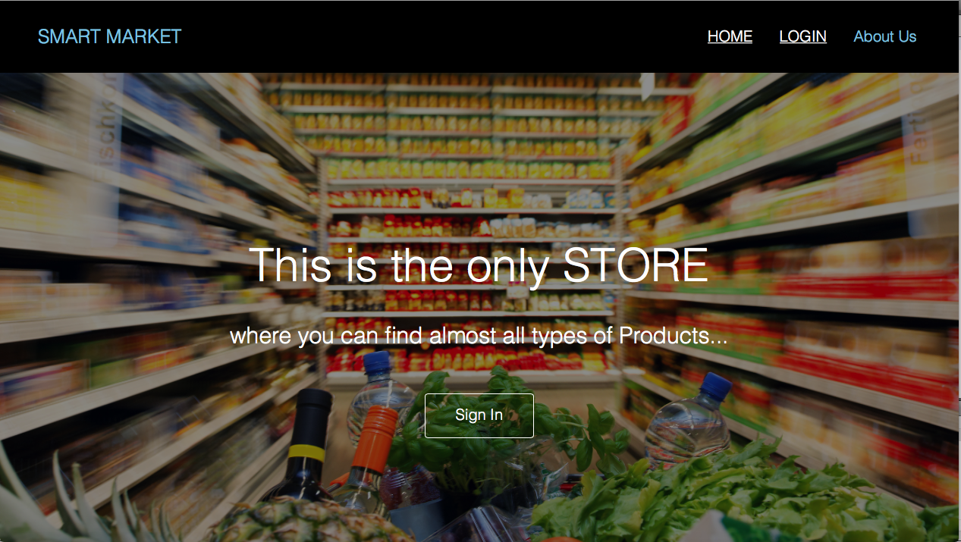

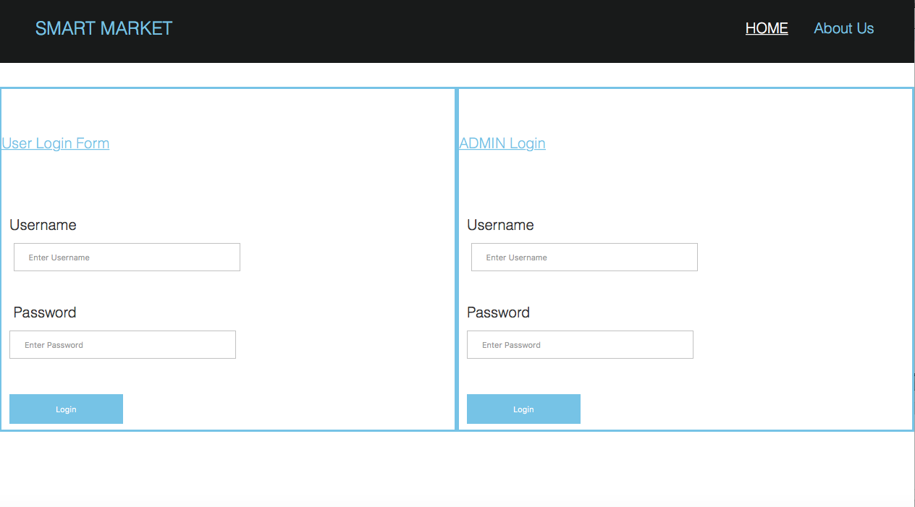**LOGIN PAGE**

**ITEM DETAILS IN ADMIN**

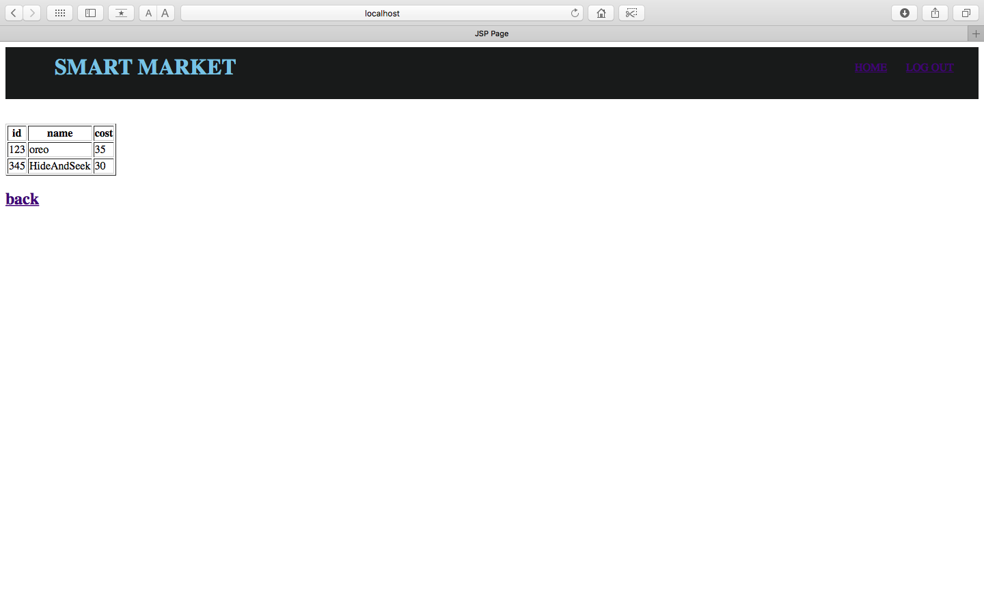

**ADD ITEMS IN ADMIN**

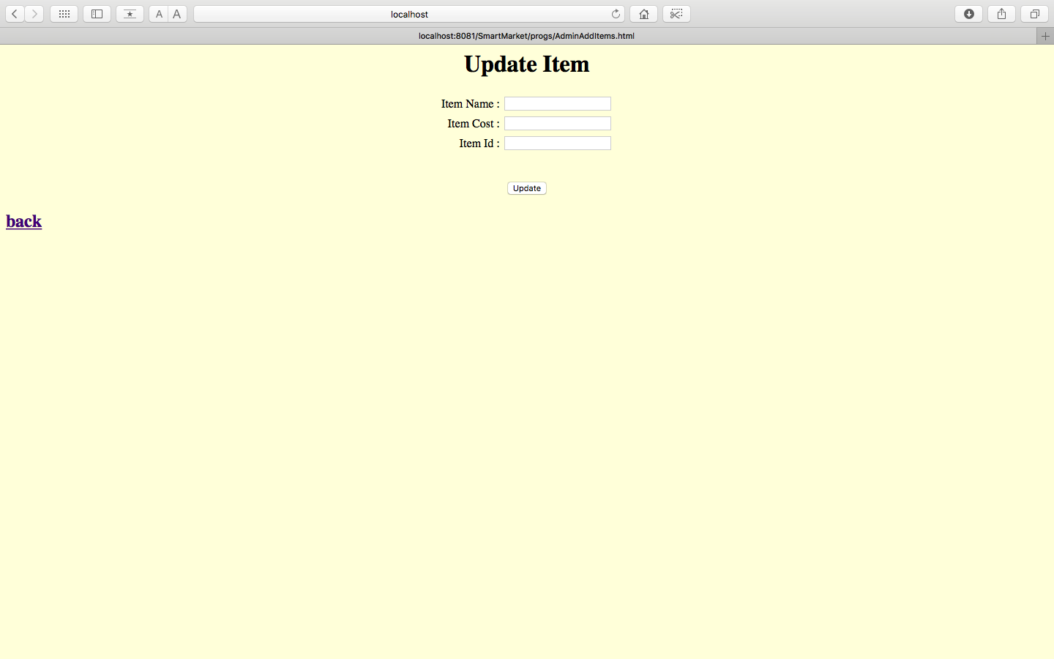

**USER DETAILS**

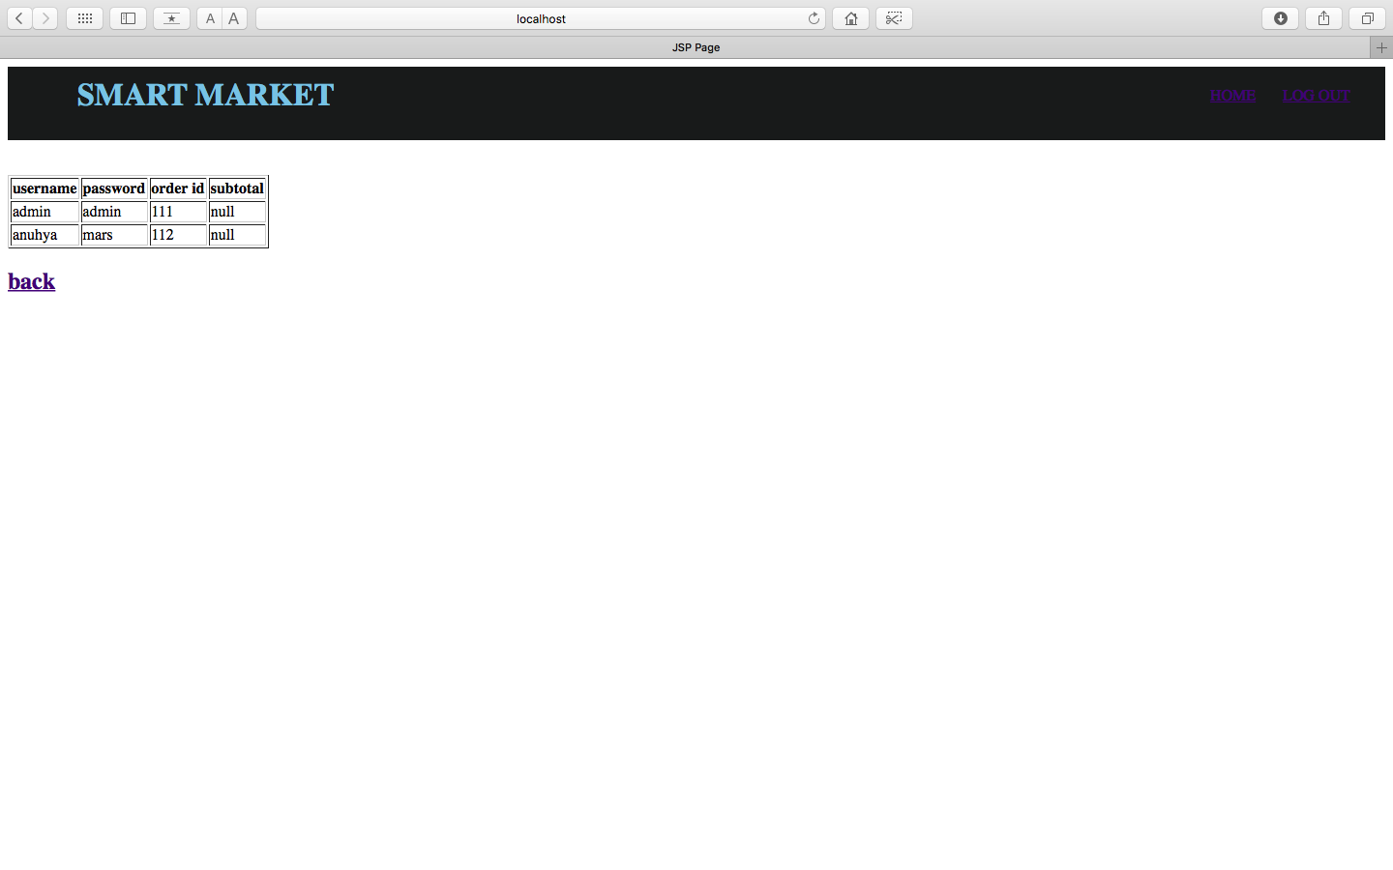

**USER HOME PAGE:**

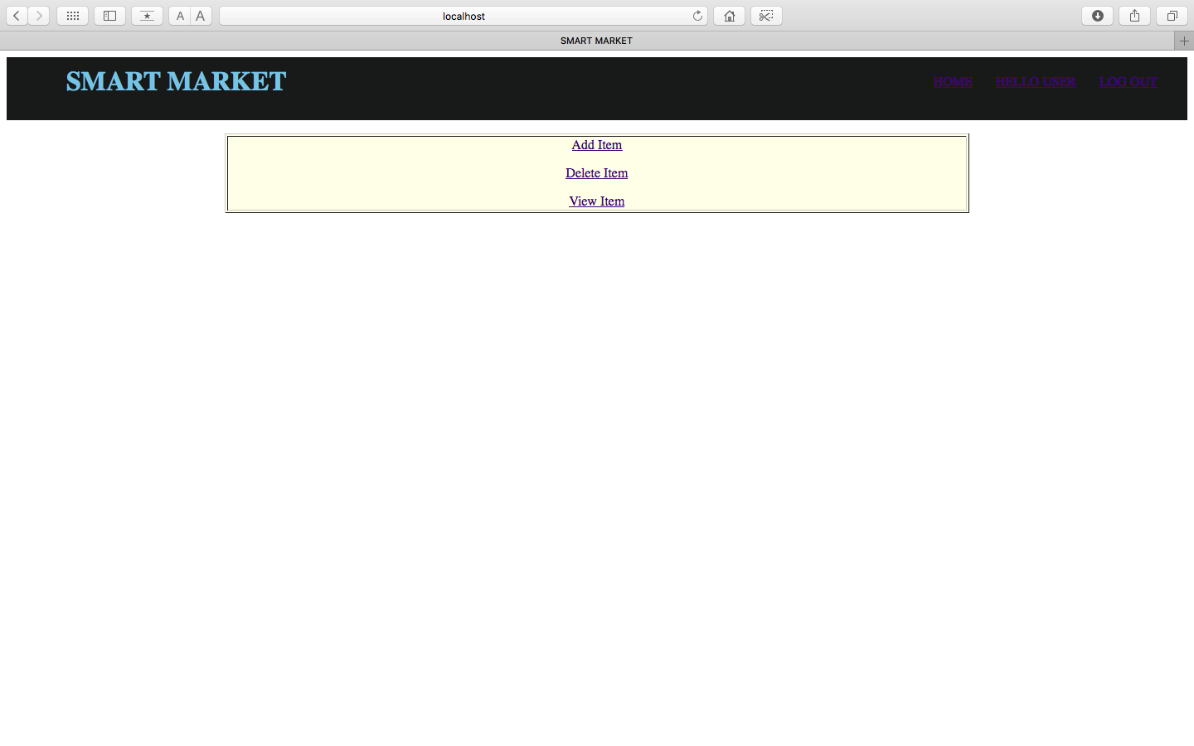

**USER REGEISTRATION FORM**

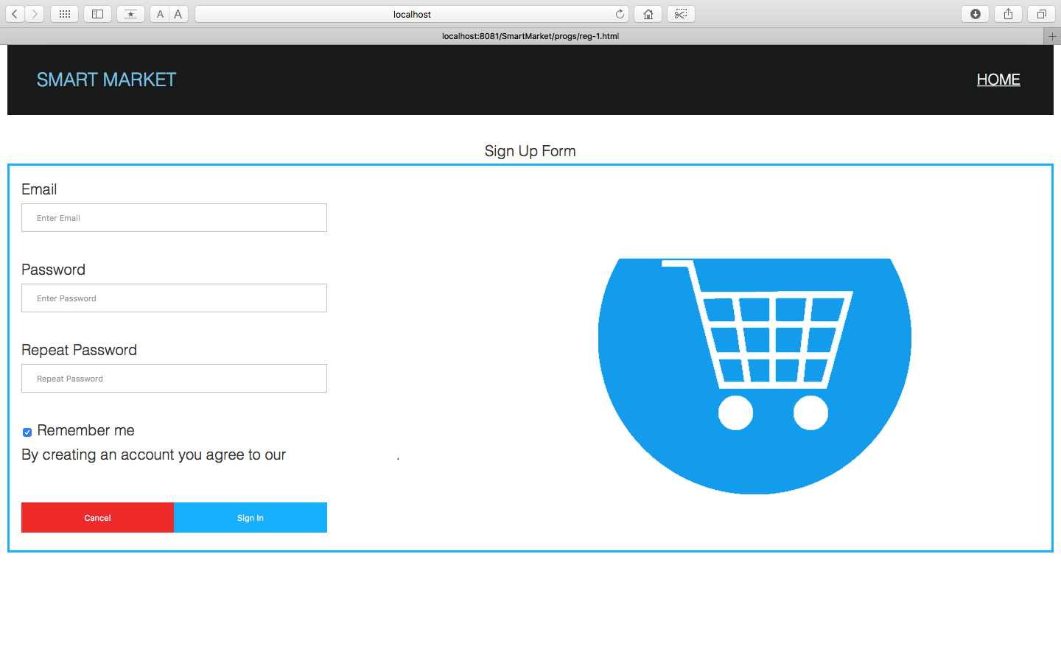

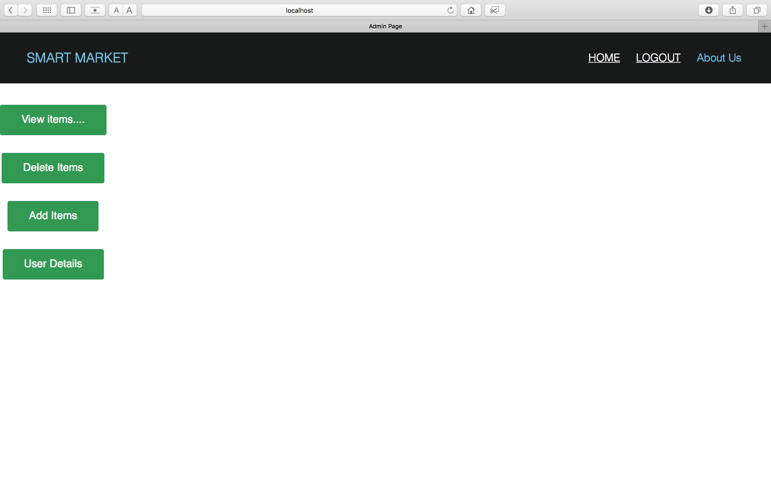

**Admin Home Page**

**DELETE ITEMS IN ADMIN**

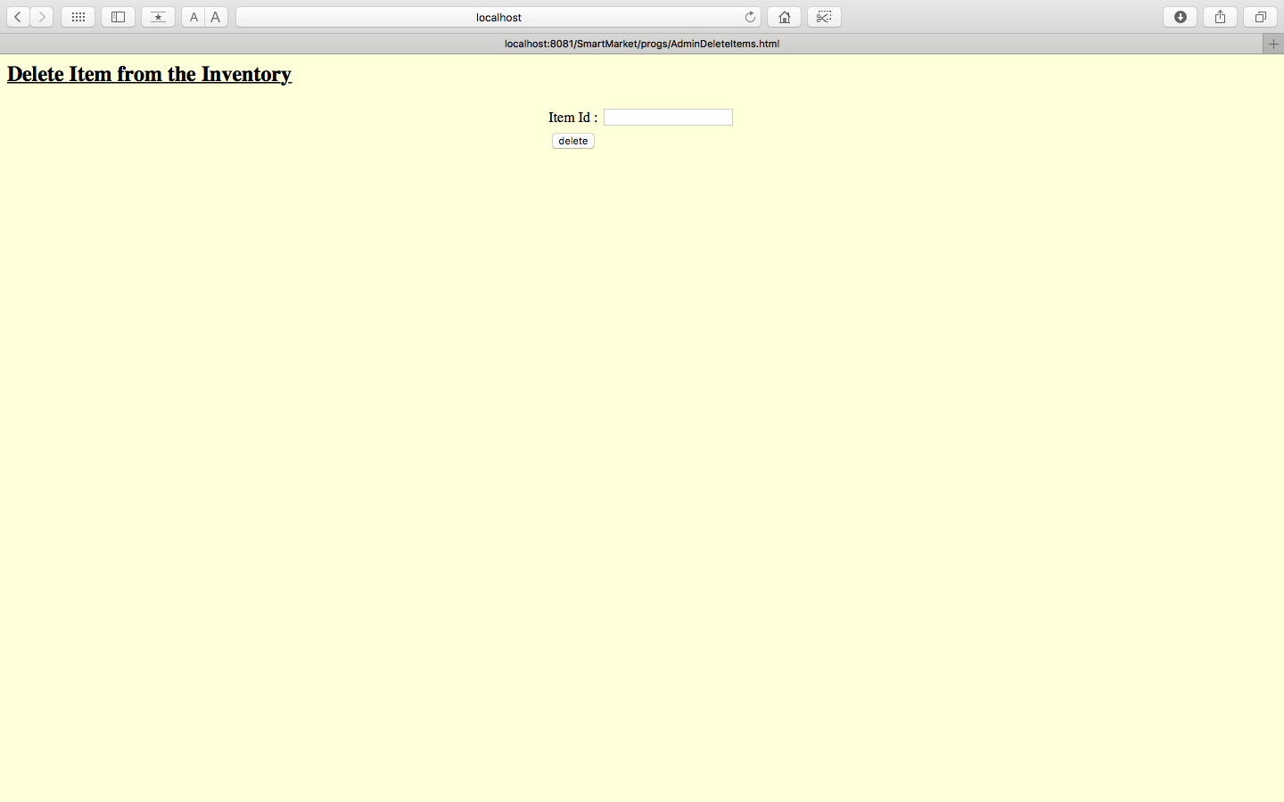

**VIEW ITEMS IN THE INVENTORY**

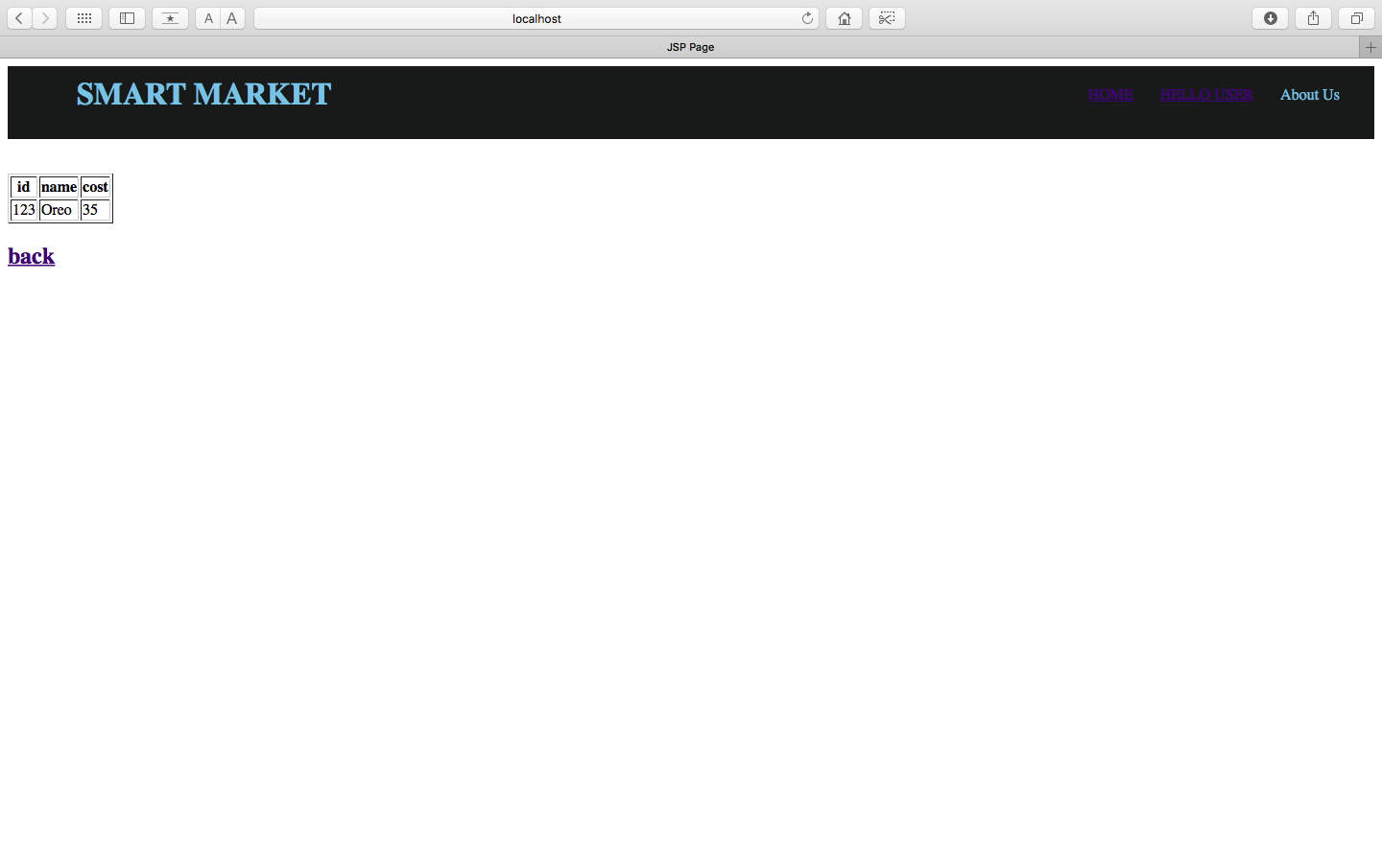

**DATABASE DESIGN**

**User Registration:**

|  |  |  |
| --- | --- | --- |
| **Field name** | **Data type** | **Constraint** |
| Username | varchar(10) |  |
| Password | varchar(10) |  |
| orderid | **integer**(10) | Primary key |

**ADMIN Registration:**

|  |  |  |
| --- | --- | --- |
| **Field Name** | **Data Type** | **Constraint** |
| User | Varchar(20) |  |
| Password | Varchar(20) |  |

**Items:**

|  |  |  |
| --- | --- | --- |
| **Field name** | **Data Type** | **Constraint** |
| Itemname | Varchar(50) |  |
| ItemCost | integer(50) |  |
| ItemId | integer(50) |  |

**IemsList:**

|  |  |  |
| --- | --- | --- |
| **Field name** | **Data type** | **Constraint** |
| Itemname | Varchar(50) |  |
| Itemcost | integer(50) |  |
| itemid | integer(50) |  |
| Orderid | integer(50) | **Foreign key** |

1. **TEST PROFILE, TEST PLAN**

**INTRODUCTION:**

Software testing is a critical element of software quality assurance and represents the ultimate review of specification, design and coding. In fact, testing is the one step in the software engineering process that could be viewed as destructive rather than constructive.

A strategy for software testing integrates software test case design methods into a well-planned series of steps that results in the successful construction of software. Testing is the ser of activities that can be planned in advanced and conducted simultaneously. The underlying motivation of program testing to affirm software quality with methods that can economically and effectively is applied to both strategic to both large and small-scale systems.

The following are the testing objectives:

* Testing is a process executing a program with the intent of finding an error.
* A good test has a high probability of finding an as yet undiscovered error.
* A successful test is one that uncovers an as yet undiscovered error.

**DESIGN OF TEST CASES AND SCENARIOS:**

The objective is to learn tests that systematically uncover different classes of errors and do so with a minimum amount of time and effort. Testing cannot show the absence of defects, it can only show that software defects are present.

**Unit Testing:**

* Interface
* Number of input characters should be equal to number of arguments.
* Parameters and arguments attributes must match.
* Parameters passed should be in correct order.
* Global variable definitions consistent across module.
* If module does I/O.
* File attribute should be correct.
* Open/Close statements must be correct.
* Format specifications should match I/O statements.
* Buffer size should match record size.
* Files should be opened before use.
* End of file condition should be handled.
* I/O errors should be handled.
* Any textual errors in output information must be checked.
* Local Data Structures (common source of errors).
* Improper or inconsistent typing.
* Erroneous initializing or default values.
* Incorrect variable names.
* Inconsistent data types.
* Overflow, underflow, address exception.
* Boundary conditions and independent paths.
* Error handling.
* Error description unintelligible.
* Error noted does not correspond to error encountered.
* Error condition handled by system run-time before error handler gets control.
* Exception condition processing incorrect.

**Integration Testing:**

Module integrated by moving down the program design hierarchy. Can use depth firs**t** or breadth first top down integration verifies major control and decision points early in design process. Top-level structure tested most. Depth first implementation allows a complete function to be implemented, tested and demonstrated and does depth first implementation of critical function early. Top down integration forced (to some extend) by some development tools in program with graphical user interfaces. Begin construction and testing with atomic modules (lowest level modules).

Bottom up integration testing as its name implies being construction and testing with atomic modules. Because modules are integrated from the bottom up, processing required for module subordinate to a given level is always available and the need for stubs is eliminated.

**Top-Down Integration:**

Top-Down Integration testing is an incremental approach to construction of program structure. Modules are integrated by moving download through the computer hierarchy, beginning with the main control module.

The Top-Down integration process is performed in the following five steps:

The main control module is used as a test driver and subs are substituted for all the components directly subordinate to the main control module.

Depending on the integration approach selected, subordinate stubs are replaced one at a time with actual components.

Tests are conducted as each component is integrated.

On completion of each of test, another stub is replaced with the real components.

Regression testing may be conducted to ensure that new errors have not been introduced.

**Bottom-Up Integration:**

Bottom-Up Integration testing as its name implies, being construction as testing with atomic modules because components are integrated from the bottom up, processing required for components subordinate to a given level is always available and for stuns is eliminated.

The Bottom-Up Integration is performed in the following four steps:

Low-Level components are combined into clusters that perform a specific software stub function.

Driver is written to coordinate test case input and output.

The cluster is tested.

**TEST CASES AND SCENERIOS:**

A TEST Plan is a systematic approach to test a system as a machine or software. The plane typically contains a detailed understanding of what the eventual work flow will be UINT LEVEL plan for JOB ad.

**Test Report and Results:**

|  |  |
| --- | --- |
| TEST REPORT NO | 1 |
| PROJECT NAME | EFFECTIVE COLLABORATION WITH INFORMATION SHARING IN VIRTUAL UNIVERSITIES |
| MODULE NAME | USER REGISTRATION |
| FORM NAME | REGISTRATION |
| UNIT NAME | USER NAME & DETAILS OF USER |
| TEST RESULTS | ON CLICKING SUBMIT BUTTON AFTER PROVIDING YOUR PARTICULAR ACCOUNT WILL BE CREATED AND YOU CAN LOGIN TO THE SITE. |

**TEST PLAN 1:**

Project Name: SMART MARKET.

Module Name: USER Module.

Unit Name: User Name.

Test Result: The User Name Textbox is tested and verified.

Test Plan (Unit Module/Test Integration)

Test plan for SMART MARKET.

Unit ID: LOGIN.

Test Case ID: Login Page.

Test Type: Unit Case.

Form Name: LOGIN.

Base Table: Registration.

**PURPOSE:**

Registration table is used for store the details of registered members details and along with their Username and Password. By using these details the administrator can perform the operations.

**TEST CASE DESCRIPTION:**

**USERNAME varchar (20)**

**Test Data**

|  |  |  |
| --- | --- | --- |
| SNO | INPUT SPECIFICATION | EXPECTED RESULT/OUTPUT |
| 1. | Column Name: User name  Valid Input: If the Username valid along with password then the form will be navigated to allotted page.  Invalid Input: If the User Name should be reentered. | Valid Output: If the User Name and Password are correct then form navigation to home page.  Invalid Output: If the User Name is incorrect error message is displayed as “User Invalid” and it will ask for enter of User Id and Password. |

**TEST COMPLETION CRITERIA:**

When expected results match the actual results performing the test, the test is considered to be completed.

**VALIDATION TESTING:**

Validation succeeds when system functions in a manner that can be reasonably by the end-user. This is achieved through a series of black-test that demonstrate with requirements.

There are two tests for system conduction for the system validation:

* Alpha Testing.

A customer conducts it at the developer’s site. The software is used in a nature setting with the developer “looking over the shoulder” of the user and recording errors and usage problems.

* Beta Testing

This test is conducted at one or more users sited by the end user of the software. Here the developer generally not presents. Therefore, the beta test in a “line” application of the software in an environment that can’t be controlled by the developer.

**System Testing:**

Once the software product is developed, it is thoroughly tested and it is delivered to the users. Now, it has to be tested by developing it on the system i.e., to what the given software is comfortable to the environment. The software engineer should consider these issues during early stages of software development to release himself from the problems which are encountered after completion of the software. Hence, the tests conducted to ensure that the software is comfortable with the system, where it is deployed is referred as “System Testing”.

* Recovery Testing

It is often a nature fact that certain errors may corrupt the system or may make the system not to function properly to a stipulated period of time. Hence, recovery testing is the process which given software id exposed to failures and it is tested to see its recovery capabilities.

Usually the recovery can be of two types:

* Automatic through human intervention.
* Recovery through human intervention.

During automatic recovery the software itself recovered. Sometimes requires certain addition support like system restart, reutilization, data recovery, etc., for tis normal execution when the system requires human intervention in order to recover from such recovery is referred as recovery through human intervention. Here, mean-time-to-repair is a value which is calculated to ensure that the software gets recovered within acceptable span of time.

* Security testing:

Security plays a major role especially in that software. Which are made to deal with highly confidence data. For these systems, often several hackers try their to break the security of the system and acquire the confidential data for their foolish requirements. Hence, for these systems, security measures should be given vital importance. For this purpose, the testers themselves disguise into hackers and perform series of attempts to breaks the security of the given software can be truly judged.

* Stress Testing

Stress testing is usually performance to check the limits of the system i.e., to what extend the system can resists the abnormal conditions. Hence, the system is tested by providing abnormal resources in different proportions. During stress testing a system can be.

* Providing the excess values of data in different proportions to check its memory management capabilities i.e., how efficiently the system manages the data which is more than its capability.
* Exposed to certain programs demanding large memory and resources not available with the current system.
* Providing too many interrupts during a specific period of time.
* Providing with too many inputs through it can survive only few inputs etc.
* Performance testing

Performance testing is essential to ensure the given software performance to the execution when it is implemented on the system. Hence, in this case it is only the software considered but also the hardware in which it is deployed. Here, the performance testing is combined with the stress testing cases to check the internal aspects such as resources utilization and various other instances.

1. **CONCLUSION**

The package was designed in such a way that future modifications can be done easily. The following conclusions can be deducted from the development of the project.

* Automation of the entire system improves the efficiency.
* It provides a friendly graphical user interface which proves to be better when compared to the existing system.
* It gives appropriate access to the authorized users depending on their permissions.
* It effectively overcomes the delay in communications.
* Updating of information becomes so easier.
* System security, data security and reliability are the striking features.
* The system has adequate scope for modifications in future if it is necessary.

This application avoids the manual work and the problems concern with it. It is an easy and fast way to access the updates information

1. **BIBILOGRAPHY**

MSDN 2000 By M.S

UML

The Unified Modeling Language By Grady Booch

User Guide By James Rumbaugh

( The Ultimate tutorial to the UML By Iyer Jacobson

From the original designer)