1. Write a procedure for the following.

a. To accept employee number , delete the record of the given

employee.

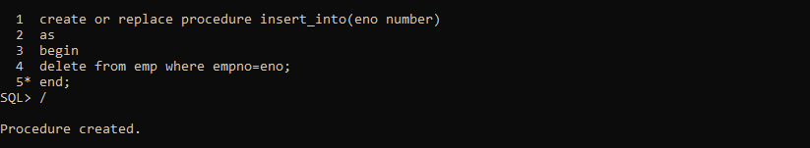

BEFORE

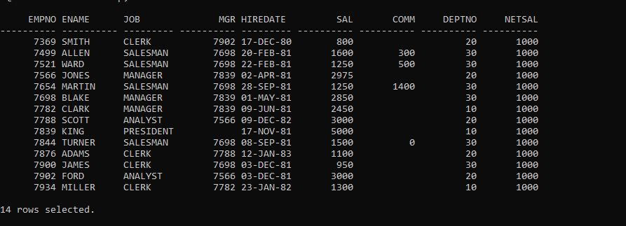

AFTER

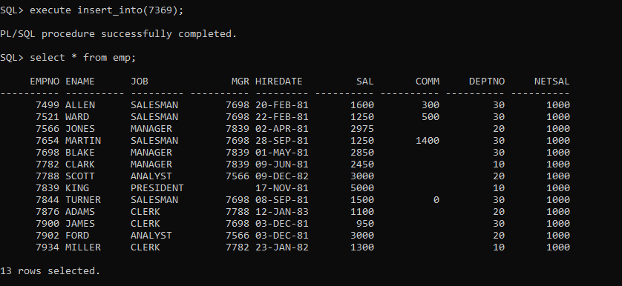

b. To accept grade,losal and hisal and insert a record into salgrad table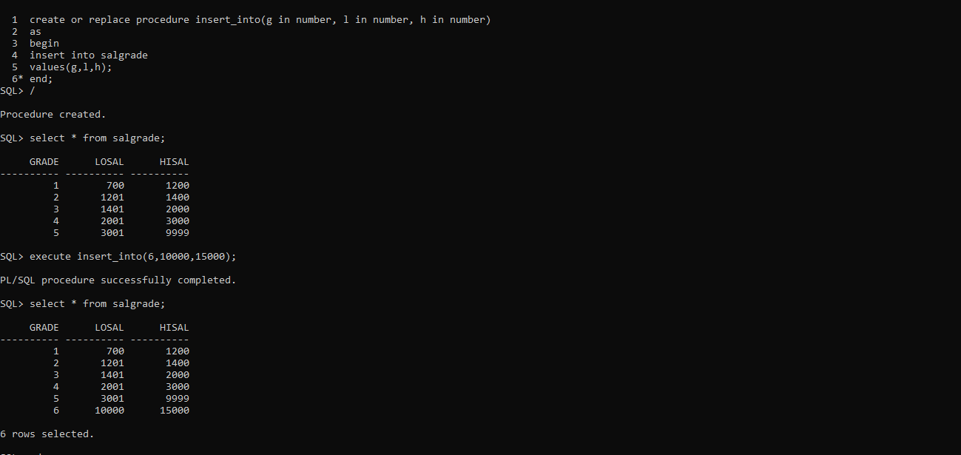

1. Write functions to perform the following.

a. Calculate experience of the employee

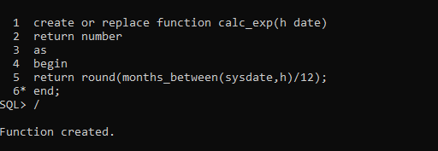

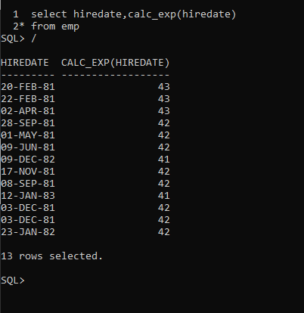

b. Ti calculate net sal by using formula.

Netsal=sal+da+hra-pf+comm

Da-→ 10% sal hra→ 15% sal pf --→ 8 % of sal

