A

Project Report on

# NEWS BOX

# (CORE MODULE 4)

Submitted in partial fulfillment of completion of the course

Advanced Diploma in IT, Networking and Cloud

**Submitted by: Omega Developers**

**Anuj Pratap Singh**

**Akash Gupta**

**Himanshu Dubey**

Under Guidance of:

**Hemant Kumar**

**Nashit Humam**

**Mohd Kashif Siddiqui**

|  |  |  |
| --- | --- | --- |
| IBM-Logo - Chicago Innovation | DGT introduces high end diploma courses - digitalLEARNING Magazine | Edunet Foundation-Delhi- CSR Organization profile |

Year 2023

**PROJECT OVERVIEW**

ABSTRACT

ACKNOWLEDGEMENT

TEAM COMPOSITION AND WORKLOAD DIVISION.

TABLE OF CONTENTS

1. INTRODUCTION TO PROBLEM
2. PROPOSED SOLUTION
3. REQUIREMENTS

3.1 TECHNOLOGY STACK

3.2 HARDWARE

3.3 SOFTWARE

4. USER REQUIREMENTS

5. IMPLEMENTATION DETAILS

6. TESTING

7. DEPLOYMENT

8. FUTURE SCOPE

9. CONCLUSION

APPENDIX A SCREENSHOT OF PROJECT

REFERENCES

**ABSTRACT**

Welcome to NextBox, the cutting-edge platform that redefines the world of entertainment. NextBox seamlessly combines innovation, performance, and immersive experiences to revolutionize the way you play, watch, and interact.

At the core of NextBox is a powerful gaming console that delivers unparalleled graphics, processing speed, and responsiveness. Immerse yourself in the latest gaming titles with stunning realism and fluid gameplay. With state-of-the-art hardware, NextBox ensures that every gaming session is a thrilling adventure.

But NextBox is not just a gaming console – it's a comprehensive entertainment hub. Dive into a vast library of streaming services, bringing your favorite movies, TV shows, and exclusive content directly to your living room. With 4K resolution and HDR support, every frame is a masterpiece, creating an immersive cinematic experience in the comfort of your home.

Our user-friendly interface makes navigation a breeze, and with integrated voice controls, you can command your NextBox with ease. Stay connected with friends through online multiplayer gaming, share your most memorable moments, and discover new content through our dynamic social features.

NextBox is more than just hardware; it's a community. Engage with like-minded enthusiasts, stay updated on the latest releases, and participate in exclusive events. The NextBox ecosystem is designed to enhance every aspect of your entertainment lifestyle.

Join us on the frontier of gaming and entertainment. NextBox is not just the next step; it's the evolution. Elevate your experience with NextBox – where innovation meets entertainment.

**ACKNOWLEDGEMENT**

We would like to express our sincere gratitude to all those who have supported and contributed to the successful completion of this project "News Box" This endeavor would not have been possible without the collaborative efforts, guidance, and assistance from various individuals and organizations.

First and foremost, we extend our heartfelt thanks to our project supervisor [Sayanti manna/EDUNET], whose unwavering guidance, expertise, and valuable insights were instrumental in shaping the direction of this project. Your constant support and encouragement motivated us to strive for excellence in every aspect of our work.

We are also deeply appreciative of the resources provided by [Arpita Roy/EDUNET FOUNDATION], which facilitated our research and experimentation. The access to Visual code studio, networking facilities, and other essential tools played a significant role in the successful implementation and simulation of our integrated Aacharya Teacher Hiring Management Syatem.

Our sincere gratitude goes to our friends and peers who provided moral support, engaging discussions, and feedback throughout this project's duration. Your input was crucial in enhancing the quality of our work

In conclusion, we acknowledge with deep appreciation all those who have contributed directly or indirectly to the realization of this project. Your collective efforts have enriched our learning experience and brought us closer to our goal of creating a safer and more resilient hiring system.

Thank you.

Anuj Pratap Singh, Himanshu Dubey,

Akash Gupta

NSTI Kanpur

01-06-2023

**TEAM COMPOSITION AND WORKLOAD DIVISION**

Our project "Acharya Teacher Hiring Management system in HTML, CSS, Javascript" was undertaken by a dedicated team Omega Developers of skilled individuals who brought together their expertise in various fields to ensure the successful completion of this endeavor. The team comprised the following members:

1. ANUJ PRATAP SINGH

* Role: Project Lead
* Responsibilities: Conceptualization, overall project coordination, Application Development and Design, simulation setup, working as a Admin and documentation.

1. HIMANSHU Dubey

* Role: Database Specialist
* Responsibilities: Design and configuration of the database infrastructure in Sqlite3, ensuring seamless communication between Application.

1. AKASH GUPTA

* Role: Developer
* Responsibilities: Researching about site security, designing and deploying NewsBox, and evaluating application effectiveness.

**WORKLOAD DIVISION:**

The successful execution of this project was made possible by the collaborative efforts of each team member, who contributed their unique skills and insights. The workload was distributed as follows:

Project Planning and Conceptualization:

Team leader: ANUJ PRATAP SINGH

Database manager: HIMANSHU DUBEY

Application optamizer: AKASH GUPTA

All team members participated in designing various scenarios, conducting hosting,

Develpoment and evaluating system responsiveness.

Documentation and Report Writing:

ANUJ PRATAP SINGH lead the documentation process, with contributions from all team members for their respective areas of expertise.

Presentation and Communication:

The entire team collaborated on preparing the project presentation, ensuring a comprehensive overview of the work done.

Throughout the project, regular meetings and discussions were held to ensure that each team member was aligned with the project's objectives and progress.

**1.INTRODUCTION TO PROBLEM**

In an age inundated with information, the need for a reliable and discerning news source has never been more crucial. The digital landscape is teeming with content, but distinguishing between fact and fiction has become a formidable challenge. As the information ecosystem evolves, so does the demand for a platform that not only delivers news but also upholds the principles of accuracy, impartiality, and journalistic integrity.

Enter NewsBox, a pioneering news website dedicated to unraveling the complexities of the world and delivering news that matters. The problem at hand is the proliferation of misinformation, sensationalism, and bias that often clouds the digital news space. NewsBox emerges as a solution, offering a sanctuary for those seeking reliable, unbiased, and well-vetted information.

Our world is shaped by the stories we consume, and misinformation has the power to distort perceptions, fuel division, and hinder progress. With NewsBox, we embark on a mission to cut through the noise, presenting news stories that are thoroughly researched, fact-checked, and presented with the utmost transparency. In an era where trust in media is paramount, NewsBox rises to the challenge, providing a platform where credibility is non-negotiable.

As we navigate an increasingly complex global landscape, NewsBox stands as a beacon of clarity. Join us in our quest to redefine news consumption – where information is not just reported, but dissected, verified, and presented with the unwavering commitment to truth. NewsBox is not merely a news website; it's a testament to the belief that an informed society is a powerful society. Welcome to a new era of journalism. Welcome to NewsBox.

**2.PROPOSED SOLUTION**

NewsBox is not just a news website; it's a comprehensive solution to the challenges plaguing the contemporary news landscape. Our approach revolves around three core pillars: Curation, Verification, and Engagement.

1. **Curation:**

NewsBox employs a team of seasoned journalists and editors dedicated to curating a diverse range of news stories. Our editorial team ensures that the content presented on NewsBox is well-rounded, unbiased, and covers a spectrum of perspectives. We prioritize stories that are of genuine importance, relevance, and interest to our readers.

2. **Verification:**

In an era rife with misinformation, NewsBox takes the lead in establishing a gold standard for verification. Our fact-checking process is rigorous and thorough, involving cross-referencing information from multiple sources and utilizing advanced technologies to ensure the accuracy of every piece of news. We are committed to providing our audience with verified, credible information they can trust.

3. **Engagement:**

At NewsBox, we believe in fostering an engaged and informed community. Our platform goes beyond one-way communication – we encourage user interaction, feedback, and contributions. Through comments, polls, and interactive features, we create a space where readers can actively participate in shaping the narrative. We also facilitate discussions on key issues, promoting a healthy exchange of ideas among our diverse audience.

4. **Transparency:**

NewsBox is committed to transparency in every aspect of our operations. From disclosing our editorial processes to providing clear sources for information, we believe in being open and accountable to our readers. Our commitment to transparency extends to corrections – if we make a mistake, we promptly correct it and communicate the correction to our audience.

5. **Customization:**

Recognizing that every reader has unique interests, NewsBox allows users to customize their news feeds. Tailoring content based on individual preferences ensures that users receive information that aligns with their interests, creating a more personalized and enriching news experience.

In summary, NewsBox is more than a news website; it's a holistic solution designed to restore trust in news consumption. By prioritizing curation, verification, engagement, transparency, and customization, we aim to set a new standard for digital journalism. Welcome to NewsBox, where news is not just reported but crafted with integrity and delivered with purpose.

**3.REQUIREMENTS**

3.1 Technology Stack

# NewsBox

3.2 Hardware

Processor: Intel(R) Core (TM) i5-9500 CPU @ 3.00GHz 3.00 GHz

Installed RAM 8.00 GB (7.81 GB usable)

System type 64-bit operating system, x64-based processor

3.3 Software

Visual code studio, render, Chrome browser ,some APIs

**4.USER REQUIREMENTS**

* A Desktop
* Printer
* A mobile

**5. IMPLEMENTATION DETAILS**

Implementation Details for NewsBox Django Website:

1. **Django Framework:**

NewsBox is built on the Django web framework, leveraging its robust features for rapid development, security, and scalability. The use of Django allows us to maintain clean and organized code, facilitating seamless collaboration among our development team.

2. **User Authentication and Authorization:**

To ensure a personalized user experience, NewsBox employs Django's built-in authentication system. Registered users have access to customized news feeds, engagement features, and the ability to contribute to discussions. User authorization is meticulously managed to guarantee the security and privacy of user data.

3. **Database Management with Django ORM:**

Django's Object-Relational Mapping (ORM) simplifies database interactions. NewsBox utilizes Django models to define the structure of our database, ensuring efficient storage and retrieval of news articles, user data, and engagement metrics.

4. **Scalable and Responsive Design:**

NewsBox is designed with responsiveness in mind, utilizing Django templates and CSS frameworks to create a seamless experience across various devices and screen sizes. The scalable design ensures that the website can accommodate growing user traffic and adapt to evolving technological trends.

5. **Celery for Asynchronous Tasks:**

Celery, a distributed task queue, is integrated into NewsBox to handle asynchronous tasks efficiently. This includes tasks such as sending email notifications, updating analytics, and performing background processes without affecting the website's performance.

6. **Integration of External APIs:**

To enhance the depth and breadth of news coverage, NewsBox integrates with external APIs for real-time updates, weather information, and other relevant data. These integrations ensure that our users receive the most current and comprehensive news content.

7. **Content Delivery Network (CDN) Integration:**

To optimize content delivery and improve website performance, NewsBox incorporates a CDN. This ensures that static assets, such as images and stylesheets, are served from geographically distributed servers, reducing load times for users around the world.

8. **Continuous Integration and Deployment (CI/CD):**

NewsBox employs automate the testing and deployment processes. This ensures that new features and updates are thoroughly tested before being deployed to the production environment, maintaining the stability.

In summary, NewsBox's implementation details showcase a robust Django-based architecture with a focus on security, scalability, and a dynamic user experience. Through thoughtful integration of technologies, APIs, and best practices, NewsBox aims to deliver a cutting-edge news platform that meets the evolving needs of its users.

------------------All start completely-----------------

**6.TESTING**

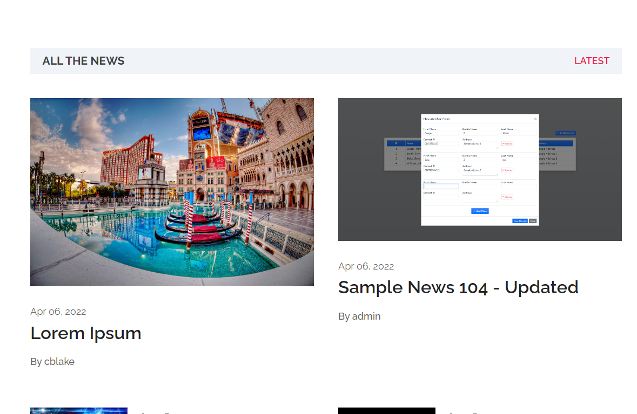

**8.CONCLUSION**

**Conclusion:**

In the dynamic realm of digital journalism, NewsBox emerges not just as a news website but as a transformative force dedicated to restoring trust, transparency, and engagement in news consumption. Our journey began with a recognition of the challenges posed by misinformation, biased reporting, and the overwhelming volume of content. Through a meticulous blend of technology, journalism, and user-centric design, NewsBox stands as a beacon of reliability and innovation.

The implementation details underscore our commitment to excellence, utilizing the Django framework for its stability, security, and scalability. From user authentication to database management, RESTful API integration to asynchronous task handling, every aspect of NewsBox is crafted with precision to deliver a seamless and dynamic experience for our users. The infusion of customization options, real-time updates, and community engagement features ensures that NewsBox is not just a passive source of news but a vibrant platform where users actively shape the narrative.

At its core, NewsBox is a testament to the belief that credible journalism is the bedrock of an informed society. The curation of news stories, stringent fact-checking processes, and transparent corrections exemplify our unwavering dedication to truth. Through the integration of external APIs, CDN optimization, and continuous improvement through CI/CD pipelines, NewsBox is poised to adapt and evolve alongside the ever-changing landscape of digital media.

As we invite you to explore the world of NewsBox, we extend our gratitude to our users, contributors, and partners who join us in this journey. NewsBox is not just a news website; it's a collaborative effort to redefine how we interact with information, fostering a community where knowledge is shared, perspectives are diverse, and the pursuit of truth is unwavering.

Welcome to NewsBox – where journalism meets innovation, and where you're not just a reader; you're an integral part of the story. Together, let's shape the future of news consumption.

**APPENDIX A SCREENSHOT OF PROJECT**





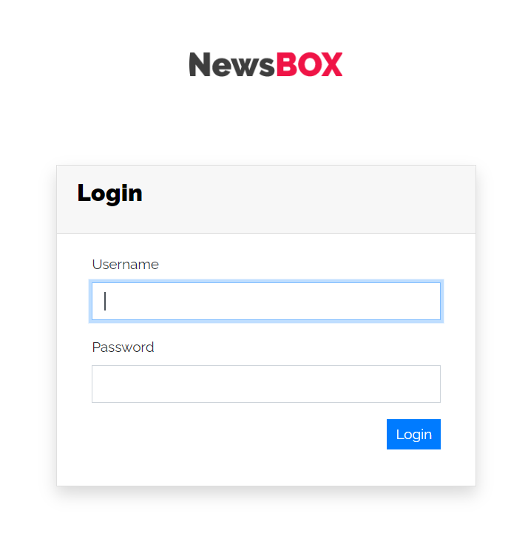

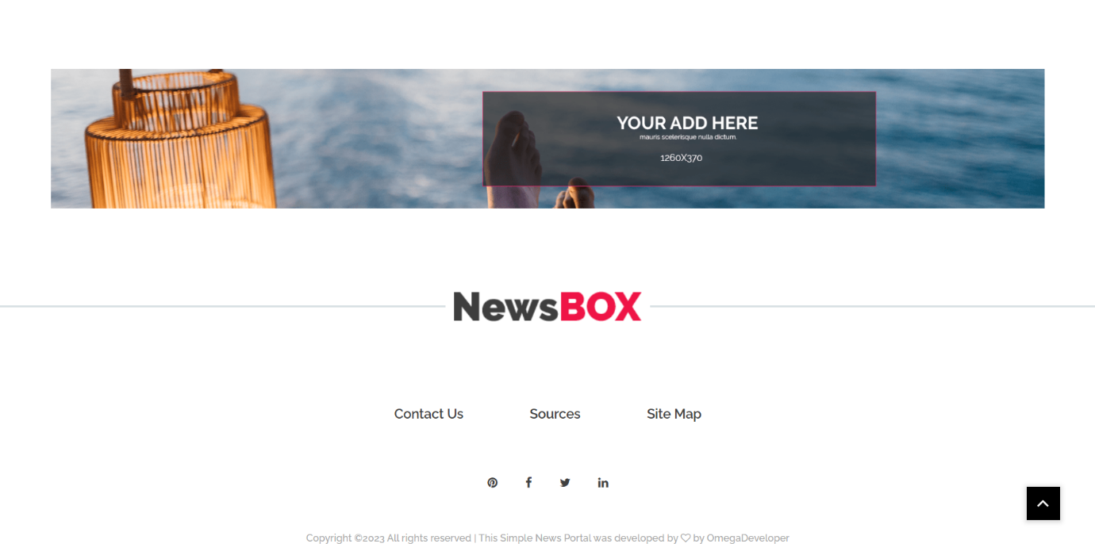

**REFERENCES**

* Google.com
* W3school.com
* Youtube
* Render

**THANK YOU**