*** N8N Short Note ***
- Section 1:
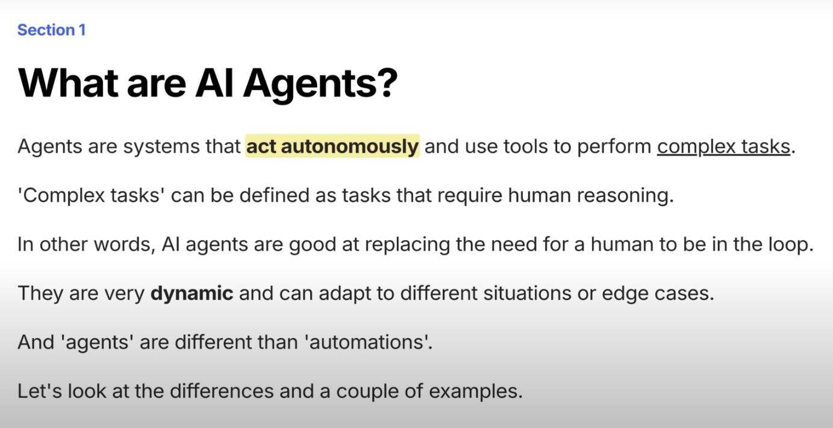

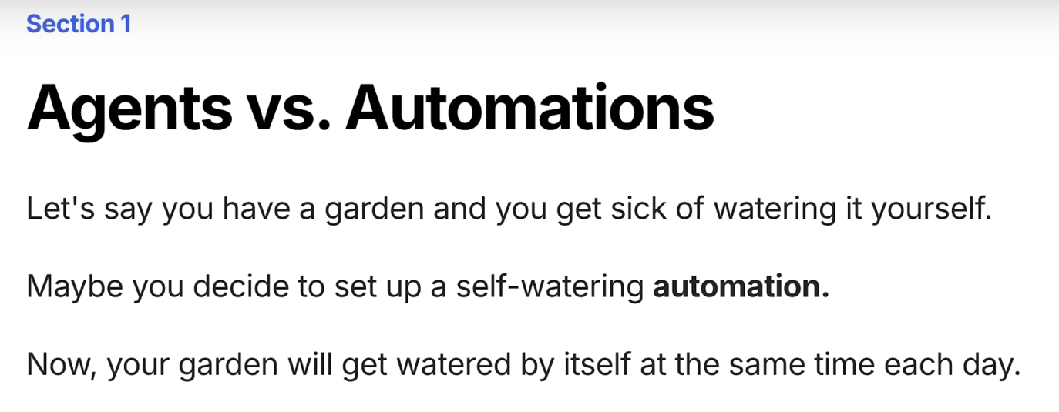
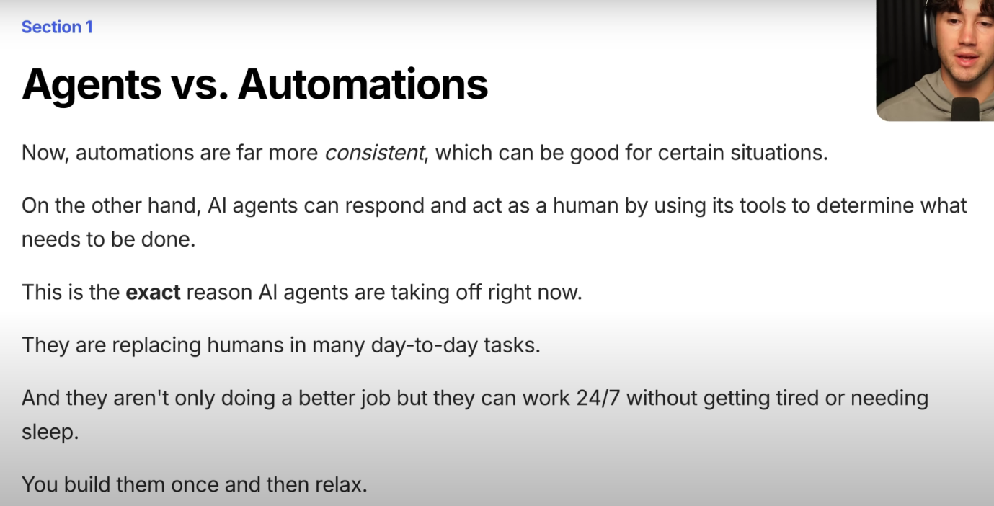
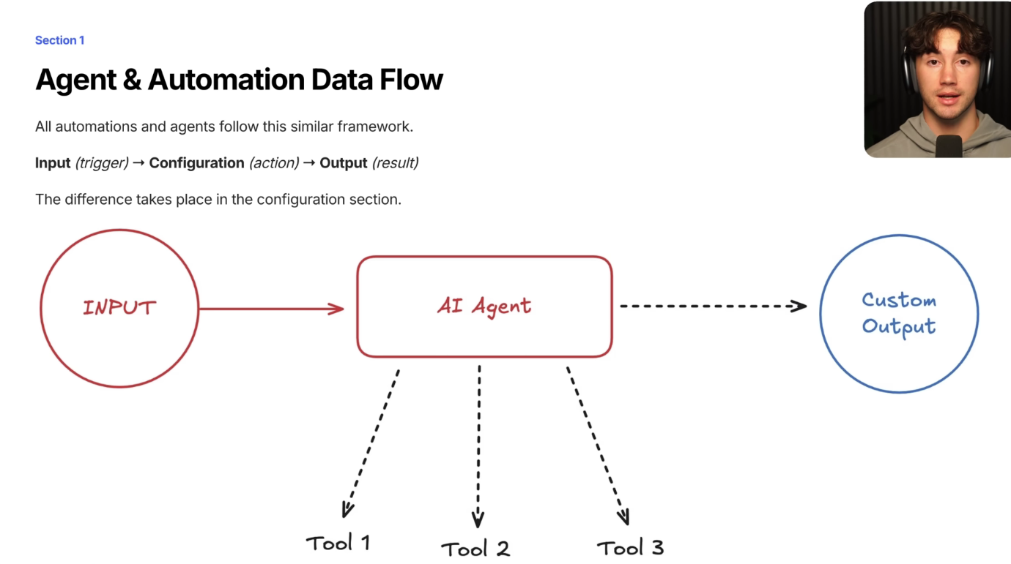


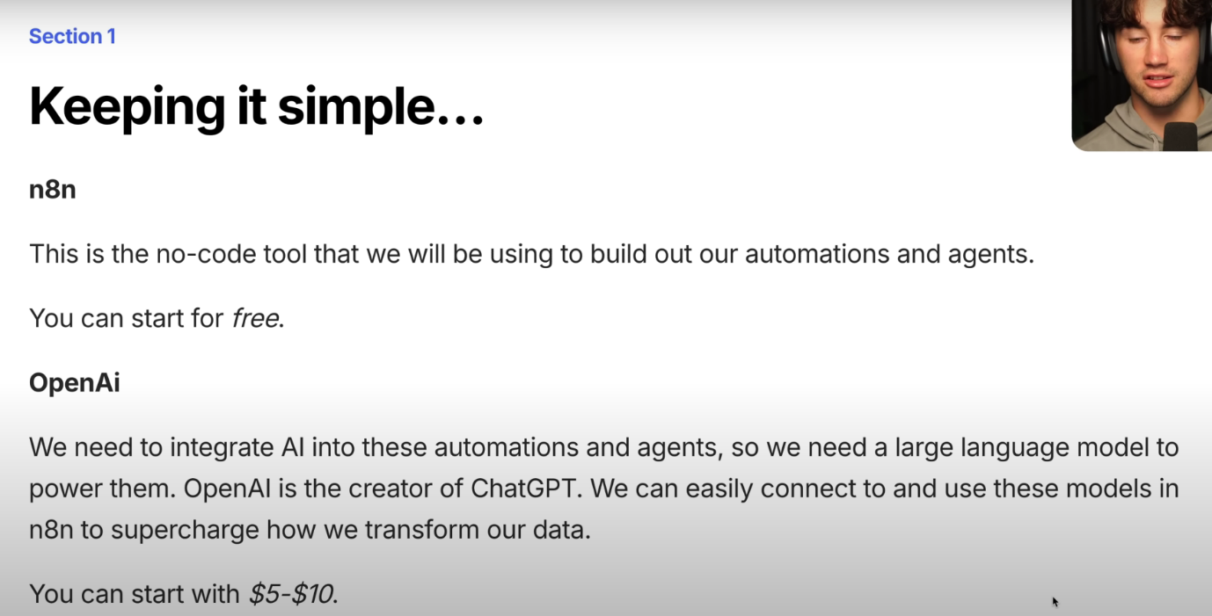

- Section 2:
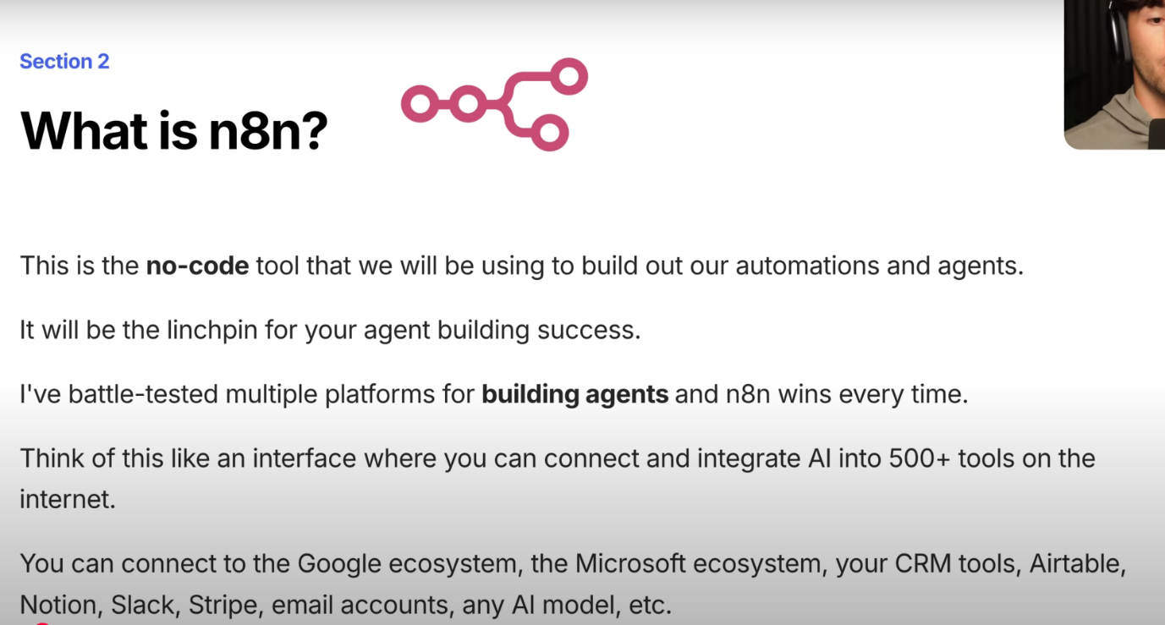
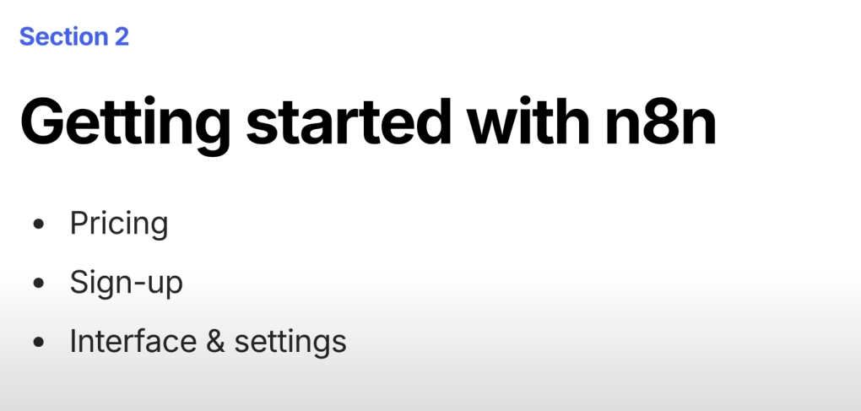

- Section 3:
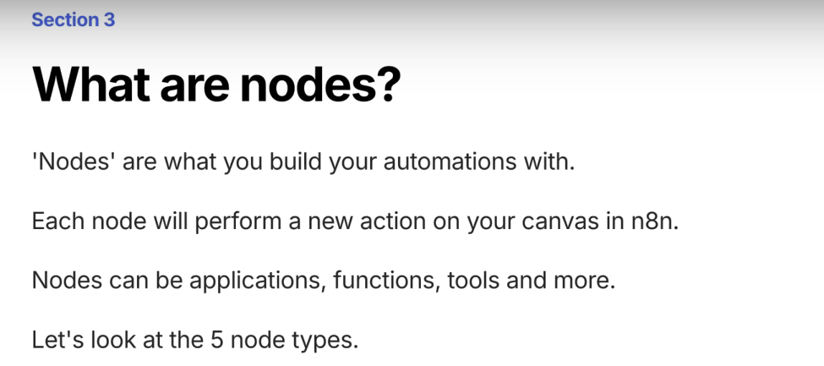

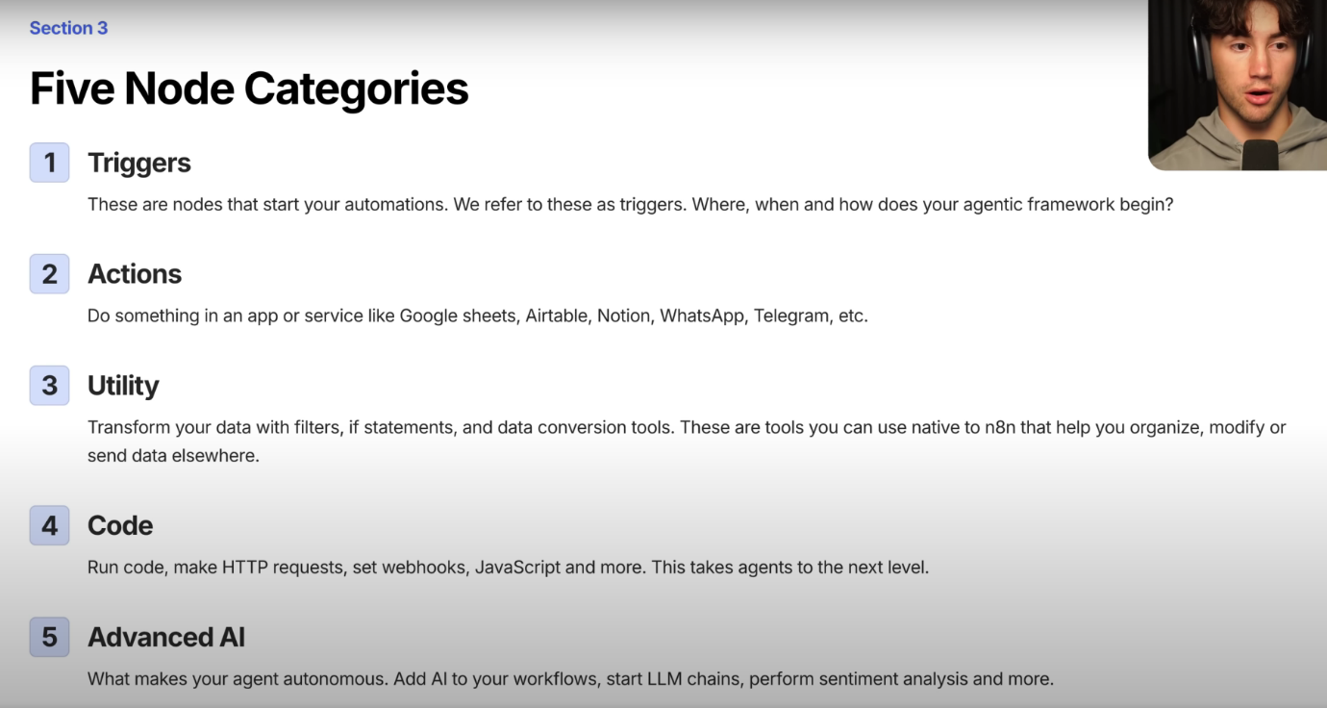

- Trigger Nodes:
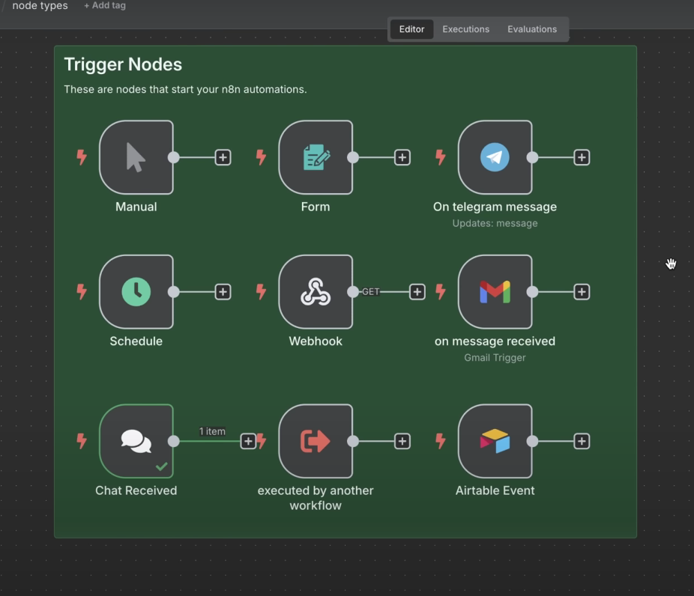
- Action Nodes:
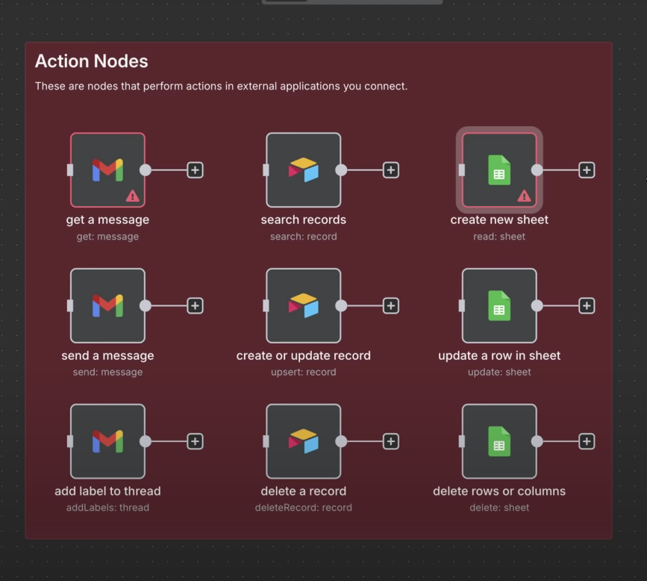

- Utility Nodes:
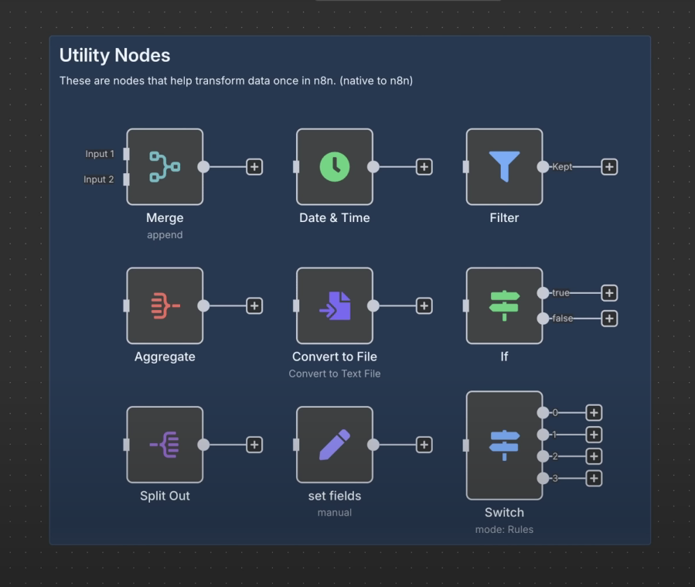

- Code & Agent Nodes:
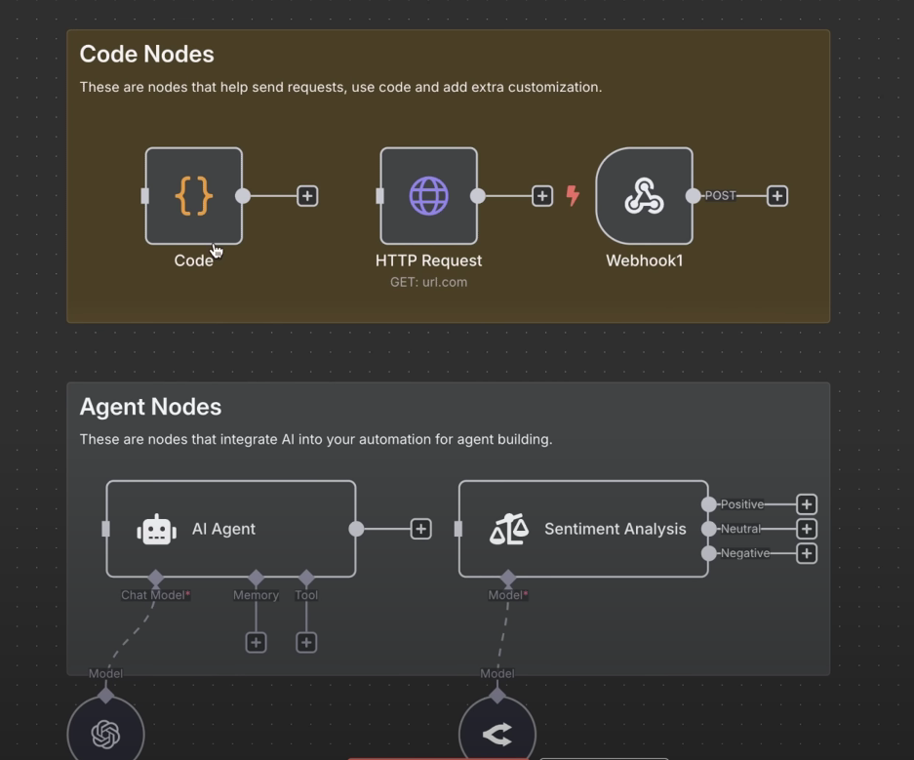

Section 4
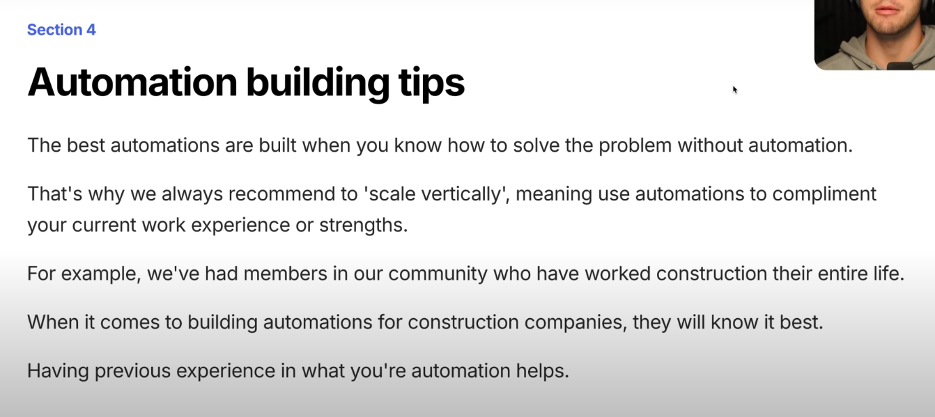
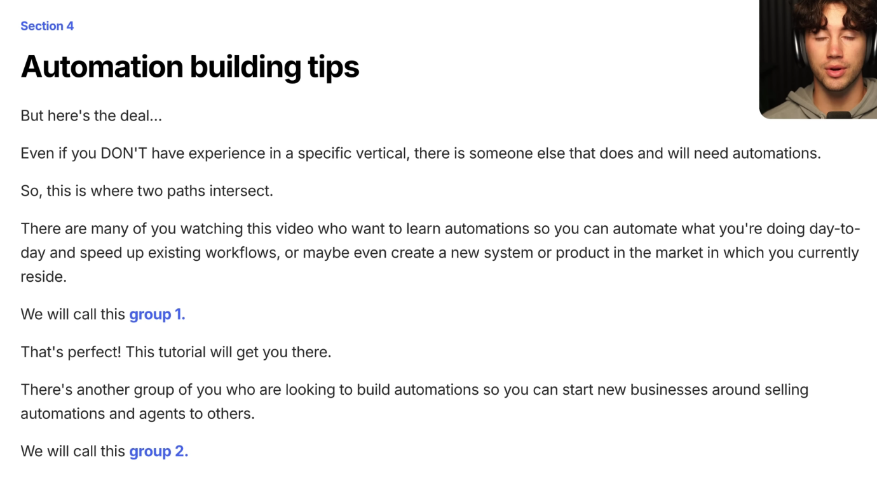

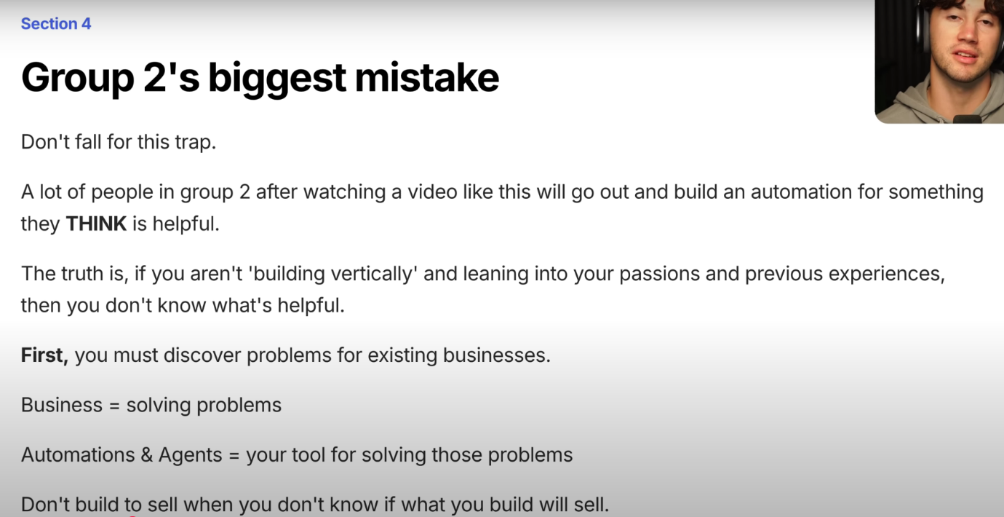
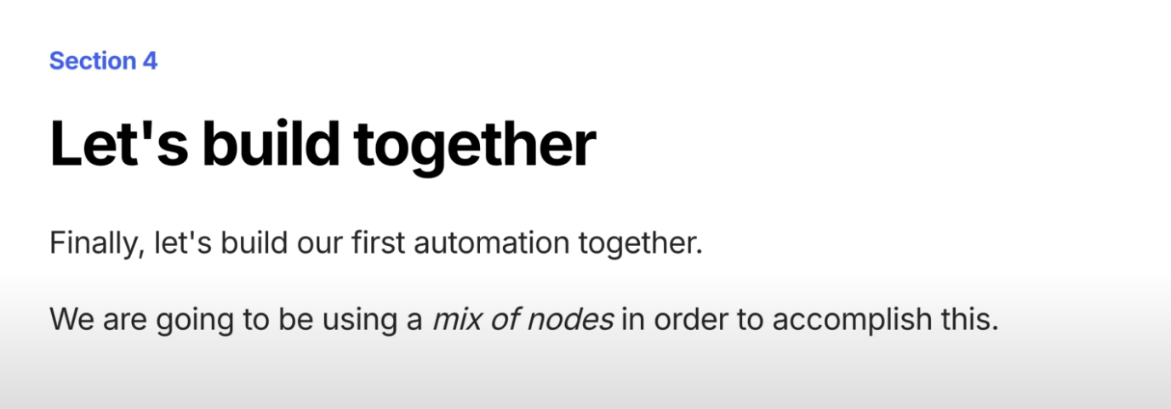
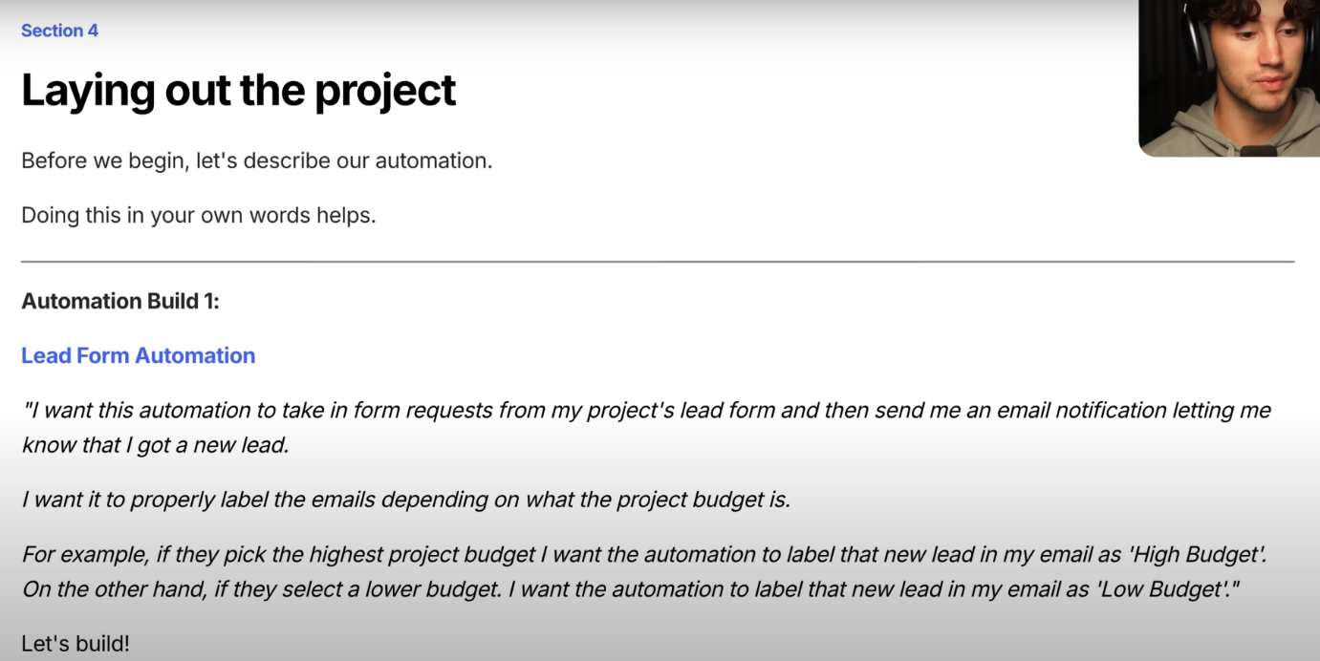

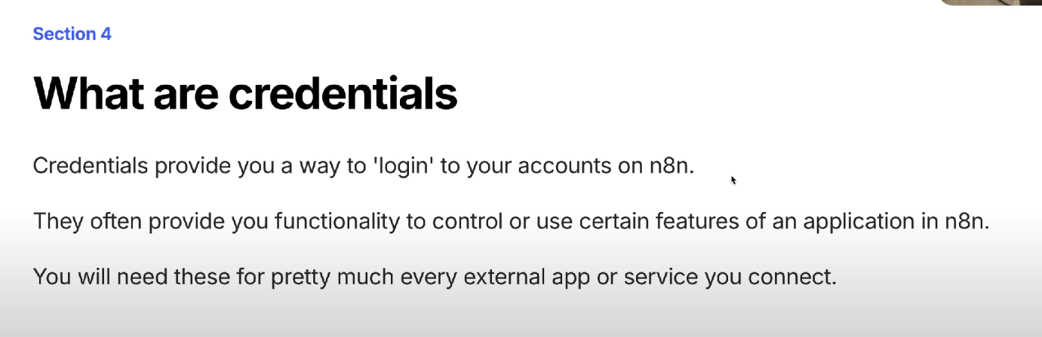
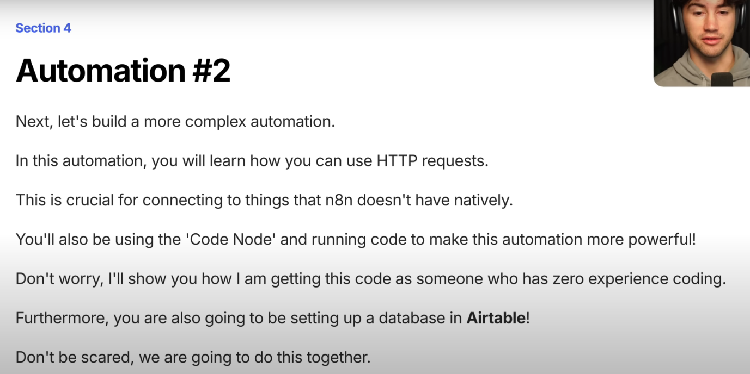
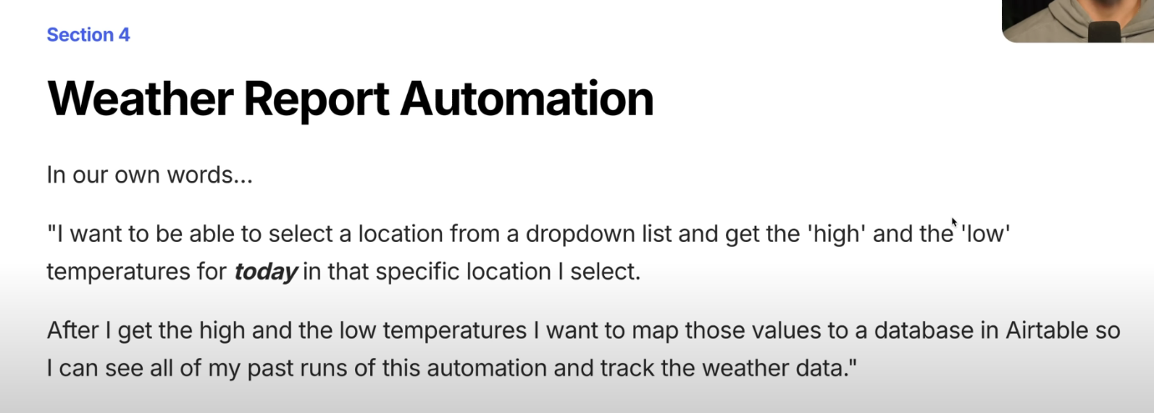
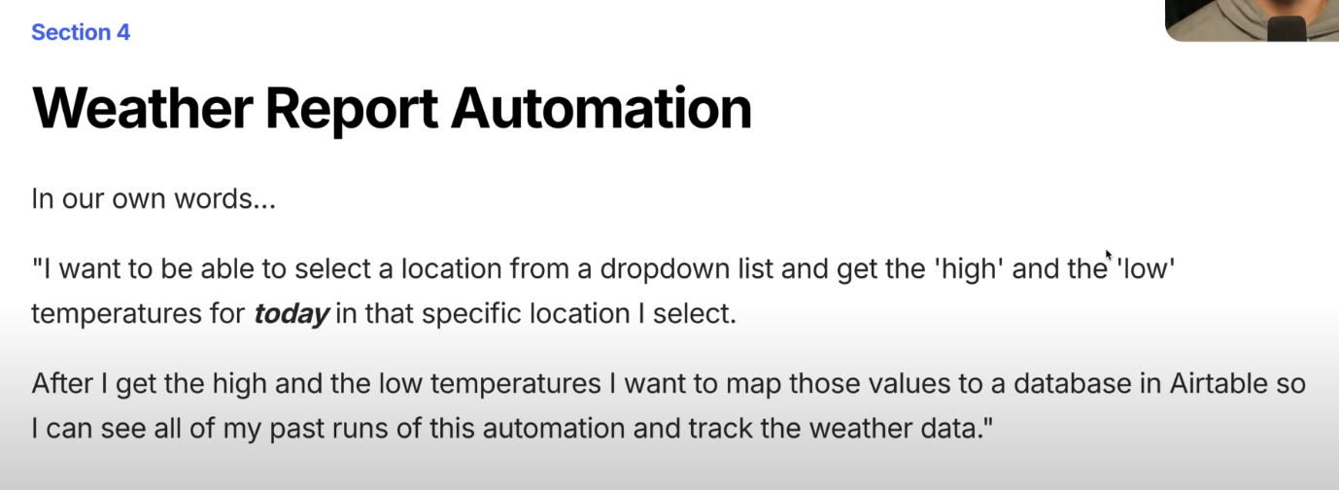

Section 5: Building An Agent
- Automation Concept:
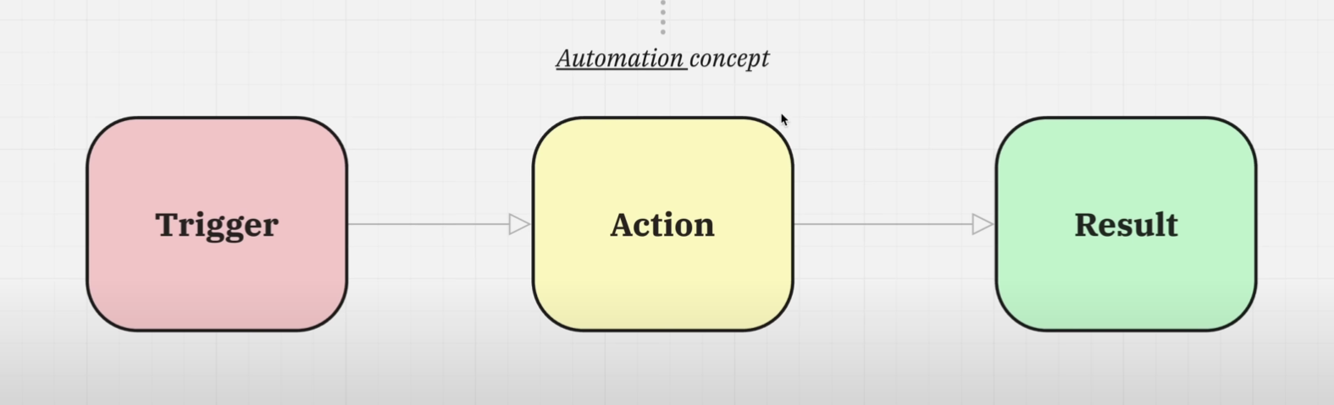
- Agent Concept:
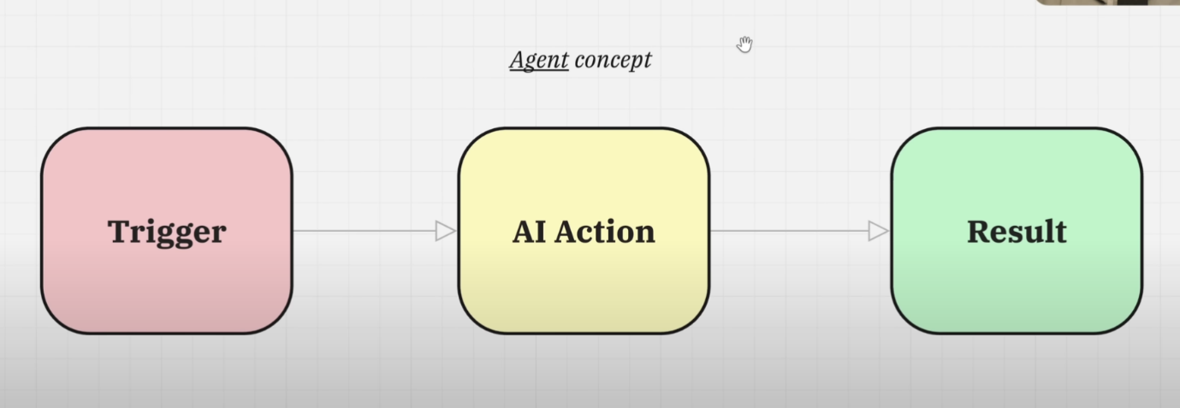
- Deff Between Agent Concept & Automation Concept:
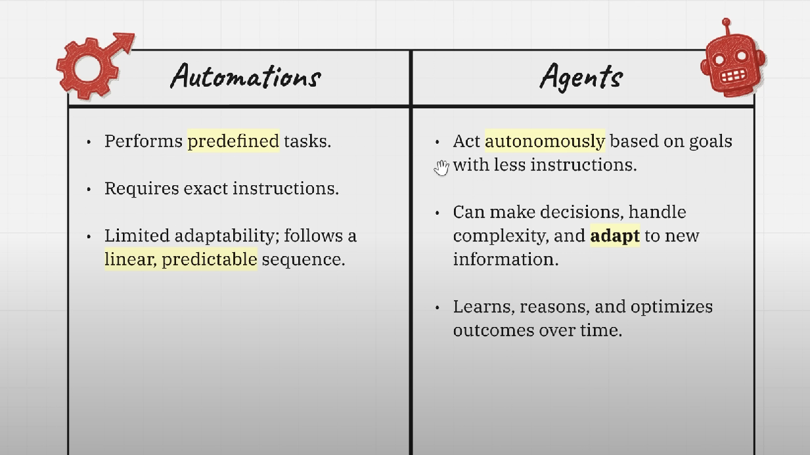
- Fixed Automation:
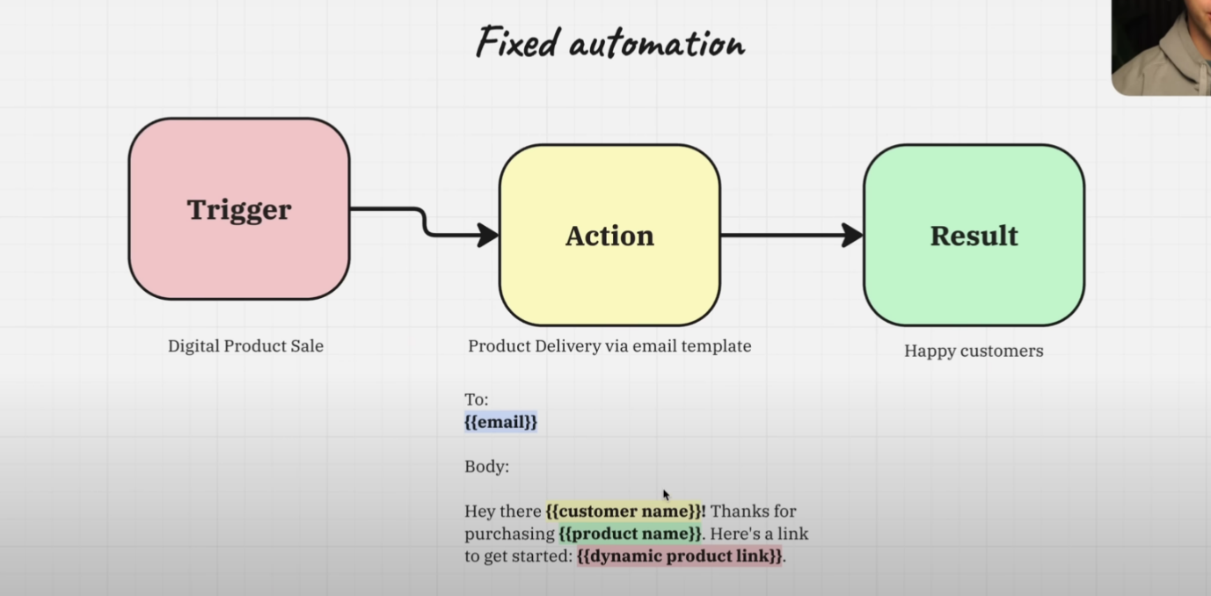
- Agentic Workflow:
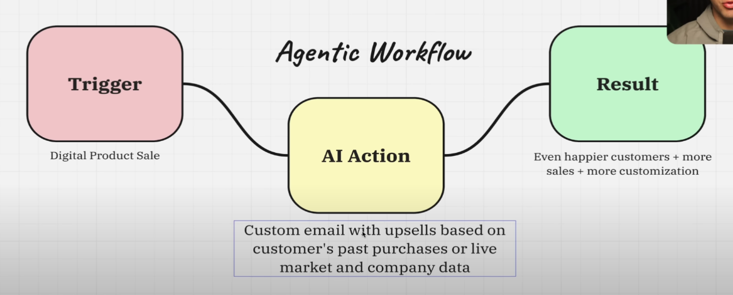
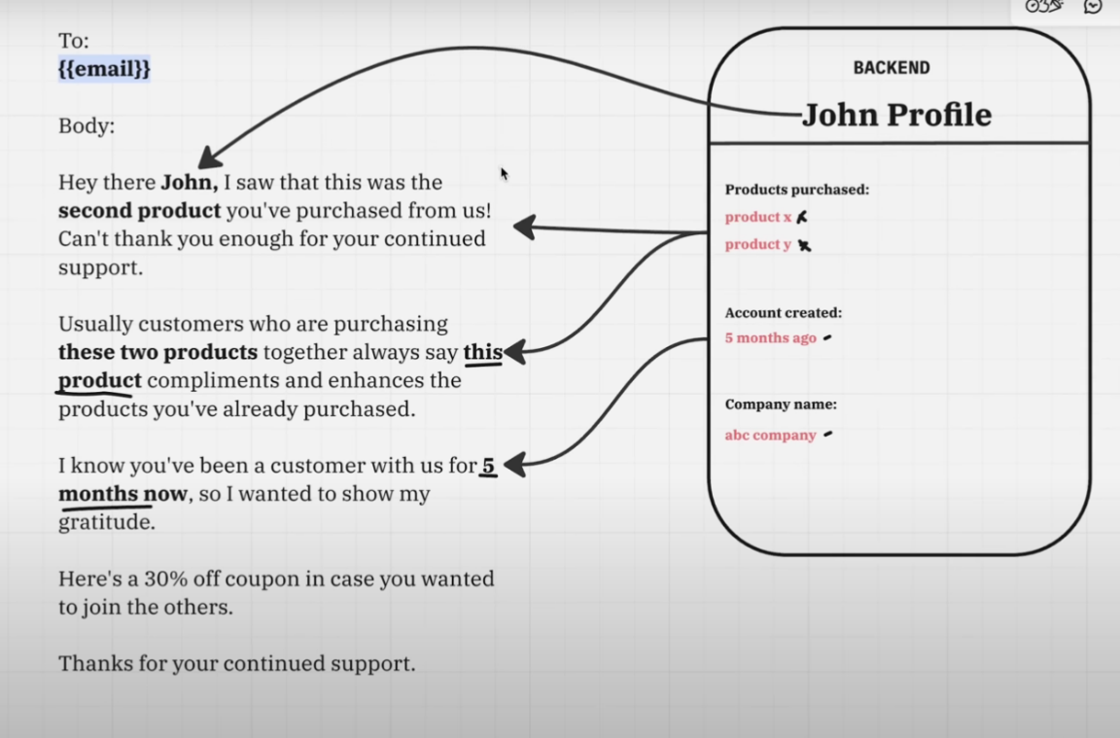
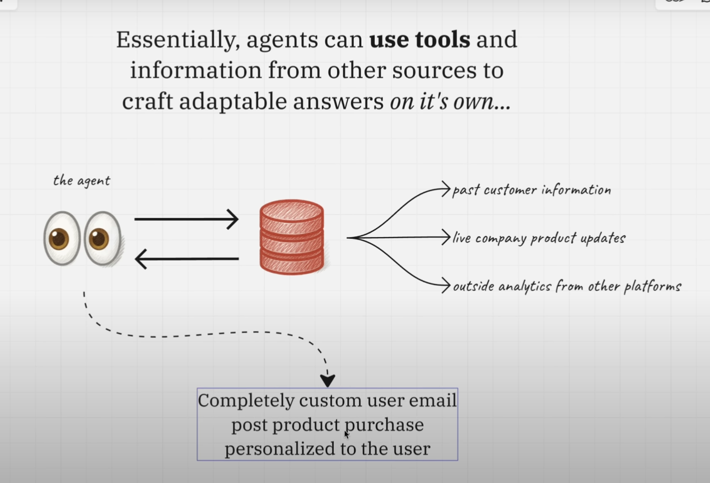

- Project Decription:
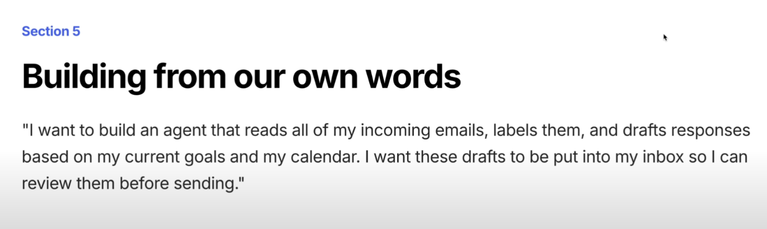

- Tools for Agents:
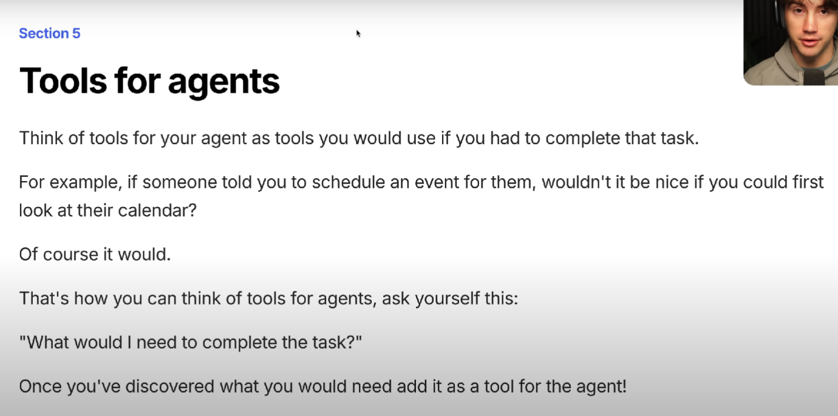
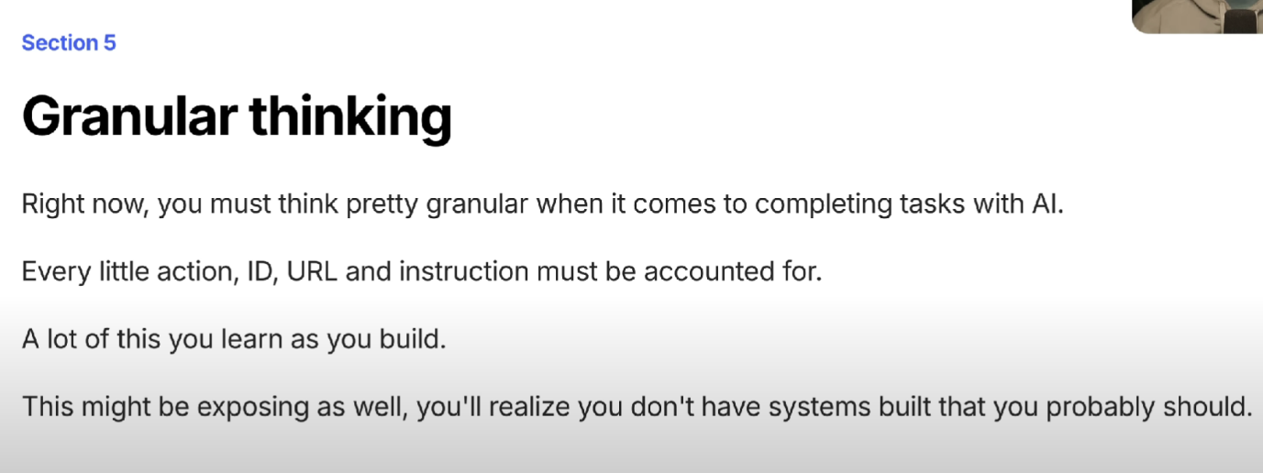
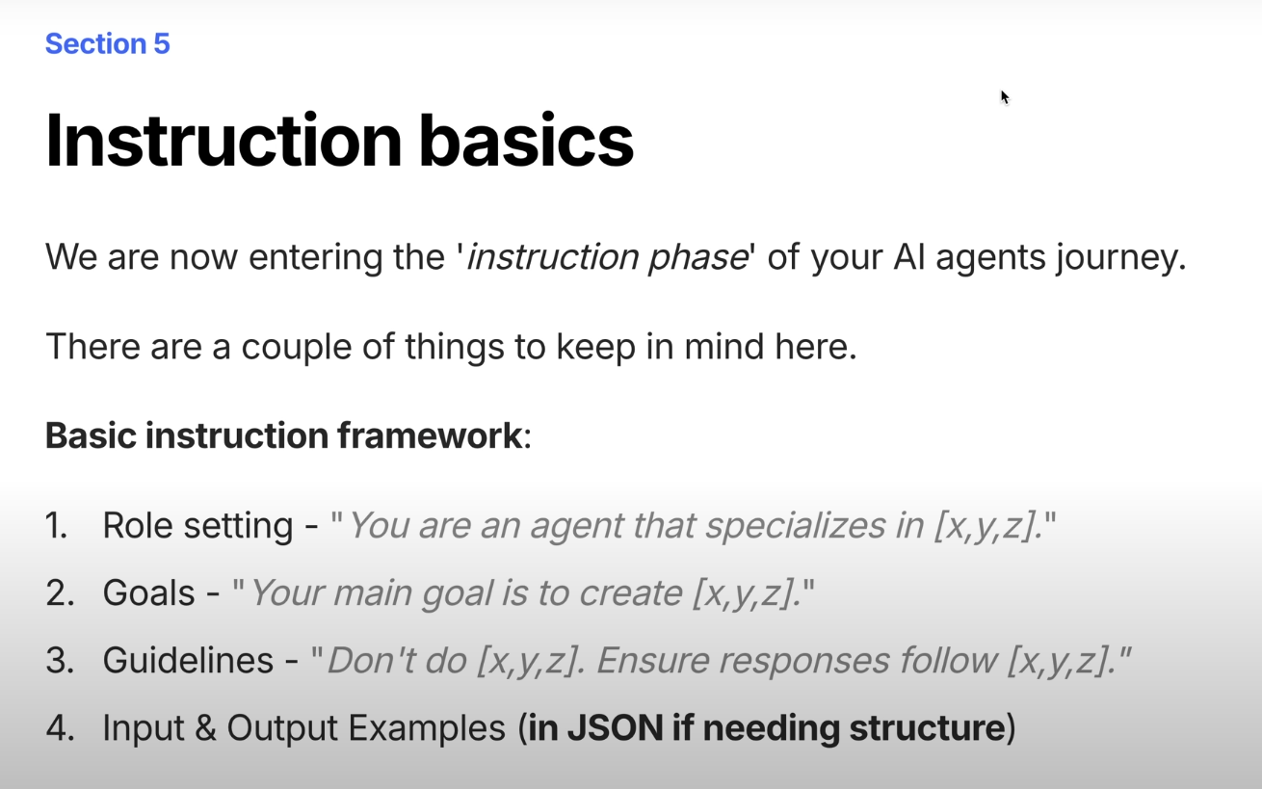
- Section 6: Communication Mediums
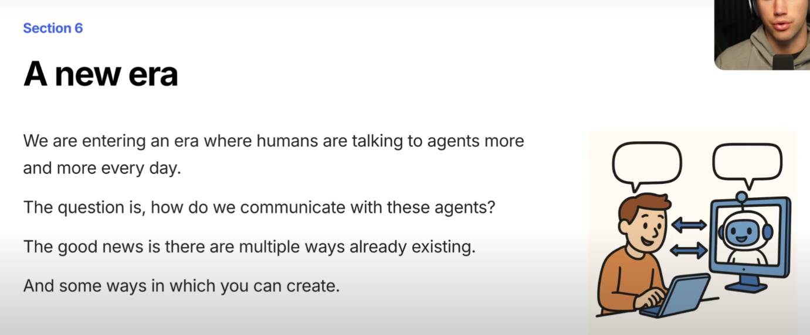
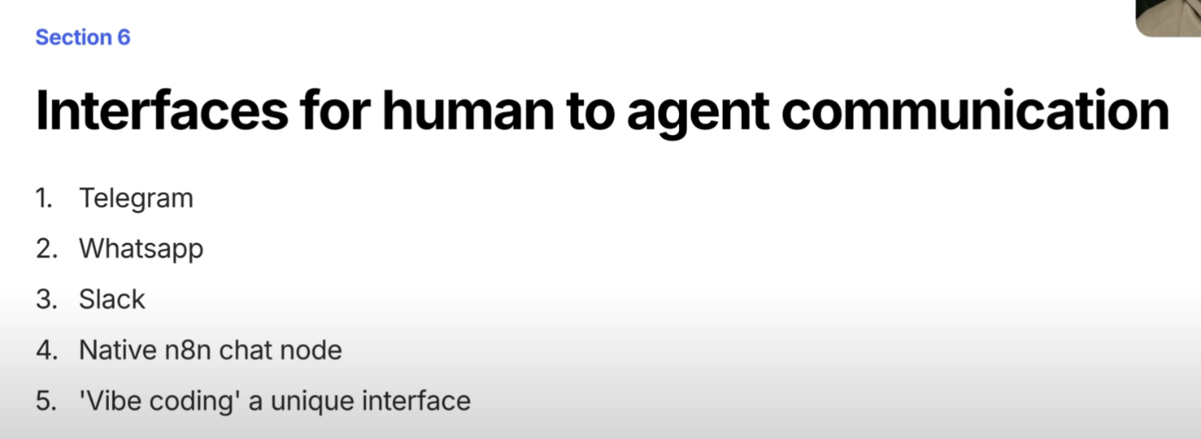
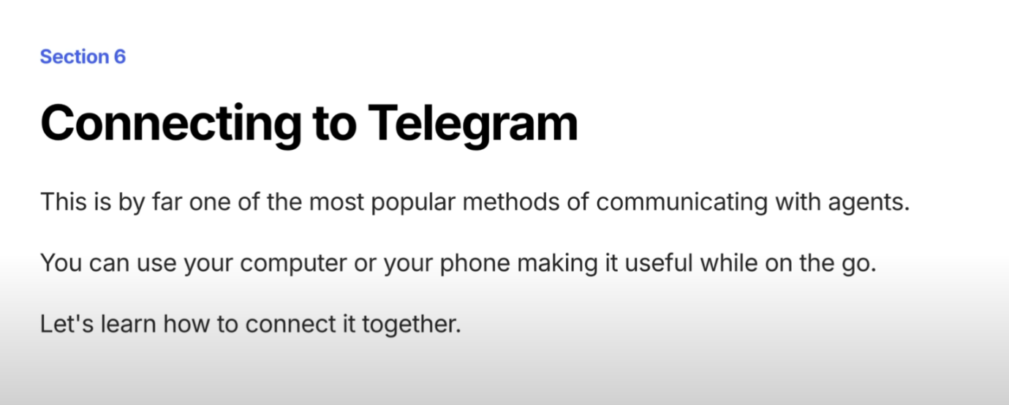

*** Project Idea ***
🧠 Beginner-Friendly Projects (Core Learning)
- Gmail Auto-Responder
  - Trigger: New email in Gmail
  - Action: Send a predefined reply
- Weather Notifier
  - Trigger: Every day at 8 AM (Cron)
  - Action: Fetch weather (via OpenWeather API) → Send to Telegram/Email
- Google Sheets Logger
  - Trigger: Webhook or Manual
  - Action: Add a row to Google Sheet (store timestamp, name, etc.)
- Daily Quote Poster
  - Trigger: Cron (daily)
  - Action: Get random quote (API) → Post to Twitter/Telegram
- GitHub Issue Notifier
  - Trigger: GitHub (new issue)
  - Action: Send alert on Slack/Telegram

⚙️ Intermediate Automation Projects
- New Lead → CRM Entry
  - Trigger: Webhook (from website form)
  - Action: Create contact in HubSpot or Zoho CRM
- Content Repurposing
  - Trigger: RSS feed updates (e.g., new blog post)
  - Action: Auto-post to LinkedIn, Twitter, and store in Airtable
- Task Sync Across Tools
  - Trigger: New task in Trello
  - Action: Create matching task in Notion/ClickUp
- Keyword Monitor
  - Trigger: Cron every 30 min
  - Action: Search keyword in Google News (via API) → Send email if found
- Simple Inventory Tracker
- Trigger: Webhook (manual entry via form)
- Action: Store product info in Google Sheet + notify on low stock

🔒 Automation for Personal Use
- Bookmark Archiver
- Trigger: Webhook (when you save a link)
- Action: Save metadata to Notion or Airtable
- YouTube Downloader
- Trigger: Paste URL in Webhook
- Action: Download via shell command (e.g., yt-dlp) → Email MP3/MP4
- Expense Tracker
- Trigger: Telegram command /add_expense
- Action: Add to Google Sheet with date/category/amount
- Automatic Invoice Generator
- Trigger: New Stripe payment
- Action: Generate invoice PDF + send via email
- Backup Twitter Favorites
- Trigger: Every day (Cron)
- Action: Get liked tweets → Save to Notion or Markdown file

🧪 Advanced Projects (Testing Automation Skills)
- Customer Support Bot
- Trigger: Telegram message or Webhook
- Action: Query GPT or Vector DB → Respond intelligently
- RAG Pipeline (Research Automation)
- Trigger: Webhook + user input
- Action: Search PDFs, summarize answers using OpenAI/Gemma → Send back
- Uptime Monitor
- Trigger: Every 5 minutes (Cron)
- Action: Ping websites → Alert on failure via Email + Retry logic
- Auto Resume Parser + Tracker
- Trigger: File uploaded via webhook
- Action: Extract data from PDF → Store in Airtable/Notion
- WhatsApp to Google Calendar
- Trigger: WhatsApp message via Twilio
- Action: Parse message → Add to Google Calendar

⚡️ Bonus: Fun/Creative Projects
- AI Meme Generator
- Trigger: Telegram /meme + topic
- Action: Generate meme using DALL·E or SD → Send back
- Voice to Task
- Trigger: Audio message on Telegram
- Action: Transcribe via Whisper → Create task in Notion
- Birthday Reminder Bot
- Trigger: Cron
- Action: Check Google Sheet → Send birthday wishes via WhatsApp or email
- Crypto Price Alert
- Trigger: Every hour (Cron)
- Action: Fetch crypto prices (CoinGecko API) → Alert if above/below threshold
- PDF Generator for Reports
- Trigger: Weekly (Cron)
- Action: Aggregate data from API/Sheet → Generate report PDF → Email

