** UNIFIDE MODALING LANGUAGE (UML) **
- What is UML?
- Why do we need UML?
- Types of UML Diagrams
- Structural UML Diagrams
- Behavioral UML Diagrams
- Object-Oriented Concepts Used in UML Diagrams
- Tools for creating UML Diagrams
- Steps to create UML Diagrams
- UML Diagrams Best Practices
- When to Use UML Diagrams
- UML and Agile Development
- Common Challenges in UML Modeling
- Benefits of Using UML Diagrams

- Object:
- This natation refers to the instance of a class.

- Interface:
- This notation represent the functionality without its implementation.
Name | Persion
Attribute | X (Not Mension)
Operation | getName()

Use Case:
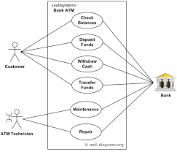
- This notation describes the users goals and possible interaction with the system.
- Use Case Is the feature and functionality of the application
- Primary Actor
- Secondary Actors
- Component:
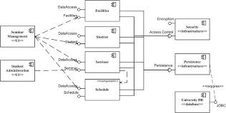
- This notation represent a section of the system

- Node:
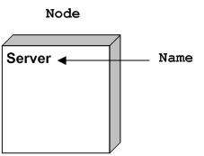
- This notatin is similar to the component notation, with the sifference being that node notation refres to the physical of a sustem, such as a server.

- Activity Diagram
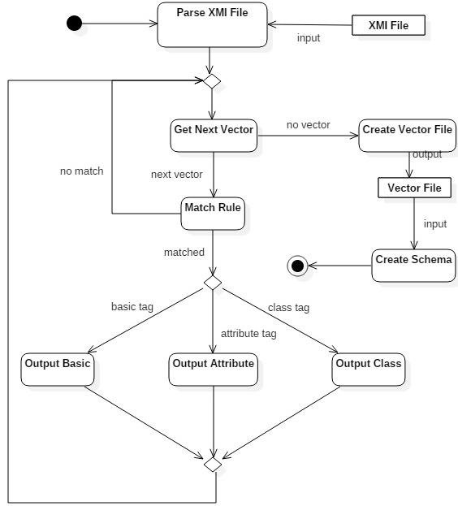
- This described the various interaction performed by difference component present in the system.
- Activity diagram Are Just a flow chart

- Interaction Diagrams:

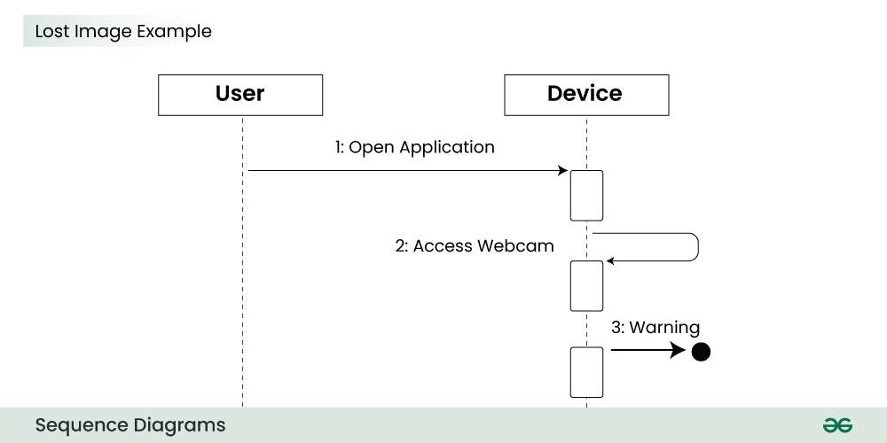

- These diagram describe the message flow between the different component present system

*** Type of UML ***
Structure and Behaviour diagrams
- Most Comman Used: (IMP)
- Class Diagram
- Use-case diagram
- Sequence diagram
- Activity diagram

