lo** IoT Code and Support **
- ESP32 GPIO PIN: ->
GPIO | Special Function | Notes
GPIO0 | Boot mode selection, LED control | Must be HIGH at boot to avoid flash mode
GPIO1 | UART TX (serial) | For serial communication (TX)
GPIO2 | Built-in LED, boot mode indicator | Must be LOW at boot for normal start
GPIO3 | UART RX (serial) | For serial communication (RX)
GPIO4 | General-purpose pin | Can be used for LEDs, sensors, etc.
GPIO5 | SPI CS (Chip Select) | Output capable, common for SPI
GPIO12 | HSPI MISO (input) | Be careful — can affect boot process
GPIO13 | HSPI MOSI (output) | Common for SPI communication
GPIO14 | HSPI SCK (clock) | Used for SPI devices
GPIO15 | HSPI CS (chip select) | Must be pulled HIGH at boot
GPIO16 | RTC wake-up pin | Can wake ESP32 from deep sleep
GPIO17 | Standard GPIO | Safe for general use
GPIO21 | I2C SDA | I2C communication line
GPIO22 | I2C SCL | I2C communication clock
GPIO23 | SPI MOSI | Output for SPI
GPIO25 | DAC Channel 1 | Can output analog voltage
GPIO26 | DAC Channel 2 | Can output analog voltage
GPIO27 | Touch sensor | Can detect touch events
GPIO32 | ADC (Analog input) | Read analog sensors
GPIO33 | ADC, Touch sensor | Can read analog values or touch

- Folder Structure:
Ans:- GitHub: https://github.com/embeddedartistry/project-skeleton
YouTube: https://www.youtube.com/watch?v=6oJ2LLxfP3s

- Important OS for Development
- Zephyr OS,
- Nucleus OS

- Big Companied Development Interface
Use Case | Industry Standard Tools
ESP32 Development | ESP-IDF (Official SDK)
RTOS Development | FreeRTOS, Zephyr OS
Large-Scale Projects | CMake, Makefiles
Automotive & Aerospace | AUTOSAR, QNX, RTEMS
Industrial IoT Yocto | Embedded Linux
Advanced Debugging | JTAG, OpenOCD, Segger Ozone

- MAC Address:->
- Master_Module -> ESP32-C3 : "84:FC:E6:00:B9:9C" -> {0x84, 0xFC, 0xE6, 0x00, 0xB9, 0x9C}
- Module_1 -> ESP32 : “94:54:C5:82:C4:48” -> {0x94, 0x54, 0xC5, 0x82, 0xC4, 0x48}
- Module_2 -> ESP32 : “C0:5D:89:B1:56:B8” -> {0xC0, 0x5D, 0x89, 0xB1, 0x56, 0xB8}

ESP8266 | GPS | OLED | DHT | MPU9250/9500 | Button
3V | GND | GND | GND | GND | (3V--10K) D7
G | VCC | VCC | VCC | VCC or AD0 | GND
D0 | - | - | - | - | -
D1 | - | SCL | - | SCL | -
D2 | - | SDA | - | SDA | -
D3 | - | - | - | -
D4 | - | - | DATA | -
D5 | TX | - | - | -
D6 | RX | - | - | -
D7 | - | - | - | - | (D7--10K R) 3V
D8 | - | - | - | -
RX | - | - | - | -
TX | - | - | - | -

- PULL-UP Button Connection :
3v ----> 10 k/omh ---> 1st side button // 2nd side button --> GND
D7 --> 10 k/omh 1st side button
Returning value is “1”
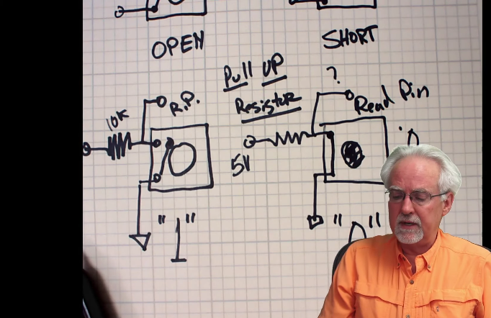

- PULL-DOWN Button Connection :
3v ----> 1st side button // 2nd side button --> 10 k/omh ---> GND
D7 --> 10 k/omh 2nd side button
Returning value is “0”

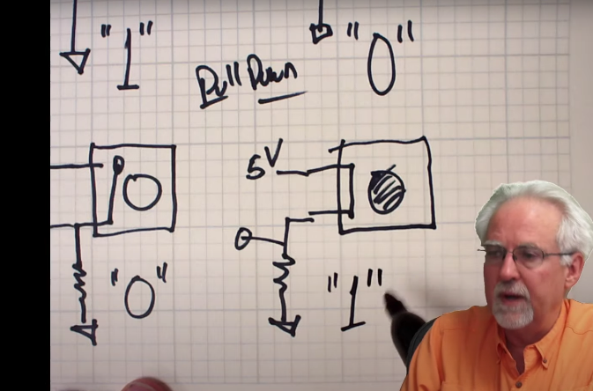

- LoRa (REYAX RYLR 890) - ESP32-C3 :->
ESP32-C3 | LoRa (REYAX RYLR 890)
3.3v | VDD
GND | GND
GPIO4 (RX) | TXD
GPI0 5(TX) | RXD

** SPI Communication Protocall **
1. SPI stands for Serial Peripheral Interface, and it is a synchronous serial data protocol used by microcontrollers to communicate with one or more peripherals. For example, your ESP32 board communicating with a sensor that supports SPI or with another microcontroller.
i. HSPI Pins: (ESP32)
- MISO (Master In Slave Out) - GPIO 12
- MOSI (Master Out Slave In) - GPIO 13
- SCK (Serial Clock) - GPIO 14
- CS (Chip Select) - GPIO 15
ii. VSPI Pins: (ESP32)
- MISO (Master In Slave Out) - GPIO 19
- MOSI (Master Out Slave In) - GPIO 23
- SCK (Serial Clock) - GPIO 18
- CS (Chip Select) - GPIO 5

- LoRa (REYAX RYLR 890) - ESP32 :->
ESP32 | LoRa (REYAX RYLR 890)
3.3v | VDD
GND | GND
GPIO16 (RX) | TXD
GPI0 17(TX) | RXD

** LoRa RYLR896 **
- AT Command :->

Command | Description | Example
AT

Some documentation AT Command link -> https://www.cavliwireless.com/blog/nerdiest-of-things/an-introduction-to-cellular-at-commands.html

- AT
- AT+ADDRESS
- AT+NETWORKID
- AT+BAND
- AT+PARAMETER - AT + PARAMETER = 10,7,1,7
- Spreading Factor
- Bandwidth
- Coding Rate
- Programmed Preamble
- AT+SEND

5) Spreading Factor (SF) :
- SF controls how long the signal stays in the air and how much it spreads.
- Higher SF → Better range & sensitivity, but slower transmission.
- Lower SF → Faster transmission, but less range
SF Value | Range | Speed
SF7 | Short | Fast ⚡
SF10 (Selected) | Medium | Medium
SF12 | Long | Slow

Chat GPT -> https://chatgpt.com/c/67adf5d6-8334-8007-8bfc-cddfbaa176d6
LoRa Document : LoRa — LoRa documentation

3. How RF & Serial Parameters Work Together
- RF parameters (SF, Bandwidth, Coding Rate, Preamble) affect wireless communication between LoRa nodes.
- Serial parameters (Baud Rate, Parity, Data Bits, Stop Bits) affect UART communication between LoRa and ESP32.
- A balance is needed:
  - If SF is high, baud rate should be moderate (to avoid delays).
  - If Bandwidth is high, SF should be lower (to avoid noise).
  - If CR is high, baud rate should be low to avoid errors.

- AT+RESET
- AT+MODE=1
- AT+IPR=115200
- AT+PARAMETER=7,3,4,5
- AT+BAND=868500000
- AT+ADDRESS=120
- AT+NETWORKID=00001
- AT+CPIN=ANUJ9052985897
- AT+CRFOP=10
- AT+SEND=50,5,HELLO -> (send data )

** Micro SD Card Adaptor **
- Function Operation:
FILE | write |  | FS | Open |  | MODE | FILE_WRITE
 | getLastWrite |  |  | Exists |  |  | FILE_APEND
 | Read |  |  | Remove |  |  | FILE_READ
 | Peek |  |  | Rename
 | Flush |  |  | Mkdir
 | seek |  |  | rmdir

- ESP8266 & Micro SD Card Adaptor:
- Install the library -> “#include <SPI.h>”, “#include <SD.h>”
- Connect with 5V with Micro SD Card Adoptor [External Power Supply]
- CODE ->
#include <SPI.h>
#include <SD.h>
if (!SD.begin(15)) {
Serial.println("Initialization failed!");
return;
}
ESP8266 | Micro SD Card Adaptor
GND | GND
5v -> external | VCC
D8 (GPIO 15) | CS
D5 (GPIO 14) | SCK
D7 (GPIO 13) | MOSI
D6 (GPIO 12) | MISO

- ESP32 & Micro SD Card Adaptor:
- Install the library -> “#include <SPI.h>”, “#include <SD.h>”
- Connect with 5V with Micro SD Card Adoptor
- CODE ->
#include <SPI.h>
#include <SD.h>
#define CS_PIN 5
while (!SD.begin(CS_PIN))
{
Serial.println("Failed to Connect the SD Card...");
return;
}
ESP32 | Micro SD Card Adaptor
GND | GND
5v | VCC
GPIO 5 | CS
GPIO 18 | SCK
GPIO 23 | MOSI
GPIO 19 | MISO

** Adafruit Fingerprint Sensor Library **
R503 Fingerprint Module | ESP32
Power Supply | 3V3
GND | GND
TXD | RX (GPIO 16)
RXD | TX (GPIO 17)
WAKEUP | Not Connected
3.3VT | 3.3 V

Descrition:
The Adafruit Fingerprint Sensor Library is a software library designed to interface with fingerprint sensors (like the R30x series) using Arduino or compatible microcontrollers. It provides functions to:
- Enroll new fingerprints.
- Verify fingerprints against stored templates.
- Delete fingerprints.
- Manage the sensor's database (e.g., clear all fingerprints).

This library simplifies the process of integrating fingerprint-based authentication into your projects.
- begin(): Initializes the fingerprint sensor and establishes communication.
- getImage(): Captures a fingerprint image from the sensor.
- image2Tz(): Converts the captured fingerprint image into a template for processing.
- createModel(): Combines two fingerprint templates (from the same finger) to create a final model for storage.
- storeModel(): Stores the fingerprint template at a specific ID in the sensor's memory.
- fingerFastSearch(): Searches the sensor's database for a matching fingerprint.
- deleteModel(): Deletes a fingerprint template associated with a specific ID.
- emptyDatabase(): Clears all fingerprint templates from the sensor's memory.

** 4x4 Matrix Keypad **
4x4 Matrix Keypad | ESP32
R1 | D13
R2 | D12
R3 | D14
R4 | D27
C1 | D26
C2 | D25
C3 | D33
C4 | D32

YouTube Video: https://www.youtube.com/watch?v=OTob_AeBUrw

** 16 Channel Analog Multiplaxer(CD74HC4067) **
- Connection With ESP8266:
CD74HC4067 | ESP8266
VCC | 3.3V
GND | GND
S0 | D1 (GPIO5)
S1 | D2 (GPIO4)
S2 | D3 (GPIO0)
S3 | D4 (GPIO2)
EN (Enable) | GND or GPIO12
SIG | D5 (GPIO14)
C0 – C15 | LEDs (With Resistors)

- Connection With ESP32:
CD74HC4067 | ESP32
VCC | 3.3V
GND | GND
S0 | GPIO 18
S1 | GPIO 19
S2 | GPIO 21
S3 | GPIO 22
EN (Enable)
SIG | GPIO 32 (for sensors - Analog input)
C0 – C15 | LEDs (With Resistors)

** RFID-RC522 **
- Connection With ESP8266:
RFID-RC522 | ESP8266
SDA (SS) | GPIO 15 (D8)
SCK | GPIO 14 (D5)
MOSI | GPIO 13 (D7)
MISO | GPIO 12 (D6)
GND | GND
RST | GPIO 0 (D3)
3.3 V | 3.3V

- Connection With ESP32:
RFID-RC522 | ESP32
SDA (SS) | GPIO 5
SCK | GPIO 18
MOSI | GPIO 23
MISO | GPIO 19
GND | GND
RST | GPIO 4
3.3 V | 3.3V

** SPI Support ESP32 Pin **

- ESP32 have Support two Type of Buses:

- VSPI (Default SPI Bus)
- HSPI (Secondary SPI Bus)
SPI | MOSI | MISO | SCLK | CS
VSPI | GPIO 23 | GPIO 19 | GPIO 18 | GPIO 5
HSPI | GPIO 13 | GPIO 12 | GPIO 14 | GPIO 15

** SPI with Star Topology (Separate CS lines) **
In this setup:
- MOSI, MISO, and SCK lines are shared among all devices.
- But each device has its own separate CS (Chip Select) pin from the master.

- All Device of MISO Line have the same line with separate the 330 Ω Registor’s.
  - ESP32 -> 330 Ω -> MISO (Every Devide Has its OWN Registor’s)
- In Some Cases Only Connect the 330 Ω Registor on SD Card Adoptor Module

** UART Communication Protocall **
- UART for ESP32
  - There are 3 UART Support -> UART0, UART1, UART2
  - UART0: this UART is used the basic serial communication. Like, Printing in the terminal.
  - UART1: this UART is used for the connecting to other Device support. Like, Fingerprint Sensor and the Pin is -> pair -> RX, TX -> 32, 33 | 25, 26 | 27, 14 | etc.
  - UART2: this UART is used for the connecting to other Device support. Like, GPS Module and the Pin is -> pair -> RX, TX -> 16, 17|

