** TOPIC and CONCEPT **

3. How RF & Serial Parameters Work Together
- RF parameters (SF, Bandwidth, Coding Rate, Preamble) affect wireless communication between LoRa nodes.
- Serial parameters (Baud Rate, Parity, Data Bits, Stop Bits) affect UART communication between LoRa and ESP32.
- A balance is needed:
  - If SF is high, baud rate should be moderate (to avoid delays).
  - If Bandwidth is high, SF should be lower (to avoid noise).
  - If CR is high, baud rate should be low to avoid errors.

- AT+RESET
- AT+MODE=1
- AT+IPR=115200
- AT+PARAMETER=7,3,4,5
- AT+BAND=868500000
- AT+ADDRESS=120
- AT+NETWORKID=00001
- AT+CPIN=ANUJ9052985897
- AT+CRFOP=10
- AT+SEND=50,5,HELLO -> (send data

- Circular Buffer:
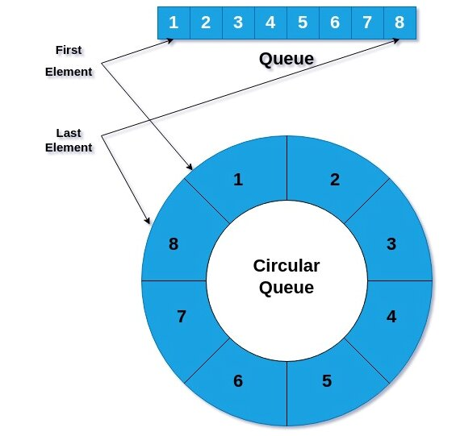
-> a circular buffer, circular queue, cyclic buffer or ring buffer is a data structure that uses a single, fixed-size buffer as if it were connected end-to-end. This structure lends itself easily to buffering data streams.^{[1]} There were early circular buffer implementations in hardware
Links:
Webside: https://en.wikipedia.org/wiki/Circular_buffer
GitHub Link :-> https://github.com/wizard97/Embedded_RingBuf_CPP
platformio.ini :-> wizard97/RingBufCPP@^1.3
Header Name :-> #include <RingBufCPP.h>

- Cycle Redundant Check (CRC): 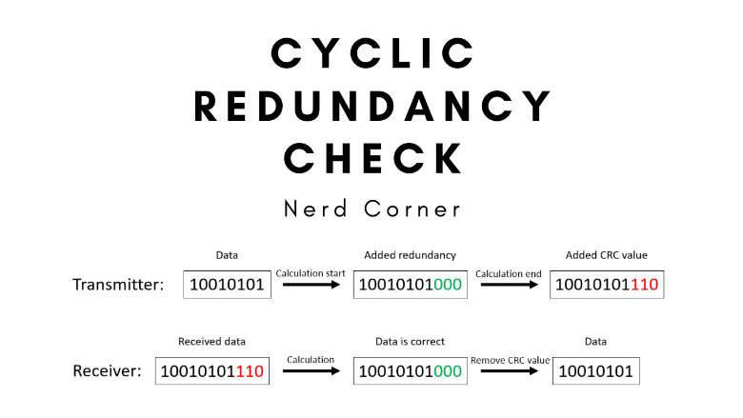
A cyclic redundancy check (CRC) is an error-detecting code commonly used in digital networks and storage devices to detect accidental changes to digital data.^{[1][2]} Blocks of data entering these systems get a short check value attached, based on the remainder of a polynomial division of their contents. On retrieval, the calculation is repeated and, in the event the check values do not match, corrective action can be taken against data corruption. CRCs can be used for error correction (see bitfilters).^{[3]}
Links:
Webside: https://en.wikipedia.org/wiki/Cyclic_redundancy_check
GitHub Link :-> https://github.com/FrankBoesing/FastCRC
platformio.ini :-> frankboesing/FastCRC@^1.41
Header Name :-> #include <FastCRC.h>

- Chirp Offset Multiple Access (COMA):
Chirp Offset Multiple Access (COMA) is a communication technique used in wireless networks, particularly in Low-Power Wide-Area Networks (LPWANs) like LoRa (Long Range). It is a method for allowing multiple devices to share the same frequency channel efficiently without causing significant interference. Here's a breakdown of how it works:
Why Is COMA Useful?
Efficient Use of Spectrum:
Instead of assigning a separate frequency to each device (which is wasteful), COMA lets many devices share the same frequency. This is crucial in IoT networks where thousands of devices might be connected.
Scalability:
COMA allows a large number of devices to communicate simultaneously, which is essential for IoT applications like smart cities, agriculture, or industrial monitoring.
Long-Range Communication:
Chirp signals are robust and can travel long distances, even in noisy environments. COMA leverages this to enable reliable communication over wide areas.
Low Power Consumption:
Devices using COMA (like LoRa devices) can transmit data efficiently without needing a lot of power, which is critical for battery-operated IoT devices.

- Forward Error Correction (FEC) [RSV]:
Imagine you’re sending a secret message to your friend over a walkie-talkie, but there’s a lot of static noise. Sometimes, parts of your message get messed up, and your friend hears the wrong words. For example:
- You say: "Meet me at 5 PM."
- Your friend hears: "Meet me at 9 PM." (Oops! The time got messed up.)
This is a problem because your friend might show up at the wrong time!
Step 1: Add Extra Information (Redundancy):
Before sending the message, you add some extra information (redundancy) to it. This extra information helps your friend figure out the original message, even if parts of it get messed up.
For example:
- Your original message: "Meet me at 5 PM."
- You add extra information: "Meet me at 5 PM. Repeat: 5 PM."
Now, you send: "Meet me at 5 PM. Repeat: 5 PM."

- Coded Chirp Spread Spectrum (CCSS):
Coded Chirp Spread Spectrum (CCSS) is a wireless communication technique where a signal is spread across different frequencies in a special pattern. This makes the signal harder to intercept or interfere with. Only devices with the correct code can decode the signal and understand the message.
It’s like sending a secret message by spreading the words across different sound pitches — only someone who knows the pattern can put the words back together!
CCSS is used in technologies like LoRaWAN, satellite communication, and military radios to make data transmission secure and reliable.
CCSS ka Real Life Use:
- LoRaWAN: Long-range wireless communication ke liye use hota hai.
- Satellite Communication: Space mein data ko secure aur noise-free bhejne ke liye helpful hai.
- Military Radios: Taaki enemies signal ko track na kar sake.

Imp
- QMesh: A Synchronized Flooded Mesh Network for Voice and Data:
QMesh is a novel mesh networking protocol designed to provide rapid self-healing and streaming capabilities to mesh networks in order to allow for voice communications. QMesh uses synchronized flooding to provide for self-healing as well as the ability to stream data. QMesh applies two techniques to the LoRa Chirp Spread Spectrum (CSS) waveform in order to make QMesh work: Coded Chirp Spread Spectrum (CCSS) and Chirp Offset Multiple Access (COMA).
Links: https://github.com/faydr/QMesh
https://chatgpt.com/c/67c14d2b-2894-8007-9a34-faa9193cba89

- BOOK REFRENCE:
- "LoRa and LoRaWAN for IoT: How to Implement LoRa and LoRaWAN Projects for Internet of Things" by Agus Kurniawan
- "Wireless Mesh Networks" by Ian F. Akyildiz and Xudong Wang
- "Error Control Coding: Fundamentals and Applications" by Shu Lin and Daniel J. Costello
2. Research Papers and Articles:
- "Secure Energy Constrained LoRa Mesh Network"
- "QMesh: A Synchronized, Flooded Mesh Network Protocol for Voice"
3. Online Resources:
- The Things Network Forum

ESP32-CAM and ESP32-CAM-MB MICRO USB Development Board
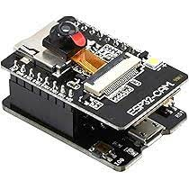

Connection:
- In PlatformIO -> code upload properly but serial monitor dose not work
- Used the Arduino IDE Serial Monitor -> it is working
- Code in platformIO and used the serial monito of Arduino IDE
- Project Of ESP32-CAM:
Basic Projects
- Capture and Save Images to SD Card
  - Learn how to capture images using the ESP32-CAM and save them to an SD card.
  - Skills: Basic camera setup, SD card interfacing.
- Live Video Streaming
  - Stream video from the ESP32-CAM to a web browser or mobile app.
  - Skills: Wi-Fi setup, video streaming, HTTP server.
- Time-Lapse Photography
  - Capture images at regular intervals and save them to an SD card or upload them to a cloud service.
  - Skills: Timers, SD card usage, basic scripting.
- Motion-Activated Camera
  - Use a PIR motion sensor to trigger the camera to capture images when motion is detected.
  - Skills: Sensor integration, event handling.
- Remote Control Camera
  - Control the camera (take photos, start/stop streaming) via a web interface or mobile app.
  - Skills: Web server, HTTP requests, UI design.

Intermediate Projects
- Face Detection and Recognition
  - Use OpenCV or TensorFlow Lite to detect and recognize faces in images captured by the ESP32-CAM.
  - Skills: AI/ML basics, image processing.
- Object Detection
  - Detect specific objects (e.g., cars, animals) using pre-trained models.
  - Skills: Machine learning, model deployment.
- Wi-Fi Security Camera
  - Build a security camera that sends alerts (email or SMS) when motion is detected.
  - Skills: IoT integration, notifications, cloud services.
- Pan-Tilt Camera Control
  - Add servo motors to create a pan-tilt mechanism for the camera and control it remotely.
  - Skills: Motor control, PWM, web interface.
- Time-Stamped Photos
  - Capture images with a timestamp overlay and save them to an SD card or cloud storage.
  - Skills: Real-time clock (RTC), image processing.
- QR Code Scanner
  - Use the ESP32-CAM to scan QR codes and decode them.
  - Skills: Image processing, QR code libraries.
- Night Vision Camera
  - Add IR LEDs to the ESP32-CAM to enable night vision and capture images in low light.
  - Skills: Hardware modification, IR lighting.

Advanced Projects
- AI-Powered Wildlife Monitoring
  - Use the ESP32-CAM to detect and classify animals in the wild.
  - Skills: AI model training, edge computing.
- Smart Doorbell with Face Recognition
  - Build a smart doorbell that recognizes faces and sends notifications to your phone.
  - Skills: AI, IoT, mobile app integration.
- Drone Camera
  - Integrate the ESP32-CAM with a drone to capture aerial images and stream video.
  - Skills: Drone control, real-time video streaming.
- Gesture-Controlled Camera
  - Use gesture recognition to control the camera (e.g., take a photo with a hand wave).
  - Skills: Gesture recognition, AI.
- Cloud-Based Surveillance System
  - Upload images and video to cloud storage (e.g., Google Drive, AWS S3) for remote monitoring.
  - Skills: Cloud APIs, data storage.
- AI-Powered Traffic Monitoring
  - Detect and count vehicles, measure traffic density, and send data to a central server.
  - Skills: AI, data analytics, IoT.
- 3D Scanning with ESP32-CAM
  - Use multiple ESP32-CAM modules to create a 3D scanner.
  - Skills: 3D modeling, image stitching.
- Augmented Reality (AR) Project
  - Overlay digital information on live video feed (e.g., object tracking with AR markers).
  - Skills: AR, image processing.
- AI-Powered Emotion Detection
  - Detect human emotions (happy, sad, angry) using AI models.
  - Skills: AI, facial expression analysis.
- Automated Plant Health Monitoring
  - Use the ESP32-CAM to monitor plant health by analyzing leaf color and texture.
  - Skills: AI, image analysis, IoT.
- Smart Retail Shelf Monitoring
  - Detect product availability on retail shelves and send alerts when stock is low.
  - Skills: AI, IoT, inventory management.
- AI-Powered Security System
  - Detect intruders and classify them (human, animal, etc.) using AI.
  - Skills: AI, security systems, IoT.
- ESP32-CAM Robot
  - Build a robot with the ESP32-CAM for navigation and object detection.
  - Skills: Robotics, AI, motor control.

Bonus Ideas
- ESP32-CAM as a Webcam: Use the ESP32-CAM as a USB webcam for your computer.
- ESP32-CAM with GPS: Add a GPS module to geotag photos.
- ESP32-CAM with BLE: Control the camera via Bluetooth Low Energy (BLE).
- ESP32-CAM with Voice Control: Use voice commands to control the camera.
- ESP32-CAM with Edge Impulse: Train custom AI models for specific tasks.

memory management (SD Card)
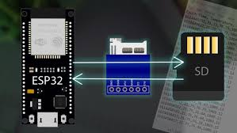

Basic Memory Projects
- Monitor Free Heap Memory
  - Create a program to monitor and display the free heap memory of the ESP32 in real-time.
  - Skills: Memory monitoring, debugging.
- Use SPIFFS for File Storage
  - Store and retrieve files (e.g., text, images) in the ESP32's SPIFFS (SPI Flash File System).
  - Skills: File system management, flash memory usage.
- Save Data to EEPROM
  - Store small amounts of data (e.g., settings, sensor readings) in the ESP32's EEPROM.
  - Skills: Non-volatile memory, data persistence.
- Measure Memory Fragmentation
  - Write a program to measure and analyze memory fragmentation on the ESP32.
  - Skills: Memory optimization, debugging.
- Basic SD Card Usage
  - Save data (e.g., logs, images) to an SD card and read it back.
  - Skills: SD card interfacing, file handling.

Intermediate Memory Projects
- External PSRAM Usage
  - Use the ESP32's external PSRAM (if available) to store large data structures (e.g., images, buffers).
  - Skills: External memory management, dynamic memory allocation.
- Memory-Efficient Image Capture
  - Capture images with the ESP32-CAM and store them in external memory (PSRAM or SD card) to avoid running out of RAM.
  - Skills: Memory optimization, camera integration.
- Data Logging with Circular Buffer
  - Implement a circular buffer in RAM to log sensor data efficiently.
  - Skills: Buffer management, memory optimization.
- Compress Data for Storage
  - Compress data (e.g., text, images) before saving it to flash or SD card to save space.
  - Skills: Data compression, memory efficiency.
- Memory Pool Allocator
  - Implement a custom memory pool allocator to manage dynamic memory more efficiently.
  - Skills: Memory management, custom allocators.
- Store and Retrieve Large Files
  - Store large files (e.g., firmware updates, images) in external flash or SD card and retrieve them when needed.
  - Skills: File system management, external storage.
- Memory Leak Detection
  - Write a program to detect and debug memory leaks in your ESP32 projects.
  - Skills: Debugging, memory analysis.

Advanced Memory Projects
- Over-the-Air (OTA) Updates with Memory Constraints
  - Implement OTA updates while managing limited memory resources.
  - Skills: OTA programming, memory optimization.
- Dual-Core Memory Sharing
  - Use both cores of the ESP32 and share memory between them for parallel processing.
  - Skills: Multi-core programming, memory synchronization.
- External Flash for Firmware Storage
  - Store part of your firmware or assets (e.g., web pages, images) in external flash memory.
  - Skills: External memory, firmware management.
- Memory-Mapped I/O
  - Use memory-mapped I/O to interact with peripherals or external memory.
  - Skills: Low-level memory access, hardware interfacing.
- Optimize Memory Usage in AI Projects
  - Run AI models (e.g., TensorFlow Lite) on the ESP32 while optimizing memory usage.
  - Skills: AI, memory optimization.
- Custom Garbage Collector
  - Implement a simple garbage collector for dynamic memory management.
  - Skills: Memory management, custom algorithms.
- Memory-Efficient Web Server
  - Build a web server on the ESP32 that serves files or data while minimizing memory usage.
  - Skills: Web server optimization, memory management.
- External SRAM for High-Speed Data Processing
  - Use external SRAM to store and process high-speed data (e.g., audio, video).
  - Skills: External memory, high-speed data handling.
- Memory Profiling Tool
  - Create a tool to profile memory usage in your ESP32 projects and identify bottlenecks.
  - Skills: Profiling, debugging.
- Hybrid Memory System
  - Combine internal RAM, external PSRAM, and SD card to create a hybrid memory system for large-scale projects.
  - Skills: Memory hierarchy, resource management.
- Fault-Tolerant Memory System
  - Implement a fault-tolerant memory system that can recover from memory errors or corruption.
  - Skills: Error handling, memory resilience.
- Memory-Efficient Real-Time Operating System (RTOS)
  - Use FreeRTOS on the ESP32 and optimize memory usage for multi-tasking applications.
  - Skills: RTOS, memory optimization.
- External Flash for Data Logging
  - Use external flash memory to log large amounts of sensor data over long periods.
  - Skills: External memory, data logging.

Bonus Ideas
- Memory Benchmarking: Compare the performance of different memory types (internal RAM, PSRAM, SD card).
- Memory-Efficient Image Processing: Process images on the ESP32 while minimizing memory usage.
- Memory-Aware Task Scheduler: Create a task scheduler that considers memory usage when allocating tasks.
- Memory Compression Algorithms: Implement and test different memory compression algorithms.
- Memory Debugging Tools: Build custom tools to debug memory-related issues on the ESP32.

** RFID Reader/Writer and RFID Tag **

1. Difference Between RFID Key vs. UID
Feature | Key (Key A / Key B) | UID (Unique ID)
Purpose | Security (authenticates the reader) | Identification (like a serial number)
Stored In | Tag’s sector trailer (last block of each sector) | Tag’s Block 0 (read-only)
Format | 6 bytes (e.g., FF FF FF FF FF FF) | 4, 7, or 10 bytes (e.g., 12 34 56 78)
Can Be Changed? | ✅ Yes (if you know the current key) | ❌ No (permanent, set by manufacturer)
Used For | Grants read/write access to data | Identifies the tag itself (no security)
Default Value | Often FF FF FF FF FF FF (weak security) | Unique per tag (e.g., 04 A3 B2 C1)
Example Use | - Unlocking a door  - Writing data to a block | - Checking if a tag is authorized  - Logging attendance

2. Difference Between “Custom Key”, “UID (Tag Unique ID)” and “System Unique ID (CHK001, etc.)”.
Identifier | Used For | Stored In | Changeable?
Custom Key | Security & Authentication | RFID Sector Trailer (Block 3, 7, 11, etc.) | ✅ Yes (Can be updated)
UID (Tag Unique ID) | Physical Tag Identification | Chip Memory (Read-Only) | ❌ No (Permanent)
System Unique ID (CHK001, etc.) | Mapping RFID to Locations | Database or RFID Data Block (Block 4, 5, 6, etc.) | ✅ Yes (Can be changed)

-> RFID Tag Will Authonticate. Not Reader :
- RFID Tag strore key , RFID Reader will send the data to Tag and if match the it will work fthat assigned.

=> What is the “Block” in RFID ?
Ans: A "block" is the smallest unit of memory in an RFID tag (like a "page" in a notebook).
🔍 Simple Analogy:
- Imagine an RFID tag as a notebook with:
  - 16 pages (blocks) in a MIFARE Classic 1K tag.
  - 64 pages (blocks) in a MIFARE Classic 4K tag.
- Each page (block) can store 16 bytes (like 16 letters or numbers).

- Industry-Standard Workflow for RFID-Based Guard Patrolling System
Your RFID Guard Patrolling System will have three major operations:
1️. RFID Tag Creation (Assigning locations or checkpoints)
2. Guard Patrolling & Data Logging (Reading checkpoints & storing logs)
3. Data Storage & Review (Saving logs for reports & analysis)

🔹 Step-by-Step Industrial Workflow
🔸 1. RFID Tag Creation & Assignment (Enrollment Phase)
✅ Objective: Create RFID tags for each checkpoint (entry gate, office, warehouse, etc.).
✅ Procedure:
- Device scans a blank RFID tag.
- User enters location details (e.g., "Gate A", "Warehouse 1").
- System writes unique ID + location details + timestamp to the RFID tag.
- Tag is now ready to be used for patrolling.
📌 Stored Data Format: Checkpoint_ID | Location_Name | Assigned Date

🔸 2. Guard Patrolling & Data Logging (Real-Time Monitoring)
✅ Objective: Guard scans each RFID checkpoint while patrolling, and logs are stored.
✅ Procedure:
- Guard carries the RFID-based device.
- When reaching a checkpoint, the device reads the RFID tag.
- Device extracts location details and saves the timestamp.
- Logs are temporarily stored in local storage (EEPROM, SD Card, or Database).
📌 Stored Log Format: Guard_ID | Checkpoint_ID | Scan_Time | Date

🔸 3. Data Storage & Review (Sync & Reporting)
✅ Objective: Store patrol logs securely and review them for security audits.
✅ Procedure:
- Device syncs patrol logs via Wi-Fi / Bluetooth / USB to a central server.
- Data is uploaded to a cloud/server/database for analysis.
- Security managers can generate patrolling reports & timestamps.
- If a checkpoint is missed, an alert is triggered.
📌 Stored Report Format: Guard_Name | Route_Completed | Missed Checkpoints | Patrol Time

📌 Industrial Standards & Best Practices
✔️ Use Encrypted RFID Tags for security.
✔️ Data Redundancy (Backup logs to SD Card & Server).
✔️ Real-Time Monitoring Dashboard (Alerts if a checkpoint is missed).
✔️ Audit & Compliance Ready (Generate reports for supervisors).
✔️ Use NFC/RFID with Authentication (To prevent unauthorized access).

