- Product Development LifeCyle:
Phase | Goal | Key Deliverables
1. Idea | Define the vision and features | Core features list, target users, hardware (Jetson), high-level tech stack
2. Planning | Finalize requirements and tech stack | Functional requirements, timeline, tool list (LangChain, Whisper, Piper, etc.), folder structure
3. Design | Design system architecture and modules | System diagram, module breakdown (speech, vision, agent), API/UI mockups
4. Development | Code all modules and pipeline | Speech, agent, vision, tools integration, FastAPI server, optional frontend
5. Testing | Validate each component and overall flow | Unit + integration tests, real-device tests, test cases + logs
6. Deployment | Run the system on Jetson and (optionally) host frontend | Docker/Service setup, FastAPI over LAN, boot-at-start setup
7. Maintenance | Fix bugs, improve performance | Error logging, model updates, better responses, OTA updates
8. Feedback/Growth | Add new features, refine user experience | User feedback, new tools/modules, UI upgrades, analytics
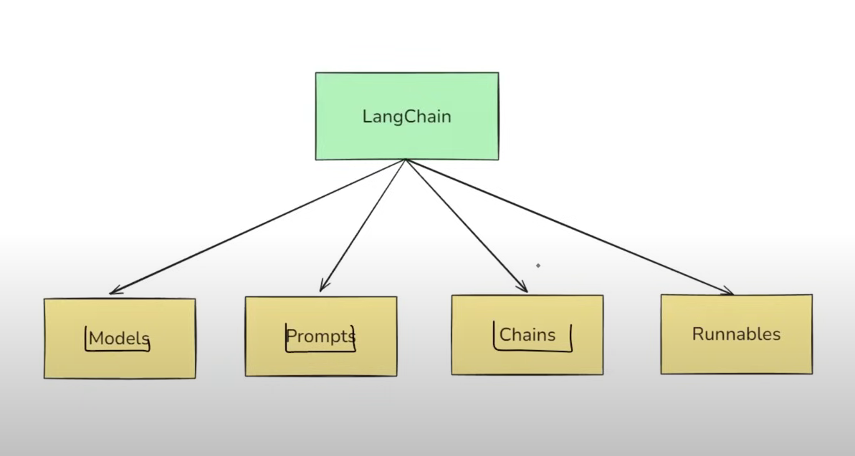
What is GenAI ?
- Generative AI is a type of artificial intelligence that creates new content – such as text, images, music, or code – by learning patterns from existing data, mimicking human creativity.
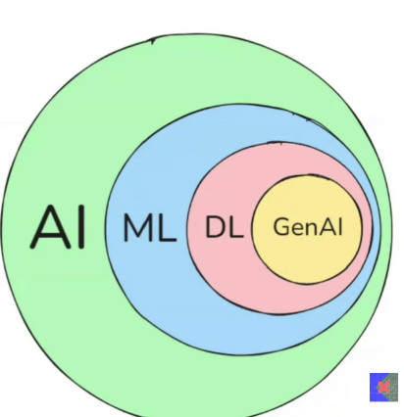
- GenAI Impact’s Areas:
- Customer Supports
- Content Creation
- Education
- Software Development

- Is GenAI Successfull:
- Does is solve real world problems ?
- Is It usefull on a daily basis ?
- Is it impacting the world economics ?
- Is it creating new jobs ?
- Is it accessible ?
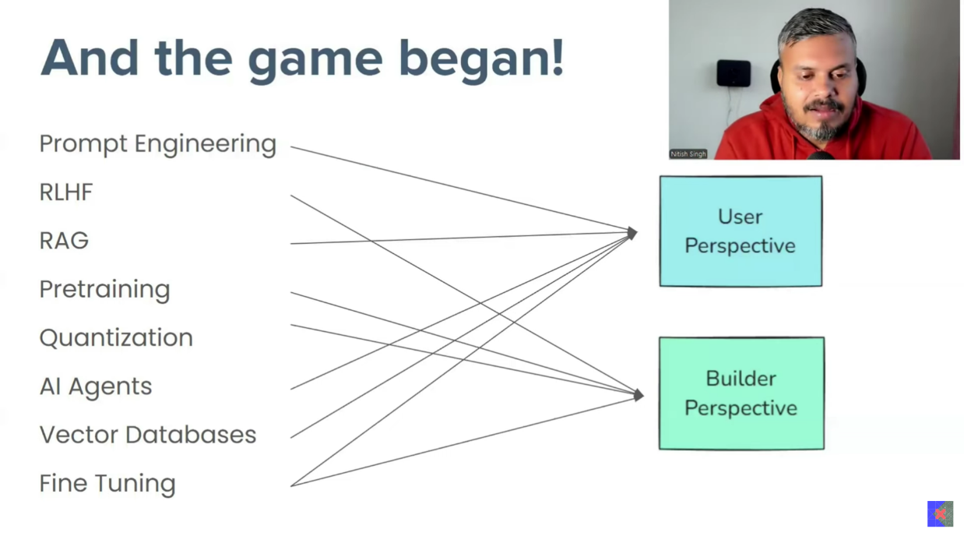

- The Builder’s Perspective:
- Transformer Architecture
- Type of Transformers
  - Encoder Only (BERT)
  - Decoder Only (GPT)
  - Encoder & Decoder based (T5)
- Pretraining
  - Training Objectives
  - Tokenization Strategies
  - Training Stratigies
  - Handling Challenges

- Optimization
  - Traning Optimization
  - Model Compression
  - Optimizaing Inference
- Fine Tuning
  - Task Specific Tuning
  - Instruction Tuning
  - Continual Pretraining
  - RLHF
  - PEFT
- Evaluation
- Deployment

- The User’s Perspective:
- Building Basic LLM Apps
  - Open Source vs Closed Source LLMs
  - Using LLM APIs
  - LangChian
  - HuggingFace
  - Ollama
- Prompt Engineering
- RAG
- Fine Tuning
- Agents
- LLMOps
- Miscellaneous

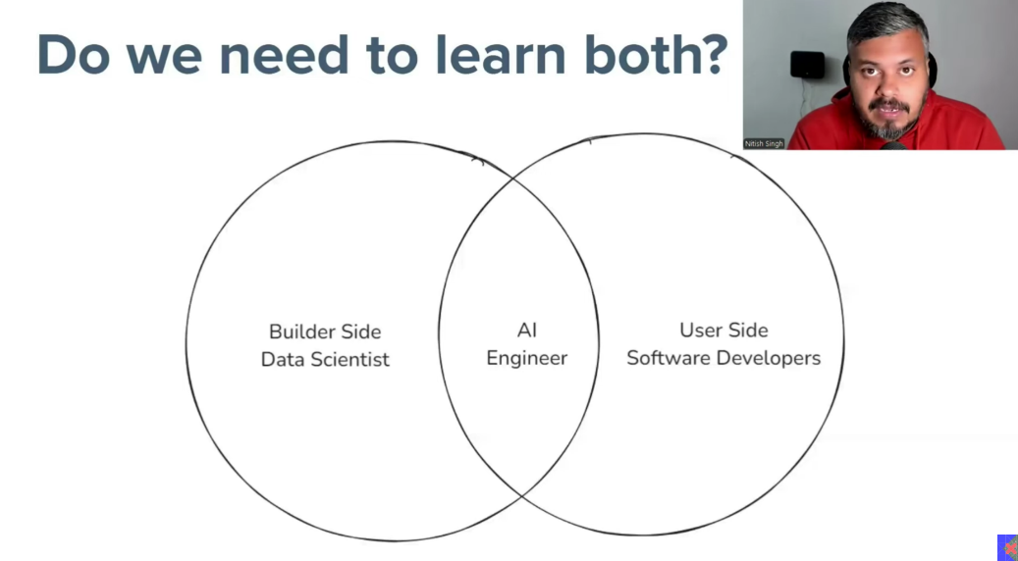

What is LangChain ?
- LangChain is an open-source framework for development applications powered by large language model (LLMs)
- LangChian is an open source framework that helps in building LLM based application. It provides modular components and end-to-end tools that help developers to build complex AI application, such as chatbots, question-answering - system, retrieval augmented generation (RAG), autonomos agents, and more.
  - Supports all the major LLMs
  - Simplefies developing LLM based applications
  - Integration available for all major tools
  - Open source/Free/Actively developed
  - Supports all major GenAI use cases
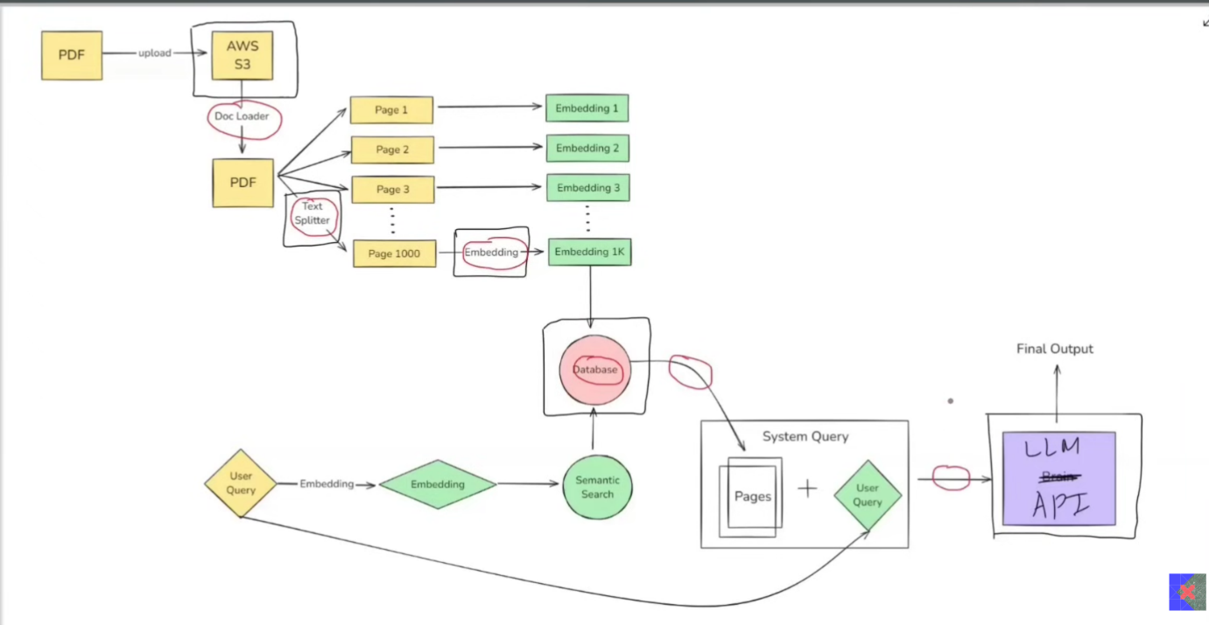
- Benefits of LangChain:
- Concept of Chain
- Model Agnostic Development
- Complete Ecosystem
- Memory and State handling
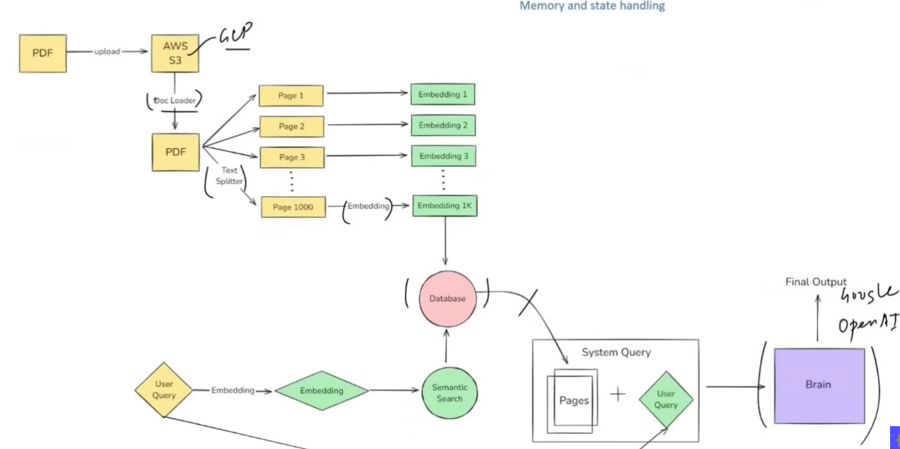

- What You Can Build ?
- Conversational Chatbots
- AI Knowledge Assistants
- AI Agent
- Workflow Automation
- Summarization / Research Helpers

- Alterbatives Framework
- LlamaIndex
- Haystack

- Embedding Models:
Embedding models are algorithms that convert complex data (like text, images, or audio) into numerical vectors, called embeddings, that capture the underlying meaning and relationships within that data. These embeddings are then used by machine learning models to perform tasks like classification, clustering, or semantic search

Start Learning LangChain
- LangChain (Components)
- Models
- Prompts
- Chain
- Memory
- Indexes
- Agent

- Models:
- In LangChain, “models” are the core interface through which you interact with AI models.

- Promps:
- A prompt is a carefully designed input that guides AI models in generating meaningful responses. It can be as simple as a question or as complex as a structured command.
- LLM -> Input -> prompt
- Dynamic & Reusable Prompts
from langchain_core.prompts import PromptTemplate
prompt = PromptTemplate.from_template('Summarize {topic} in {emotion} tone')
print(prompt.format(topic='Cricket', length='fun'))

- Role-Based Prompts
# Define the ChatPrompTemplate using from_template
chat_prompt = ChatPromptTemplate.from_template([
('system', 'Hi you are a experienced {professional}'),
('user', 'Tell me about {topic}')
])

# Format the prompt with the variable
formatted_message = chat_prompt,formatted_message(professional="Doctor", topic="Viral Fever")

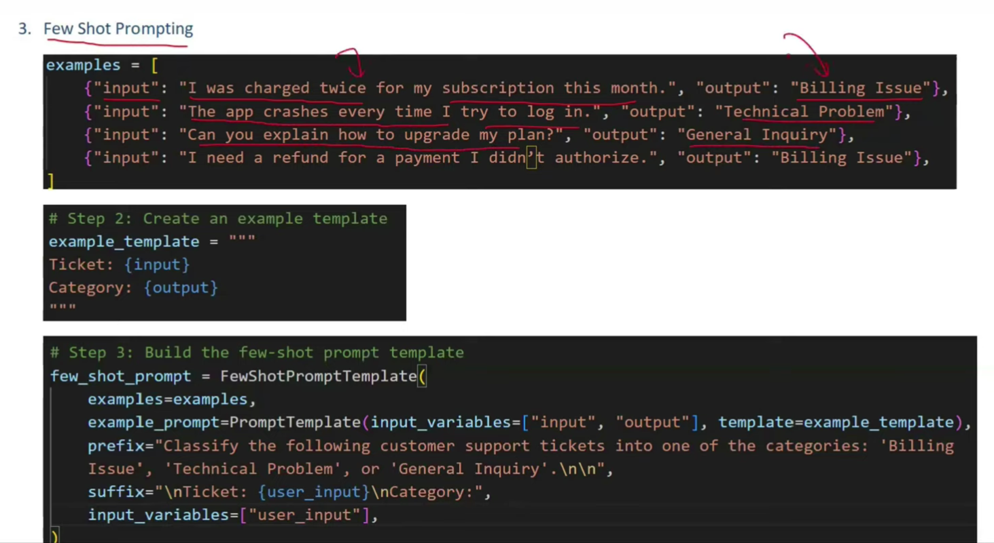
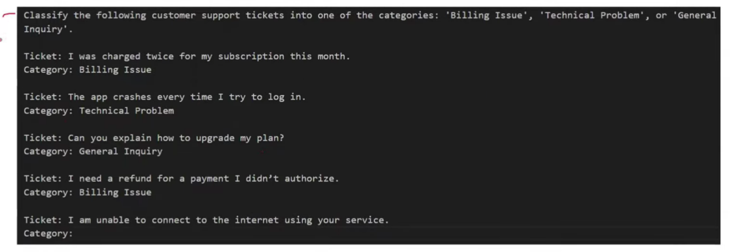

- Chain: (IMP Component)
- In LangChain, a chain is a structured sequence of calls to different components, like language models, prompts, or data processing steps, that are executed in a defined order to achieve a specific task
- Example:
  - Input LLM Insert LLM Summiery Reult
- We Able to Create the Complex Pipeline
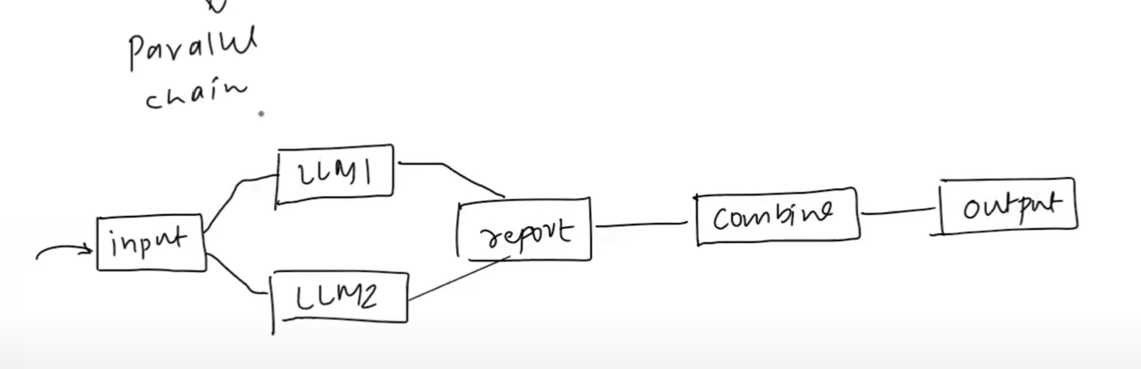
- Indexes:
- Indexes Connect You Application to external knowledge – such as PDFs, Websites or databases
- Exampels:
- Doc Loader
- Text Splitter
- Vector Store
- Retrivals

- Memory:
- LLM API Calls are Stateless
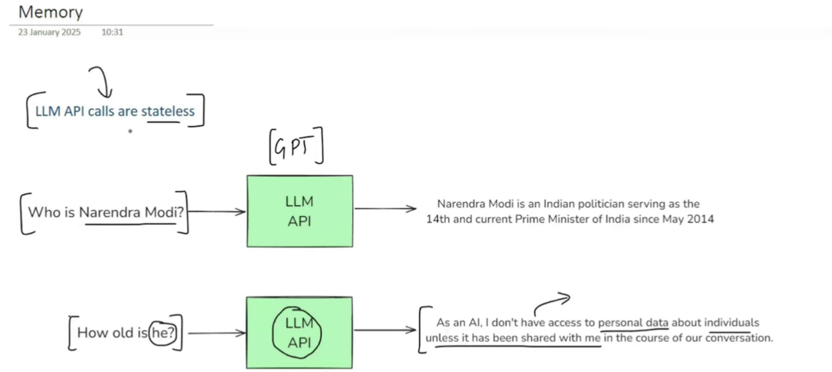
- ConversationBufferMemory: Stores a transcript of recent messages. Great for short chats but can grow large quickly.
- ConversationBufferWindowMemory: Only Keep the last N interactions to avoid excessive token usage.
- Summarizer-Based Memory: Periodically summarizes older chat segments to keep a condensed memory footprint.
- Custom Memory: for advanced use cases, you can store specialized state (e.g. the user’s preferences or key facts about them) in a custom memory class.

- Agents:
- Reasning capability
- Access the tool of devices

Feature | LLM-Based Models | Chat-Based Models
Organization | Meta (LLaMA 3), Mistral (7B, Mixtral), Microsoft (Phi), 01.AI (Yi) | OpenAI (GPT-4o, GPT-3.5), Anthropic (Claude), Google (Gemini), Cohere (Command R), Nous (Hermes)
License | Mostly Open Source (Apache, MIT) | Mostly Proprietary or Commercial
Fine-tuned for Chat | ❌ (Usually raw LLMs) | ✅ Tuned for dialogue & instructions
Typical Use Cases | RAG, Code Gen, Embedding, Reasoning | Assistant bots, customer support, Copilots
Context Length | 8k–128k tokens (varies) | Up to 1M tokens (e.g., Gemini 1.5)
Multimodal Support | Limited (some vision) | ✅ Full: vision, audio, even video (GPT-4o)
Real-Time Capability | ❌ Mostly offline/inference | ✅ Real-time APIs with streaming
Offline Usage | ✅ (via Hugging Face, Docker, etc.) | ❌ Mostly needs cloud APIs
Inference Hardware | Supports local GPU, TPUs | Cloud-based, optimized for inference
Popular OSS Models | LLaMA 3, Mixtral, Phi, Yi, Falcon | OpenChat, Nous-Hermes, Command R+
Examples | Meta-LLaMA-3-70B, Mixtral-8x7B, Yi-34B, Phi-3 | GPT-4o, Claude 3 Opus, Gemini 1.5, Command R+

- Model Temprature:
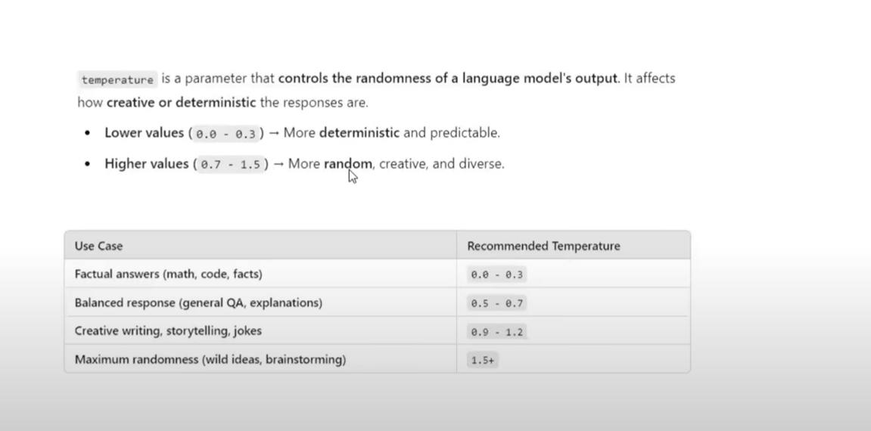

*** Open Source Model’s ***
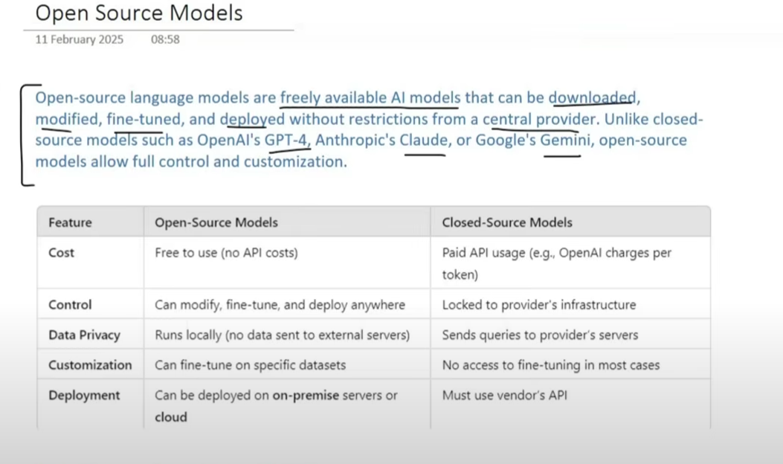

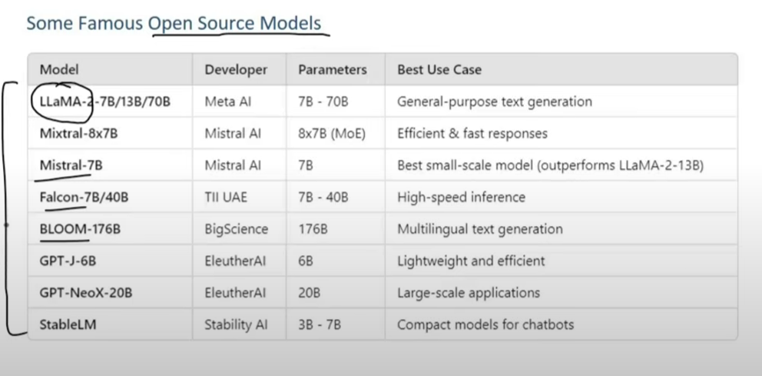
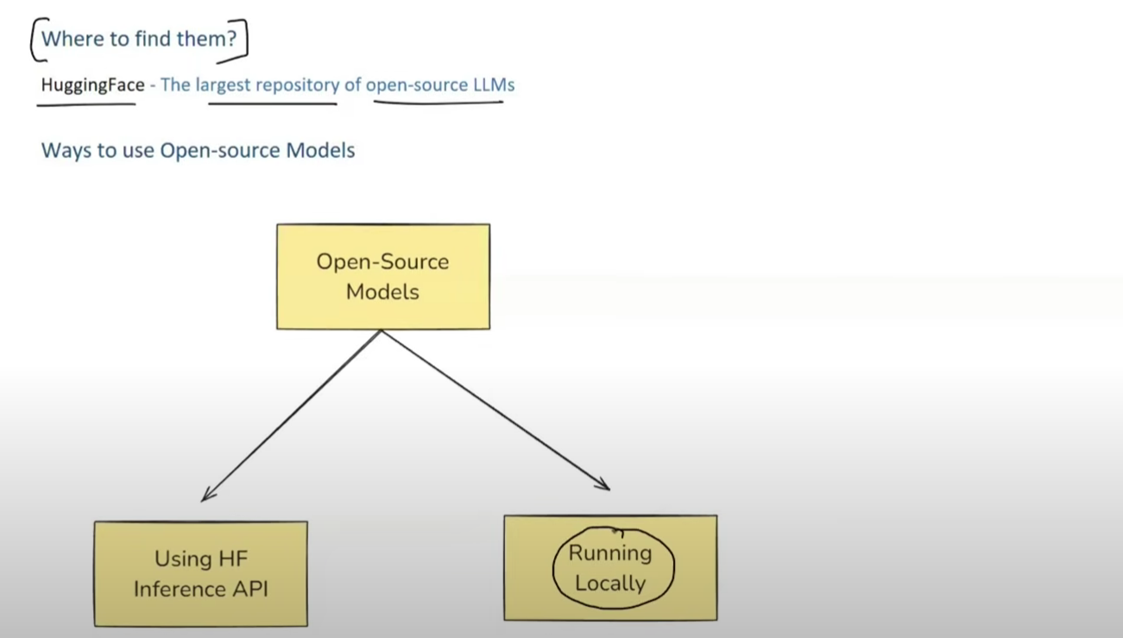

Prompt Template
- A PromptTemplate in LangChain is a structured way to create prompts dymanically by inserting variable into a predefind template. Instead of hardcoding prompts, PromptTemplate allow you to defined the placeholders that can be filled in at runtime with defferent inputs.
- This makes it reusable, flexible and easy to manage, especially when working with dynamic inputs or automated workflow
Why use PromptTemplate over f string?
- Defualt Validation
- Reusable
- LangChain Ecosystem

Type of Messages in LangChain
- System Message
- Humman Message
- AI Message

🧠 1. System Message:
- 👉 Definition: A message that sets the behavior or role of the AI.
- 🗣️ Example:
  - “You are a helpful assistant.”
- 📌 Use: It tells the AI how it should act during the chat.

🙋‍♂️ 2. Human Message:
- 👉 Definition: A message from the user (human) to the AI.
- 🗣️ Example:
  - “What is the capital of India?”
- 📌 Use: This is the actual question or command from the user.

🤖 3. AI Message:
- 👉 Definition: A response from the AI to the human message.
- 🗣️ Example:
  - “The capital of India is New Delhi.”
- 📌 Use: It's the AI's answer to what the human asked.

Message Placeholder
A MessagesPlaceholder in LangChain is a special placeholder used inside a ChatPrompTemplate to dynamically insert Chat History or a list of message at runtime

Structured Output (AI Ans. Management)
- In LangChain, Structured output refers to the practice of having langchain model return
- Responces in a well-defined data format (for example, JSON), rather then free-form text. This makes the model output easier to parse and work with programmatically.
- Possible to interact with other application (exe, etc) by using Structured output
- Process the Output in a Proper Way.
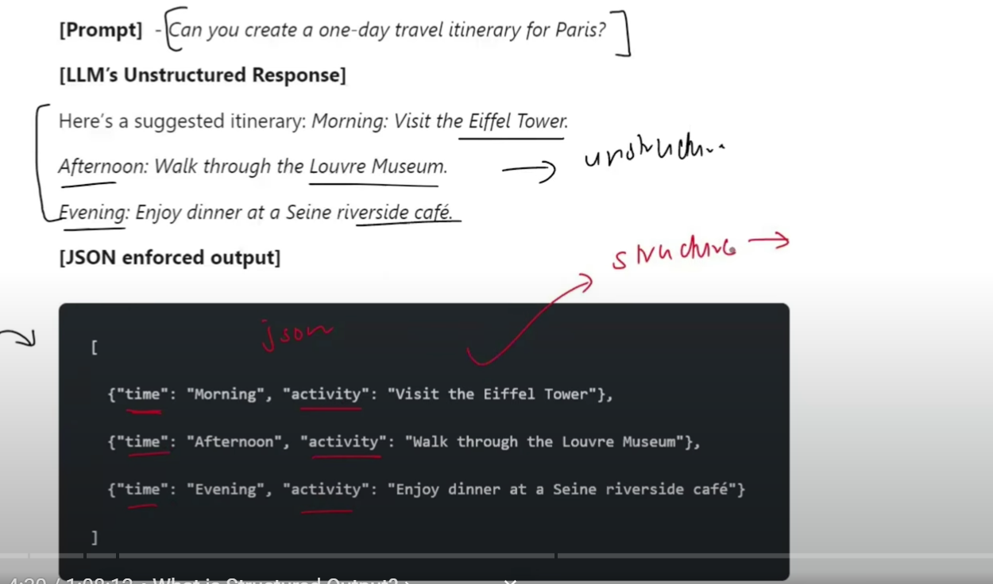
Why do we need Structured Output
- Data Extraction
- API Building
- Agent

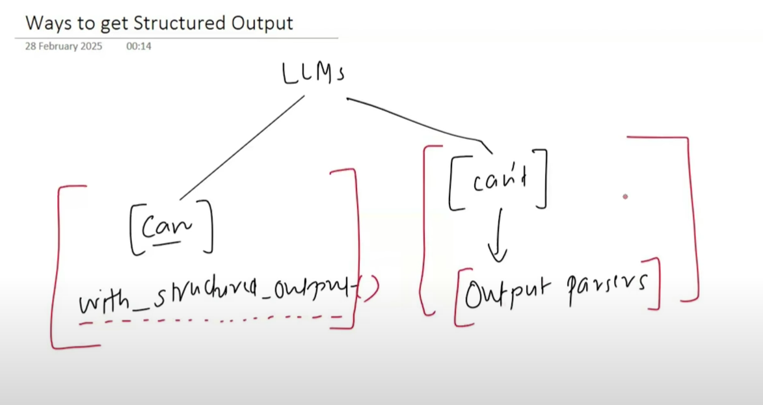
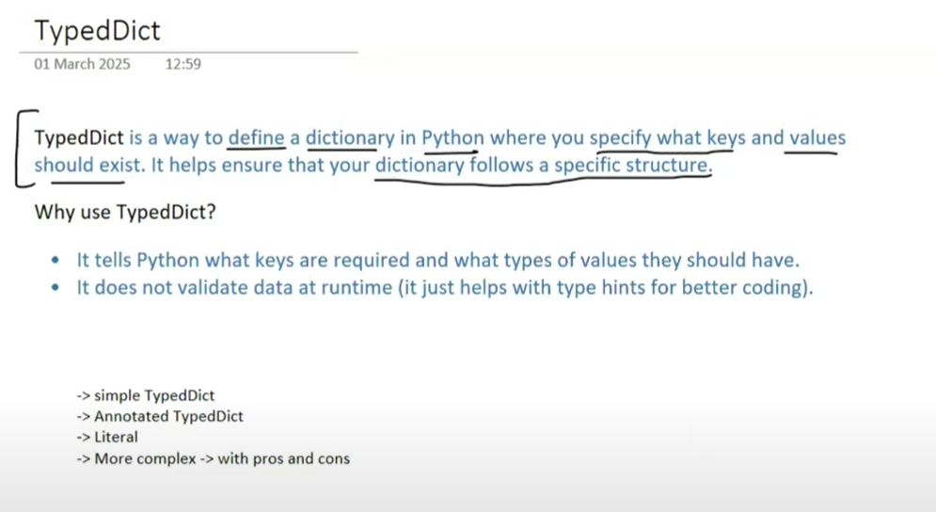

Pydantic:
Pydantic is a data validation and data parsing library for python. It ensures that the data you work with Is correct, structured, and type-safe

*** When to USE What ? (Structured Output) ***
• Use { TypedDict } if:
o You only need type hints (basic structure enforcement).
o You don’t need validation (e.g., checking if numbers are positive).
o You trust the LLM to return the correct data.

• Use { Pydantic } if:
o You need strict validation (e.g., lengths, regex, positive numbers).
o You want runtime error handling when incorrect data is returned.
o You want to define default values, aliases, field constraints, or use validators.
o You plan to re-use models across your app (e.g., for FastAPI or LangChain agents).
o You want robust debugging and error messages.

• Use JSON Schema if:
o You need to define structure in a language-agnostic way (e.g., for APIs).
o You are communicating structure across systems, possibly written in different languages.
o You want to use schema-based tools (e.g., OpenAPI, validation tools, documentation generators).
o You don’t want to rely on Python-specific libraries like Pydantic.

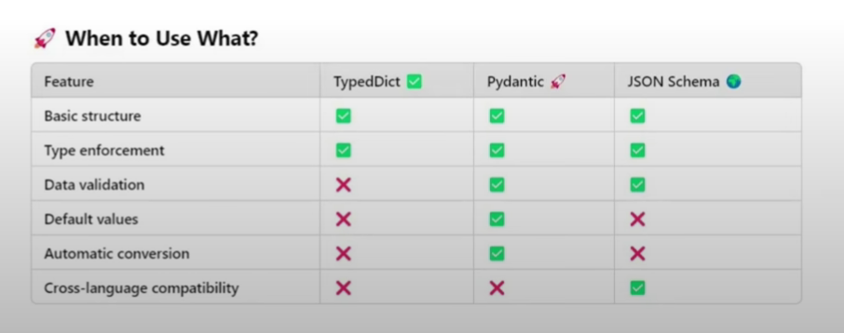

======================*****======================

*** Output Parsers ***
- Output Parser in LangChain help convert raw LLM Response into structured formats like JSON, CSV, Pydantic Model, and more. They ensure consistency, validation, and easy of use in application
  - String Output Parser
  - JSON Output Parser
  - Structured Output Parser
- StrOutputParser:
- The StrOutputParser is the simple output parser in LangChain. It is used to parser the output of a language Model (LLM) and return it is a plain string.
- JSON Output Parser:
- A JSON Output Parser is a utility used to extract structured data from the text response of an LLM (Large Language Model) by interpreting it as valid JSON.
- 🔍 Purpose
- It ensures that the model's response is machine-readable and follows a defined JSON schema or structure — such as a dict, TypedDict, or Pydantic model.
- 🧠 Why Use It?
- LLMs usually return plain text, which may be:
    - Ambiguous
    - Not strictly structured
    - Inconsistent in format
  - The JSON Output Parser helps:
- Convert model output into a structured Python dictionary
- Validate or enforce a predefined schema
- Use the result programmatically (e.g., for automation, decision making)
- StructuredOutputParser:
- StructuredOutputParser is an output parser in LangChain that helps extract structured JSON data from LLM response based on predefined field schemas.
- It works by defining a list of fields (Response Schema) that the model should returen, ensuring the output follows a structured format.

- PydanticOutputParser:
- What is PydanticOutputParser In LangChain ?
- PydanticOutputParser is a structure output parser in Langchain that used Pydantic Module to schema valiadation when pricessing LLM response.

- Why used PydanticOutputParser ?
- Strict Schema Enforcement
- Type Safety
- Easy Validation
- Seamless Integration

*** Chains In LangChain ***
- A Chain is a way to connect multiple steps together, where the output of one step becomes the input for the next step.
- 📦 Types of Chains in LangChain:
- Simple Chain (LLMChain)
- One prompt → One LLM → One output
- 🧠 Example: Ask the model a question and get an answer.
- Sequential Chain
- Multiple steps run one after another.
- 🧠 Example:
- Step 1: Summarize text
- Step 2: Analyze sentiment
- Step 3: Translate result
- Parallel Chain: (imp)
  - Parallel chains allow multiple tasks to run concurrently, reducing overall execution time and improving resource utilization. This is especially beneficial when dealing with tasks that can operate independently, such as extracting different components from a dataset.
- Conditional Chain: (imp)
  - In LangChain, a RunnableBranch acts like an if-else logic block in your chain pipeline.
  - It lets you dynamically route execution based on intermediate outputs, making it a powerful tool for:
    - Response personalization
    - Workflow switching
    - Decision trees within agents or apps
- Router Chain
- Routes input to different chains based on conditions.
- 🧠 Example:
- If input is a math problem → Use math chain
- If input is a joke → Use joke chain
- Transform Chain
- Applies a custom function to data in between steps.
- 🧠 Example: Clean text or convert format before passing to LLM.
- API Chain
- Combines LLM with external API calls.
- 🧠 Example: Get weather info from an API, then explain it using LLM.

***Pre-Define Chains In LangChain ***
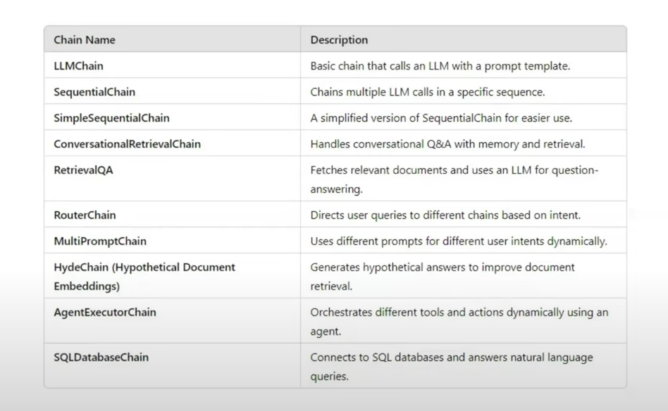

*** Retrieval-Augmented Generation (RAG) ***
- RAG is a techniques that combines information retrieval with language generation, where a modal as context retrieves relevant documents from a knowledge base and then uses then as context to generate accurate and ground responses.
- Benefits of using RAG:
  - Use of up-to-date information
  - Batter privacy
  - No limits of document size
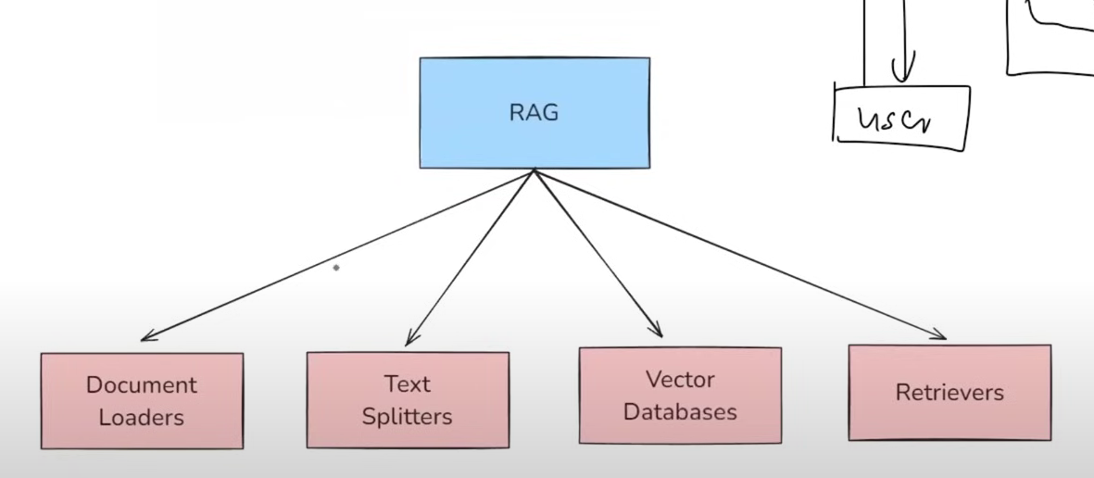

- Document Loaders:
- Document loaders load data into LangChain's expected format for use-cases such as retrieval-augmented generation (RAG).
- LangChain.js categorizes document loaders in two different ways:
- File loaders, which load data into LangChain formats from your local filesystem.
- Web loaders, which load data from remote sources.
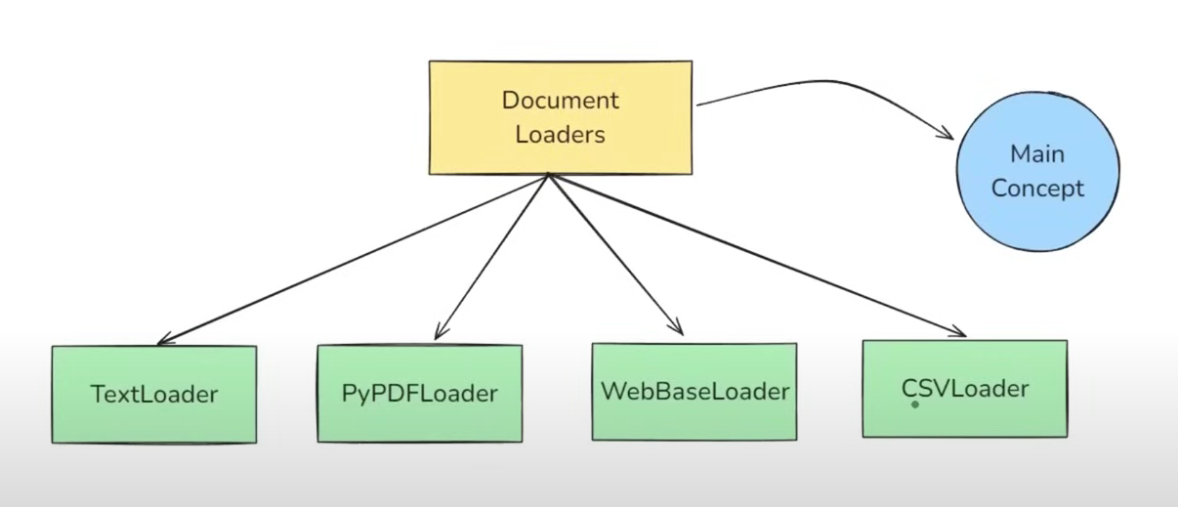
  - TextLoader:
- Textloader is a simple and commonly used document loader in langChain that reads plain text (.txt) files and convert them into LangChian Document
- Use Case:
  - Idel for loading chat logs, scraped text, transcrits, code snippeds, or any plain text data into a LangChain pipline.
- Limitation:
  - Works only with .txt files

  - PyPDFLoader:
- PyPDFLoader is a document loader in langchain used to load content form PDF files and convert each page into a Document object.
- Limtations
- It uses the PyPDF library under the hood – not greate with scanned PDF’s or complex layout.
- Other PDF Loader that work with other sinario
  - https://python.langchain.com/docs/concepts/document_loaders/
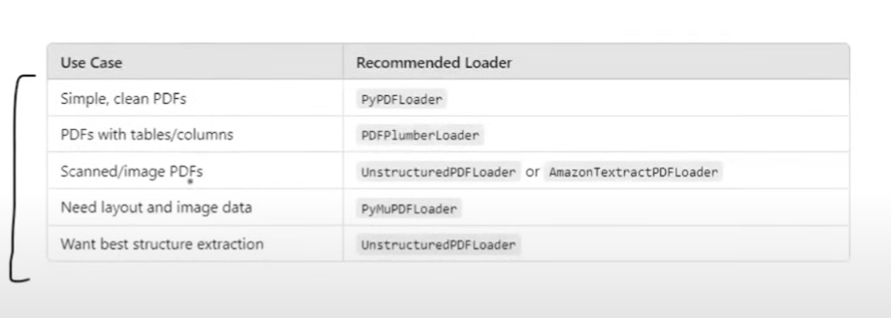

  - DirectoryLoader:
- DirectoryLoader is a document loader that lets you load multiple form a directory (folder) of files.
  - Load vs Lazy Load:
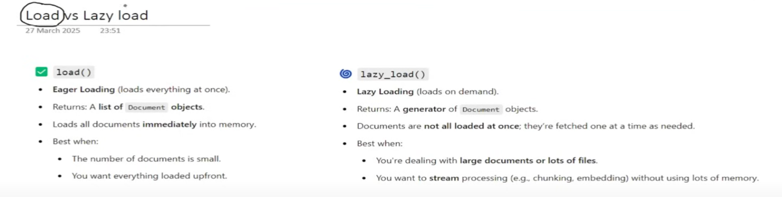
  - WebBaseLoader:
- WebBaseLoader is a document loader In LangChain used and extract text content from web pages (URLs).
- Is uses BeautifulSoup under the hood to parse HTML extract visible text.
- When to Use:
  - For Blog, news articles, or public website where the content is primearly text-based and static.
- Limitation:
  - Dosent handle javascript-heavy pages well (use SelenumURLLoader for that).
  - Loads only static content (what’s in the HTML, not what loades after the page refers.

  - CSVLoader
- CSVLoader is a document loader ised to load CSV files into CSV files into LangChain Document object – one pwe row, by default.
- Other Document Loaders:
  - https://python.langchain.com/docs/concepts/document_loaders/

*** Text Splitting ***
- Text Splitting is the process of breaking large chunks of text (like articles, PDFs, HTML pages, or books) into smaller, manageable pieces (chunk) that an LLM can handle effectively.
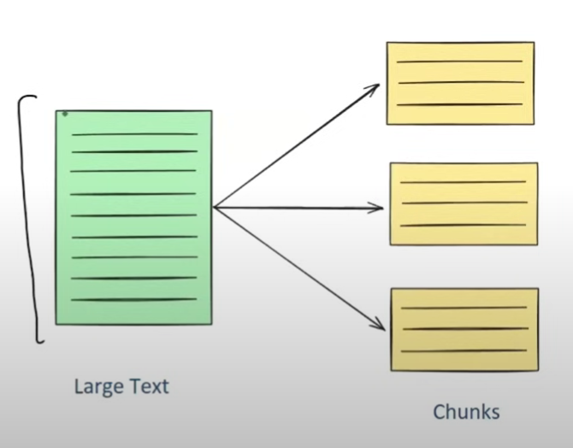
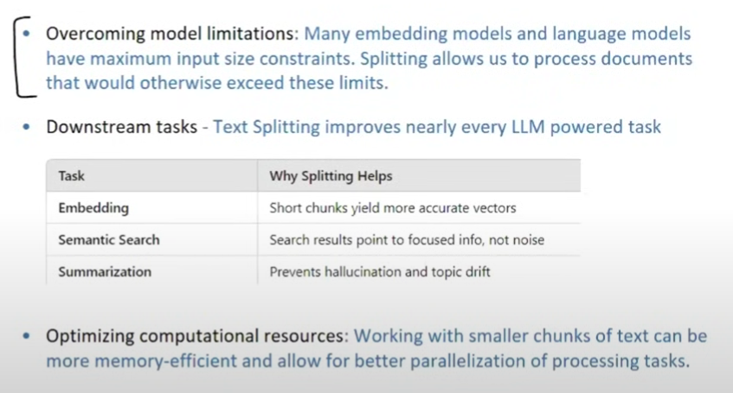
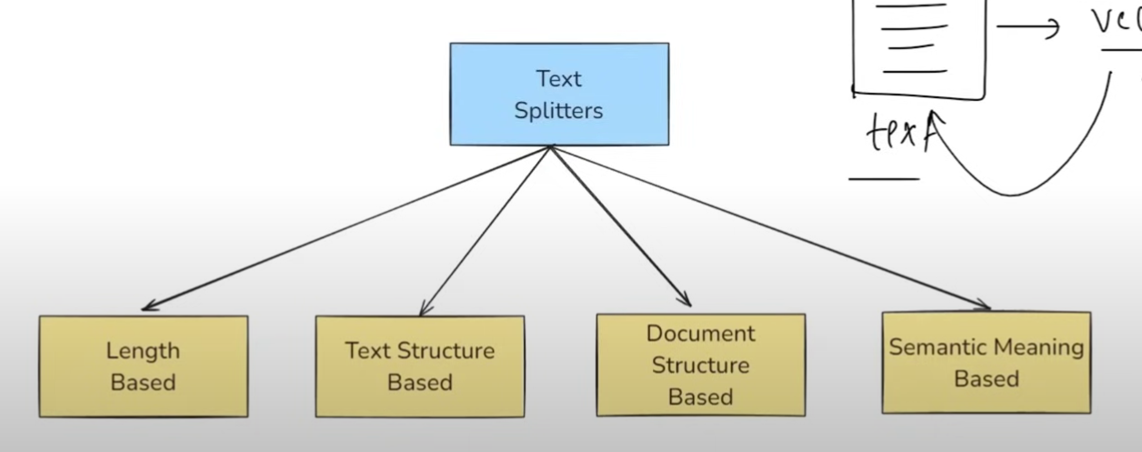
  - Type of Text Splitting:
  - Length Based Text Splitting
  - Text-Structured Based
  - Document-Structured Based
  - Semantic Meaning Based

*** What is Vector Stores ***
- A Vector store is a system designed to store and representd as numerical vectors.
- Key Features:
- Storage: Ensure that vectors and their associated metadata are retained whether in-memory for quick lookups or on-disk for durability and large-scale use.
- Similarity Search: Helps retrieve the vectors most similar to a query vector
- Indexing: Provide a data structure or method that enable fast similarity searches on high-dimensional vectors (e.g. approximate nearest neighbor lookups).
- CURD Operations: Manage the lifecycle of the data – adding new vectors, reading them, updating existing entries, removing outdated vectors.
- Used Cases:
- Semantic Search
- RAG
- Recommender Systems
- Image / Multimedia Search
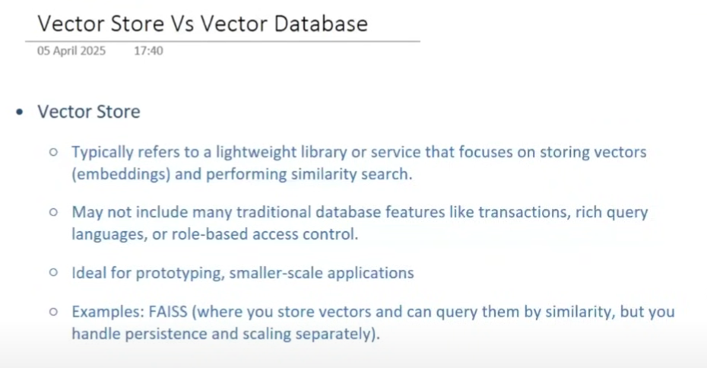

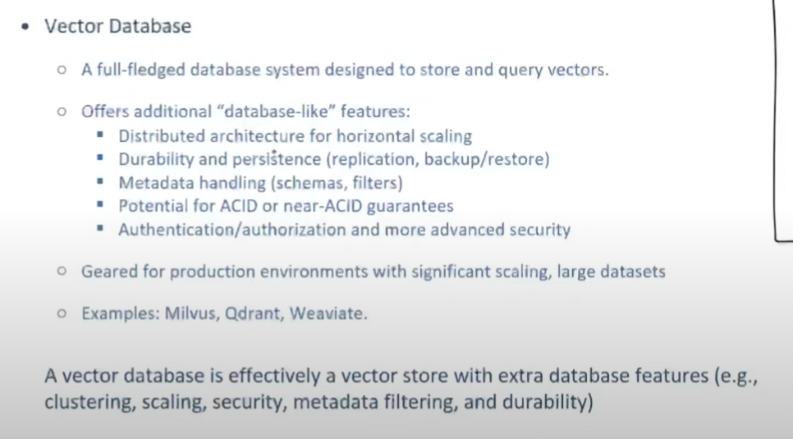
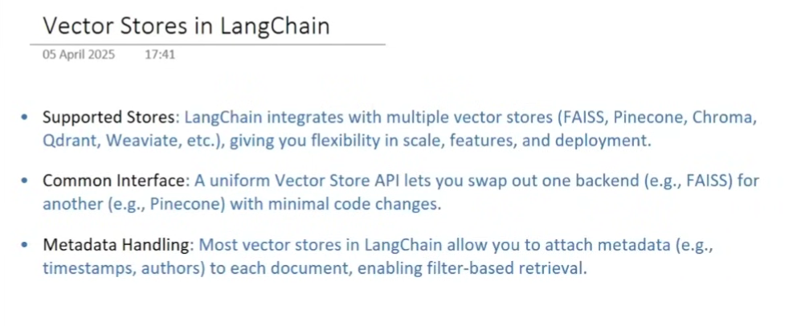

*** Chroma Vector Store ***
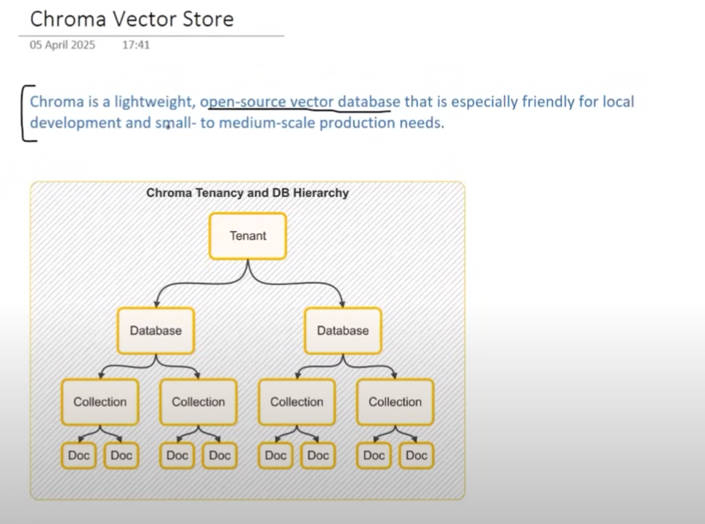

*** What are Retrievers ***
- A Retrievers In LangChain that fetches relevant documents from af data source in response to a use’s query.
- There are multiple types of retrivers
- All retrievers in LangChain are runnables
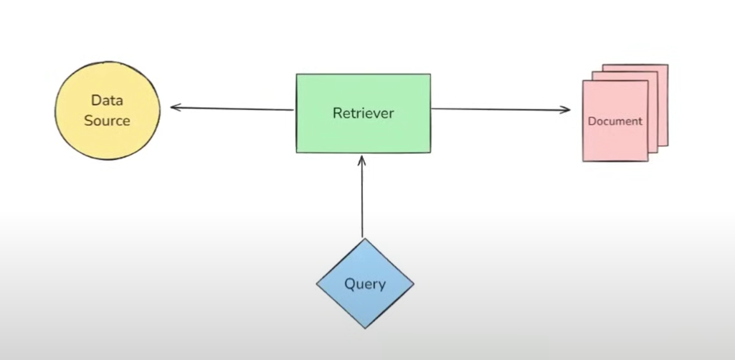

- Component of RAG Base Application:
- Documenet Loader
- Text Splitter
- Vector Databases
- Retrievers

- Documenet Loader in LangChain:
Documenet Loader are component in LangChain used to laod data from various sources into a standardized format (usually as document objects), which can then be used for chunking, embedding, retrieval and generation.
Document(
Page_content=”The Actual text Content”
Metadata={“source”: “filename.pdf”, …}
)

- TextLoader:
- TextLoader is simple and commony used document loader in LangChain that reads plain text (.txt) files and converts them into LangChain Document objects.
- Use Case:
  - Ideal for loading chat logs, scraped text, transcripts, code snippets, or any plain text data into a LangChain pipeline.
- Limitation:
  - Work Only with .txt files

- LangChain Project List:
- Project Main: https://mail.google.com/mail/u/0/?tab=rm&ogbl#inbox/FMfcgzQbfVGwJpQgrwWksHjjPgdGTQSM
- GitHub: https://github.com/bhancockio?tab=repositories
- Installetion Envoirment (venv): https://python-poetry.org/docs/#installation

- MCP + Agent Development Kit Crash Course​
  - https://github.com/bhancockio/adk-mcp-tutorial
- ​Build your first Voice Assistant ADK​
  - https://github.com/bhancockio/adk-voice-agent
- ​Build your first RAG ADK Agent​
  - https://github.com/bhancockio/adk-rag-agent
- ​Clone YouTube Thumbnails With ADK gpt-image-1​
  - https://github.com/bhancockio/adk-youtube-thumbnail-agent
- ​Agent Development Kit (ADK) Crash Course​
- ​Lovable Custom GPT​
- ​Deploy ADK Agents to Agent Engine​
- ​o3-mini vs deepseek-r1 vs gemini Agent Test​
- ​DeepSeek vs o3-mini - Developer Test​
- ​Scrape Website with DeepSeek & Crawl4AI​
- ​CrewAI Chat - Newsletter Crew​
- ​CrewAI Noob vs Pro - Tools​
- ​CrewAI Noob vs Pro - God Task​
- ​Sora Masterclass​
- ​AI Email Autoresponder​
- Fullstack AI Video Idea Generator w/ CrewAI Enterprise (NextJS Repo + CrewAI Repo)
- ​CrewAI Flows Feedback Loop​
- ​CrewAI Flows Crash Course​
- ​Supabase Vector Store Crash Course​
- ​v0, Cursor, Claude - Ultimate AI Coding Stack​
- ​Claude 3.5 Crash Course Templates​
- ​CrewAI + RAG Deep Dive​
- ​LangChain Master Class​
- ​ChatGPT4o Experiment​
- ​LangGraph + CrewAI Tutorial​
- ​Llama 3 + CrewAI Tutorial​
- ​Groq + CrewAI Tutorial​
- ​NextJS + CrewAI Full Stack Tutorial​
- ​Automate YouTube with CrewAI​
- ​CrewAI with Ollama​
- ​CrewAI Updated Features (Hierarchical, etc)​
- ​CrewAI Crash Course​
- ​Securely Store Client OpenAI API Keys​
- ​David Goggins AI Fitness Coach​
- ​5 Must Have GPTs for Developers​
- ​OpenAI Assistant API Crash Course​
- ​Tinder Profile Roaster​
- ​ChatGPT Vision Tutorial​
- ​Full Stack AI Lead Magnets SaaS Tutorial​
- ​Chat with Alex Hormozi​
- ​How to Chat With YouTubers​
- ​How to Build a ChatGPT Chrome Extension​
- ​Did ChatGPT Just Replace Developers?​
- ​ChatGPT API Javascript Tutorial For Beginners​
- ​How To Build A Landing Page With AI In 20 Minutes

- What is a parser in LangChain?
- In LangChain, a parser is a component that processes or formats the raw output from the LLM (Language Model) into a more usable or structured form.
- Think of it like a translator that converts the sometimes messy or over-detailed response from an LLM into exactly what you need (clean string, dictionary, JSON, list, etc.).

- WorkFlow of LangChain
- LCEL
- Prompt Template
- Message
- OutPut Parser
- Third Party Intigration
  - OpenAPI
  - GemmiAI
  - AntroPic
  - HuggingFaces
  - Ollama
  - Azur
  - Etc….

- Embedding’s
- Doc Loader | Data Onnehor
- Multimodility
- Runnables Interface
- Callback

