

INDIAN FORCE SECURITY SERVICES

Gate Management System software

Indian Force Security Services is a technology-driven organization dedicated to delivering innovative solutions in security and access control. We design products that make residential, commercial, and industrial spaces safer and more efficient. Our flagship Gate Management System ensures seamless visitor authentication, real-time monitoring, and intelligent reporting.

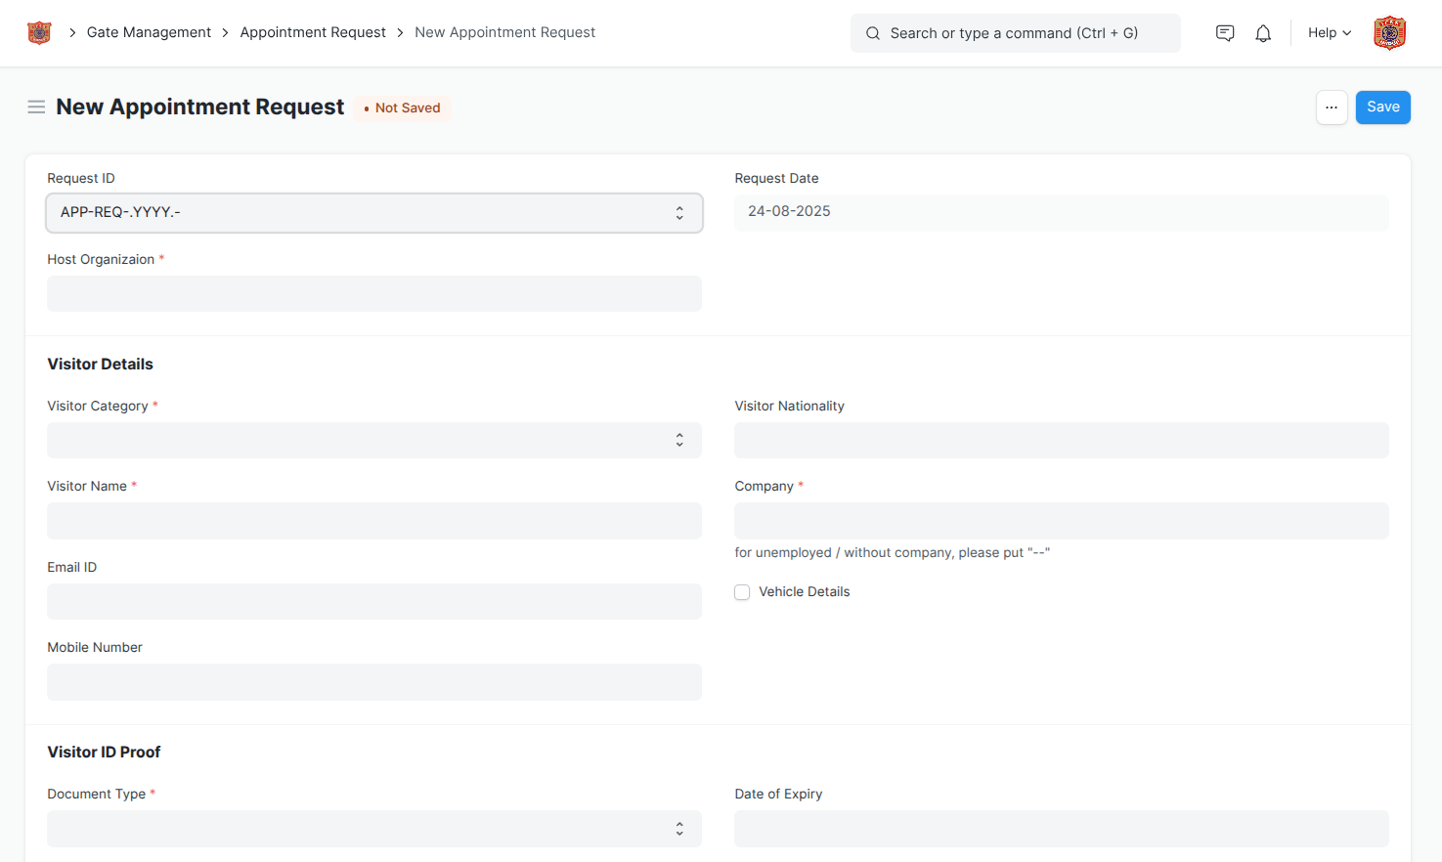
1.0. Appointment Request:
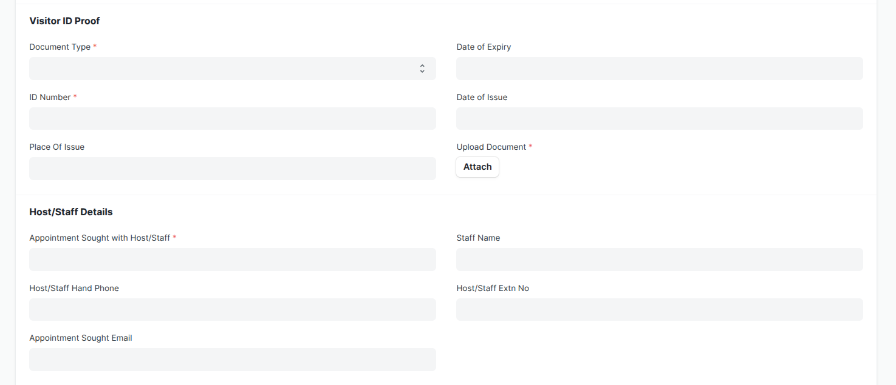

- Visitor Details Entry
– Security guard/reception can record visitor’s full name, contact number, company/organization, and purpose of visit.
- Visitor ID Proof Collection
– Capture ID proof details such as Aadhaar, PAN, Passport, Driving License, or any valid government-issued ID.
- Host/Staff Selection
– Choose the host/staff member whom the visitor wishes to meet (with department details, if required).
- Appointment Date & Time
– Schedule the exact date and time of the meeting request to avoid overlaps or unauthorized entry.
- Visitor Photograph
– Capture or upload visitor photo instantly for better identification and record-keeping.
- Visitor Signature
– Collect visitor’s digital signature at the gate or reception as part of entry verification.
- Approval Request Notification
– Automatically send appointment requests to the host/staff for approval or rejection via system notification/SMS/email.
- Badge/Pass Generation
– Once approved, system generates a digital/printable visitor pass with QR/barcode for seamless entry.
- Special Instructions/Notes
– Option to add notes like “Requires escort”, “Car parking needed”, or “High-priority guest.”
- Secure Record Management
– All appointment requests (approved/denied) are stored in the system for future reference, reporting, and audits.

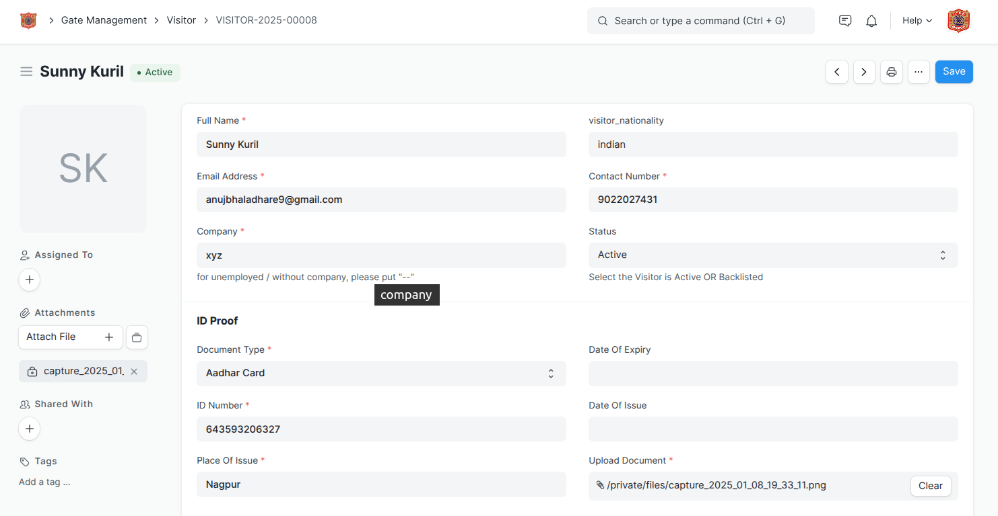
2.0. Visitor Profile:

- Visitor Profile Creation
– Save complete visitor details including full name, contact number, and purpose of visit.
- Photo Capture & Storage
– Capture and store visitor’s photograph for accurate identification and future reference.
- ID Proof Management
– Record and maintain ID proof details (Aadhaar, Passport, Driving License, etc.) for each visitor.
- Separate Visitor Records
– Maintain individual records for every visitor, avoiding duplication and ensuring easy search.
- Quick Access & History Tracking
– Easily retrieve visitor details and view their past visit history for security and audit purposes.

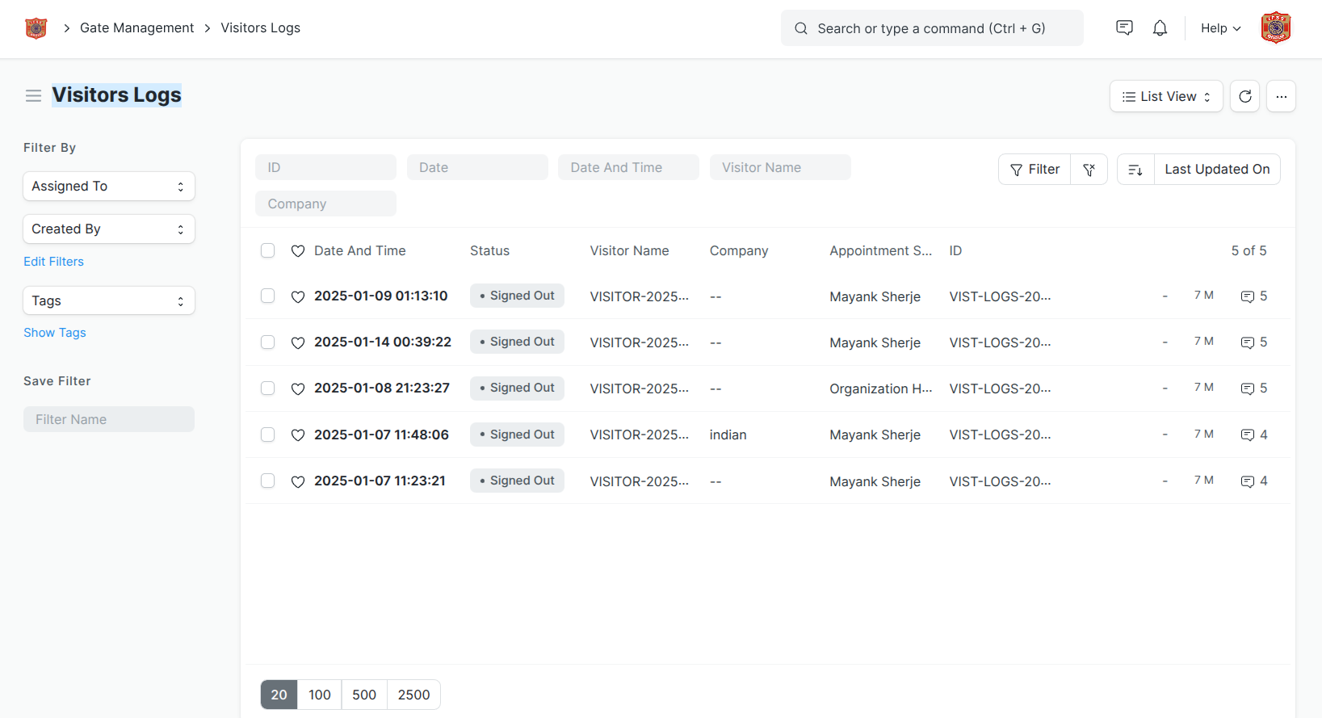
3.0. Visitors Logs:

- Comprehensive Entry & Exit Records
– Automatically logs visitor check-in and check-out time with exact date and duration of stay.
- Host/Staff Meeting Details
– Maintains record of which host/staff the visitor met, along with department information.
- Visitor Pass Tracking
– Links each log entry with the visitor pass/QR code for seamless monitoring.
- Search & Filter Options
– Quickly find past visitor logs by name, ID proof, date, or host for easy reference.
- Export & Reporting
– Generate daily, weekly, or monthly visitor log reports for security audits and management review.

4.0. Appointment Accept Reject:
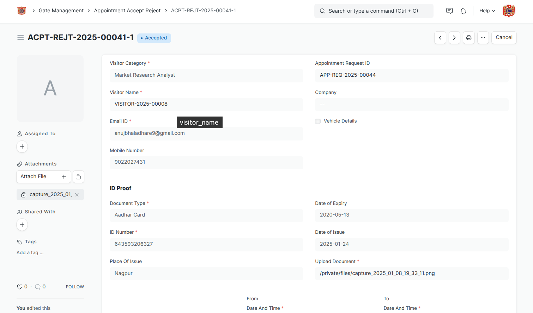

- Instant Notification to Host
– Hosts receive real-time alerts (system/SMS/email) when a new appointment request is created.
- One-Click Approval or Rejection
– Host/Staff can easily accept or reject requests with a single click.
- Reason/Remarks Option
– While rejecting, host can add remarks (e.g., not available, reschedule required).
- Automatic Visitor Update
– Visitor (or guard) gets immediate confirmation of approval/rejection.
- Auto Pass Generation on Approval
– If approved, a visitor pass/QR code is automatically generated for smooth entry.
- Reschedule Option (optional)
– Host can propose a new time/date instead of outright rejection.
- Secure Log Maintenance
– All accept/reject decisions are stored in the system for audit and reference.

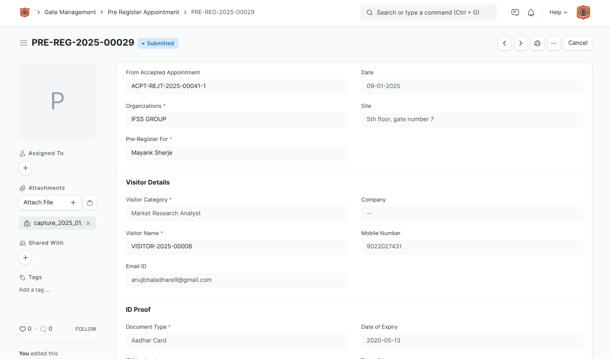
5.0: Pre-Registered Appointment:

- Advance Appointment Scheduling
– Hosts or admins can pre-register visitor details before the actual visit.
- Visitor Information Entry
– Record visitor’s name, contact, company, ID proof, and purpose of visit in advance.
- Pre-Approval by Host
– Host approves the appointment beforehand to speed up check-in at the gate.
- Pre-Generated Visitor Pass
– System creates a digital/print pass or QR code that can be shared with the visitor.
- Quick Check-In at Gate
– Visitor only needs to show the pre-approved pass/QR for instant entry, reducing wait time.
- Reduced Manual Data Entry
– Guards don’t need to re-enter visitor details; all data is already available in the system.
- Enhanced Security & Accuracy
– Ensures only pre-approved visitors can access the premises, minimizing unauthorized entry.
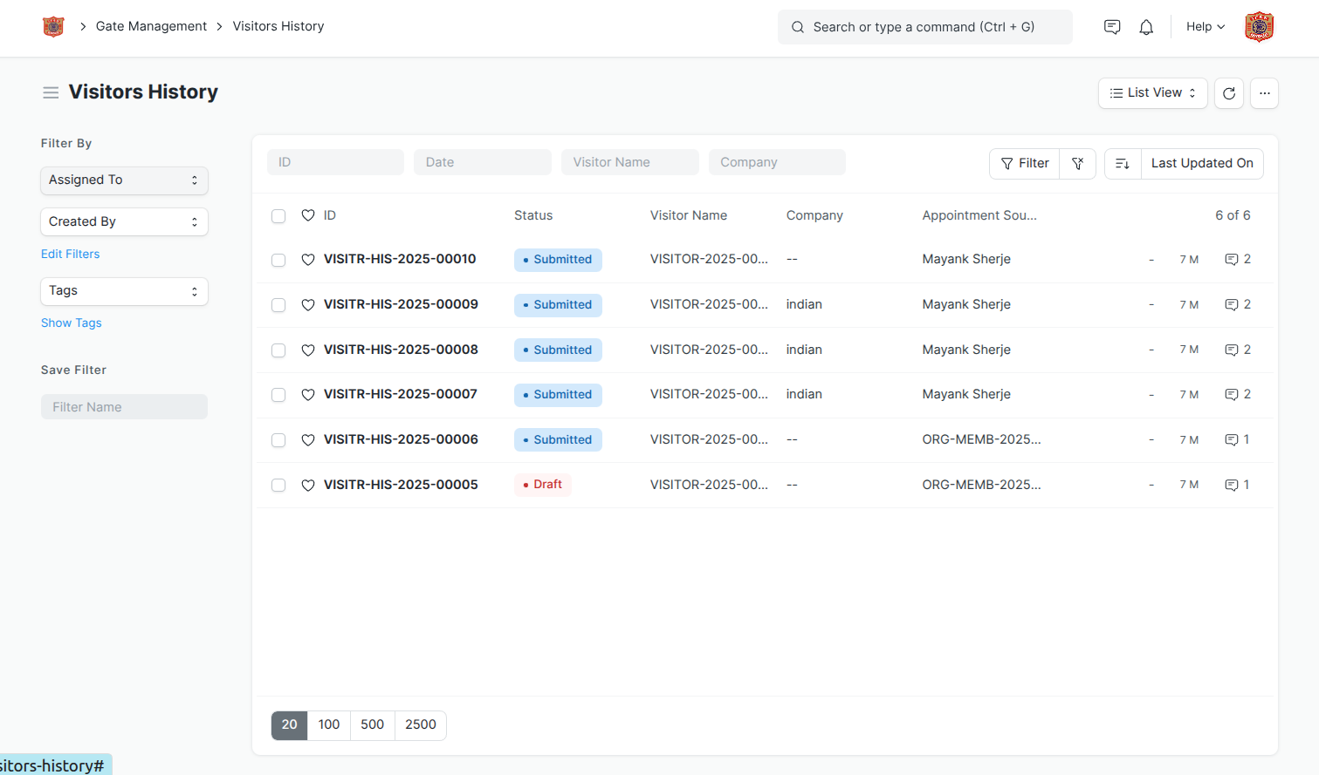
5.0: Visitors History:

- Complete Visit Records
– Stores detailed logs of all past visits including visitor name, ID, photo, host, and purpose.
- Check-In / Check-Out Tracking
– Maintains accurate entry and exit time for each visit.
- Quick Search & Filters
– Easily find visitor history by name, date, ID proof, or host.
- Repeat Visitor Identification
– Instantly recognize returning visitors with previous records and visit patterns.
- Security & Audit Reports
– Generate visitor history reports for compliance, audits, and incident tracking.
- Data Retention & Backup
– Ensures secure storage and backup of visitor records for long-term use.
- Export & Sharing (optional)
– Export visitor history into Excel/PDF for management review or security teams.

6.0: Re Schedule Appointment:
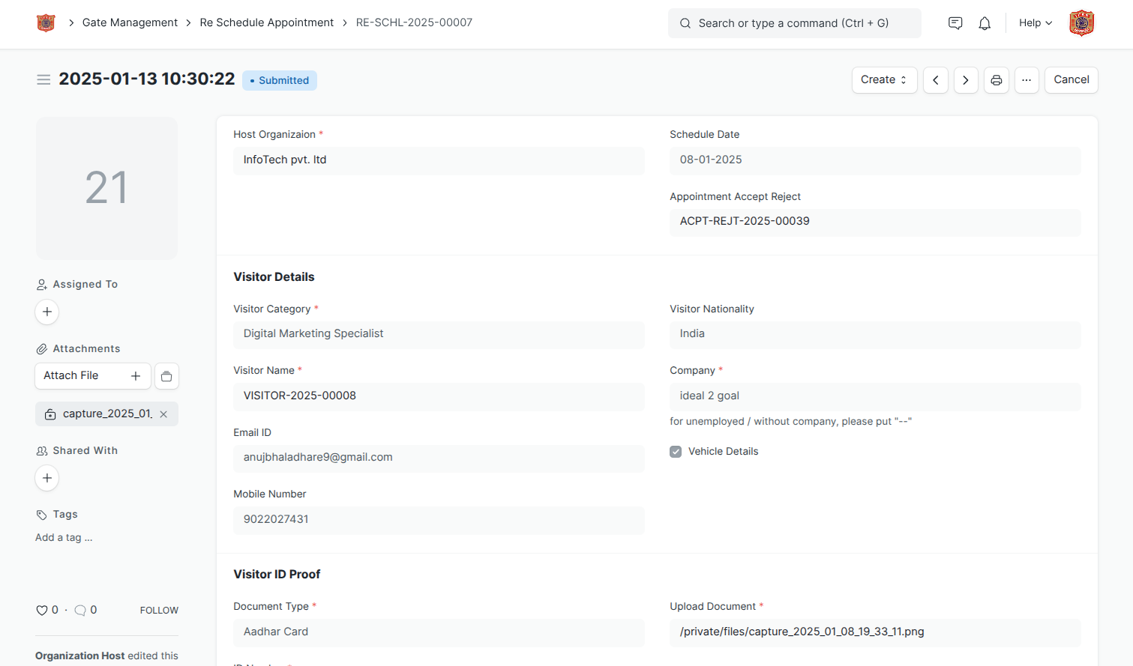

- Easy Date & Time Change
– Hosts can quickly modify the appointment schedule without creating a new request.
- Visitor Notification
– Automatic alerts (SMS/email/system) sent to visitors regarding the updated date and time.
- Approval Workflow
– The re-scheduled appointment is updated in the system and requires host confirmation if needed.
- Automatic Pass Update
– Visitor pass/QR code gets regenerated with the new date and time to avoid confusion at entry.
- Conflict-Free Scheduling
– System checks host availability to prevent overlapping appointments.
- Complete Log Maintenance
– All reschedules are recorded in the visitor’s history for security and audit purposes.
- Convenience for Both Parties
– Saves time for host and visitor by eliminating the need to cancel and re-create appointments.

