ARMY INSTITUTE OF TECHNOLOGY, PUNE
(Affiliated to Savitribai Phule Pune University)
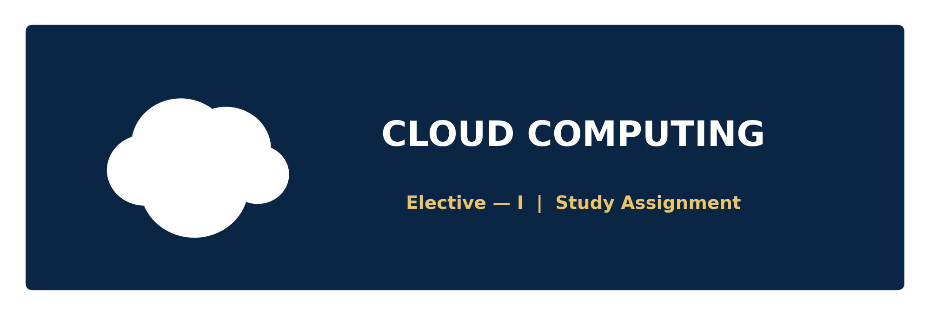
STUDY ASSIGNMENT
Fundamental Concepts, Architecture & Deployment Models of Cloud Computing
Subject: Elective – I (Cloud Computing)
Submitted By | Anuj Kumar Tomar
Roll Number | 3308
Class | Second Year, Computer Engineering
Subject | Elective – I : Cloud Computing
Submitted To | Prof. Sharayu Lokhande
Institute | Army Institute of Technology, Pune
University | Savitribai Phule Pune University

INDEX
Sr. No. | Topic | Page No.
1 | Introduction to Cloud Computing | 1
2 | Essential Characteristics of Cloud Computing | 2
3 | Cloud Computing Architecture | 3
4 | Components of Cloud Architecture (Detailed) | 4
5 | Cloud Service Models (IaaS, PaaS, SaaS) | 5
6 | Cloud Deployment Models | 6
7 | How a Cloud Request Works — Flowchart | 7
8 | Advantages & Disadvantages of Cloud Computing | 8
9 | Real-World Applications & Examples | 9
10 | Conclusion | 9
11 | References | 10

1. Introduction to Cloud Computing
Cloud Computing is a technology paradigm that enables on-demand delivery of computing resources — such as servers, storage, databases, networking, software, and analytics — over the Internet, on a pay-as-you-go basis. Instead of owning and maintaining physical hardware and data centres, individuals and organizations can rent computing power and storage from a cloud service provider whenever it is needed.
Definition (NIST): According to the National Institute of Standards and Technology (NIST), “Cloud Computing is a model for enabling ubiquitous, convenient, on-demand network access to a shared pool of configurable computing resources that can be rapidly provisioned and released with minimal management effort or service provider interaction.”

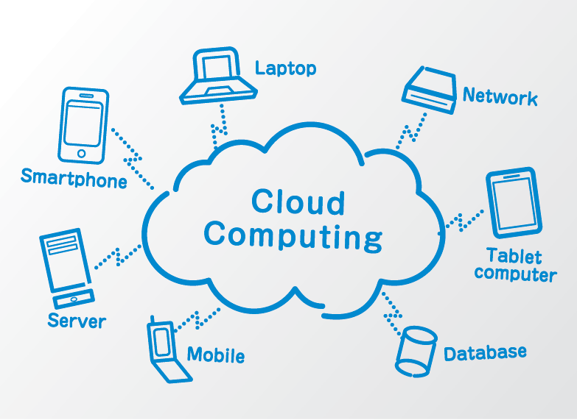

1.1 Why Cloud Computing?
- Eliminates the heavy upfront capital cost of purchasing hardware and infrastructure.
- Provides scalability — resources can be increased or decreased instantly based on demand.
- Enables global accessibility — data and applications can be accessed from anywhere with an Internet connection.
- Improves reliability through data replication and disaster recovery across multiple servers.
- Shifts IT expenditure from CapEx (Capital Expenditure) to OpEx (Operational Expenditure).

1.2 Evolution of Cloud Computing
The concept of cloud computing evolved from earlier computing models such as mainframe computing, cluster computing, grid computing, and utility computing. The idea of delivering computing as a utility (similar to electricity or water) was popularized in the early 2000s, and companies like Amazon (with AWS in 2006), Google, and Microsoft played a pivotal role in commercializing and scaling this model into what we now recognize as modern cloud computing.

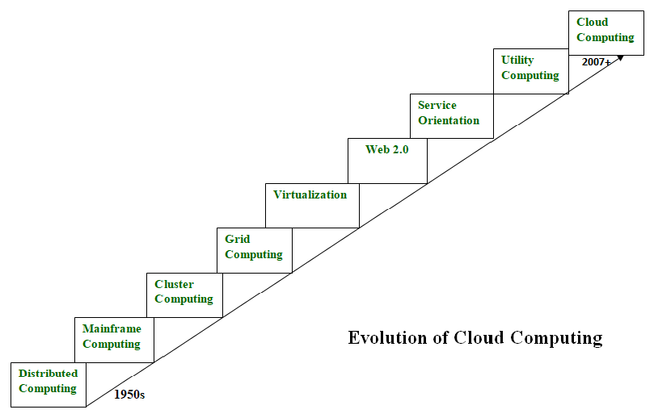

2. Essential Characteristics of Cloud Computing
As defined by NIST, cloud computing exhibits five essential characteristics that distinguish it from traditional computing models:
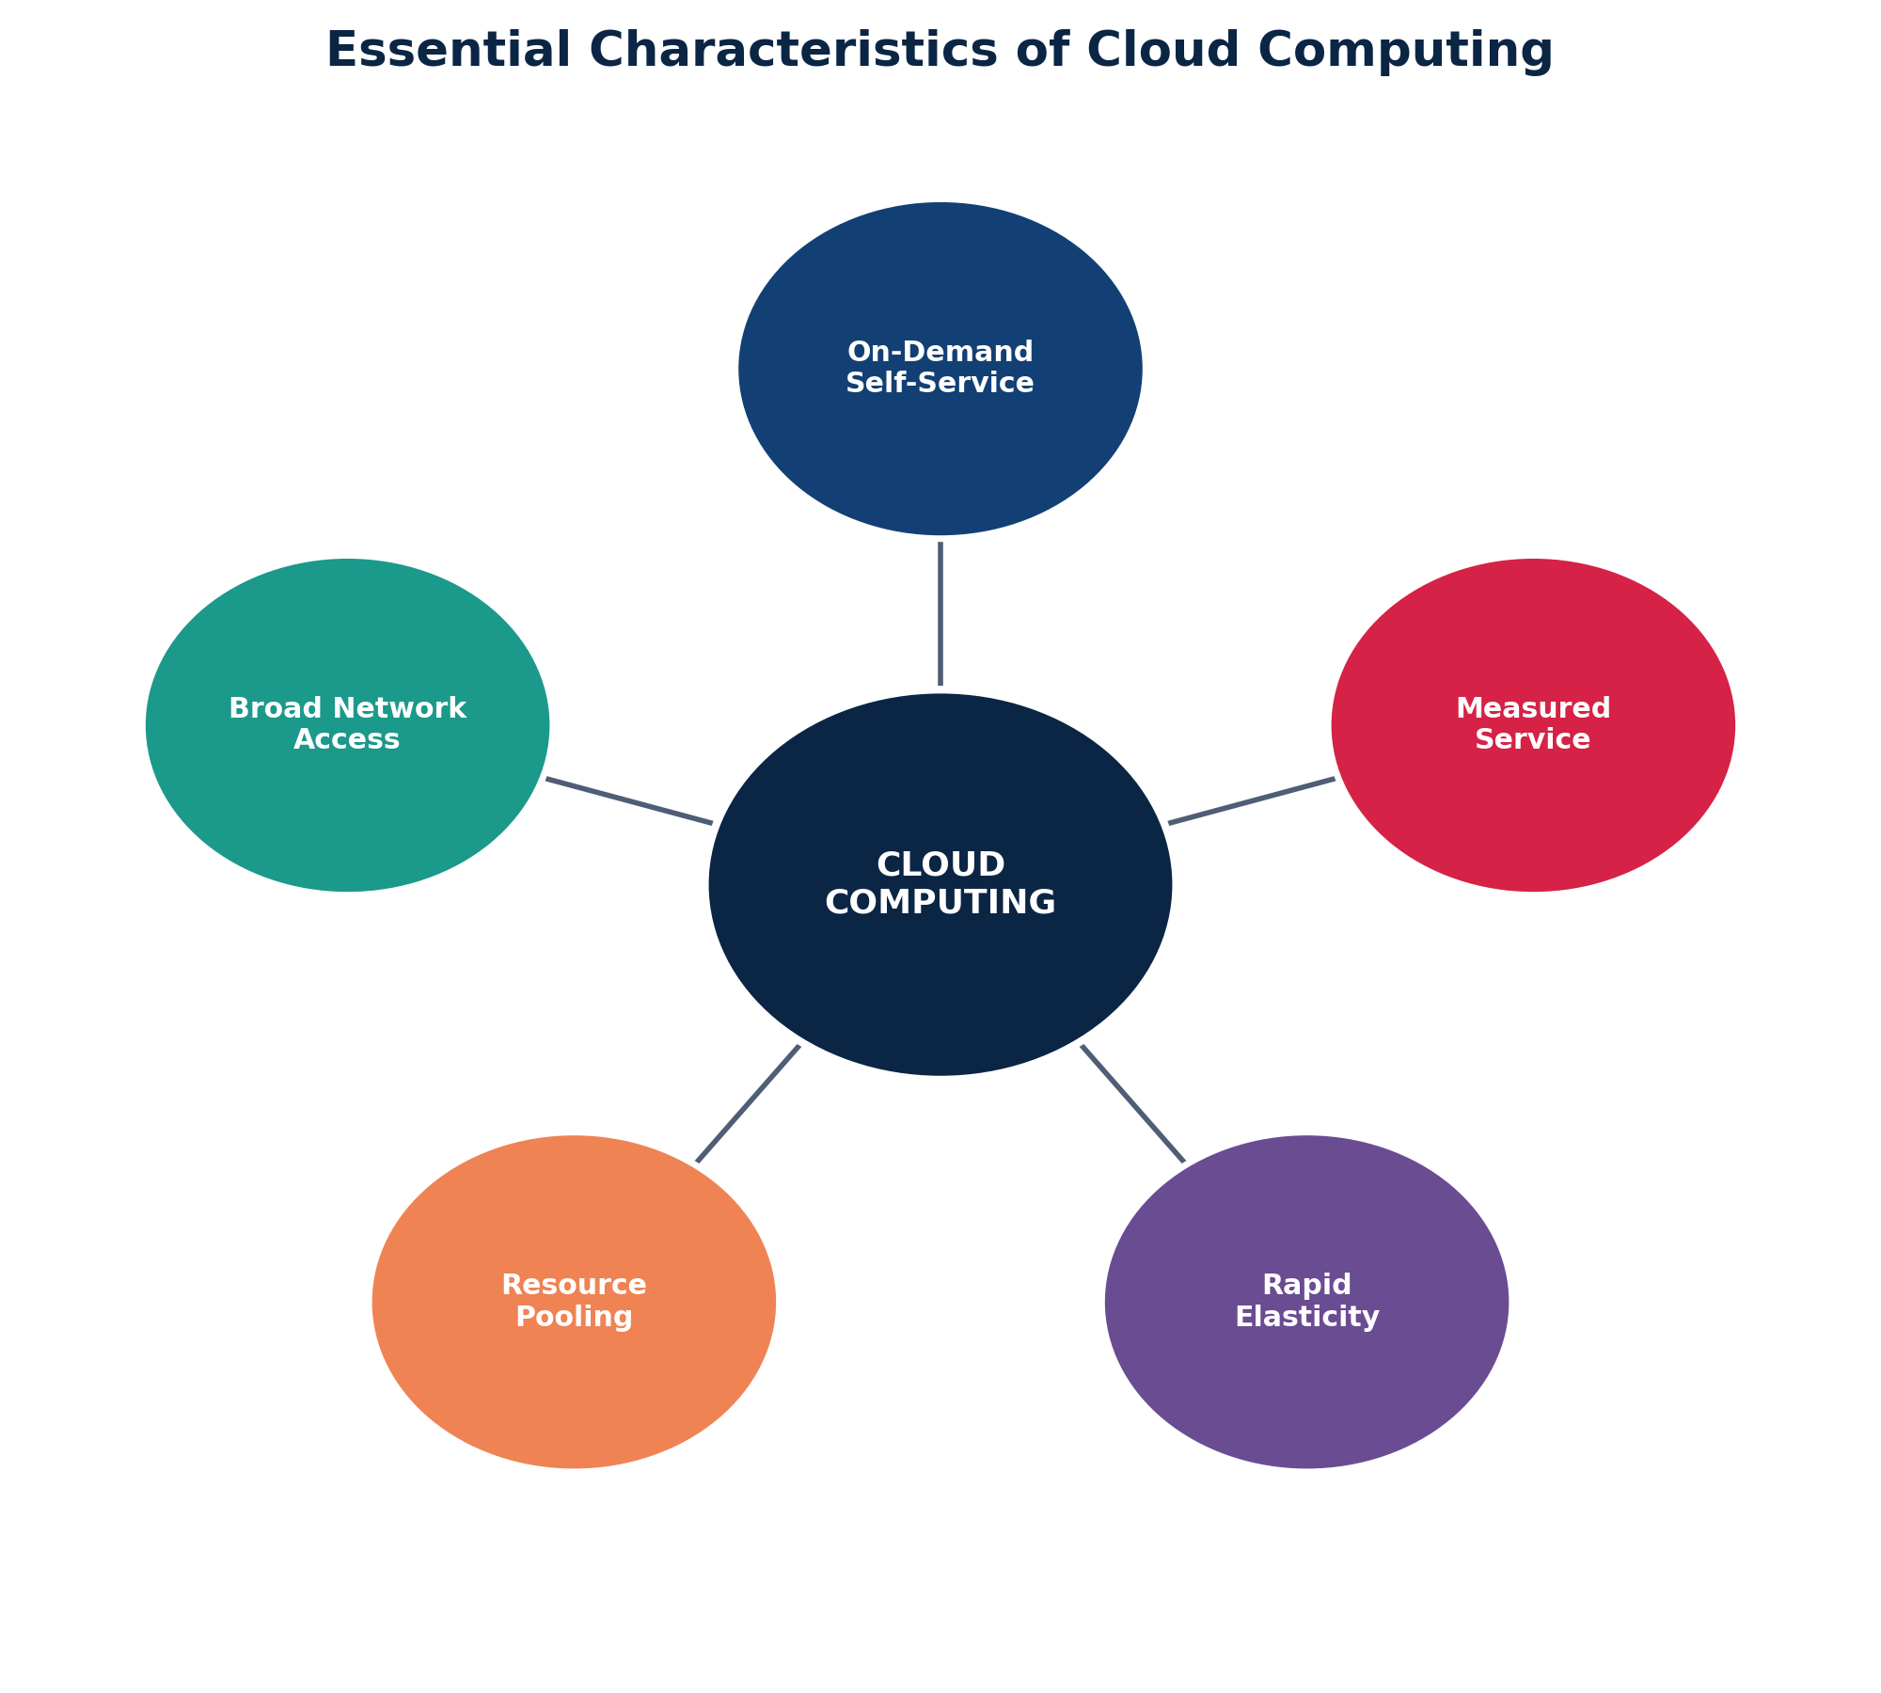
Fig. 2.1 — The Five Essential Characteristics of Cloud Computing (NIST Model)
1. On-Demand Self-Service: A consumer can unilaterally provision computing capabilities (server time, network storage) automatically, without requiring human interaction with the service provider.
2. Broad Network Access: Capabilities are available over the network and accessed through standard mechanisms via heterogeneous client platforms such as mobile phones, tablets, laptops, and workstations.
3. Resource Pooling: The provider's computing resources are pooled to serve multiple consumers using a multi-tenant model, with different physical and virtual resources dynamically assigned according to consumer demand.
4. Rapid Elasticity: Capabilities can be elastically provisioned and released, in some cases automatically, to scale rapidly outward and inward commensurate with demand.
5. Measured Service: Cloud systems automatically control and optimize resource use by leveraging a metering capability, so that usage can be monitored, controlled, and reported — providing transparency for both provider and consumer (Pay-Per-Use model).

3. Cloud Computing Architecture
Cloud Computing Architecture refers to the components and sub-components that are required for cloud computing. These components typically consist of a Front End platform (the client / device used to access the cloud), a Back End platform (servers and storage), a cloud-based delivery model, and a network (Internet, Intranet, or Intercloud) that connects them together.
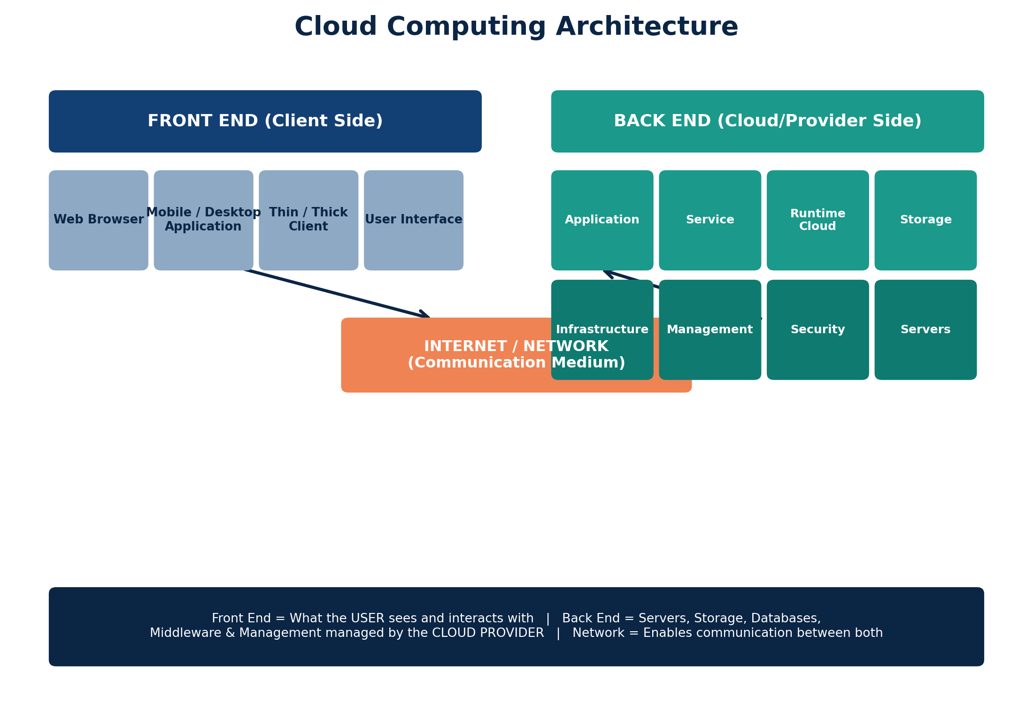
Fig. 3.1 — Cloud Computing Architecture: Front End, Network, and Back End

3.1 Front End
The Front End refers to the client side of the cloud computing system. It comprises the interfaces and applications that are required to access the cloud computing platform, e.g. Web Browsers, mobile applications, or thin/thick client software installed on the user's device.

3.2 Back End
The Back End refers to the cloud itself, consisting of all the resources required to provide cloud computing services. It comprises huge data storage, virtual machines, security mechanisms, deployment models, servers, traffic control mechanisms, and much more — all managed by the cloud service provider.

3.3 Network
The network (typically the Internet) is the medium through which the front end and back end communicate and interact with each other. It could also be an Intranet, Intercloud, or a dedicated network link provided by the CSP (Cloud Service Provider).

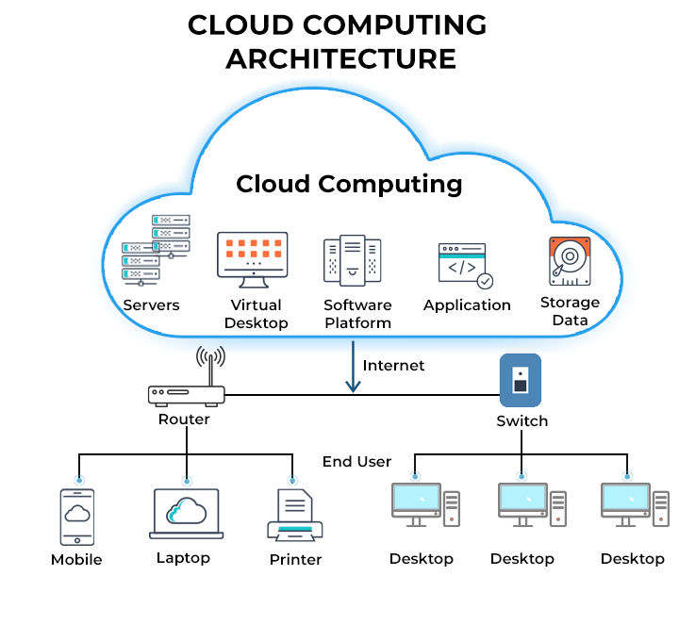

4. Components of Cloud Architecture (Detailed)
Cloud architecture can also be represented as a layered stack, where each layer builds upon the one below it, ultimately delivering software as a service to the end user.
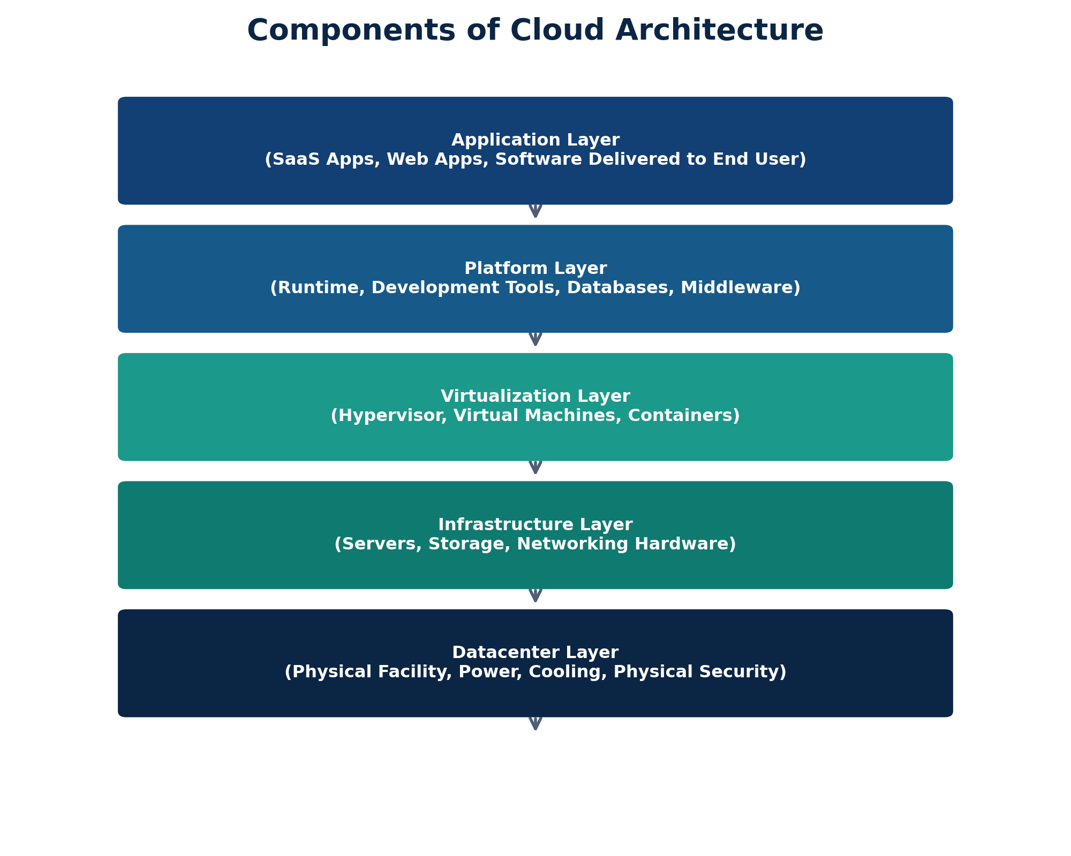
Fig. 4.1 — Layered View of Cloud Architecture Components

4.1 Detailed Description of Components
Component | Description
Client Infrastructure | The Front-End component that provides the GUI / interface for users to interact with the cloud platform (browsers, apps).
Application | Any software or platform that a client wants to access and use, which is deployed and delivered from the cloud.
Service | The three types of cloud-based services — SaaS, PaaS, IaaS — managed and delivered by the Cloud Service Provider.
Runtime Cloud | Provides the execution and runtime environment (virtual machines / containers) to the virtualized application components.
Storage | One of the most vital components — provides flexible, scalable storage capacity to store and manage vast amounts of data.
Infrastructure | Provides the hardware and software components (servers, network equipment) that support the cloud services being provided.
Management | Responsible for managing components such as application, service, runtime cloud, storage, infrastructure, and other security matters in the backend, along with coordination among them.
Security | An in-built mechanism in the back end that implements a security protocol maintaining confidentiality, integrity, and availability of data (CIA Triad).
Internet | The medium via which the front end and back end interact and communicate with each other.

5. Cloud Service Models
Cloud Computing is broadly delivered through three fundamental service models, each offering different levels of control, flexibility, and management responsibility to the user.
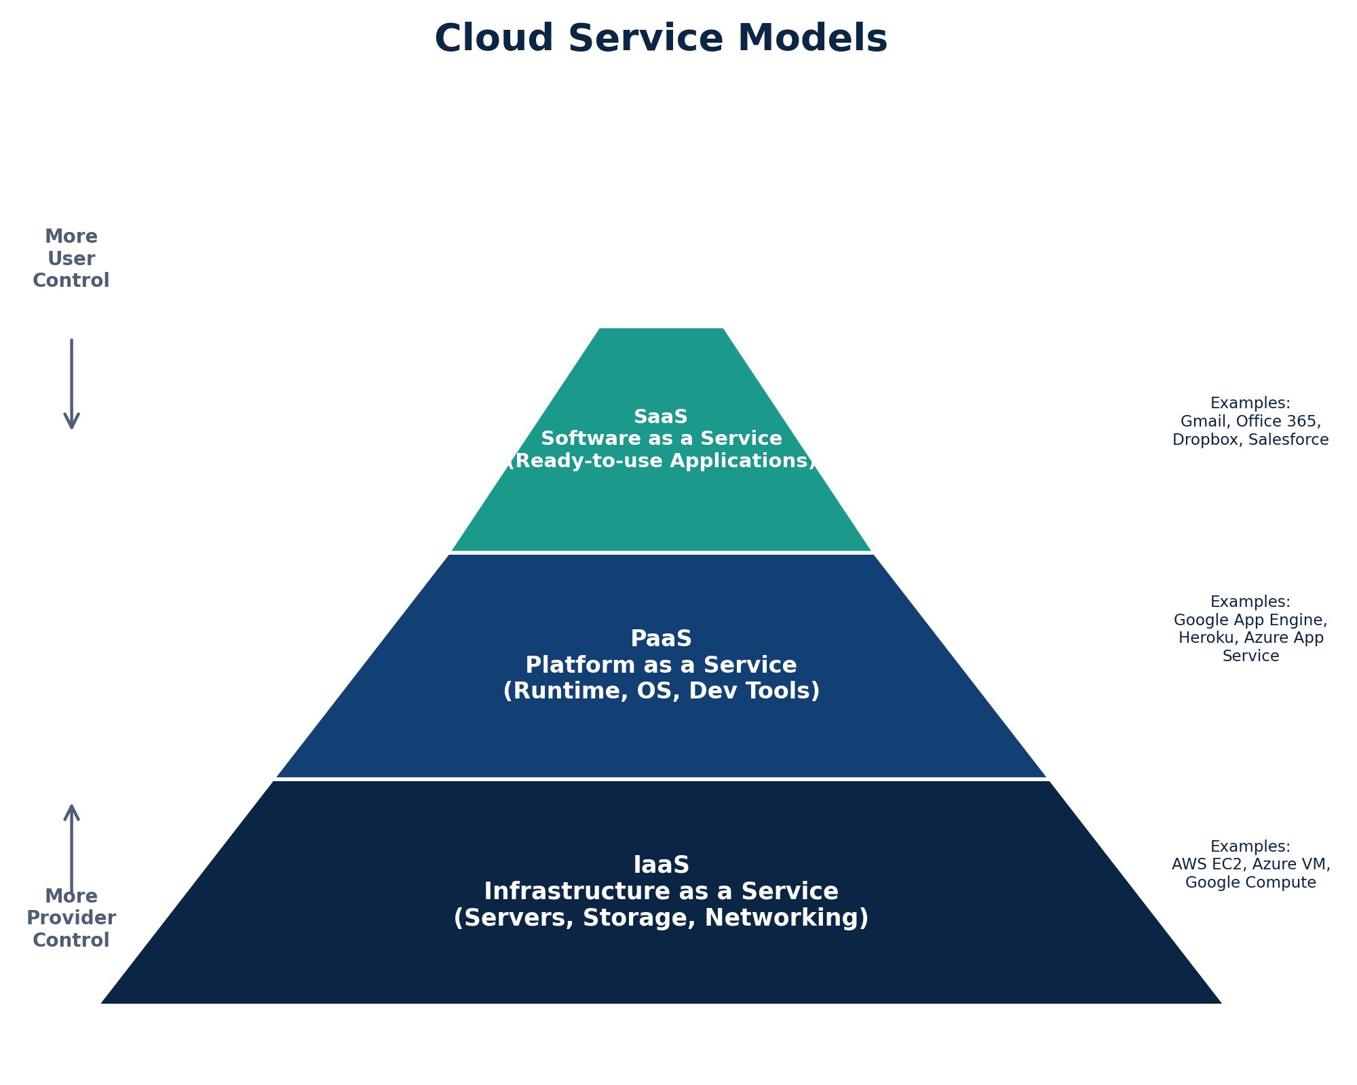
Fig. 5.1 — Cloud Service Models: IaaS, PaaS, and SaaS

Model | What Is Managed by Provider | What Is Managed by User | Examples
IaaS (Infrastructure as a Service) | Servers, Storage, Networking, Virtualization | OS, Middleware, Runtime, Data, Applications | Amazon EC2, Microsoft Azure VM, Google Compute Engine
PaaS (Platform as a Service) | Servers, Storage, Networking, Virtualization, OS, Middleware, Runtime | Applications and Data only | Google App Engine, Microsoft Azure App Service, Heroku
SaaS (Software as a Service) | Everything — Complete Application Stack | Only User Data / Configuration | Gmail, Microsoft Office 365, Dropbox, Salesforce

6. Cloud Deployment Models
A Cloud Deployment Model defines where the infrastructure resides, who owns and manages it, and who has access to it. NIST classifies cloud deployment into four primary models:
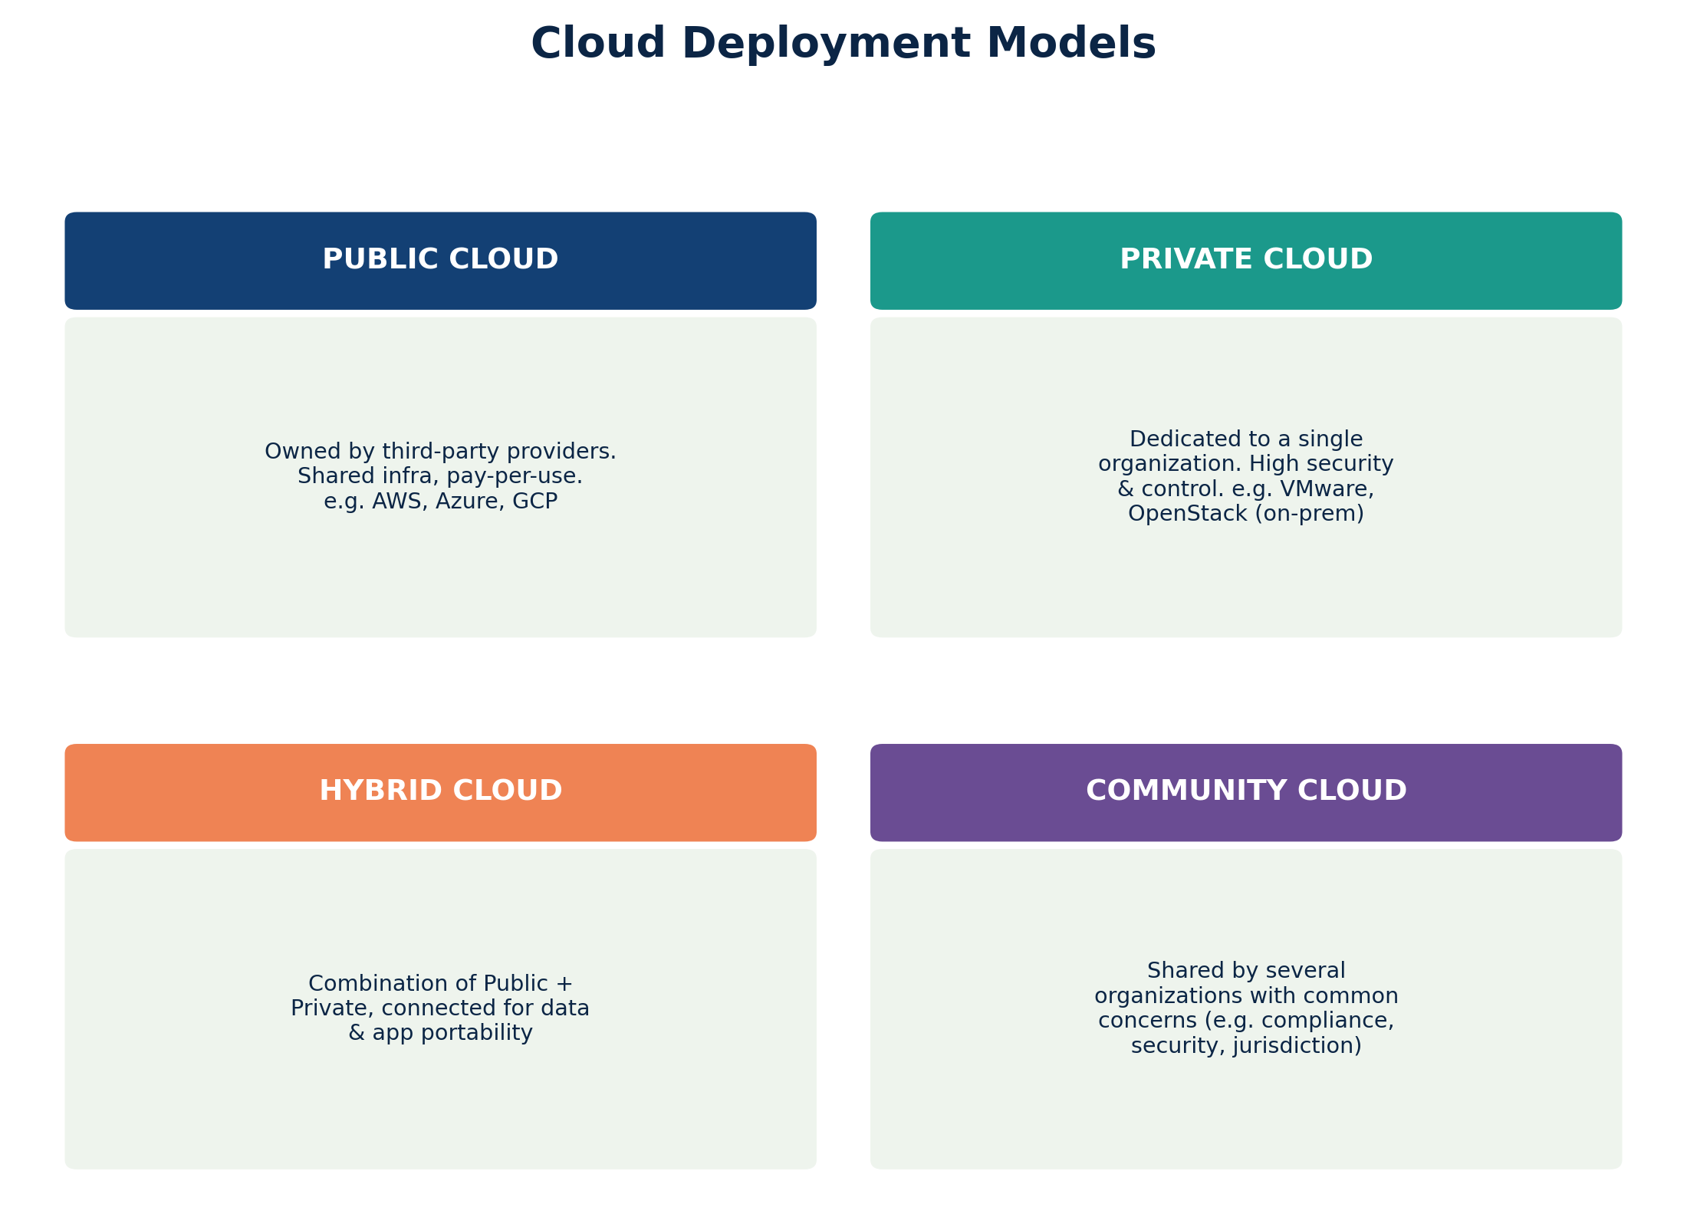
Fig. 6.1 — The Four Cloud Deployment Models

6.1 Public Cloud
Public Cloud infrastructure is provisioned for open use by the general public. It is owned, managed, and operated by a business, academic, or government organization (the Cloud Service Provider). Resources are shared among multiple tenants (multi-tenancy) and billed on a pay-per-use basis. Examples: Amazon Web Services (AWS), Microsoft Azure, Google Cloud Platform (GCP).

6.2 Private Cloud
Private Cloud infrastructure is provisioned for exclusive use by a single organization comprising multiple consumers (e.g. business units). It may be owned, managed, and operated by the organization itself, a third party, or a combination of both, and may exist on or off premises. It offers greater control, customization, and security — ideal for organizations with strict compliance or data-privacy requirements.

6.3 Hybrid Cloud
Hybrid Cloud is a composition of two or more distinct cloud infrastructures (private, community, or public) that remain unique entities but are bound together by standardized or proprietary technology that enables data and application portability. This allows organizations to keep sensitive workloads on a private cloud while leveraging the scalability of a public cloud for less-sensitive tasks.

6.4 Community Cloud
Community Cloud infrastructure is provisioned for exclusive use by a specific community of consumers from organizations that share common concerns such as mission objectives, security requirements, policy, or compliance considerations (e.g. Government departments, banking consortiums, or research institutions).

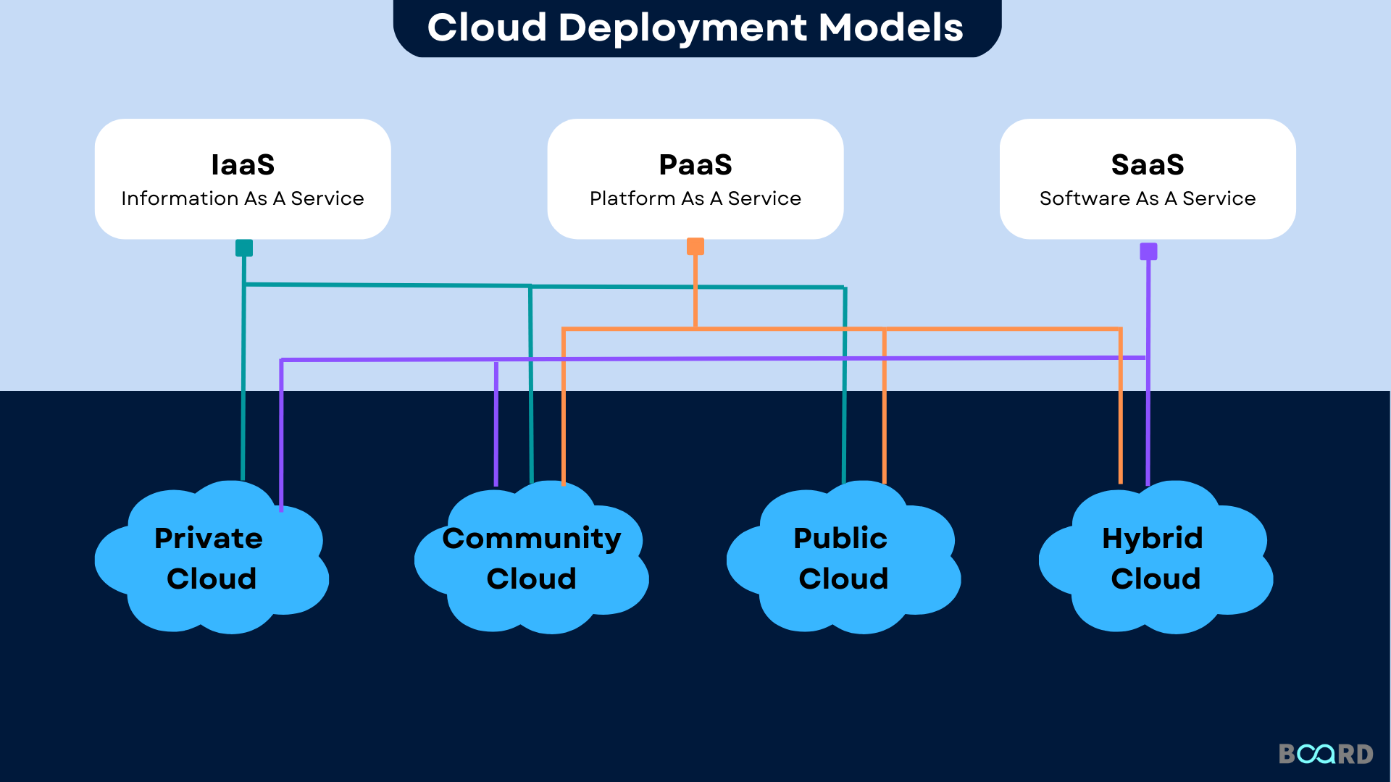

7. How a Cloud Request Works — Flowchart
The following flowchart illustrates the step-by-step journey of a single user request from the client device, through the network, into the cloud provider's infrastructure, and back to the user as a response.
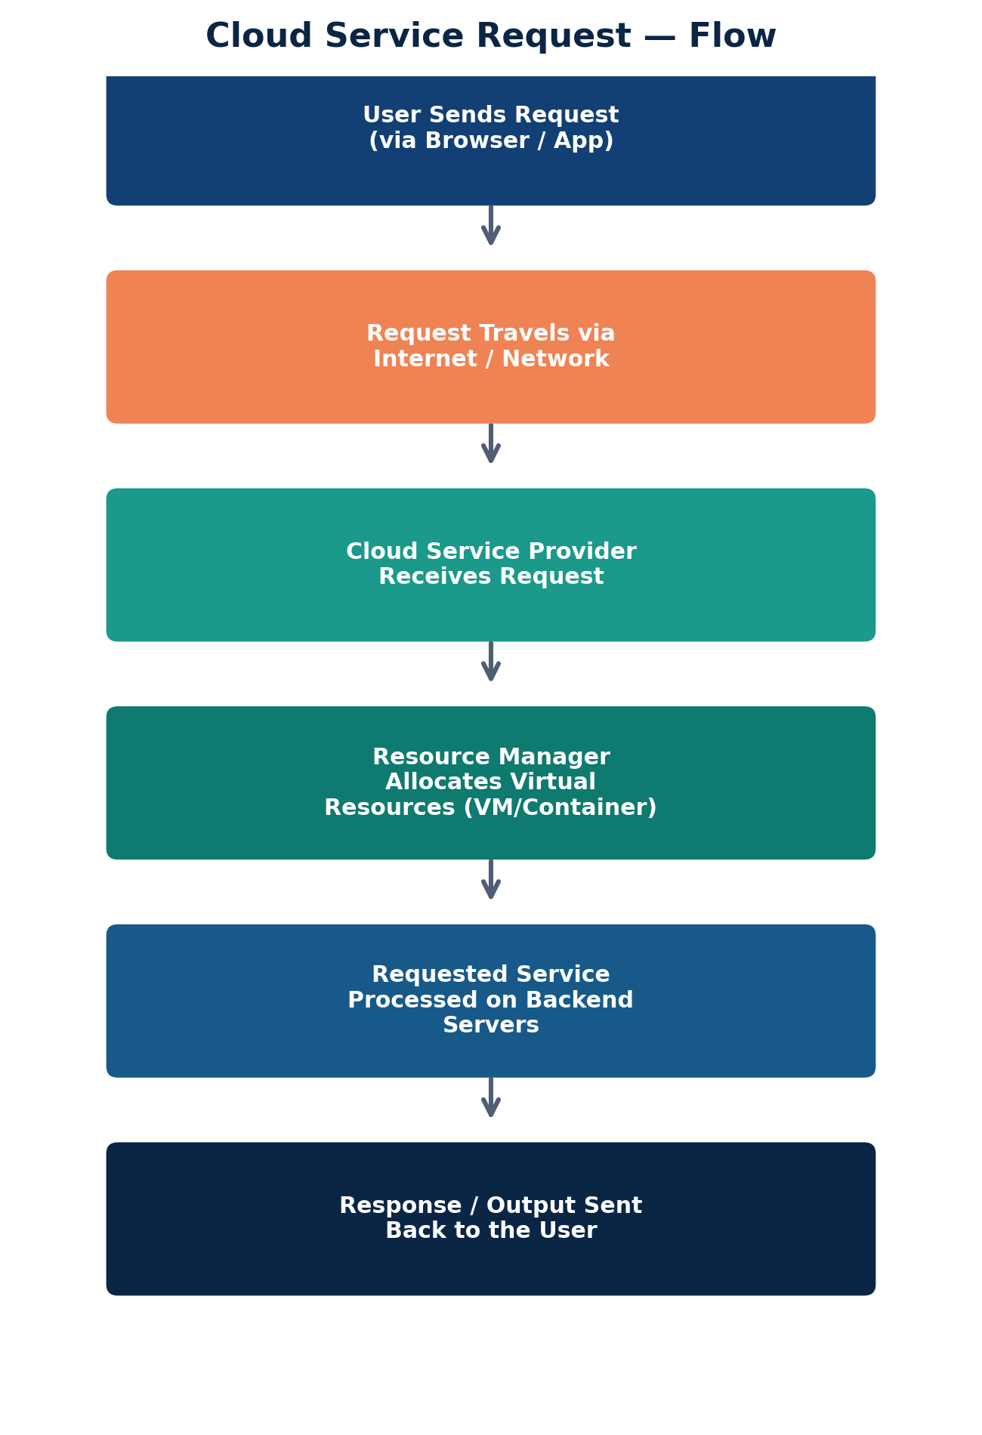
Fig. 7.1 — Flowchart: Life Cycle of a Cloud Service Request

8. Advantages & Disadvantages of Cloud Computing

8.1 Advantages
Advantage | Explanation
Cost Efficiency | No need to invest in expensive hardware; pay only for resources consumed.
Scalability & Elasticity | Resources scale up or down instantly based on real-time demand.
Accessibility | Services can be accessed anytime, anywhere, from any Internet-enabled device.
Automatic Updates | Providers handle maintenance, patches, and software updates automatically.
Disaster Recovery | Data is replicated across multiple servers/regions, ensuring high availability.
Collaboration | Enables real-time collaboration on shared documents and applications.

8.2 Disadvantages
Disadvantage | Explanation
Internet Dependency | Requires a stable Internet connection; limited access during outages.
Data Security & Privacy | Storing sensitive data off-premises raises security and compliance concerns.
Limited Control | Users have limited control over the underlying infrastructure, especially in SaaS.
Vendor Lock-In | Migrating between cloud providers can be complex and costly.
Downtime | Service outages at the provider's end can disrupt business operations.

9. Real-World Applications & Examples
- Email & Productivity: Gmail, Microsoft 365, Google Workspace
- Storage & Backup: Google Drive, Dropbox, OneDrive, Amazon S3
- Streaming Services: Netflix, Spotify (hosted on AWS infrastructure)
- E-Commerce Platforms: Amazon, Flipkart (elastic scaling during sales events)
- AI/ML Platforms: Google Vertex AI, Azure Machine Learning, AWS SageMaker
- Social Media: Facebook, Instagram, and Twitter/X — all rely on massive distributed cloud infrastructure

10. Conclusion
Cloud Computing has fundamentally transformed the way individuals and organizations access, store, and process information. By understanding its fundamental concepts — the essential characteristics defined by NIST, the layered architecture comprising front end and back end components, the three primary service models (IaaS, PaaS, SaaS), and the four deployment models (Public, Private, Hybrid, Community) — one gains a holistic view of how modern computing infrastructure is designed and delivered as a utility. As businesses continue to move towards digital transformation, cloud computing will remain a cornerstone technology enabling scalability, cost-efficiency, and global accessibility.

11. References
- Mell, P., & Grance, T. (2011). The NIST Definition of Cloud Computing. National Institute of Standards and Technology.
- Rajkumar Buyya, Cloud Computing: Principles and Paradigms, Wiley Publications.
- Official Documentation — Amazon Web Services (aws.amazon.com/what-is-cloud-computing)
- Official Documentation — Microsoft Azure (azure.microsoft.com/resources/cloud-computing-dictionary)
- Official Documentation — Google Cloud Platform (cloud.google.com/learn/what-is-cloud-computing)
- Class Lecture Notes — Elective I: Cloud Computing, Army Institute of Technology, Pune

