

**Tribhuvan University**

**Faculty of Humanities and Social Sciences**

**“GizmoGrove: Laptop and Accessories Selling E-commerce Website”**

**A PROJECT REPORT**

**Submitted to**

**Department of Bachelor in Computer Application**

**Kathmandu Business Campus**

***In partial fulfillment of the requirements for the Bachelors in Computer Application***

Submitted by

Reejan Chhetri Kelvin Maharjan

BCA 4th Semester BCA 4th Semester

University SN:6-2-1219-20-2021 University SN: 6-2-1219-12-2021

Roll No:20 Roll No: 12

Under the Supervision of

**Sulav Nepal**



**Tribhuvan University**

**Faculty of Humanities and Social Sciences**

**Kathmandu Business Campus**

**Banasthali , Balaju**

**Supervisor’s Recommendation**

I hereby recommend that this project prepared under my supervision by **Reejan Chhetri( reg no:6-2-1219-20-2021)** and **Kelvin Maharjan(reg no:6-2-1219-12-2021)** entitled **“GizmoGrove: Laptop & Accessories Selling E-commerce Website”** in the Partial Fulfillment of requirement for the degree of Bachelor in Computer Application is recommended for that final evaluation.

Sulav Nepal

Project Supervisor

BCA Department

Kathmandu Business Campus



**Tribhuvan University**

**Faculty of Humanities and Social Sciences**

**Kathmandu College of Technology**

**LETTER OF APPROVAL**

This is to certify that this project prepared by **Kelvin Maharjan** and **Reejan Chhetri** entitled “**GizmoGrove: Laptop & Accessories Selling E-commerce Website”** in partial fulfillment of the requirements for the degree of Bachelor in Computer Application has been evaluated. In our opinion it is satisfactory in the scope and quality as a project for the required degree.

Sulav Nepal Ram Prasad Subedi

Supervisor Program Coordinator

BCA Department Kathmandu Business Campus

Kathmandu Business Campus

Internal Examiner External Examiner

**ABSTRACT**

The proposed system is an e-commerce platform designed to facilitate online shopping for users. It aims to provide a user-friendly interface for browsing, selecting, and purchasing products from a diverse range of categories. The system incorporates features such as user registration, product catalog management, shopping cart functionality, and secure payment processing. Through a comprehensive system analysis and design process, the project identified key requirements and constraints, leading to the development of a robust and scalable solution. The system's architecture was carefully designed to ensure scalability, reliability, and performance, utilizing modern technologies and best practices. Overall, the e-commerce platform offers an intuitive and seamless shopping experience for users while providing administrators with efficient management tools for maintaining the product catalog. With future recommendations and lessons learned, the system aims to continuously evolve and improve to meet the dynamic needs of online shoppers and businesses.

Keywords: e-commerce, online shopping, user interface, product catalog, shopping cart, payment processing, system analysis, system design, scalability, reliability, performance, modern technologies, best practices, shopping experience, administration tools, continuous improvement.

**ACKNOWLEDGEMENT**

We would like to express our special thanks of gratitude to our supervisor Mr. Sulav Nepal who gave us the golden opportunity to do this wonderful project on the topic of ‘**GizmoGrove: Laptop & Accessories Selling E-commerce Website’**, which also helped us in doing a lot of research and we came to know about so many new tools and technologies.

I would like to express my special gratitude and thanks to our BCA Program Coordinator Mr. Ram Prasad Subedi for his support and help for our personnel development and mainly for the completion of this Project

I am highly indebted to Kathmandu Business Campus for their guidance and constant supervision as well as for providing necessary information regarding the Project and support in the completion.

We would also like to express my gratitude towards library and member of Kathmandu Business Campus for their kind co-operation and encouragement which help me in completion of this Project.

We would also like to thank our parents and friends who helped us a lot in finalizing this project within the limited time frame.

In the end, we would also like to thank Tribhuvan University for giving us this opportunity via the course of Computer Application to help us understand the project ethics at this early stage and helped us to evaluate my knowledge and expand it a little more.

Yours sincerely,

Reejan Chhetri

Kelvin Maharjan

**LIST OF ABBREVIATIONS**

CRUD Create, Read, Update and Delete

CSS Cascading Style Sheet

DFD Data Flow Diagram

ERD Entity Relationship Diagram

HTML Hyper Text Markup Language

JS Java Script

MySQL Microsoft Server Structured Query Language

PHP Hypertext Preprocessor

**TABLE OF CONTENTS**

Contents

Supervisor’s recommendation ii

Letter of approval iii

Abstract iv

Acknowledgement v

List of abbreviations vi

List of figures  ix

List of tables x

CHAPTER: 1 1

INTRODUCTION 1

1.1 Introduction 1

1.2 Problem Statement 2

1.3 Objectives 2

1.4 Scope and limitation 2

1.4.1 Scope 2

1.4.2 Limitation 3

1.5 Report Organization 3

CHAPTER: 2 5

BACKGROUND STUDY AND LITERATURE REVIEW 5

2.1 Study of existing systems 5

2.2 Literature review 6

CHAPTER: 3 7

SYSTEM ANALYSIS AND DESIGN 7

3.1 System Analysis 7

3.1.1 Requirement Identification 8

3.1.2 Feasibility Study 9

3.1.3 Data Modeling (ER-diagram) 10

3.1.4 Process Modeling (DFD) 11

3.2 System Design 13

3.2.1 Architectural Design 13

3.2.2 System flowchart 13

3.2.3 Database schema design 16

3.2.4 Interface Design (UI Interface) 16

CHAPTER: 4 17

IMPLEMENTATION AND TESTING 17

4.1 Implementation 17

4.1.1 Tools Used (CASE tools, Programming language, Database platforms) 17

4.1.2 Implementation Details of Modules 18

4.2 Testing 19

CHAPTER: 5 21

CONCLUSION AND FUTURE RECOMMENDATIONS 21

5.1. Lesson Learnt / Outcome 21

5.2. Conclusion 21

5.3. Future Recommendations 22

References 23

Appendix 24

**LIST OF FIGURES**

Figure 3.1 Waterfall model for e-commerce website. 7

Figure 3.2: Use case diagram for e-commerce website. 8

Figure 3.3: Gantt chart for e-commerce website. 10

Figure 3.4: Entity Relationship diagram for e-commerce website. 11

Figure 3.5: level 0 DFD for E-commerce website 12

Figure 3.6: level 1 DFD for e-commerce website 12

Figure 3.7: Architecture Design of e-commerce website 13

Figure 3.8: Flowchart of e-commerce website for user 14

Figure 3.9: Flowchart of e-commerce website for admin 15

Figure 3.10: Database Schema Design 16

**LIST OF TABLES**

Table 3.1: Gantt chart Table for E-commerce website………………………………........9

Table 4.1: Test case for checkout of GizmoGrove………………………………………24

# CHAPTER 1

# INTRODUCTION

## Introduction

Introducing **“GizmoGrove: Laptop & Accessories Selling E-Commerce Website”**. An innovative and user-friendly e-commerce website specializing in the sale of laptops and accessories. This platform aims to provide a seamless and efficient online shopping experience for customers looking to purchase laptops and accessories.

GizmoGrove is a simple website where one can find their dream laptops. It is a place where you can find latest laptop and accessories at the best price.

Our project is aimed at general public who are looking for a suitable and trusted online laptop and accessories store where one can search through available laptops, accessories, check its description, read reviews of previous people who purchased the product and order it directly through the website.

We hope to provide a safe and easy place to view and purchase branded laptops and accessories and help people to acquire there best fitted laptops and accessories. GizmoGrove offers various filters which helps people to find a laptop and accessories with their Specification.

In summary, GizmoGrove is a simple but effective website with its user-friendly interface and straightforward design, it's the perfect place to look for one’s specific laptop and accessories

## Problem Statement

In the rapidly evolving landscape of e-commerce, businesses face the challenge of adapting to changing consumer preferences and technological advancements. With the proliferation of online shopping platforms, consumers now expect seamless and engaging experiences across all touchpoints. To address this demand, our project focuses on developing a comprehensive e-commerce platform that prioritizes user experience, efficient product management, scalability, and mobile accessibility. By addressing these key areas, our platform aims to bridge the gap between traditional retail and digital commerce, offering businesses a competitive edge in the online marketplace. Through innovative features and intuitive design, we seek to enhance user engagement, drive conversions, and foster long-term customer loyalty. Our goal is to create a platform that not only meets the current needs of businesses and consumers but also anticipates and adapts to future trends in e-commerce, ensuring sustained growth and success in an ever-changing market.

## Objectives

The objective of this project are outlined below, focusing on enhancing customer experience, optimizing inventory management, and fostering user engagement.

* + 1. To provide wide variety products with the option of comparison.
    2. To provide mechanisms for user interaction, reviews, and feedback to improve the shopping experience and product offerings.
    3. To provide inventory management systems for accurate stock levels and smooth product administration.

## Scope and limitation

### Scope

The scope of our project encompasses several key features:

* + - Diverse Product Range.
    - Comprehensive Product Information.
    - Admin dashboard
    - Cart functionalities.

### Limitation

However, there are certain limitations to consider:

* + - * Limited Physical Interaction
      * Inability to Experience Performance
      * Logistical Challenges.

## Report Organization

**Introduction**

The E-commerce Website project aims to create a user-friendly platform for seamless online shopping and efficient management. It prioritizes enhancing user experience, streamlining administrative tasks, ensuring scalability and security, and adapting to market demands. Despite potential constraints like technology limitations and market competition, the project is driven by the need to meet consumer demand, and achieve efficiency through innovation. Ultimately, it aims to deliver a competitive solution that fosters growth in the digital marketplace.

**Background Study and Literature Review**

The chapter reviews recent advancements in data mining, emphasizing its role in enhancing E-commerce platforms. It also discusses key features of popular E-commerce platforms, offering insights for the project's development.

**System Analysis and Design**

This chapter analyzes system requirements, feasibility, and architecture. It visualizes the system's structure through diagrams and outlines database schema design and user interface considerations.

**Implementation and Testing**

This chapter details the tools and technologies used in system development, implementation steps, and testing procedures. It focuses on ensuring system robustness, reliability, and functionality through comprehensive testing.

**Conclusion and Future Recommendation**

The chapter summarizes project outcomes, lessons learned, and future prospects. It provides recommendations for system enhancement and explores potential research directions in the E-commerce domain.

# CHAPTER 2

# BACKGROUND STUDY AND LITERATURE REVIEW

## Study of existing systems

In this section, an examination of existing e-commerce systems provides insights into established practices, features, and challenges. By analyzing various platforms, such as Amazon, eBay, and Shopify, valuable lessons can be learned to inform the development of our own e-commerce solution.

Amazon, as a global leader in e-commerce, offers a vast array of products, streamlined shopping experiences, and efficient logistics. Its personalized recommendations, user reviews, and robust seller ecosystem contribute to its success. However, challenges such as counterfeit products, seller fraud, and complex navigation highlight areas for improvement.

eBay, known for its auction-style marketplace, emphasizes user-to-user transactions and a wide range of product categories. Its bidding system fosters competition and engagement among users. Yet, issues related to seller credibility, shipping delays, and disputes underscore the importance of effective dispute resolution mechanisms.

Shopify stands out for its user-friendly interface and comprehensive suite of e-commerce tools, making it an attractive option for businesses of all sizes. Its customizable themes, integrated payment gateways, and extensive app ecosystem enable merchants to create and manage online stores efficiently. Nevertheless, concerns regarding platform fees, limited scalability, and dependency on third-party apps warrant consideration.

By studying these and other e-commerce platforms, we aim to identify best practices, innovative features, and areas for improvement to inform the design and development of our own system. This analysis will guide our efforts in creating a competitive and user-centric e-commerce solution tailored to the needs of our target audience.

## Literature review

The literature review examines existing research and publications related to e-commerce systems. [1] It focuses on understanding user behavior, technological advancements, and business strategies within the e-commerce domain. By reviewing relevant literature, we aim to gain insights into best practices, challenges, and opportunities in the field of online commerce.

Several studies have explored consumer preferences and behaviors in e-commerce environments [2], highlighting the importance of user experience, convenience, and trust in driving online sales. Additionally, research has investigated the impact of emerging technologies such as social media and mobile commerce on e-commerce trends, emphasizing the need for businesses to adapt to changing consumer habits and preferences.

Furthermore, scholarly works have addressed security concerns and privacy issues in e-commerce transactions [3], emphasizing the importance of implementing robust security measures to protect user data and build trust with customers. Additionally, literature on e-commerce business models and revenue strategies provides valuable insights into monetization approaches and digital marketing techniques for maximizing online revenue.

Overall, the literature review serves as a foundation for understanding key concepts and trends in e-commerce, informing the development and strategic planning of our project to ensure its alignment with industry standards and best practices.

# CHAPTER 3

# SYSTEM ANALYSIS AND DESIGN

## System Analysis

System analysis is the most important phase in the development of GizmoGrove: Laptop & Accessories selling E-commerce website. It plays a fundamental role in understanding the requirements, functionalities, and components of the system. Thus, it helps in ensuring its successful design and implementation of a system.

This system is designed with the series of processes starting with requirement analysis, design, implementation, testing and deployment. During requirement analysis, all the functional and nonfunctional requirement are analyzed and system is developed according to the requirement then designing of the system is carried out. After the design process, coding and development part is started then after integrating the system there is testing of the system. After testing is positive then system is moved on to deployment phase.

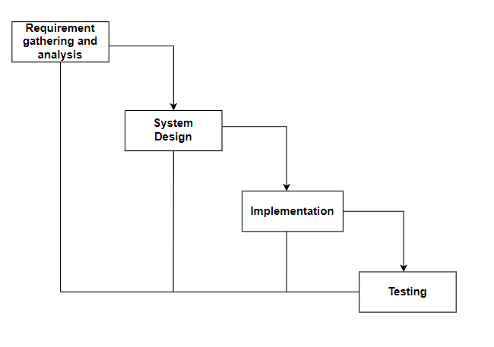

**Figure 3.1 Waterfall model for e-commerce website.**

### Requirement Identification

Requirement identification is a critical step in the development of an GizmoGrove: Laptop & Accessories selling E-commerce website. This process involves identifying the functional and non-functional requirements of the system to ensure that it meets the needs of the organization and its customers.

1. **Functional requirement**
   * + - * Users can login into the website.
         * Customers can search, view products and add to cart.
         * Customers can compare products.
         * Admin can login into the website.
         * Admin can manage users and products.

**USECASE DIAGRAM**

In GizmoGrove, there are two actors such admin and customer where admin can login, logout, manage customer and products from the website. Likewise, customers can register, login, Search Products, View Products, Add to Cart, checkout and logout from the website.

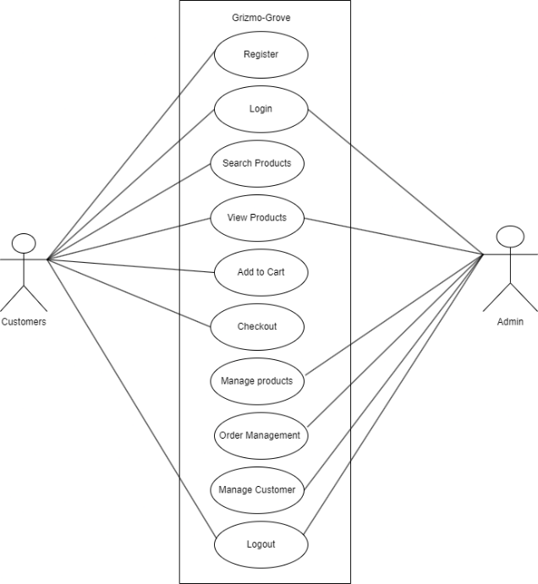

**Figure 3.2: Use case diagram for e-commerce website.**

1. **Non-functional requirement**

* **Security**

We have not saved the user password into the database, only the hashed password is saved.

* **Performance**

This system will be designed for better performance of users and admin.

* **Reliability**

This system will be reliable for both the user and admin

* **Usability**

This system will be easy to use and navigate, with user-friendly interface.

### Feasibility Study

A feasibility study is a preliminary assessment of a proposed project, plan, or idea to determine whether it is practical, feasible, and economically viable. The purpose of a feasibility study is to identify potential risks, challenges, and opportunities associated with the project.

Following feasibility were studied before building the system to see if the system could be built with exact requirement in required time.

* **Technical feasibility**

This system uses existing technologies, software and hardware so there is no technological hurdle to build this system.

* **Operational feasibility**

This system uses simple technologies to design so it is easy to use and understand and it is user-friendly.

* **Schedule feasibility**

The system is completed within scheduled time and do not exceed the scheduled time.

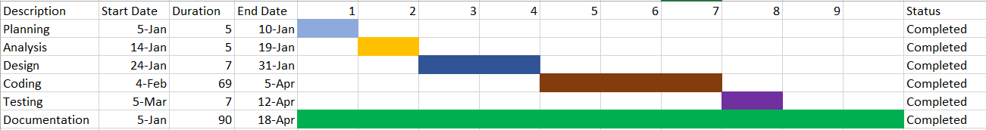 **Table 3.1: Gantt chart Table for GizmoGrove**

|  |  |
| --- | --- |
| **Task name** | **Duration** |
| Planning | 1 week |
| Analysis | 1 week |
| Design | 2 week |
| Coding | 12 week |
| Testing | 1 week |
| Deployment | 1 week |

**Figure 3.3: Gantt chart for e-commerce website.**

### Data Modeling (ER-diagram)

In Entity-Relationship diagram there are 9 entities named user, rating, review, contact messages, cart, product, Wishlist, checkout and admin. Products has attributes such as name, brand, id, price. Like-wise user has name, contact, email, user id. Admin can delete user manage products whereas user can view products buy them or add to cart.

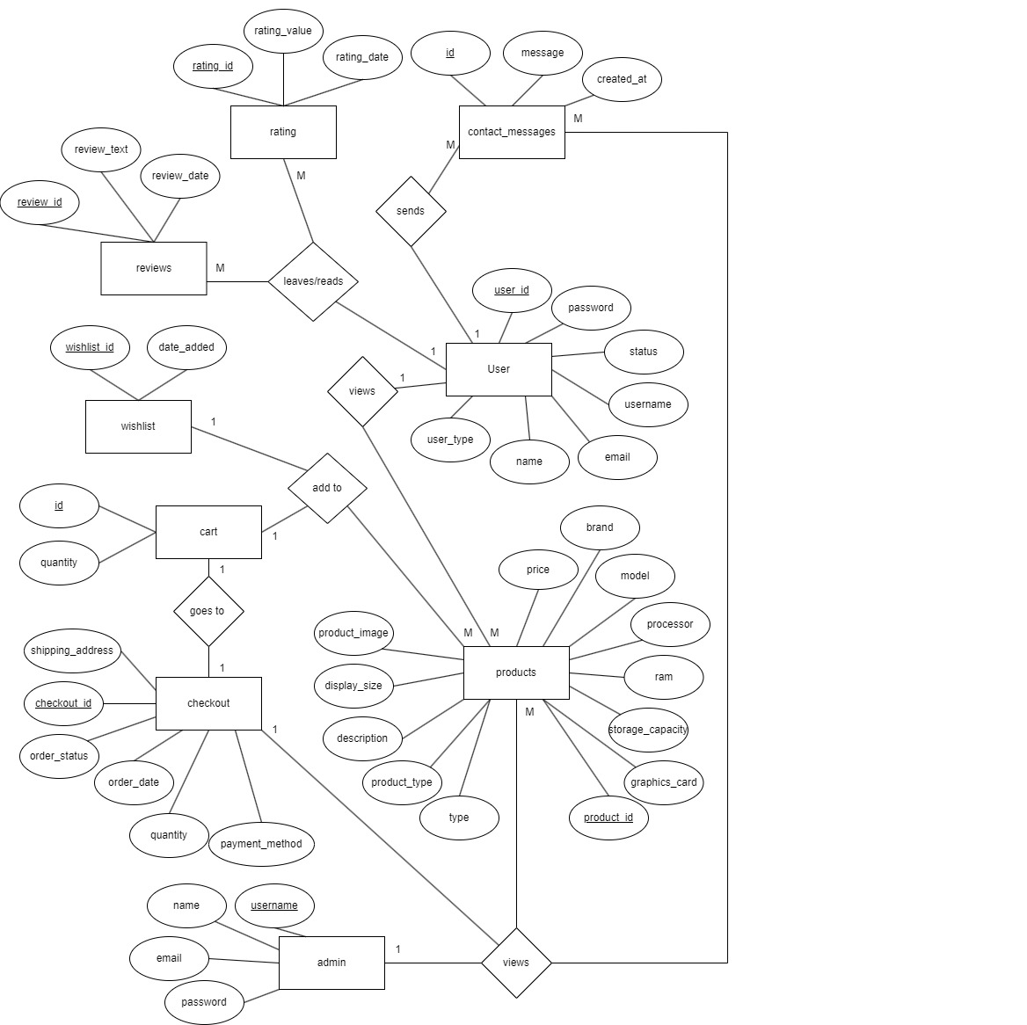

**Figure 3.4: Entity Relationship diagram for e-commerce website.**

### Process Modeling (DFD)

Data Flow Diagram of GizmoGrove: An e-commerce website consists of two levels of DFD context diagram and level one DFD. Both these levels are used for making data flow diagram of GizmoGrove: An e-commerce website.

In context diagram, the user can view and search products add them to cart or buy them. The admin can manage products and users get order details and update the delivery details. Then the customer can get the delivery details.

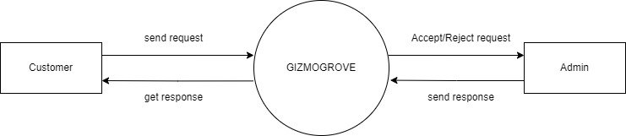

**Figure 3.5: level 0 DFD for E-commerce website**

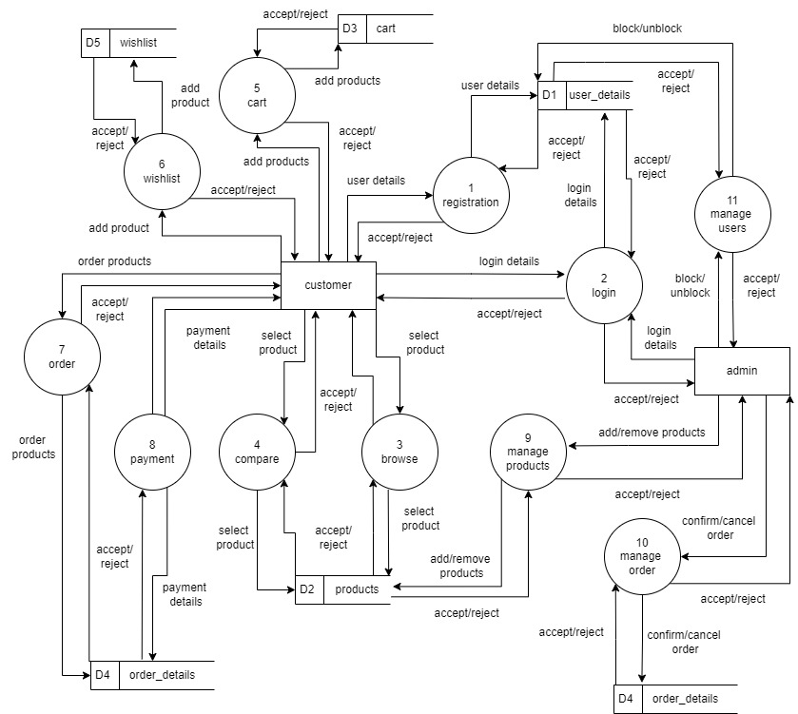

**Figure 3.6: level 1 DFD for e-commerce website**

## System Design

To realize the different functional requirement of the system in graphical form, different design diagram of the system has been prepared which are as follows:

### Architectural Design

For this system, three tier architecture is used which includes user interface, web server and database. In architectural design, basic structure of the system is show.

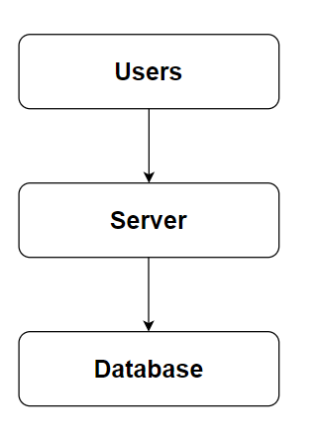

**Figure 3.7: Architecture Design of e-commerce website**

### System flowchart

The flowchart for the E-commerce Website begins with the start of the process. Users are prompted with a question asking if they have an account. If they do, they proceed to the login stage where the validity of their credentials is checked. Upon successful validation, they are directed to the landing page where they can view and buy products, as well as add them to their cart. After selecting their desired items, users proceed to checkout before the process concludes.

For the admin, the process begins with the start followed by login. The system then verifies the validity of the admin's credentials. Upon successful authentication, the admin is directed to the dashboard where they can manage users and products. After completing their tasks, the admin can choose to logout before the process ends.

**For user**

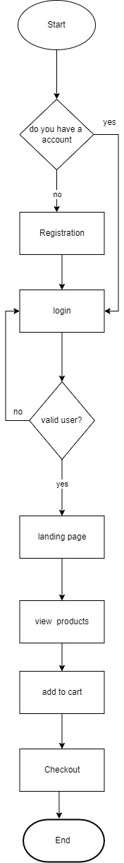

**Figure 3.8: Flowchart of e-commerce website for user**

**For Admin**

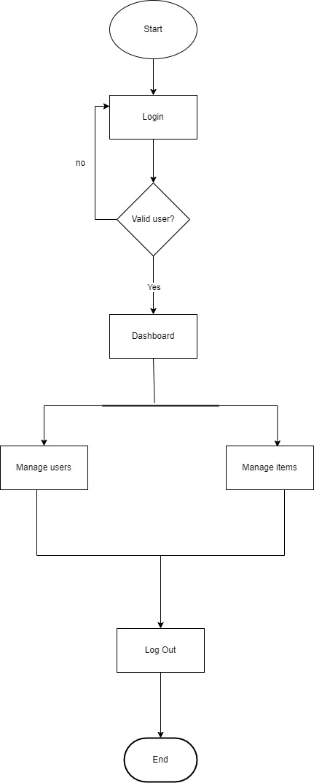

**Figure 3.9: Flowchart of e-commerce website for admin**

### Database schema design

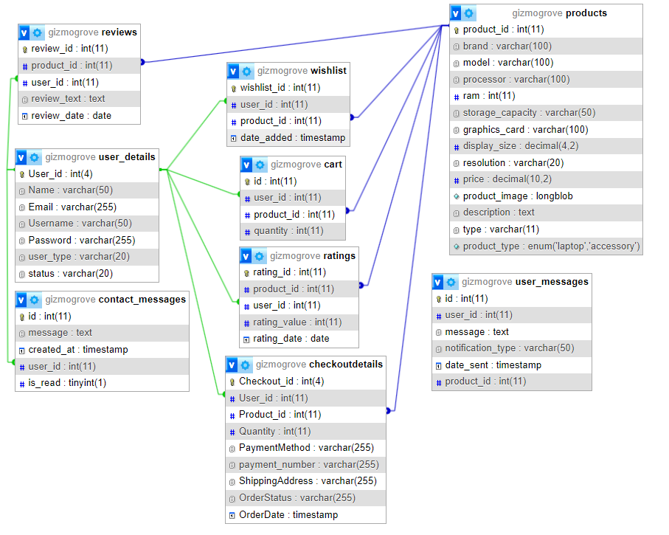The figure below is the database schema design of e-commerce website. Database schema design is used to show basic structure of the system. In the e-commerce website there are two tables in the databases each of them have their own fields where their id is primary key and if that id is used in another table it becomes foreign key.

**Figure 3.10: Database Schema Design**

### Interface Design (UI Interface)

Interface design is used to design how the e-commerce website looks like and this design is shown to user that how the website will look. And after finalizing the system development starts. The UI design of login page, registration page, landing page, laptops section, accessories section, product description page, admin dashboard page, order management page of GizmoGrove: A e-commerce website are shown in the appendix section.

# CHAPTER 4

# IMPLEMENTATION AND TESTING

## Implementation

### Tools Used (CASE tools, Programming language, Database platforms)

Following are the tools and framework used for the accomplishment of this project:

* **Front end**
  + **Html:** HTML (Hyper Text Markup Language) was used to create and structure the web pages. This involved organizing content with various elements and tags to define sections, headings, links, and paragraphs, ensuring a clear and accessible structure for the website.
  + **CSS:** CSS, which stands for Cascading Style Sheets, was employed to style the web pages, controlling the presentation and appearance. I used CSS to define text colors, font styles, spacing between paragraphs, column sizes, and layout designs, resulting in a visually appealing and consistent user interface.
  + **JavaScript:** JavaScript was implemented to add interactivity and dynamic behavior to the website. I utilized JavaScript for client-side validation, creating dynamic, interactive, and responsive web pages, and adding special effects to enhance the user experience.
* **Back end**
  + **PHP:** PHP was extensively utilized due to its versatility and powerful features. It was used to generate dynamic content on web pages based on user inputs, database queries, and other external data sources, ensuring personalized and relevant information delivery. PHP handled server-side scripting tasks such as connecting to the database, encrypting data, and validating user inputs, which allowed for secure data transactions and accurate data processing. Additionally, PHP was implemented for user authentication, managing login pages, and controlling user access to specific pages, thereby enhancing the security and overall functionality of the website.
* **Server**
  + - **APACHE SERVER:** In GizmoGrove, Apache server is used to run php files and creating fast and dynamic web pages.
* **Database**
  + **MYSQL:** MySQL was used as the foundational database management system. It served crucial roles such as storing product information, managing customer data including profiles and purchase histories, processing and storing orders, and facilitating secure transactions. MySQL's relational database capabilities ensured efficient data organization and retrieval, supporting the seamless operation of our website's backend processes.
* **Documentation Tools** 
  + - **MS Office**: MS Office was utilized in our project for creating and editing documents, spreadsheets, and presentations essential for business operations, communication, and reporting.
    - **Draw.io:** Draw.io was used to create a variety of diagrams such as flowcharts, DFD, ER-diagram, and more, aiding in visualizing complex concepts, processes, and structures within our project.

### Implementation Details of Modules

Different modules of this system are described as below:

**Admin module:**

* **Admin manage user module.**

In this module, an admin can check the list of users their details and block them if needed. The admin can simply check the status of the account and choose to either activate the account or block them.

* **Admin manage product module.**

This module enables an Admin to add product and edit products. The admin can choose to add laptop or accessories then they can add the details, image and description of the product and press add product to add the product.

* **Admin order management module.**

This module enables an admin to check the order details where they can check the product id, user id, quantity, shipping address, payment method and order status.

Change the status when it is completed or cancelled through the button.

**User module:**

* **User view module.**

Enables the user to view various dynamically loaded product listing.

* **User add to cart module.**

Users are able to click on the add to cart button to add the items to cart.

* **User add to Wishlist module.**

Users are able to add their preferred items in Wishlist. They can do so my viewing the products then clicking on the heart to add or remove from wishlist.

**Login module:**

In login module, we have implemented two modules which takes the admin login into admin panel and user login into landing page.

**Register module:**

In register module, we have user register into the system by entering all the details such as email, username, password to register. And then can log in to system with their valid username and password.

## Testing

System testing is done by giving different training and testing datasets. This test is done to evaluate whether the system is providing accurate summary or not. During the phase of the development of the system, our system is tested time and again. The series of testing conducted are as follow:

**Checkout**

**Table 4.1: Test case for checkout of GizmoGrove.**

|  |  |  |  |  |  |
| --- | --- | --- | --- | --- | --- |
| S.No. | Test Name | Input | Expected Output | Actual Output | Test Result |
| 1 | Product Page Navigation | User navigates to product page | Product page is displayed | Product page displayed | Pass |
| 2 | Product Description  Navigation | User navigates to description page | Unique description page is displayed | Unique description page displayed | Pass |
| 3 | Add to cart | User clicks on the add to cart | Product added to cart alert is displayed | Product added to cart alert displayed | pass |
| 4 | Cart Page Navigation | User navigates to cart page | Cart page is displayed | Cart page displayed | Pass |
| 5 | Increase quantity | User increases the quantity | Total price is updated | Total price updated | Pass |
| 6 | Proceed to Checkout | User clicks "Checkout" button | Checkout page is displayed | Checkout page displayed | Pass |
| 7 | Shipping Information Entry | User enters shipping information | Shipping information is entered | Shipping information entered | Pass |
| 8 | Payment Information Entry | User enters payment information | Payment information is entered | Payment information entered | Pass |
| 9 | Place Order | User clicks "Place Order" button | Order is successfully placed | Order successfully placed | Pass |

# CHAPTER 5

# CONCLUSION AND FUTURE RECOMMENDATIONS

## Lesson Learnt / Outcome

Every project makes us to learn and gain the knowledge in different aspects. In the following project, we have learned lots of problem-solving skills and learn things like team work, finding the solution on our own, proper use of guidelines, communication and writing skills and management of team.

* + - **Teamwork**

Since this is a team project, it teaches how to work with group members and develop the system together. We have learned how to work with team and divide our task with each other and deal with the problem and error occur in this system.

* + - **Problem Solving Skills**

From this project, we have learned lots of problem-solving skills and also learned to recognize different errors occur in this system and solve it.

* + - **Writing Skills**

We have learned how to prepare proposal and documentation related with project and also learned to use different case tools for use case diagram, schema diagram, data flow diagram, and ER- diagram and so on.

* + - **Managing time**

The most important lesson learnt was management of time according to the complexity of the system components i.e., know which components to prioritize.

## Conclusion

GizmoGrove has been successfully developed with predefined objectives. This system fulfills all the objectives that have been set to develop. This system can be viewed by any user without registering but the user has to register and login the system use the system as well as access various other features offered by the system such as Wishlist, add to cart etc. This system also provides easy and smooth user interface that can be used by non-technical users.

## Future Recommendations

The development project could have been more efficiently handled about design and development. The documentation process might have been better programming the project prior to any documentation. The system can be updated based on the users’ requirements recommendation. The page load and server load speed might be improved.

Some of the future recommendation for this system are:

* + - Include different roles for the system.
    - Implement password recovery features.
    - Add search feature.
    - Add more filter option.
    - Include more Electronic Gizmos.

## References

[1] Liang, T. P., & Lai, H. J. (2000). Effect of store design on consumer purchases: An empirical study of online bookstores. International Journal of Electronic Commerce, 5(3), 135-154.

[2] Lee, K. C., & Kwon, O. B. (2011). Impact of network externalities on the adoption of e-book readers: User interface and media compatibility perspectives. International Journal of Electronic Commerce, 15(3), 105-134.

[3] Pavlou, P. A. (2003). Consumer acceptance of electronic commerce: Integrating trust and risk with the technology acceptance model. International Journal of Electronic Commerce, 7(3), 101-134.

## Appendix



**Figure 11: Login page of GizmoGrove.**

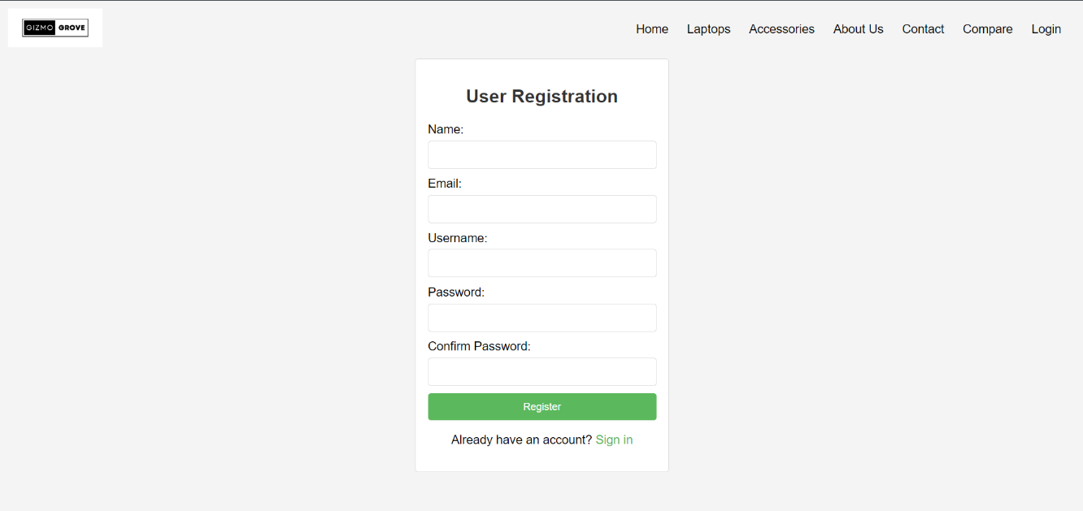

**Figure 12: Registration page of GizmoGrove.**

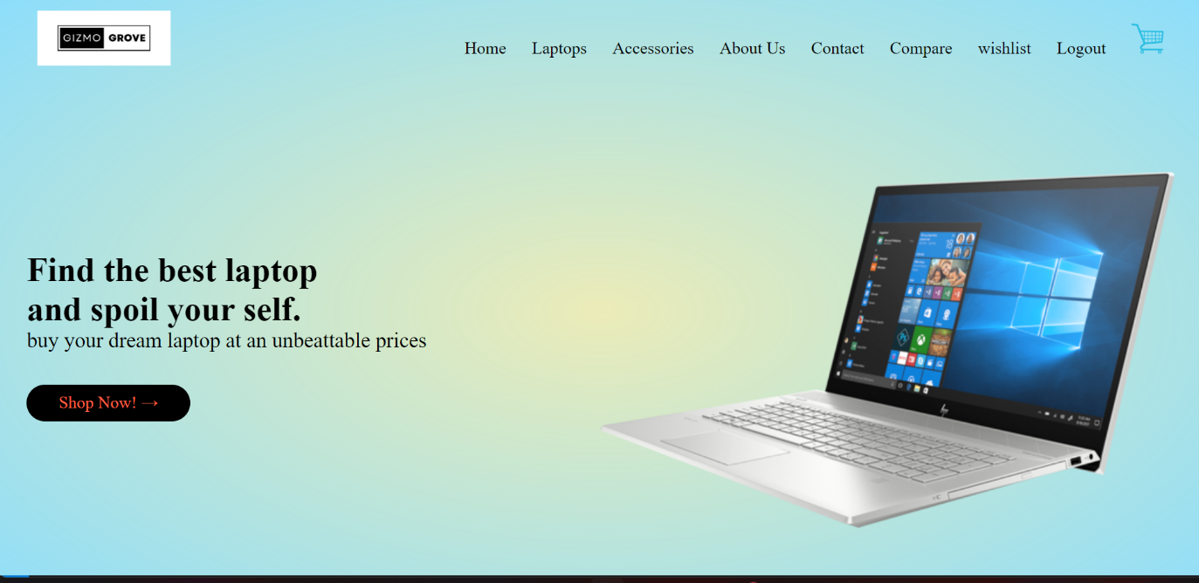

**Figure 13: landing page of GizmoGrove**

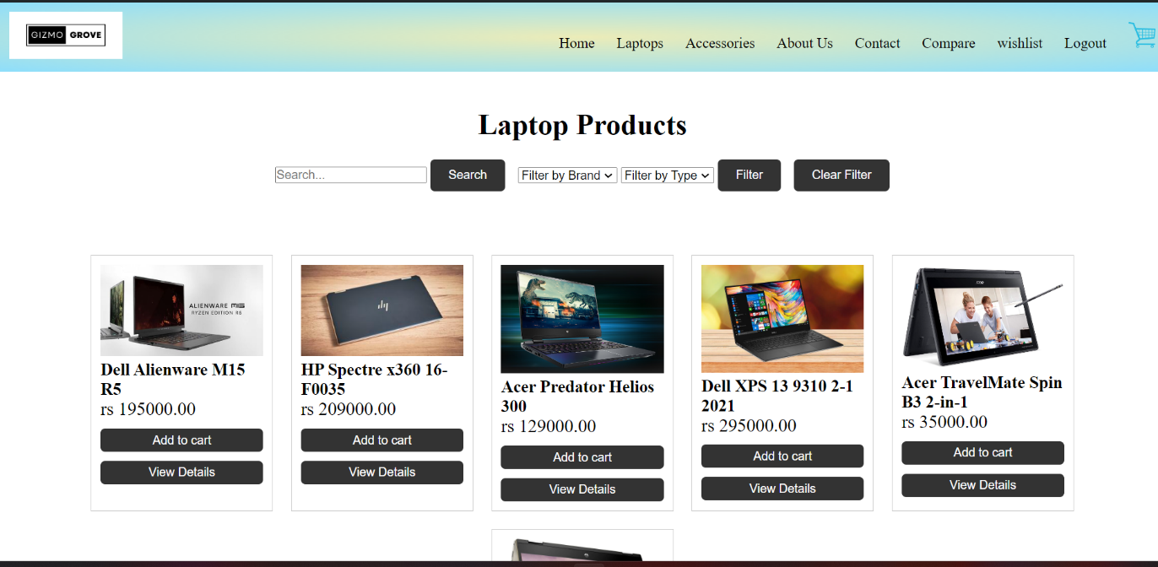

**Figure 14: product section of GizmoGrove**

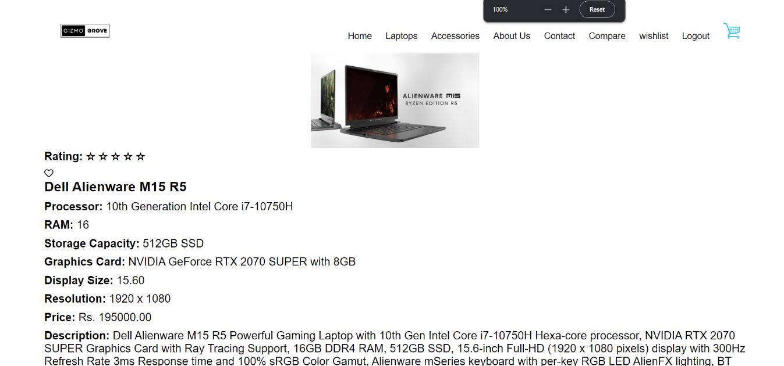

**Figure 15: Product description page of GizmoGrove**

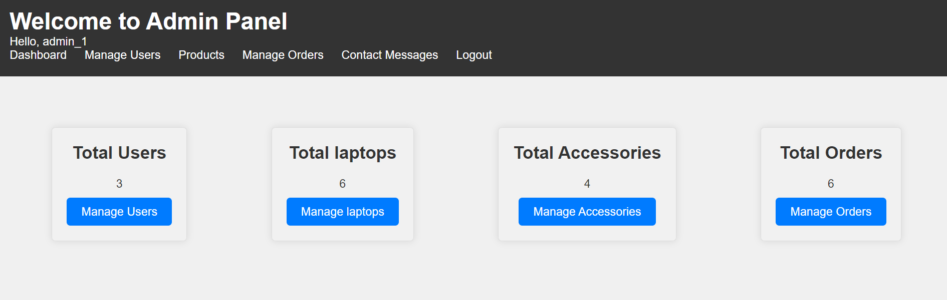

**Figure 16: Admin panel page of GizmoGrove.**

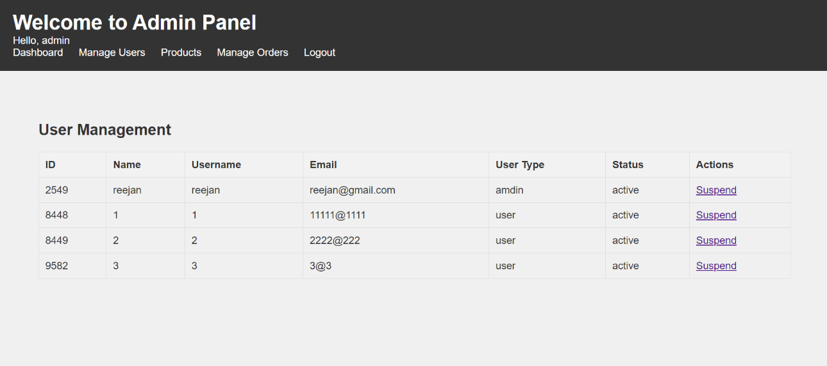

**Figure 17: User management page of GizmoGrove.**

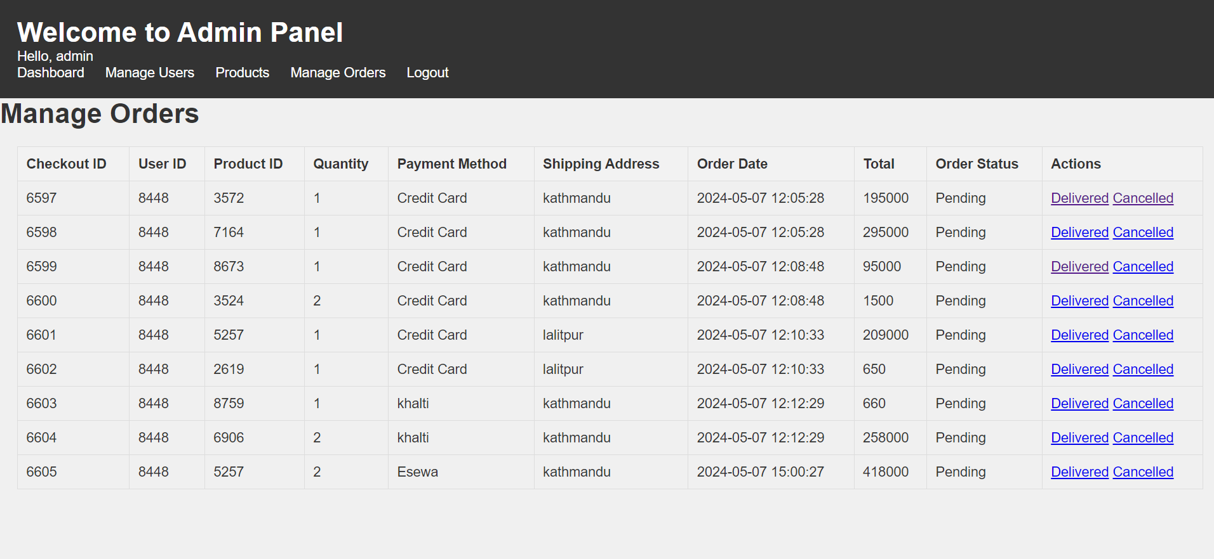

**Figure 18: Order management page of GizmoGrove.**