**Tribhuvan University**



**Faculty of Humanities and Social Sciences**

**SAFEPAWS**

An animal welfare system

A PROJECT PROPOSAL

**Submitted to**

**Department of Computer Application**

**Kathmandu Business Campus**

**Banasthali, Kathmandu**

***In partial fulfillment of the requirements for the Bachelors in Computer Application***

**Submitted by**

Anuj Sijapati Saait Prasad Pradhan

BCA 4th Semester BCA 4th Semester

Reg. No: 6-2-1219-2-2022 Reg. No: 6-2-1219-23-2022

Roll No.: 02 Roll No.: 23

**Introduction**

## Introduction of Proposed project:

**SafePaws** will be an innovative web-based platform designed to support animals in need by connecting shelters with vital resources and fostering collaboration among animal welfare organizations. The platform will enable users to report lost pets, facilitate fostering and adoption, and provide access to essential resources on animal care and welfare. By streamlining these processes, SafePaws will enhance the efficiency and effectiveness of animal rescue efforts, helping more pets find loving homes and ensuring that they receive the care they need.

In addition to its core services, SafePaws will offer specialized features such as pet training, veterinary support, and grooming, allowing users to connect with certified professionals for tailored care. The platform will also provide educational materials on topics like nutrition, behavior, and health, empowering users with the knowledge needed to responsibly care for their pets. By centralizing these resources, SafePaws will create a user-friendly environment where individuals and organizations can work together to improve animal welfare.

Ultimately, SafePaws will serve as a comprehensive hub for animal welfare, promoting a culture of compassion and proactive involvement within the community. By connecting users with the necessary tools and services, SafePaws will drive meaningful change, ensuring that animals in need receive the support and protection they deserve.

"SafePaws: Where compassion meets action—empowering you to save lives, one paw at a time.".

## Problem Statement:

• Significant gap in coordinating efforts to help stray and abandoned animals.

• People who wish to help often struggle to find reliable information and contacts.

• Resources are scattered, making it difficult for shelters to connect and provide necessary support.

## Objectives

• To enable users to report lost pets, find animals for adoption, or offer to foster them.

• To provides educational resources on pet care, adoption processes, and more.

• To facilitates the connection of shelters with necessary resources, such as pet training, veterinary support, and grooming services.

## Scope and Limitations

**Scope**

* The platform will connect users with animal shelters and rescue organizations, enabling them to report lost pets, adopt or foster animals, and access necessary resources.
* It will serve as an educational resource, providing information on pet care, animal welfare, and related topics.
* It will offer access to pet training services, veterinary support, and pet grooming resources to ensure the well-being of animals in need.

## 

## Limitations

* It won't handle donations or payments, redirecting users to external platforms for these.
* It won't manage the legal process of adoption; users must contact shelters or legal entities directly.

# Literature Review

Through our research, we identified several platforms that share Safe Paws' mission of supporting animals in need. Notable examples include Sneha care, Kat Centre Nepal, and Hart Nepal. These platforms are committed to animal welfare, providing various services such as shelter information, adoption resources, and support for stray animals.

Sneha care focuses on adoption services and emergency response for animals in distress, offering detailed information and resources. Kat Centre Nepal specializes in rescuing and fostering stray animals, providing tools for reporting lost pets and connecting with shelters. Hart Nepal supports animal rescue and adoption, featuring educational content on animal care and welfare. While these platforms are valuable, their services are often broad and can be fragmented, making it difficult for users to find specific information or connect with the right resources efficiently.

In addition to these platforms, recent research highlights a growing trend where singles and couples, especially in urban areas, are increasingly choosing to raise pets as family members instead of having more children. This shift has led to a rise in the pet population and a corresponding demand for high-quality pet products and services, including pet grooming. Pet grooming services, which encompass everything from basic hygiene to advanced care like spa treatments and creative grooming, are now more essential than ever for pet parents, who are willing to invest significantly in their pets' well-being.

Safe Paws seeks to address the challenges faced by existing platforms by offering a centralized hub dedicated to connecting users with shelters, and resources. Unlike the broader scope of other platforms, Safe Paws will focus on streamlining communication and providing targeted services such as pet training, veterinary support, and grooming. By narrowing its focus, Safe Paws will enhance the quality of interactions and support, delivering a more specialized and effective solution for animal welfare.

The rise in pet ownership, particularly among those who see pets as family members, underlines the importance of Safe Paws’ mission. The platform aims to meet the increasing demand for specialized, high-quality services, ensuring that pet parents have easy access to the resources and support they need. In doing so, Safe Paws will not only contribute to animal welfare but also foster a community of responsible and compassionate pet ownership.

# Methodology

Our project has specific documentation, time and the fixed requirements, which makes the waterfall methodology the most appropriate system for this development life cycle. This is the reason why we are using Waterfall Model.

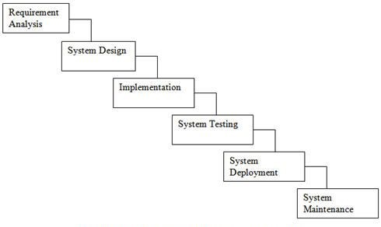

**Figure: Waterfall Model**

The Waterfall Model was the first Process Model. It is also referred as a linear- sequential life cycle model. It is very simple to understand as well as for the use. Each phase must be completed before the next phase can begin.

Waterfall model can’t be used to develop the software having high risk and complex nature.

## System Analysis:

System Analysis is the process in which a system is studied in such way that an information system can be analyzes, modeled, and a logical alternative can be chosen.

It is conducted for the purpose of studying a system or its parts in order to identify its objectives. It is a problem-solving technique that improves the system and ensures that all the components of the system work efficiently to accomplish their purpose.

## 3.1.1. Requirements Identification:

Requirement identification is a most needed step in the development of our project SafePaws system. System needs to fulfill following function and non-functional requirements.

## 3.1.1.1. Functional Requirements:

* Users will be able to create and manage accounts and securely log in.
* Users will be able to report lost pets with details, photos, and location information.
* The platform will provide features for connecting with shelters and accessing services such as pet training, veterinary support, and grooming.
* Users will have the ability to browse for animals available for adoption or fostering.
* The platform will offer resources and educational content on pet care, animal welfare, and related topics.

## Non-Functional Requirements:

* + - **Availability**: Our system(website) will be available online.
    - **Security**: This system will be secured as the document/license of the user will not be visible to other except admin.
    - **Performance**: This system will be optimized to have a smooth performance.
    - **Reliability**: It will be very reliable for the users as we exclude every other third parties.
    - **Usability:** This system will be focused for user experience and user-friendly interface.

## Feasibility Study:

A feasibility study is an analysis that consider all of a project’s affecting factors like economic, technical, legal and scheduling considerations.

* + - * **Technical Feasibility:** This system (website) is technically feasible because we are using pre-existing technical tools and software that are most commonly used.
      * **Economic Feasibility:** The cost for this development is minimum other than internet and it doesn’t require extra software and hardware so it is affordable.
      * **Operational Feasibility:** This system is user friendly and uses simple technology. So, everyone can use without any tutorial.

**3.3 Tools:**

**Frontend:**

* HTML
* CSS
* JavaScript

**Backend:**

* PHP
* MYSQL

**Design Tools:**

* Photoshop
* Canvas
* Draw.io

## 

## 3.4. System Design:

## 3.4.1 Data Flow Diagram:

**Context Level:**

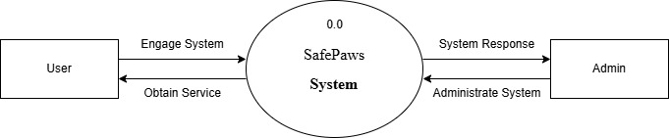

**Figure: Context Level Diagram**

**Gantt Chart (Project Schedule)**

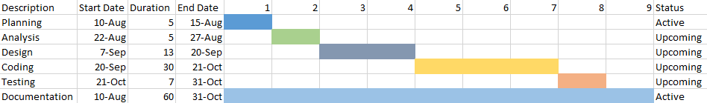

**Fig: Gantt Chart**

By using a Gantt chart, we can visualize the project schedule, identify critical path tasks, and manage dependencies to ensure that the project is completed on time and within budget.

According to our Gantt chart, Task 1, Planning is the first step in the project and is expected to take 5 days. Task 2, Analysis is expected to take 5 days. Task 3, Design is expected to take 13 days. Task 4, Coding is expected to take 30 days. Task 5, Testing is expected to take 7 days. Task 6, Documentation is an ever-going process so, it is active all the time from start of the project to the end of the project.

## Expected Outcome

The expected outcome of this project is to create a user-friendly, informative, and impactful platform that significantly enhances the community's ability to support and care for animals in need. By offering a centralized hub of resources, including educational materials, pet training, veterinary support, and grooming services, SafePaws aims to empower users to take actionable steps in animal welfare.

Through intuitive design and engaging content, SafePaws will facilitate a deeper understanding of the challenges faced by animals and provide practical solutions for addressing these issues. By fostering a culture of compassion and proactive involvement, the project aspires to build a more empathetic and supportive society.

In addition to individual engagement, SafePaws will serve as a valuable tool for collaboration among animal shelters and welfare organizations. By streamlining communication and coordination efforts, it will help amplify the impact of collective initiatives and drive meaningful change in the lives of animals.

Ultimately, this project seeks to create a positive ripple effect, inspiring users to make a difference in their communities while promoting a sustainable and compassionate approach to animal care and advocacy. SafePaws will stand as a specialized platform dedicated to connecting users with the essential resources and services necessary to ensure the well-being of animals in need.

# References

|  |  |
| --- | --- |
|  |  |
|  |  |
| [1]  [2] | **Mahidol University College of Management.** (2024). Research on Pet Industry Growth [Online]. Available: <https://archive.cm.mahidol.ac.th/handle/123456789/5127>.  [Accessed: 14-Aug-2024].  **Doe, J.** (2023). Analysis of Pet Grooming Services Market. [Online]. Available: <https://www.proquest.com/openview/c7f89e8396bf10658cd8ea207fb2fe37/1.pdf?pq-origsite=gscholar&cbl=41532>. [Accessed: 14-Aug-2024]. |

### **Bibliography**

[i] Sneha Care. Sneha's Care – Helping Stray Animals in Nepal. [Online]. Available: <https://www.snehacare.org>. [Accessed: 14-Aug-2024].

[ii] Kat Centre Nepal. Kathmandu Animal Treatment Centre. [Online]. Available: <https://www.katcentre.org.np>. [Accessed: 14-Aug-2024].

[iii] Hart Nepal. Himalayan Animal Rescue Trust (HART) Nepal. [Online]. Available: <https://www.hartnepal.org>. [Accessed: 14-Aug-2024].