

**Tribhuvan University**

**Faculty of Humanities and Social Sciences**

**“SAFEPAWS”**

An animal welfare system

**A PROJECT REPORT**

**Submitted to**

**Department of Computer Application**

**Kathmandu Business Campus**

***In partial fulfillment of the requirements for the Bachelors in Computer Application***

Submitted by

Anuj Sijapati Saait Prasad Pradhan

BCA 4th Semester BCA 4th Semester

University SN: 6-2-1219-2-2022 University SN: 6-2-1219-23-2022

Roll No: 2 Roll No: 23

Under the Supervision of

**Mr. Uddhav Bhattrai**



**Tribhuvan University**

**Faculty of Humanities and Social Sciences**

**Kathmandu Business Campus**

**Banasthali, Balaju**

**Supervisor’s Recommendation**

I hereby recommend that this project prepared under my supervision by **Anuj Sijapati ( reg no:6-2-1219-2-2022)** and **Saait Prasad Pradhan(reg no:6-2-1219-23-2022)** entitled **“SAFEPAWS :An animal welfare system”** in the Partial Fulfillment of requirement for the degree of Bachelor in Computer Application is recommended for that final evaluation.

Uddhav Bhattrai

Project Supervisor

BCA Department

Kathmandu Business Campus



**Tribhuvan University**

**Faculty of Humanities and Social Sciences**

**Kathmandu College of Technology**

**LETTER OF APPROVAL**

This is to certify that this project prepared by **Anuj Sijapati** and **Saait Prasad Pradhan** entitled “**SAFEPAWS: An animal welfare system”** in partial fulfillment of the requirements for the degree of Bachelor in Computer Application has been evaluated. In our opinion it is satisfactory in the scope and quality as a project for the required degree.

Uddhav Bhattrai Ram Prasad Subedi

Supervisor Program Coordinator

BCA Department Kathmandu Business Campus

Kathmandu Business Campus

Internal Examiner External Examiner

**ABSTRACT**

The proposed SafePaws platform is an animal welfare system designed to support and enhance the rescue and care of animals in need. SafePaws provides a comprehensive online environment where users can report lost pets, access adoption and fostering resources, and find educational materials on pet care and welfare. This user-friendly platform is tailored to facilitate seamless interactions between animal shelters, veterinary professionals, and pet owners, encouraging community involvement in animal welfare efforts. Key features of SafePaws include user registration, lost pet reporting, pet adoption listings, training and grooming services, and access to veterinary support.

Through thorough system analysis and design, SafePaws was structured with a robust and scalable architecture, leveraging modern technologies and best practices to ensure reliability, security, and efficiency. Designed with an emphasis on usability and accessibility, the platform offers intuitive navigation and relevant resources to empower users to take an active role in supporting animal welfare. Administrators benefit from streamlined management tools to efficiently maintain and update services. With a vision for continuous improvement, SafePaws aims to expand its resources and services to meet evolving community needs, providing a centralized hub that promotes compassion, collaboration, and proactive action in animal care.

Keywords: animal welfare, SafePaws, online platform, pet adoption, lost pets, community support, veterinary services, training and grooming, system analysis, system design, scalability, security, user-friendly, animal rescue, continuous improvement.

**ACKNOWLEDGEMENT**

We would like to express our sincere gratitude to our supervisor, Mr. Uddhav Bhattrai, for his invaluable guidance, support, and encouragement throughout the development of this project, “SafePaws: An Animal Welfare System.” His insights and expertise provided us with a golden opportunity to expand our knowledge in web development and the use of technologies for social good.

Our heartfelt thanks go to our BCA Program Coordinator, Mr. Ram Prasad Subedi, for his constant support and encouragement, which has been instrumental in our personal and professional growth. His commitment to our development has been a major factor in the successful completion of this project.

We are deeply grateful to Kathmandu Business Campus for their ongoing guidance and support. Their provision of essential resources and an environment conducive to learning has been crucial in the accomplishment of our project goals.

Special thanks to our families and friends, whose constant encouragement and assistance helped us complete this project within the limited time frame.

Finally, we would like to thank Tribhuvan University for including such an insightful project component in the Bachelor of Computer Application program. This project has allowed us to gain a deeper understanding of project ethics, broaden our technical skills, and further our commitment to making a positive impact in the field of animal welfare.

Yours sincerely,

Anuj Sijapati

Saait Prasad Pradhan

**LIST OF ABBREVIATIONS**

CRUD Create, Read, Update and Delete

CSS Cascading Style Sheet

DFD Data Flow Diagram

ERD Entity Relationship Diagram

HTML Hyper Text Markup Language

JS Java Script

MySQL Microsoft Server Structured Query Language

PHP Hypertext Preprocessor

**TABLE OF CONTENTS**

Contents

Supervisor’s recommendation ii

Letter of approval iii

Abstract iv

Acknowledgement v

List of abbreviations vi

List of figures  ix

List of tables x

CHAPTER 1 1

INTRODUCTION 1

1.1 Introduction 1

1.2 Problem Statement 2

1.3 Objectives 2

1.4 Scope and limitation 2

1.4.1 Scope 2

1.4.2 Limitation 2

1.5 Report Organization 3

CHAPTER 2 4

BACKGROUND STUDY AND LITERATURE REVIEW 4

2.1 Study of existing systems 4

2.2 Literature review 5

CHAPTER 3 6

SYSTEM ANALYSIS AND DESIGN 6

3.1 System Analysis 6

3.1.1 Requirement Identification 7

3.1.2 Feasibility Study 8

3.1.3 Data Modeling (ER-diagram) 9

3.1.4 Process Modeling (DFD) 10

3.2 System Design 12

3.2.1 Architectural Design 12

3.2.2 System flowchart 12

3.2.3 Database schema design 15

3.2.4 Interface Design (UI Interface) 15

Appendix……………………………………………………………………………………….17

References 19

**LIST OF FIGURES**

Figure 3.1 Waterfall model for Safepaws website. 6

Figure 3.2: Use case diagram for Safepaws website. 7

Figure 3.3: Gantt chart for Safepaws website. 8

Figure 3.4: Entity Relationship diagram for Safepaws website. 9

Figure 3.5: level 0 DFD for Safepaws website 10

Figure 3.6: level 1 DFD for Safepaws website 11

Figure 3.7: Architecture Design of Safepaws website 12

Figure 3.8: Flowchart of Safepaws website for user 13

Figure 3.9: Flowchart of Safepaws website for admin 14

Figure 3.10: Database Schema Design 15

**LIST OF TABLES**

Table 3.1: Gantt chart Table for Safepaws website………………………………........9

# CHAPTER 1

# INTRODUCTION

## Introduction

SafePaws is an innovative platform designed to support animals in need by connecting shelters with resources and promoting animal welfare collaboration. With its mission to centralize resources and improve animal rescue efforts, SafePaws aims to make a positive impact on the lives of animals and their caretakers.

At SafePaws, we believe that every animal deserves a loving home. Our platform offers various services, including pet adoption, pet training, veterinary support, grooming, and educational materials on animal care. Users can report lost or found pets, adopt animals, access veterinary care, and find expert guidance on animal welfare.

Our website is designed to create a seamless and supportive experience for individuals who want to contribute to the welfare of animals. Through SafePaws, users can easily search for available pets, connect with shelters, and access a wealth of information on responsible pet ownership.

We are committed to building a compassionate community where animal lovers can come together to make a difference. SafePaws is a safe, reliable platform where users can be assured of making informed decisions while fostering or adopting pets.

In conclusion, SafePaws is more than just a website; it's a movement for animal welfare. Whether you're looking to adopt a pet, access veterinary services, or simply learn more about caring for animals, SafePaws is here to support you every step of the way.

## Problem Statement

* Significant gap in coordinating efforts to help stray and abandoned animals.
* People who wish to help often struggle to find reliable information and contacts.
* Resources are scattered, making it difficult for shelters to connect and provide necessary support.

## Objectives

* To enable users to report lost pets, find animals for adoption, or offer to foster them.
* To provides educational resources on pet care, adoption processes, and more.
* To facilitates the connection of shelters with necessary resources, such as pet training, veterinary support, and grooming services.

## Scope and limitation

### Scope

* The platform will connect users with animal shelters and rescue organizations, enabling them to report lost pets, adopt animals, and access necessary resources.
* It will serve as an educational resource, providing information on pet care, animal welfare, and related topics.
* It will offer access to pet training services, veterinary support, and pet grooming resources to ensure the well-being of animals in need.

### Limitation

* It won't handle donations or payments, redirecting users to external platforms for these.
* It won't manage the legal process of adoption; users must contact shelters or legal entities directly.

## Report Organization

The **SafePaws platform** aims to create a user-friendly online space dedicated to animal welfare, connecting shelters, pet owners, and the community. Its focus is on improving the adoption process, enhancing shelter management, ensuring scalability, and delivering a positive user experience. SafePaws addresses challenges like limited resources and competition, with the goal of making a lasting impact on pet adoption and support services, while offering a comprehensive solution that fosters animal welfare.

The **Background Study and Literature Review** explores advancements in animal welfare, particularly the role of digital platforms in pet adoption, shelter management, and community engagement. Insights from other platforms provide valuable tools and features for SafePaws, while current challenges in the sector—such as fragmented services and limited user engagement—highlight the need for integrated digital solutions. These findings guide the development of SafePaws to address existing gaps and improve the welfare of animals.

In the **System Analysis and Design** chapter, the platform’s requirements, architecture, and key functionalities are outlined. Visual diagrams and detailed descriptions of the database schema and user interfaces ensure a clear understanding of how SafePaws will operate. Emphasis is placed on accessibility and scalability, ensuring the platform can efficiently support growing user numbers and remain easy to navigate for all stakeholders.

The **Implementation and Testing** chapter discusses the development tools and technologies used for SafePaws. It outlines the step-by-step implementation process for features like lost pet reporting, shelter management, and access to resources. Thorough testing ensures that the platform is reliable, secure, and user-friendly, identifying any issues to optimize performance and stability across all devices.

Finally, the **Conclusion and Future Recommendations** chapter summarizes the project’s outcomes and lessons learned. SafePaws has successfully met its goals of connecting shelters with adopters and providing resources for pet care. The chapter also offers recommendations for future improvements, such as new features, enhanced user engagement, and exploring research opportunities to strengthen the platform’s impact on animal welfare.

# CHAPTER 2

# BACKGROUND STUDY AND LITERATURE REVIEW

## Study of existing systems

In this section, we examine existing animal welfare platforms to gain insights into best practices, features, and challenges. By analyzing platforms like Sneha Care, Kat Centre Nepal, and Hart Nepal, we can improve the development of SafePaws.

Sneha Care focuses on adoption services and emergency responses for animals in distress. While it provides valuable resources, challenges such as limited-service outreach and complex navigation for users looking for specific information can be improved.

Kat Centre Nepal specializes in rescuing and fostering stray animals, offering tools for reporting lost pets and connecting with shelters. However, fragmented services and the difficulty in accessing targeted resources hinder its efficiency, suggesting the need for more streamlined communication.

Hart Nepal supports animal rescue and adoption, while also educating the public about responsible animal care. Despite its broad scope, Hart Nepal faces issues with user interface and the lack of specialized services like grooming or veterinary support, which SafePaws plans to address.

By learning from these platforms, SafePaws aims to provide a centralized, user-friendly hub for pet owners. The platform will focus on specialized services like pet training, veterinary support, and grooming, ensuring more effective and accessible animal welfare services. With the growing trend of pet ownership, SafePaws will meet the rising demand for high-quality pet services while fostering responsible pet care.

## Literature review

The literature review examines existing research and publications related to animal welfare platforms, focusing on the role of technology in improving animal rescue efforts, user engagement, and service delivery. By reviewing relevant studies, we aim to gain insights into the challenges and opportunities in animal welfare and the integration of digital solutions to support animal care and adoption.

Several studies highlight the growing trend of pet ownership, particularly in urban areas, where pets are increasingly considered family members rather than mere animals. This shift has fueled the demand for specialized pet services, including grooming, veterinary care, and training. Research by Mahidol University College of Management [1] and Doe [2] underscores the rapid expansion of the pet industry and the surging popularity of grooming and training services. These findings resonate with SafePaws’ objective to centralize such services, catering to the evolving needs of modern pet owners.

In addition, research has delved into the role of online platforms in advancing animal adoption and rescue initiatives. Centralized systems are pivotal in connecting pet owners, shelters, and veterinarians, while also streamlining communication and adoption processes. However, challenges such as fragmented services, limited user engagement, and insufficient access to resources often hinder their effectiveness. Community-driven efforts by organizations such as Sneha's Care [3], Kat Centre Nepal [4], and HART Nepal [5] exemplify the potential of grassroots solutions in addressing these obstacles and fostering responsible pet ownership.

Technological advancements have further enhanced the delivery of animal welfare services. Mobile applications and websites designed for pet adoption, reporting lost pets, and accessing veterinary support improve user experiences and expand the reach of welfare programs. Nevertheless, there remains a pressing need for platforms like SafePaws to offer a diverse suite of services, including pet training, grooming, and community engagement, to bridge the existing gaps and provide holistic solutions.

In conclusion, this literature review sheds light on the prevailing trends, challenges, and opportunities in the field of animal welfare. By addressing the limitations of current platforms and harnessing technological innovations, SafePaws aspires to create an efficient, user-centric, and inclusive platform. This initiative will enhance animal welfare efforts while promoting responsible pet ownership and sustainable community engagement.

# CHAPTER 3

# SYSTEM ANALYSIS AND DESIGN

## System Analysis

System analysis is a crucial phase in the development of the SafePaws platform, as it ensures that the system aligns with the needs of both animal shelters and potential pet adopters. This phase plays a pivotal role in understanding the core requirements, functionalities, and components of the platform, ultimately helping to ensure its successful design and implementation.

The development process of SafePaws follows a structured series of steps, beginning with requirement analysis, followed by design, implementation, testing, and deployment. During the requirement analysis phase, both functional and non-functional requirements are carefully examined to understand the needs of the users and the objectives of the platform. Based on these insights, the system is designed to meet these specific needs. Once the design phase is completed, the development and coding process begins. After coding, the system is integrated and thoroughly tested to ensure all features function as intended. Once testing is successfully completed and the platform meets quality standards, it moves into the deployment phase, where it becomes accessible to users.

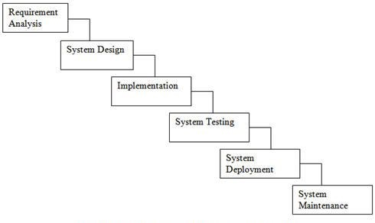

**Figure 3.1 Waterfall model for Safepaws website**

### Requirement Identification

Requirement identification is a most needed step in the development of our project SafePaws system. System needs to fulfill following function and non-functional requirements.

1. **Functional requirement**
   * + - * Users will be able to create and manage accounts and securely log in.
         * Users will be able to report lost pets with details, photos, and location information.
         * The platform will provide features for connecting with shelters and accessing services such as pet training, veterinary support, and grooming.

**USECASE DIAGRAM**

In SafePaws, there are two actors such admin and User where admin can login/register, logout, manage resources, Users and manage the reports of lost pets from the website. Likewise, users can login/register, logout, report pets and view resources from the website.

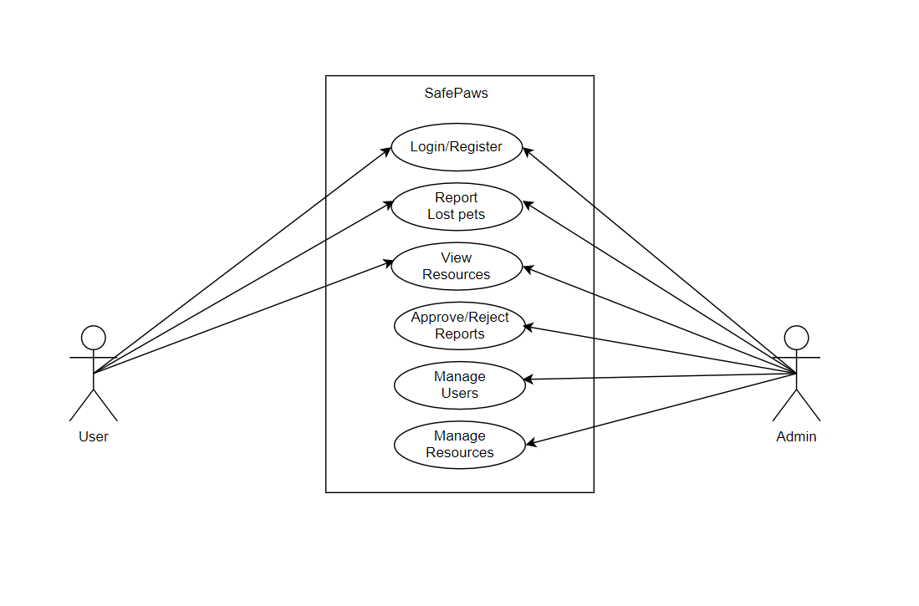

**Figure 3.2: Use case diagram for SafePaws.**

1. **Non-functional requirement**
   * + **Availability**: Our system(website) will be available online.
     + **Security**: This system will be secured as the document/license of the user will not be visible to other except admin.
     + **Performance**: This system will be optimized to have a smooth performance.
     + **Reliability**: It will be very reliable for the users as we exclude every other third parties.

* **Usability:** This system will be focused for user experience and user-friendly interface.

### Feasibility Study

A feasibility study is an analysis that consider all of a project’s affecting factors like economic, technical, legal and scheduling considerations.

* **Technical feasibility**

This system uses existing technologies, software and hardware so there is no technological hurdle to build this system.

* **Operational feasibility**

This system uses simple technologies to design so it is easy to use and understand and it is user-friendly.

* **Schedule feasibility**

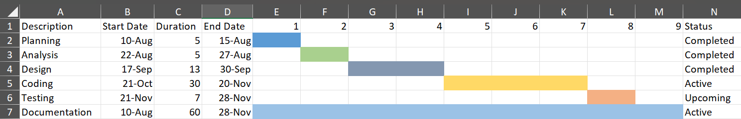The system is completed within scheduled time and do not exceed the scheduled time.

**Figure 3.3: Gantt chart for SafePaws.**

### Data Modeling (ER-diagram)

In Entity-Relationship diagram there are 2 entities named users and Reports. users entity represents the individuals who interact with the platform. Like-wise reports entity represents the lost pet reports created by **Users**.

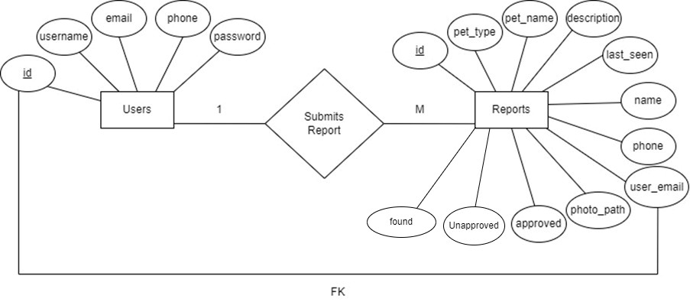

**Figure 3.4: Entity Relationship diagram for SafePaws.**

### Process Modeling (DFD)

Data Flow Diagram of SafePaws: An animal welfare website consists of two levels of DFD context diagram and level one DFD. Both these levels are used for making data flow diagram of SafePaws: An animal welfare website

In context diagram, the user can Engage in the system and Obtain services. The admin can give system response and administrate system.

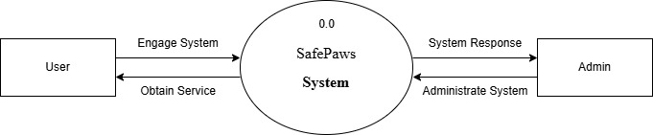

**Figure 3.5: level 0 DFD for SafePaws.**

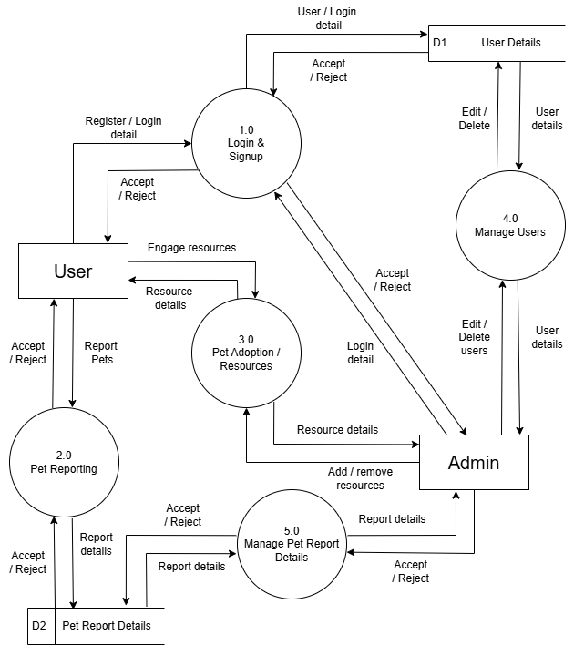

**Figure 3.6: level 1 DFD for SafePaws**

## System Design

To realize the different functional requirement of the system in graphical form, different design diagram of the system has been prepared which are as follows:

### Architectural Design

For this system, three tier architecture is used which includes user interface, web server and database. In architectural design, basic structure of the system is show.

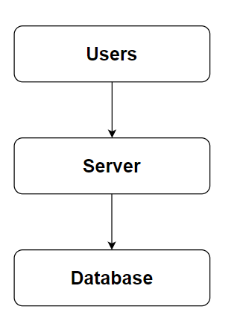

**Figure 3.7: Architecture Design of SafePaws.**

### System flowchart

The flowchart for the SafePaws platform begins with the start of the process. Users are prompted with a question asking if they want to report a lost or found pet. If they do, they are directed to account verification. If the user does not have an account, they proceed to the registration page to create one. If they have an account, they are directed to the login stage where the validity of their credentials is checked. Upon successful validation, they are redirected to the Report Page, where they can submit details about the lost or found pet. After submitting the report, users can choose to explore other features of the platform on the landing page or log out to end the process.

For the admin, the process begins with the start followed by the login stage. The system verifies the validity of the admin's credentials. Upon successful authentication, the admin is directed to the dashboard, where they can manage user information, resources, and pet reports. After completing their tasks, the admin can log out to end the process.

**For user**

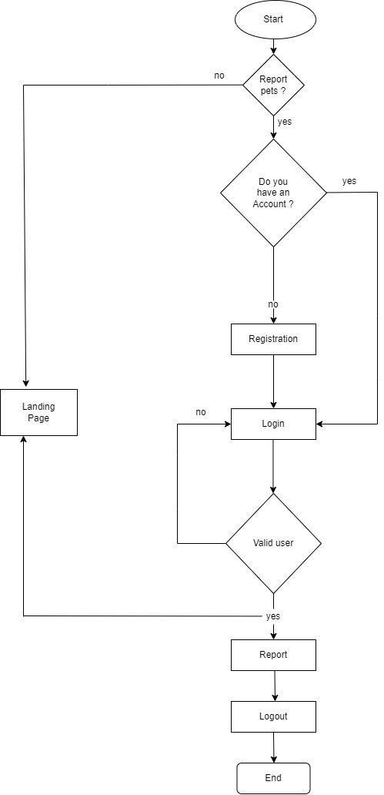

**Figure 3.8: Flowchart of SafePaws website for user**

**For Admin**

**Figure 3.9: Flowchart of SafePaws website for admin**

### Database schema design

The figure below is the database schema design of SafePaws website. Database schema design is used to show basic structure of the system. In the SafePaws website there are two tables in the databases each of them has their own fields where their id is primary key and if that id is used in another table, it becomes foreign key.

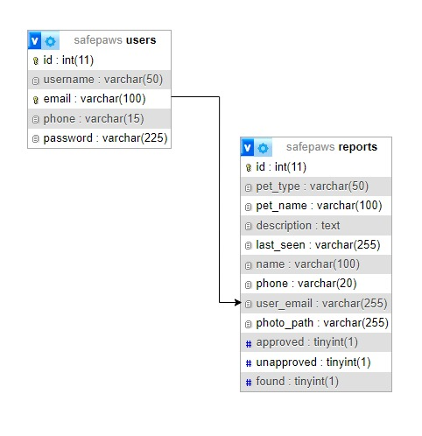

**Figure 3.10: Database Schema Design**

### Interface Design (UI Interface)

Interface design is used to plan how the SafePaws platform will look and function, ensuring a user-friendly experience. This design is presented to users for feedback before finalizing, after which the system development begins. The UI design of the Report Page, Landing Page,Admin Dashboard Page of SafePaws: A platform for animal welfare, are shown in the appendix section.

# CHAPTER 4

# IMPLEMENTATION AND TESTING

## Implementation

### 4.1.1 Tools Used (CASE tools, Programming language, Database platforms)

Following are the tools and framework used for the accomplishment of this project:

* **Front end**
  + **Html:** HTML (Hyper Text Markup Language) was used to create and structure the web pages. This involved organizing content with various elements and tags to define sections, headings, links, and paragraphs, ensuring a clear and accessible structure for the website.
  + **CSS:** CSS, which stands for Cascading Style Sheets, was employed to style the web pages, controlling the presentation and appearance. I used CSS to define text colors, font styles, spacing between paragraphs, column sizes, and layout designs, resulting in a visually appealing and consistent user interface.
  + **JavaScript:** JavaScript was implemented to add interactivity and dynamic behavior to the website. I utilized JavaScript for client-side validation, creating dynamic, interactive, and responsive web pages, and adding special effects to enhance the user experience.
* **Back end**
  + **PHP:** PHP was extensively utilized due to its versatility and powerful features. It was used to generate dynamic content on web pages based on user inputs, database queries, and other external data sources, ensuring personalized and relevant information delivery. PHP handled server-side scripting tasks such as connecting to the database, encrypting data, and validating user inputs, which allowed for secure data transactions and accurate data processing. Additionally, PHP was implemented for user authentication, managing login pages, and controlling user access to specific pages, thereby enhancing the security and overall functionality of the website.
* **Server**
  + - **APACHE SERVER:** Apache Server was used to run PHP files and create fast, dynamic web pages for the SafePaws website.
* **Database**
  + **MYSQL:** MySQL was used as the database management system. It stores user details, product information, orders, and other data related to animal care, fostering, and adoption. MySQL supports efficient data retrieval and ensures secure management of the website’s backend operations.
* **Documentation Tools** 
  + - **MS Office**: MS Office was used for creating and editing documents, spreadsheets, and presentations essential for project documentation, reporting, and communications.
    - **Draw.io:** Draw.io was utilized to create flowcharts, DFDs (Data Flow Diagrams), ER diagrams, and other visual diagrams that helped in the understanding and visualization of the project structure and processes.

### 4.1.2 Implementation Details of Modules

Different modules of this system are described as below:

**Admin module:**

* **Admin manage user module.**

In this module, the admin can view the list of users, their details, and manage them effectively. The admin can access user data such as their registration details and interactions with the website so that everything is running smoothly.

* **Admin manage report module.**

This module allows the admin to manage lost pet’s reports, including approving reports, unapproving reports, and removing lost pet’s reports.

**User module:**

* **User view module.**

Users can browse pet adoption listings, view lost pets, report lost pets and other pet-related services such as veterinary care and grooming.

* **User report module.**

Users have the ability to report lost pets, view the list of lost pets reported by others, and mark a pet as found by clicking the 'Found' button when the pet has been located.

**Login module:**

This module manages the login process for both admins and users. Admins have access to the admin panel, where they can manage all aspects of the website, while users can log into the site separately. Users are limited to viewing and making changes to certain features, while admins have full control over the entire platform.

**Register module:**

Users can register by providing necessary details such as email, username, and password. Once registered, users can log into the system to access features like pet care service and more.

## Testing

System testing is performed to ensure that the SafePaws platform is functioning as expected and providing accurate and secure services. During the phase of the development of the system, our system is tested time and again. The series of testing conducted are as follow:

**Checkout**

**Table 4.1: Test case for checkout of Safepaws**

|  |  |  |  |  |  |
| --- | --- | --- | --- | --- | --- |
| **S.No.** | **Test Name** | **Input** | **Expected Output** | **Actual Output** | **Test Result** |
| 1 | Home Page Navigation | User navigates to the home page | Home page is displayed | Home page is displayed | Pass |
| 2 | Pet Profile View | User clicks on a pet profile | Pet profile page is displayed | Pet profile page displayed | Pass |
| 3 | Add Report (Lost Pet) | User fills out and submits a report form | Report is successfully submitted | Report successfully submitted | Pass |
| 4 | Login/Signup Navigation | User navigates to login/signup page | Login/Signup page is displayed | Login/Signup page displayed | Pass |
| 5 | User Login | User enters valid credentials and logs in | User is redirected to their dashboard | User redirected to their dashboard | Pass |
| 6 | View Services List | User Hovers over "Services” in navbar | Services are displayed | Services are displayed | Pass |
| 7 | View Blog Section | User navigates to blog section | Blog page is displayed | Blog page displayed | Pass |
| 8 | View Notifications | User clicks on the notification icon | User sees a list of personal notifications | Personal notifications displayed | Pass |
| 9 | Found Button | User clicks the "Found" button on their report | A message is sent to the admin that the pet is found | Message successfully sent to the admin panel | Pass |
| 10 | Logout | User clicks "Logout" | User is redirected to the home page | User redirected to the home page | Pass |

# CHAPTER 5

# CONCLUSION AND FUTURE RECOMMENDATIONS

## Lesson Learnt / Outcome

Every project offers an opportunity to learn and grow in various areas. Through the SafePaws project, we have gained valuable experience in problem-solving, teamwork, effective communication, writing skills, and time management.

* + - **Teamwork**

Every project offers an opportunity to learn and grow in various areas. Through the SafePaws project, we have gained valuable experience in problem-solving, teamwork, effective communication, writing skills, and time management.

* + - **Problem Solving Skills**

The project involved overcoming several challenges, helping us sharpen our problem-solving skills. We became proficient in identifying errors and finding efficient solutions to ensure the system worked seamlessly.

* + - **Writing Skills**

Throughout the project, we improved our ability to write proposals, documentation, and technical specifications. We also used various case tools to create essential diagrams like use case, schema, data flow, and entity-relationship diagrams, which were essential in organizing and documenting the project.

* + - **Managing time**

One of the key lessons was learning to prioritize tasks and manage time effectively based on the complexity of the components in the system. We understood the importance of timely execution to meet project deadlines.

## Conclusion

The SafePaws platform has been successfully developed in line with the predefined objectives. The system meets all the goals set at the beginning, offering features like pet adoption, fostering, training, and veterinary support. While users can view certain pages without logging in, access to personalized features (like reporting lost pets, managing pet adoption, etc.) requires registration and login. The system offers an intuitive and smooth user interface, designed to be accessible for both technical and non-technical users alike.

## Future Recommendations

Though the development of SafePaws has been successful, there are areas for improvement and opportunities for further enhancement. Some of the future recommendations include:

Some of the future recommendation for this system are:

* + - Include different roles for the users.
    - Implement password recovery features.
    - Add search feature.
    - Add more filter option.
    - Include More Animal Welfare Services.

**Appendix**

**References**

1. **Mahidol University College of Management. (2024). *Research on Pet Industry Growth*. [Online]. Available:** [**https://archive.cm.mahidol.ac.th/handle/123456789/5127**](https://archive.cm.mahidol.ac.th/handle/123456789/5127)**. [Accessed: Aug. 14, 2024].**
2. **Doe, J. (2023). *Analysis of Pet Grooming Services Market*. [Online]. Available:** [**https://www.proquest.com/openview/c7f89e8396bf10658cd8ea207fb2fe37/1.pdf?pq-origsite=gscholar&cbl=41532**](https://www.proquest.com/openview/c7f89e8396bf10658cd8ea207fb2fe37/1.pdf?pq-origsite=gscholar&cbl=41532)**. [Accessed: Aug. 14, 2024].**

**Bibliography**

**3. Sneha Care. *Sneha's Care – Helping Stray Animals in Nepal*. [Online]. Available:** [**https://www.snehacare.org**](https://www.snehacare.org)**. [Accessed: Aug. 14, 2024].**

**4. Kat Centre Nepal. *Kathmandu Animal Treatment Centre*. [Online]. Available:** [**https://www.katcentre.org.np**](https://www.katcentre.org.np)**. [Accessed: Aug. 14, 2024].**

**5. Himalayan Animal Rescue Trust (HART) Nepal. *Himalayan Animal Rescue Trust (HART) Nepal*. [Online]. Available:** [**https://www.hartnepal.org**](https://www.hartnepal.org)**. [Accessed: Aug. 14, 2024].**