

**Tribhuvan University**

**Faculty of Humanities and Social Sciences**

**“SAFEPAWS”**

An animal welfare system

**A PROJECT REPORT**

**Submitted to**

**Department of Computer Application**

**Kathmandu Business Campus**

***In partial fulfillment of the requirements for the Bachelors in Computer Application***

Submitted by

Anuj Sijapati Saait Prasad Pradhan

BCA 4th Semester BCA 4th Semester

University SN: 6-2-1219-2-2022 University SN: 6-2-1219-23-2022

Roll No: 2 Roll No: 23

Under the Supervision of

**Mr. Uddhav Bhattrai**



**Tribhuvan University**

**Faculty of Humanities and Social Sciences**

**Kathmandu Business Campus**

**Banasthali , Balaju**

**Supervisor’s Recommendation**

I hereby recommend that this project prepared under my supervision by **Anuj Sijapati ( reg no:6-2-1219-2-2022)** and **Saait Prasad Pradhan(reg no:6-2-1219-23-2022)** entitled **“SAFEPAWS :An animal welfare system”** in the Partial Fulfillment of requirement for the degree of Bachelor in Computer Application is recommended for that final evaluation.

Uddhav Bhattrai

Project Supervisor

BCA Department

Kathmandu Business Campus



**Tribhuvan University**

**Faculty of Humanities and Social Sciences**

**Kathmandu College of Technology**

**LETTER OF APPROVAL**

This is to certify that this project prepared by **Anuj Sijapati** and **Saait Prasad Pradhan** entitled “**SAFEPAWS: An animal welfare system”** in partial fulfillment of the requirements for the degree of Bachelor in Computer Application has been evaluated. In our opinion it is satisfactory in the scope and quality as a project for the required degree.

Uddhav Bhattrai Ram Prasad Subedi

Supervisor Program Coordinator

BCA Department Kathmandu Business Campus

Kathmandu Business Campus

Internal Examiner External Examiner

**ABSTRACT**

The proposed SafePaws platform is an animal welfare system designed to support and enhance the rescue and care of animals in need. SafePaws provides a comprehensive online environment where users can report lost pets, access adoption and fostering resources, and find educational materials on pet care and welfare. This user-friendly platform is tailored to facilitate seamless interactions between animal shelters, veterinary professionals, and pet owners, encouraging community involvement in animal welfare efforts. Key features of SafePaws include user registration, lost pet reporting, pet adoption listings, training and grooming services, and access to veterinary support.

Through thorough system analysis and design, SafePaws was structured with a robust and scalable architecture, leveraging modern technologies and best practices to ensure reliability, security, and efficiency. Designed with an emphasis on usability and accessibility, the platform offers intuitive navigation and relevant resources to empower users to take an active role in supporting animal welfare. Administrators benefit from streamlined management tools to efficiently maintain and update services. With a vision for continuous improvement, SafePaws aims to expand its resources and services to meet evolving community needs, providing a centralized hub that promotes compassion, collaboration, and proactive action in animal care.

Keywords: animal welfare, SafePaws, online platform, pet adoption, lost pets, community support, veterinary services, training and grooming, system analysis, system design, scalability, security, user-friendly, animal rescue, continuous improvement.

**ACKNOWLEDGEMENT**

We would like to express our sincere gratitude to our supervisor, Mr. Uddhav Bhattrai, for his invaluable guidance, support, and encouragement throughout the development of this project, “SafePaws: An Animal Welfare System.” His insights and expertise provided us with a golden opportunity to expand our knowledge in web development and the use of technologies for social good.

Our heartfelt thanks go to our BCA Program Coordinator, Mr. Ram Prasad Subedi, for his constant support and encouragement, which has been instrumental in our personal and professional growth. His commitment to our development has been a major factor in the successful completion of this project.

We are deeply grateful to Kathmandu Business Campus for their ongoing guidance and support. Their provision of essential resources and an environment conducive to learning has been crucial in the accomplishment of our project goals. We would also like to thank the library staff and members of Kathmandu Business Campus for their cooperation and assistance, which facilitated our research and development process.

Special thanks to our families and friends, whose constant encouragement and assistance helped us complete this project within the limited time frame.

Finally, we would like to thank Tribhuvan University for including such an insightful project component in the Bachelor of Computer Application program. This project has allowed us to gain a deeper understanding of project ethics, broaden our technical skills, and further our commitment to making a positive impact in the field of animal welfare.

Yours sincerely,

Anuj Sijapati

Saait Prasad Pradhan

**LIST OF ABBREVIATIONS**

CRUD Create, Read, Update and Delete

CSS Cascading Style Sheet

DFD Data Flow Diagram

ERD Entity Relationship Diagram

HTML Hyper Text Markup Language

JS Java Script

MySQL Microsoft Server Structured Query Language

PHP Hypertext Preprocessor

**TABLE OF CONTENTS**

Contents

Supervisor’s recommendation ii

Letter of approval iii

Abstract iv

Acknowledgement v

List of abbreviations vi

List of figures  ix

List of tables x

CHAPTER 1 1

INTRODUCTION 1

1.1 Introduction 1

1.2 Problem Statement 2

1.3 Objectives 2

1.4 Scope and limitation 2

1.4.1 Scope 2

1.4.2 Limitation 2

1.5 Report Organization 3

CHAPTER 2 4

BACKGROUND STUDY AND LITERATURE REVIEW 4

2.1 Study of existing systems 4

2.2 Literature review 5

CHAPTER 3 6

SYSTEM ANALYSIS AND DESIGN 6

3.1 System Analysis 6

3.1.1 Requirement Identification 7

3.1.2 Feasibility Study 8

3.1.3 Data Modeling (ER-diagram) 9

3.1.4 Process Modeling (DFD) 10

3.2 System Design 12

3.2.1 Architectural Design 12

3.2.2 System flowchart 12

3.2.3 Database schema design 15

3.2.4 Interface Design (UI Interface) 15

Appendix……………………………………………………………………………………….16

References 18

**LIST OF FIGURES**

Figure 3.1 Waterfall model for Safepaws website. 6

Figure 3.2: Use case diagram for Safepaws website. 7

Figure 3.3: Gantt chart for Safepaws website. 8

Figure 3.4: Entity Relationship diagram for Safepaws website. 9

Figure 3.5: level 0 DFD for Safepaws website 10

Figure 3.6: level 1 DFD for Safepaws website 11

Figure 3.7: Architecture Design of Safepaws website 12

Figure 3.8: Flowchart of Safepaws website for user 14

Figure 3.9: Flowchart of Safepaws website for admin 15

Figure 3.10: Database Schema Design 15

**LIST OF TABLES**

Table 3.1: Gantt chart Table for Safepaws website………………………………........9

# CHAPTER 1

# INTRODUCTION

## Introduction

SafePaws is an innovative platform designed to support animals in need by connecting shelters with resources and promoting animal welfare collaboration. With its mission to centralize resources and improve animal rescue efforts, SafePaws aims to make a positive impact on the lives of animals and their caretakers.

At SafePaws, we believe that every animal deserves a loving home. Our platform offers various services, including pet adoption, pet training, veterinary support, grooming, and educational materials on animal care. Users can report lost or found pets, adopt animals, access veterinary care, and find expert guidance on animal welfare.

Our website is designed to create a seamless and supportive experience for individuals who want to contribute to the welfare of animals. Through SafePaws, users can easily search for available pets, connect with shelters, and access a wealth of information on responsible pet ownership.

We are committed to building a compassionate community where animal lovers can come together to make a difference. SafePaws is a safe, reliable platform where users can be assured of making informed decisions while fostering or adopting pets.

In conclusion, SafePaws is more than just a website; it's a movement for animal welfare. Whether you're looking to adopt a pet, access veterinary services, or simply learn more about caring for animals, SafePaws is here to support you every step of the way.

## Problem Statement

* Significant gap in coordinating efforts to help stray and abandoned animals.
* People who wish to help often struggle to find reliable information and contacts.
* Resources are scattered, making it difficult for shelters to connect and provide necessary support.

## Objectives

* To enable users to report lost pets, find animals for adoption, or offer to foster them.
* To provides educational resources on pet care, adoption processes, and more.
* To facilitates the connection of shelters with necessary resources, such as pet training, veterinary support, and grooming services.

## Scope and limitation

### Scope

* The platform will connect users with animal shelters and rescue organizations, enabling them to report lost pets, adopt animals, and access necessary resources.
* It will serve as an educational resource, providing information on pet care, animal welfare, and related topics.
* It will offer access to pet training services, veterinary support, and pet grooming resources to ensure the well-being of animals in need.

### Limitation

* It won't handle donations or payments, redirecting users to external platforms for these.
* It won't manage the legal process of adoption; users must contact shelters or legal entities directly.

## Report Organization

The SafePaws platform aims to create a user-friendly online space dedicated to animal welfare, fostering connections between shelters, pet owners, and the community. The project focuses on improving the adoption and care process, streamlining shelter management, ensuring scalability, and enhancing the overall user experience. Despite potential challenges like resource limitations and competition, SafePaws is driven by the mission to improve animal welfare and make a lasting impact on pet adoption and support services. Ultimately, the goal is to provide a comprehensive solution that supports animals and individuals in need, fostering growth in animal welfare initiatives.

Background Study and Literature Review  
This chapter reviews recent advancements in animal welfare, with a focus on online platforms and their role in enhancing pet adoption, shelter management, and community engagement. It also examines key features of popular animal welfare platforms, offering insights into the features and tools that can benefit the development of SafePaws. The chapter discusses current challenges in the animal welfare sector and how digital solutions can help address those needs.

System Analysis and Design  
This chapter analyzes the system requirements, feasibility, and overall architecture of the SafePaws platform. It includes visualizations of the platform's structure through diagrams and outlines the design of the database schema, user interfaces, and key functionalities. The chapter emphasizes ensuring accessibility, ease of use, and scalability, particularly in terms of supporting growing numbers of users and animals.

Implementation and Testing  
This chapter details the tools and technologies used in the development of the SafePaws platform, including the implementation steps and the testing procedures. It focuses on validating system functionality, ensuring that all features—such as lost pet reporting, shelter management, and educational resources—are working as intended. Comprehensive testing is conducted to ensure that the platform is reliable, secure, and user-friendly across all devices.

Conclusion and Future Recommendations  
The chapter summarizes the outcomes of the SafePaws project, reflecting on the lessons learned during development. It highlights the platform's success in meeting its goals, such as connecting shelters with potential adopters and providing comprehensive resources for pet care. The chapter also provides recommendations for enhancing the platform, including the addition of new features, improved user engagement, and potential research directions in the field of digital solutions for animal welfare.

# CHAPTER 2

# BACKGROUND STUDY AND LITERATURE REVIEW

## Study of existing systems

In this section, we examine existing animal welfare platforms to gain insights into best practices, features, and challenges. By analyzing platforms like Sneha Care, Kat Centre Nepal, and Hart Nepal, we can improve the development of SafePaws.

Sneha Care focuses on adoption services and emergency responses for animals in distress. While it provides valuable resources, challenges such as limited-service outreach and complex navigation for users looking for specific information can be improved.

Kat Centre Nepal specializes in rescuing and fostering stray animals, offering tools for reporting lost pets and connecting with shelters. However, fragmented services and the difficulty in accessing targeted resources hinder its efficiency, suggesting the need for more streamlined communication.

Hart Nepal supports animal rescue and adoption, while also educating the public about responsible animal care. Despite its broad scope, Hart Nepal faces issues with user interface and the lack of specialized services like grooming or veterinary support, which SafePaws plans to address.

By learning from these platforms, SafePaws aims to provide a centralized, user-friendly hub for pet owners. The platform will focus on specialized services like pet training, veterinary support, and grooming, ensuring more effective and accessible animal welfare services. With the growing trend of pet ownership, SafePaws will meet the rising demand for high-quality pet services while fostering responsible pet care.

## Literature review

The literature review examines existing research and publications related to animal welfare platforms, focusing on the role of technology in improving animal rescue efforts, user engagement, and service delivery. By reviewing relevant literature, we aim to gain insights into the challenges and opportunities in the field of animal welfare and the integration of digital solutions to support the care and adoption of animals.

Several studies have explored the growing trend of pet ownership, particularly in urban areas, where pets are increasingly viewed as family members rather than just animals. This shift has led to an increased demand for specialized pet services, including grooming, veterinary care, and training. Studies such as those conducted by Mahidol University College of Management [2] and Doe (2023) [2] highlight the rapid growth of the pet industry and the rising popularity of grooming and training services. These findings align with SafePaws’ aim to centralize such services to meet the needs of modern pet owners.

Additionally, research has explored the role of online platforms in enhancing animal adoption and rescue efforts. Centralized systems play a critical role in connecting pet owners, shelters, and veterinarians while streamlining communication and adoption processes [i][ii]. However, challenges such as fragmented services, limited user engagement, and inadequate access to resources often hinder their effectiveness. Initiatives like Sneha's Care, Kat Centre Nepal, and HART Nepal demonstrate the impact of community-driven solutions in overcoming these obstacles and promoting responsible pet ownership [i][ii][iii].

Furthermore, technological advancements have significantly improved the delivery of animal welfare services. The use of mobile applications and websites for pet adoption, reporting lost pets, and accessing veterinary support enhances user experience and broadens the reach of welfare programs. Nonetheless, the need for platforms like SafePaws to offer a diverse range of specialized services—such as pet training, grooming, and community engagement—remains critical to addressing existing gaps [ii][iii].

In conclusion, this literature review provides valuable insights into the current trends, challenges, and opportunities in animal welfare. By addressing the limitations of existing platforms and leveraging advanced technological solutions, SafePaws seeks to create an efficient, user-friendly, and inclusive platform that supports animal welfare and promotes responsible pet ownership.

# CHAPTER 3

# SYSTEM ANALYSIS AND DESIGN

## System Analysis

System analysis is a crucial phase in the development of the SafePaws platform, as it ensures that the system aligns with the needs of both animal shelters and potential pet adopters. This phase plays a pivotal role in understanding the core requirements, functionalities, and components of the platform, ultimately helping to ensure its successful design and implementation.

The development process of SafePaws follows a structured series of steps, beginning with requirement analysis, followed by design, implementation, testing, and deployment. During the requirement analysis phase, both functional and non-functional requirements are carefully examined to understand the needs of the users and the objectives of the platform. Based on these insights, the system is designed to meet these specific needs. Once the design phase is completed, the development and coding process begins. After coding, the system is integrated and thoroughly tested to ensure all features function as intended. Once testing is successfully completed and the platform meets quality standards, it moves into the deployment phase, where it becomes accessible to users.

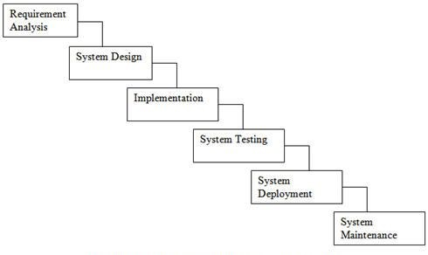

**Figure 3.1 Waterfall model for Safepaws website.**

### Requirement Identification

Requirement identification is a most needed step in the development of our project SafePaws system. System needs to fulfill following function and non-functional requirements.

1. **Functional requirement**
   * + - * Users will be able to create and manage accounts and securely log in.
         * Users will be able to report lost pets with details, photos, and location information.
         * The platform will provide features for connecting with shelters and accessing services such as pet training, veterinary support, and grooming.
         * Users will have the ability to browse for animals available for adoption or fostering.
         * The platform will offer resources and educational content on pet care, animal welfare, and related topics.

**USECASE DIAGRAM**

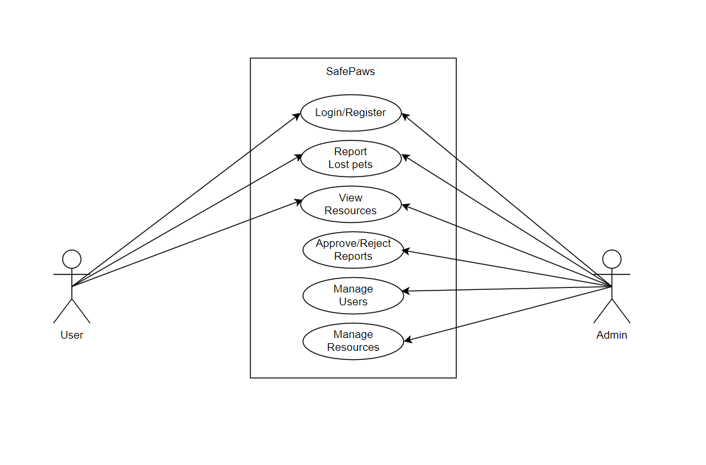In SafePaws, there are two actors such admin and customer where admin can login, logout, manage customer and products from the website. Likewise, customers can register, login, Search Products, View Products, Add to Cart, checkout and logout from the website.

**Figure 3.2: Use case diagram for SafePaws.**

1. **Non-functional requirement**
   * + **Availability**: Our system(website) will be available online.
     + **Security**: This system will be secured as the document/license of the user will not be visible to other except admin.
     + **Performance**: This system will be optimized to have a smooth performance.
     + **Reliability**: It will be very reliable for the users as we exclude every other third parties.

* **Usability:** This system will be focused for user experience and user-friendly interface.

### Feasibility Study

A feasibility study is an analysis that consider all of a project’s affecting factors like economic, technical, legal and scheduling considerations.

* **Technical feasibility**

This system uses existing technologies, software and hardware so there is no technological hurdle to build this system.

* **Operational feasibility**

This system uses simple technologies to design so it is easy to use and understand and it is user-friendly.

* **Schedule feasibility**

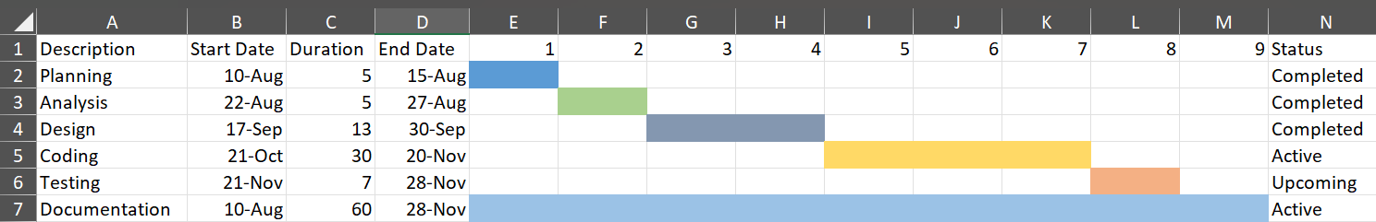The system is completed within scheduled time and do not exceed the scheduled time.

**Figure 3.3: Gantt chart for SafePaws.**

### Data Modeling (ER-diagram)

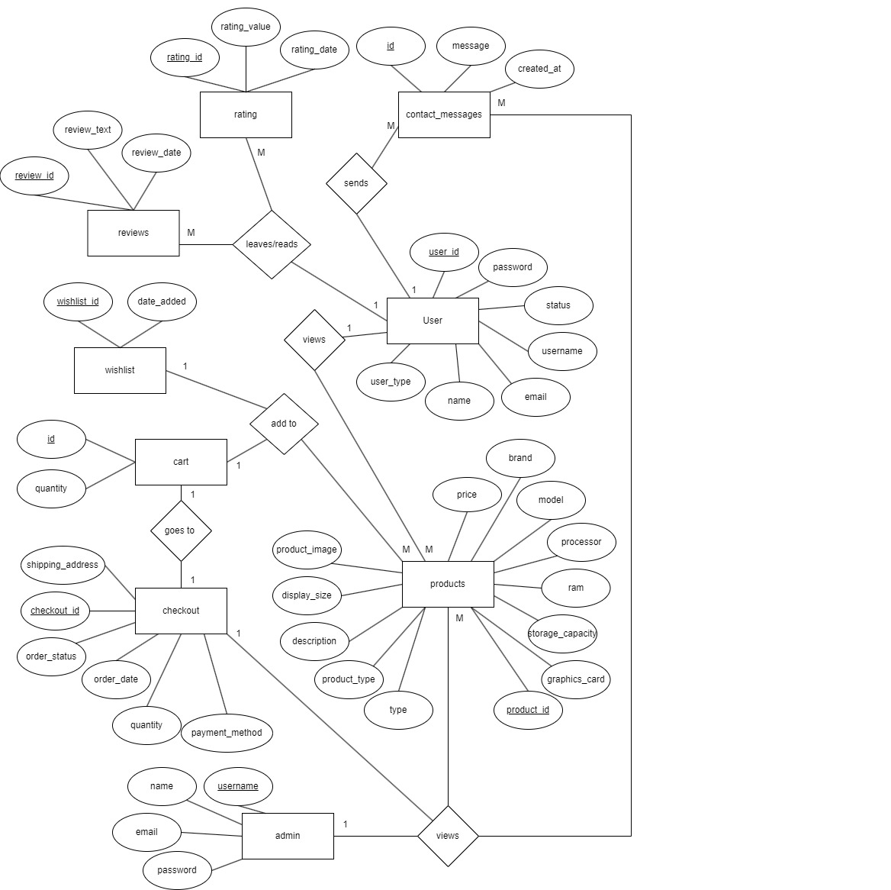In Entity-Relationship diagram there are 9 entities named user, rating, review, contact messages, cart, product, Wishlist, checkout and admin. Products has attributes such as name, brand, id, price. Like-wise user has name, contact, email, user id. Admin can delete user manage products whereas user can view products buy them or add to cart.

**Figure 3.4: Entity Relationship diagram for SafePaws.**

### Process Modeling (DFD)

Data Flow Diagram of SafePaws: An animal welfare website consists of two levels of DFD context diagram and level one DFD. Both these levels are used for making data flow diagram of SafePaws: An animal welfare website

In context diagram, the user can Engage in the system and Obtain services. The admin can give system response and administrate system.

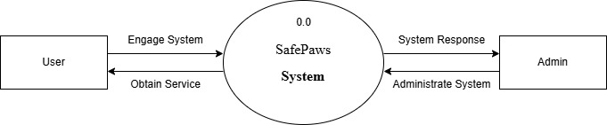

**Figure 3.5: level 0 DFD for SafePaws.**

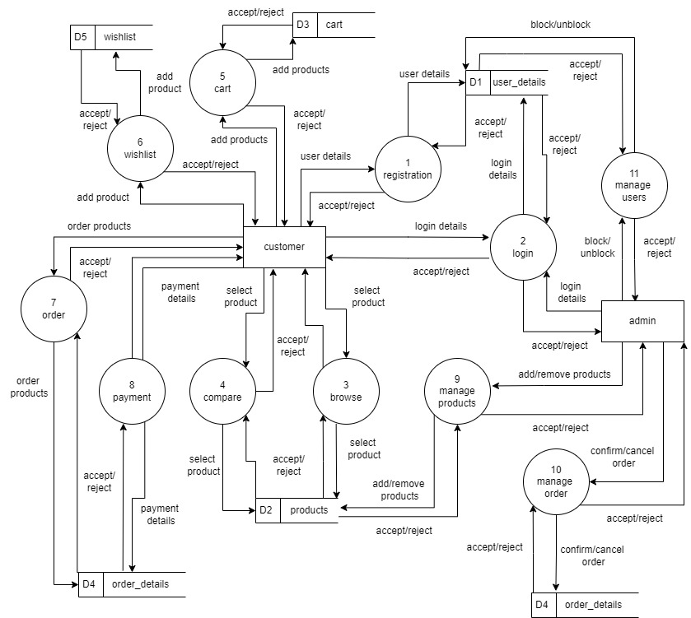

**Figure 3.6: level 1 DFD for SafePaws**

## System Design

To realize the different functional requirement of the system in graphical form, different design diagram of the system has been prepared which are as follows:

### Architectural Design

For this system, three tier architecture is used which includes user interface, web server and database. In architectural design, basic structure of the system is show.

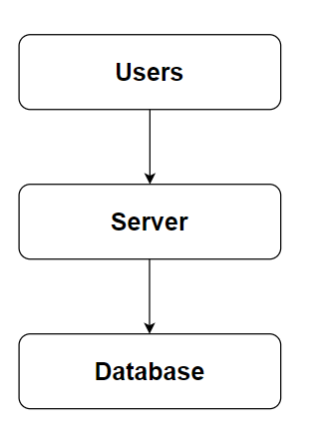

**Figure 3.7: Architecture Design of SafePaws.**

### System flowchart

The flowchart for the E-commerce Website begins with the start of the process. Users are prompted with a question asking if they have an account. If they do, they proceed to the login stage where the validity of their credentials is checked. Upon successful validation, they are directed to the landing page where they can view and buy products, as well as add them to their cart. After selecting their desired items, users proceed to checkout before the process concludes.

For the admin, the process begins with the start followed by login. The system then verifies the validity of the admin's credentials. Upon successful authentication, the admin is directed to the dashboard where they can manage users and products. After completing their tasks, the admin can choose to logout before the process ends.

**For user**

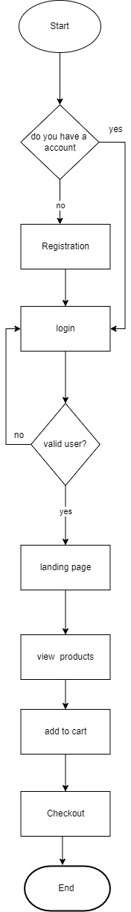

**Figure 3.8: Flowchart of e-commerce website for user**

**For Admin**

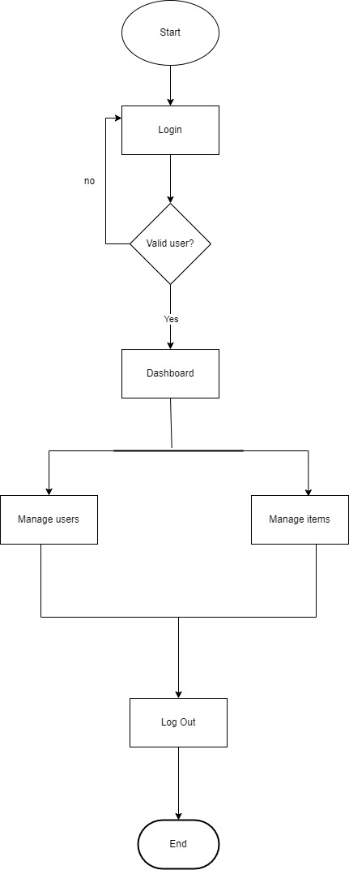

**Figure 3.9: Flowchart of e-commerce website for admin**

### Database schema design

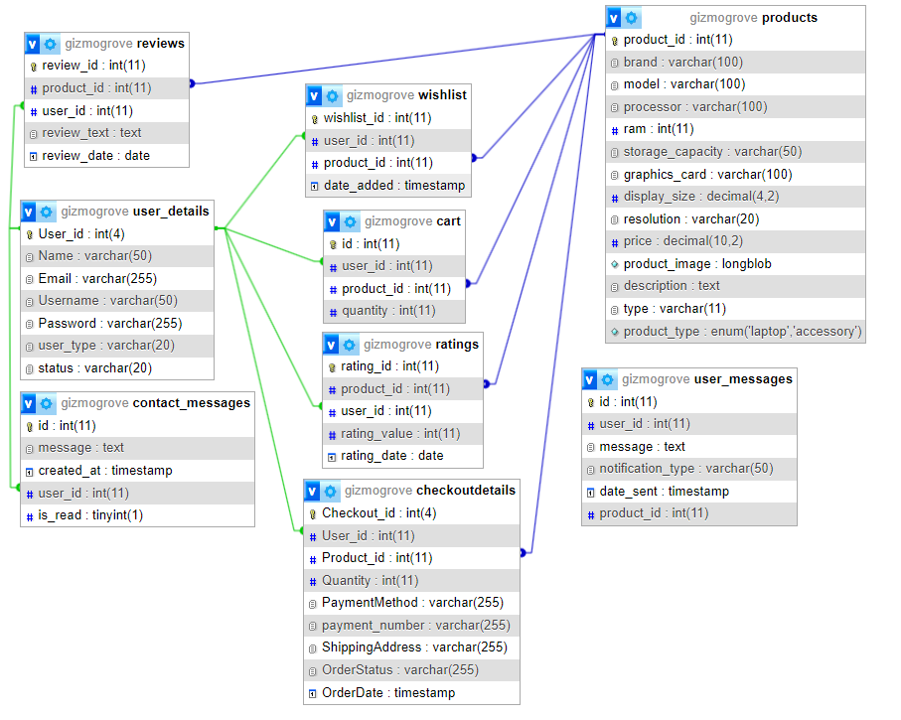The figure below is the database schema design of e-commerce website. Database schema design is used to show basic structure of the system. In the e-commerce website there are two tables in the databases each of them have their own fields where their id is primary key and if that id is used in another table it becomes foreign key.

**Figure 3.10: Database Schema Design**

### Interface Design (UI Interface)

Interface design is used to design how the e-commerce website looks like and this design is shown to user that how the website will look. And after finalizing the system development starts. The UI design of login page, registration page, landing page, laptops section, accessories section, product description page, admin dashboard page, order management page of GizmoGrove: A e-commerce website are shown in the appendix section.

**Appendix**

**References**

1. **Mahidol University College of Management. (2024). *Research on Pet Industry Growth*. [Online]. Available:** [**https://archive.cm.mahidol.ac.th/handle/123456789/5127**](https://archive.cm.mahidol.ac.th/handle/123456789/5127)**. [Accessed: Aug. 14, 2024].**
2. **Doe, J. (2023). *Analysis of Pet Grooming Services Market*. [Online]. Available:** [**https://www.proquest.com/openview/c7f89e8396bf10658cd8ea207fb2fe37/1.pdf?pq-origsite=gscholar&cbl=41532**](https://www.proquest.com/openview/c7f89e8396bf10658cd8ea207fb2fe37/1.pdf?pq-origsite=gscholar&cbl=41532)**. [Accessed: Aug. 14, 2024].**

**Bibliography**

**i. Sneha Care. *Sneha's Care – Helping Stray Animals in Nepal*. [Online]. Available:** [**https://www.snehacare.org**](https://www.snehacare.org)**. [Accessed: Aug. 14, 2024].**

**ii. Kat Centre Nepal. *Kathmandu Animal Treatment Centre*. [Online]. Available:** [**https://www.katcentre.org.np**](https://www.katcentre.org.np)**. [Accessed: Aug. 14, 2024].**

**iii. Himalayan Animal Rescue Trust (HART) Nepal. *Himalayan Animal Rescue Trust (HART) Nepal*. [Online]. Available:** [**https://www.hartnepal.org**](https://www.hartnepal.org)**. [Accessed: Aug. 14, 2024].**