Case Study: Pays Tree’s Strategic Expansion and Financial Analysis

Company Background:

* Pays Tree is a significant player in India's digital payments sector, aiming to diversify its services by entering the lending space.
* The company's current plan sets its IPO timeline at 7 years.
* A successful entry into the lending domain and subsequent profitability could potentially shorten the IPO timeline to 3-4 years.

Objective:

The objective is to conduct a comprehensive market analysis to assess the feasibility and potential impact of Pays Tree's entry into the lending space on its IPO timeline.

Analytical Approach:

This analysis will involve conducting: -

1. SWOT Analysis
2. PEST Analysis
3. Porter’s Five Forces Analysis
4. Data Visualization
5. Conclusion

SWOT Analysis:

1. Strengths:

* Established brand presence in India's digital payments sector.
* Extensive client base of over 100,000 businesses.
* Strong revenue growth from ₹123 crores in FY22 to ₹236 crores in FY24 and profitability.
* Robust suite of APIs like Fee Tree, Easy-peasy, InstaCollect, Smart Billing, and Build Tree.
* APIs like Fee Tree, Easy-peasy, InstaCollect, Smart Billing, and Build Tree.

1. Weaknesses:

* Heavy reliance on the digital payments market.
* Fluctuating profits, with a dip from FY22 to FY23 ₹23 crores to ₹95 lakhs.
* Potential scalability challenges in new ventures like lending.

1. Opportunities:

* Diversification into the lending space to capitalize on market trends.
* Development of digital remittance and collection services for SMEs.
* Favourable government initiatives promoting financial inclusion and digitization.

1. Threats:

* Compliance with financial regulations and potential policy changes.
* Intense competition from established and emerging players.
* Economic downturns affecting the financial health of potential borrowers.

PEST Analysis:

1. Political:

* Supportive government policies promoting digital payments and financial inclusion.
* Compliance with RBI regulations and other financial laws.

1. Economic:

* Rapid growth of India’s digital economy, boosting payment and financial services demand.
* Inflation and economic fluctuations impacting consumer spending and borrowing behaviour.

1. Social:

* Increasing adoption of digital payments among consumers and businesses.
* Growing preference for online and mobile financial services.
* Rising financial literacy and awareness of digital financial tools.

1. Technological:

* Advancements in fintech innovations, enabling new payment and lending solutions.
* Increasing AI and machine learning use for risk assessment and fraud detection.
* Growing importance of cybersecurity measures to protect financial transactions and data.

Porter’s Five Forces Analysis:

1. Threat of New Entrants:

* **Moderate to High:** While the fintech industry is attractive, substantial capital, regulatory compliance, and technology development act as barriers.

1. Bargaining Power of Suppliers:

* **Low:** Pays Tree develops its suite of APIs, reducing dependency on external suppliers.

1. Bargaining Power of Buyers:

* **High:** Businesses have multiple options for payment and lending solutions, increasing their bargaining power.

1. Threat of Substitutes:

* **Moderate:** Traditional banking services and emerging fintech startups offer alternative financial solutions.

1. Industry Rivalry:

* **High:** Intense competition from established players and new entrants in the digital payments and lending space.

Data Visualization:

We'll create visualizations using Python(matplotlib) and Jupyter Notebook, to illustrate Pays Tree's financial performance, market trends, and potential growth trajectories.

1. Revenue Growth:

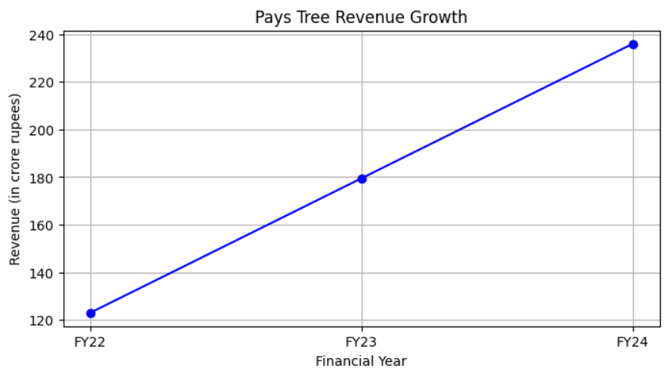

**Note**: As the revenue for FY23 was not provided we have calculated it using Liner Interpolation (it helps us to estimate a value within two known values on a linearly spaced scale).

After performing liner interpolation we got revenue for **FY23** as **179.5 cr.**

**Conclusion:**

* Pays Tree shows a strong and consistent revenue growth trajectory from FY22 to FY24.
* The upward revenue trend may attract more investors, enhancing market position and facilitating strategic plans.

1. Profit Trend:

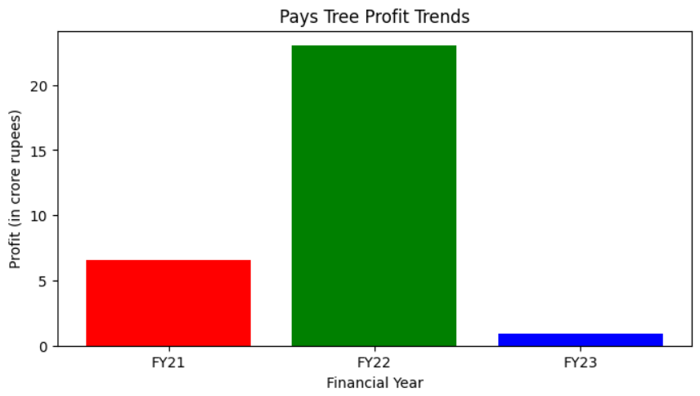

**Conclusion:**

* Despite a strong increase in FY22, profits significantly declined in FY23.
* Potential investors may seek explanations for the profit volatility before committing.
* Pays Tree should focus on stabilizing profits as it explores new markets like lending.

1. Transaction Volume:

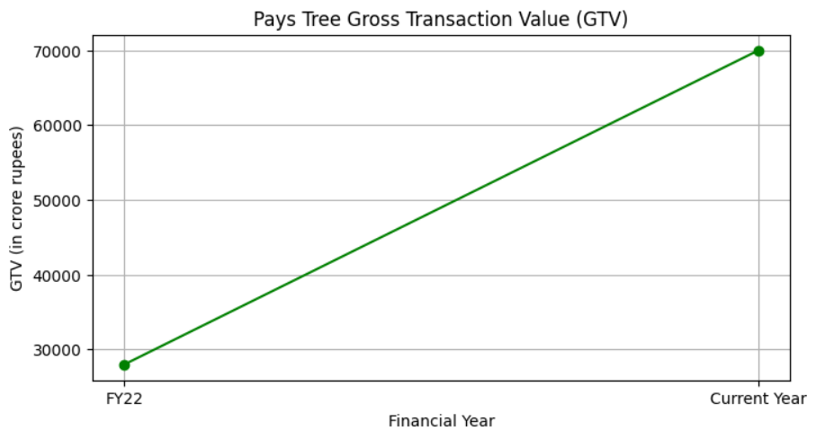

**Conclusion:**

* Gross Transaction Value (GTV) has shown a significant increase, which is 2.5x from FY22 to the current year (28000 to 70000).
* Sustained GTV growth reflects the potential for continued expansion and success in new ventures like lending.

Recommendations for the Above Analysis:

1. Diversification into Lending:

* Leverage the existing strong market presence and operational efficiency to enter the lending space.

1. Stabilize Profitability:

* Implement measures to stabilize profits, focusing on cost management and enhancing revenue streams.
* Conduct a thorough analysis of the factors contributing to the profit decline in FY23 and address these issues promptly.

1. Regulatory Compliance:

* Stay ahead of regulatory changes by actively engaging with policymakers and ensuring full compliance with financial regulations.

*“Please check the link* [*Python Jupyter Notebook Visual Analysis*](https://colab.research.google.com/drive/1wt5hse9GZc6kf5ybZCPv0eZwXJ7QFIcu?usp=sharing) *for the detailed implication of Python code for visualization and calculation of revenue for FY23”*