Education History
Schooling (class 10)
St. Albert High School, Bongaigaon, India
Higher Secondary (Class 12)
Little Flower School, Alwar, India
VFX & 3D Animation 8 Months Program
NFDC (National Film Development Corporation) & Aptech
(Central Government of India)

Expertise
Branding & Visual Identity, Digital
Illustration, Motion Graphic, Video Editing, 3D
Modeling, Basic Sculpting, Compositing,
Visual Composition, Real-Time Rendering

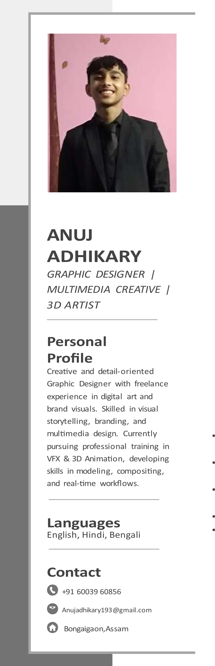
SOFTWARE SKILLS
Adobe Photoshop, Adobe Illustrator, After
Effects, Premiere Pro, Animate CC, 3ds Max,
Maya,

Work Experience
Freelance Graphic Designer / Digital Artist
Self-Employed | 2025 – Present
Ex trainer at bng design studio
Designed social media posts, posters, and branding materials
Created custom digital illustrations based on client requirements
Delivered creative projects within deadlines

Portfolio - https://anuj-dev-9-portfolio.netlify.app/
Behance –https://www.behance.net/anujadhikary193
Instagram-https://www.instagram.com/designbylines_/
Artstation- https://www.artstation.com/anuj_adhikary

