SYNOPSIS OF EXPLORATORY PROJECT (EP)
ON
DeepTrace: Explainable Deepfake and AI-Generated Image Detection System
submitted in partial fulfilment of the requirements for the award of degree of

BACHELOR OF ENGINEERING
In
COMPUTER SCIENCE AND ENGINEERING

Submitted by: Supervised By:
Anuj Kumar
2310991699
Arpit Madaan
2310991707

Dr. Preeti Saini
Assistant Professor



DEPARTMENT OF COMPUTER SCIENCE AND ENGINEERING

CHITKARA UNIVERSITY INSTITUTE OF ENGINEERING AND TECHNOLOGY
CHITKARA UNIVERSITY, PUNJAB, INDIA

CONTENTS

Title Page No.
Abstract 3
1. Introduction 4
1.1 Background and Context 4
1.2 Problem Statement 4
1.3 Significance of the Project 4
1.4 Objectives 5
1.5 Scope and Limitations 5
2. Methodology 6
2.1 Technical Approach 6
2.2 System Architecture 6
2.3 Functional Modules Overview 7
2.4 Workflow Diagram 10
3. Tools and Technologies 11
3.1 Programming Languages 11
3.2 Frameworks / Libraries 11
3.3 Databases / Storage 11
3.4 IDEs / Platforms 11
3.5 APIs / External Integrations 12
3.6 Hosting / Deployment Tools 12
4. Project Plan 13
4.1 Module-wise Feature Breakdown 13
4.2 Week-wise Development Timeline 13
4.3 Expected Outcomes 14
4.4 Risk Factors / Assumptions 14
5. References / Literature Review Table 15
References in the APA format 17

Abstract
With the rapid proliferation of Generative Adversarial Networks (GANs) and Diffusion Models (e.g., Midjourney, Stable Diffusion, Flux), digital media manipulation has reached photorealistic fidelity. DeepTrace is an end-to-end, explainable web-based forensic system engineered to detect deepfakes and synthetic imagery with high accuracy and interpretability. The system employs a multi-scale hybrid architecture combining Vision Transformers (ViT) / Swin Transformers for global and face-level artifact detection, Multi-Task Cascaded Convolutional Networks (MTCNN) for facial localization, Error Level Analysis (ELA) for compression inconsistency mapping, and EXIF metadata integrity verification. To address the black-box nature of deep learning, DeepTrace integrates Gradient-weighted Class Activation Mapping (Grad-CAM) to generate visual saliency heatmaps highlighting decision-critical manipulation regions. Developed with FastAPI, React.js, Tailwind CSS, PyTorch, MongoDB Atlas, and Cloudinary, DeepTrace provides authenticated users with real-time confidence scores, multi-level risk categorization, an interactive analysis dashboard, and automated, downloadable forensic PDF audit reports.

1. Introduction

1.1 Background and Context
With rapid advancements in Generative Adversarial Networks (GANs) and modern Diffusion Models (e.g., Midjourney, Stable Diffusion, Flux, DALL-E), synthesizing hyper-realistic, manipulated images and face-swaps has become accessible to non-technical users. While these generative capabilities foster creative applications, they pose unprecedented threats to identity security, public trust, journalism, and judicial integrity through the automated generation of digital misinformation and synthetic fraud.

1.2 Problem Statement
Existing commercial and open-source detection tools suffer from three core limitations:
- Opaque "Black-Box" Outputs: Binary scores are provided without spatial explainability or visual evidence indicating why or where an image was altered.
- High False-Positive Rates on Genuine Photos: Standard convolutional networks frequently misclassify compressed or filtered camera photos as synthetic due to standard quantization noise.
- Accessibility & Documentation Gap: Accessible verification platforms lack integrated, formal forensic reporting for documentation, auditing, and chain-of-custody logging.

1.3 Significance of the Project
DeepTrace establishes an open, transparent, and multi-layered image verification platform. By fusing deep Vision Transformers (ViT) / Swin Transformers with Error Level Analysis (ELA), MTCNN facial localization, EXIF metadata integrity parsing, and Grad-CAM visual heatmaps, DeepTrace empowers journalists, investigators, and everyday users to verify digital media authenticity with verifiable forensic rationale.

1.4 Objectives
- Deep Learning Classification: Implement a high-accuracy Transformer-based classification engine to distinguish authentic photos from GAN/Diffusion deepfakes.
- Multi-Scale Facial Localization: Use MTCNN to extract high-resolution face crops and isolate localized facial boundary manipulations.
- Forensic Signal Fusion: Integrate Error Level Analysis (ELA) and EXIF hardware metadata validation to suppress false positives on genuine camera captures.
- Explainable AI (XAI) Visualization: Generate Gradient-weighted Class Activation Maps (Grad-CAM) highlighting decision-critical spatial regions.
- Interactive Web Platform & Audit Reports: Deliver a responsive React.js UI with JWT authentication, MongoDB Atlas history tracking, Cloudinary media hosting, and automated ReportLab PDF forensic reports.

1.5 Scope and Limitations
- Scope: Static digital images (JPEG, PNG, WebP), facial deepfakes, face-swaps, full-scene diffusion synthesis, EXIF provenance verification, ELA compression analysis, and downloadable PDF forensic documentation.
- Limitations: Focused strictly on static image media. Video stream analysis, real-time video feeds, and audio deepfake detection are beyond the current scope and reserved for future project phases.

2. Methodology

2.1 Technical Approach
DeepTrace follows an asynchronous, decoupled client-server architecture. The frontend provides a modern, interactive single-page application (SPA). The backend orchestrates a multi-stage forensic analysis pipeline combining deep representation learning (ViT/Swin Transformers) with traditional digital signal forensics (JPEG quantization error analysis and EXIF header validation).

2.2 System Architecture
- Frontend Layer: React 18 + Vite SPA managing state, dynamic routing, image uploads, interactive result inspection, and report downloading.
- Backend API Layer: FastAPI asynchronous ASGI server managing REST endpoints, thread pooling using asyncio.to_thread, and token-based security.
- AI & Forensic Pipeline:
  - Multi-scale face cropping using MTCNN for high-resolution facial evaluation.
  - Vision Transformer (ViT) inference with multi-stage softmax probability calibration.
  - Spatial gradient extraction (∂yᶜ/∂X) for Grad-CAM overlay generation.
  - ELA compression variance computation and EXIF header parsing.
- Data Structures Used:
  - 4D PyTorch Tensors (B × C × H × W): Used for batch representation, spatial convolutions, and backpropagation gradients.
  - Hash Maps / Document Models: Key-value dictionaries used for JSON serialization, user schemas, and forensic score packaging.
  - Bounding Box Arrays ([x₁, y₁, x₂, y₂]): Used for facial boundary coordinates and contextual crop margins.
  - Byte Buffers (io.BytesIO): Used for in-memory JPEG re-compression during ELA analysis and dynamic PDF generation without disk I/O bottlenecks.

2.3 Functional Modules Overview

User Authentication & Access Control (Security & Identity Management)
- Purpose & Logic: Manages the complete user identity lifecycle, including secure registration, login, and session validation.
- Technical Process: Utilizes JSON Web Tokens (JWT) signed with HMAC-SHA256 for stateless authentication. User passwords are cryptographically salted and hashed using direct bcrypt hashing before persistence in MongoDB Atlas. Protected API endpoints enforce token decoding and user validation before accepting image analysis requests.

Image Ingestion & Orientation Preprocessing (Input Handling & Normalization)
- Purpose & Logic: Ingests user-submitted image files while enforcing strict security and formatting standards.
- Technical Process: Validates incoming multipart form-data streams against supported MIME types (JPEG, PNG, WebP) and restricts file sizes to 10 MB to prevent memory exhaustion. Applies ImageOps.exif_transpose() to parse EXIF orientation tags, automatically correcting rotated smartphone photos. Maintains dual image streams: an untouched raw stream for metadata parsing and a normalized RGB tensor for neural network ingestion.

Face Detection & Multi-Scale Crop Extraction (Data Localization & Segmentation)
- Purpose & Logic: Isolates human facial regions to perform targeted, high-resolution forensic inspection of facial boundaries.
- Technical Process: Executes Multi-Task Cascaded Convolutional Networks (MTCNN) on the CPU to detect facial bounding boxes and landmark points. For every detected face with greater than 40% confidence, the module extracts a localized sub-image expanded by a 20% contextual boundary margin, capturing hair, ear, chin, and forehead blending seams where deepfake warping artifacts typically reside.

Deep Learning Transformer Classification Engine (Core Inference & Feature Extraction)
- Purpose & Logic: Evaluates deep spatial representations to classify images into Authentic, Suspicious, or Deepfake categories.
- Technical Process: Feeds high-resolution face crops and full-scene images into a Vision Transformer (ViT) / Swin Transformer architecture. The model divides images into non-overlapping spatial patches (16 × 16) or hierarchical shifted windows, computing multi-head self-attention to identify high-frequency synthesis patterns, lighting inconsistencies, and diffusion-generator textures.

Forensic Signal Analysis (ELA & EXIF Metadata Validation)
- Purpose & Logic: Supplements deep learning predictions with physical compression analysis and camera provenance verification.
- Technical Process: Error Level Analysis (ELA) intentionally resaves images at a fixed 90% JPEG quality and computes matrix difference maps to measure compression variance across image segments, identifying potential localized cut-and-paste edits. Concurrently, the EXIF parser analyzes camera make/model, exposure values, and creation timestamps, discounting fake probability when genuine camera hardware signatures are verified.

Explainable AI & Grad-CAM Heatmap Generation (Visualization & Interpretability)
- Purpose & Logic: Eliminates the "black-box" nature of deep learning by visually pinpointing the exact pixels driving model decisions.
- Technical Process: Computes input-gradient backpropagation (∂yᶜ/∂X) with respect to the predicted class logits. Applies Gaussian smoothing kernels, cubic normalization, and OpenCV ColorMap overlays (COLORMAP_JET) to superimpose a transparent saliency heatmap over the original image, rendering high-influence regions in warm red/yellow tones.

Cloud Storage & Analysis History Dashboard (Data Sorting, Filtering & Persistence)
- Purpose & Logic: Provides users with a searchable, sortable history of all past forensic verifications.
- Technical Process: Stores analysis metadata, confidence scores, and forensic rationale in MongoDB Atlas while securely offloading visual assets—including original uploads, saliency heatmaps, ELA maps, and face crops—to Cloudinary CDN. The client-side dashboard enables real-time search queries, status filtering (Authentic / Suspicious / Deepfake), and multi-parameter sorting (Newest / Oldest).

Automated Forensic PDF Report Generator (Export & Audit Documentation)
- Purpose & Logic: Compiles comprehensive forensic audit dossiers for legal, journalistic, or record-keeping verification.
- Technical Process: Uses the ReportLab layout engine to dynamically fetch Cloudinary media into memory buffers (io.BytesIO), format visual evidence grids, render quantitative risk indicators, implement dynamic two-pass page numbering, and generate plain-English explanatory findings within a standardized PDF document.

2.4 Workflow Diagram
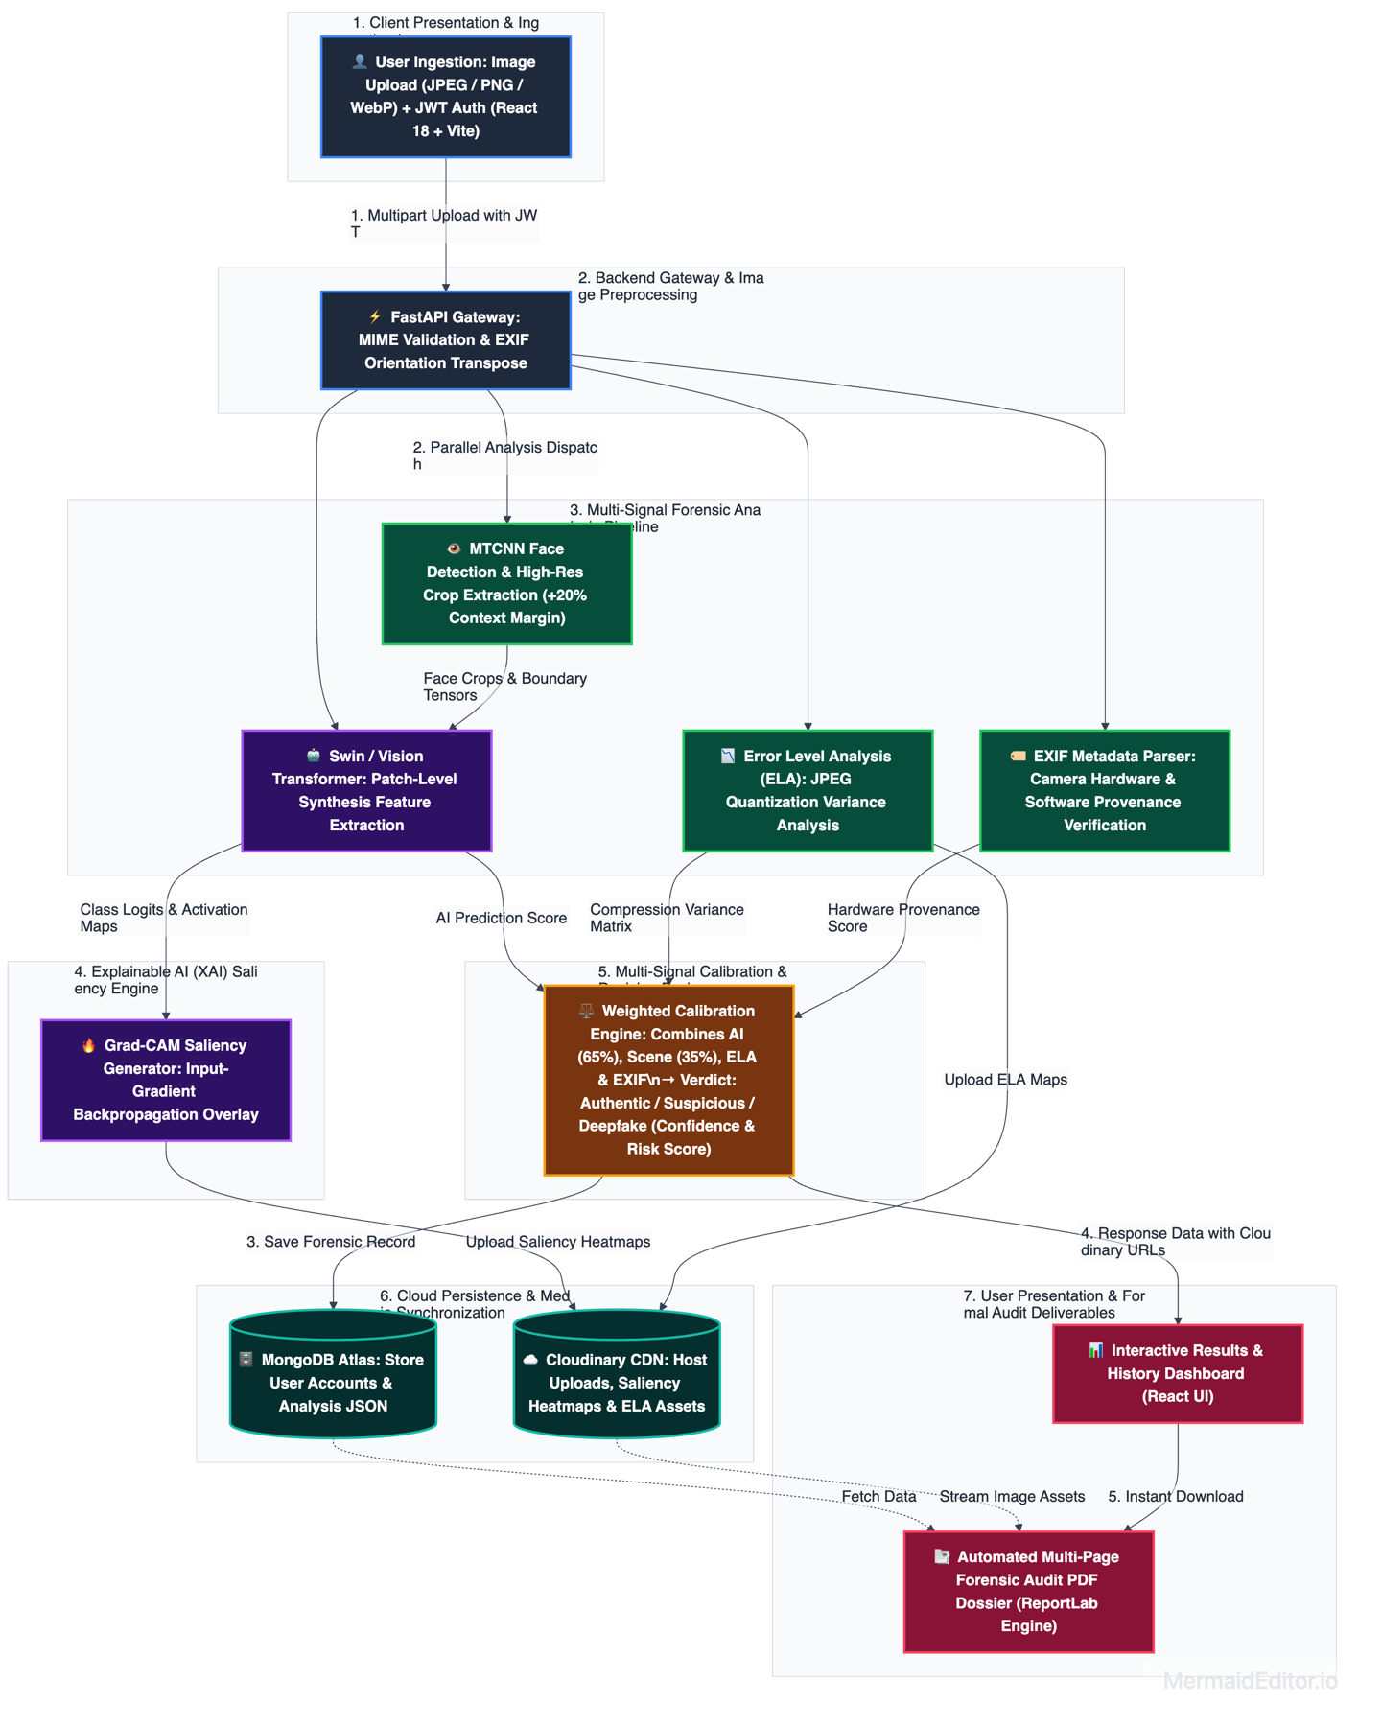

3. Tools and Technologies

3.1 Programming Languages
- Python 3.11+: Backend API, PyTorch deep learning models, computer vision pipelines, PDF generation.
- JavaScript / JSX (ES6+): Frontend user interface, state management, and asynchronous API calls.
- HTML5 & CSS3: Semantic layout structure and dark-mode styling.

3.2 Frameworks / Libraries
- Backend: FastAPI, Uvicorn, PyTorch, Torchvision, Hugging Face Transformers (transformers, datasets, evaluate), OpenCV (cv2), Pillow (PIL), Facenet-PyTorch (MTCNN), ReportLab, PyMongo, Python-Jose (JWT), Passlib/Bcrypt, Python-Dotenv.
- Frontend: React 18, Vite, Tailwind CSS, Framer Motion, Lucide React icons.

3.3 Databases / Storage
- Primary Database: MongoDB Atlas (Cloud NoSQL Database Cluster) for user accounts and analysis records.
- Media / Asset Storage: Cloudinary Cloud CDN for original, heatmap, ELA, and face crop images.
- In-Memory Buffers: io.BytesIO for real-time ELA re-compression and memory-buffered PDF generation.

3.4 IDEs / Platforms
- Development Environment: Visual Studio Code.
- Model Training & GPU Acceleration: Google Colab (NVIDIA T4 GPU), Apple Silicon MPS (Metal Performance Shaders).
- Version Control: Git, GitHub.

3.5 APIs / External Integrations
- Hugging Face Hub API: Pre-trained Vision Transformer and Swin Transformer weights.
- Cloudinary Python SDK: Automated cloud media upload and secure CDN URL generation.
- MongoDB PyMongo Driver: Persistent cloud database indexing and querying.

3.6 Hosting / Deployment Tools
- Development Environment: Localhost deployment on macOS (FastAPI: localhost:8000, React Vite: localhost:5173) with full Git version control on GitHub.
- Production Deployment:
  - Backend API: Cloud deployment on Render / Railway / AWS EC2 (Containerized with Uvicorn).
  - Frontend UI: Global edge deployment on Vercel / Netlify.
  - Cloud Services: Connected directly to MongoDB Atlas (Managed Database) and Cloudinary (Managed CDN Media Storage).

4. Project Plan

4.1 Module-wise Feature Breakdown
Module | Functionality Description
1. Authentication & Access Control | User registration, login with JWT tokens, secure password storage using bcrypt, and session management.
2. Image Ingestion & UI Interface | Drag-and-drop upload zone, client-side format and size validation, real-time loading feedback, and image preview handling.
3. Face Detection & Preprocessing | MTCNN-based facial localization, automated image orientation correction, and extraction of high-resolution face crops.
4. Deep Learning Classifier | Vision Transformer (ViT) and Swin Transformer inference for evaluating patch-level synthesis artifacts across facial regions and scene backgrounds.
5. Multi-Signal Forensic Analysis | Error Level Analysis (ELA) for compression quantization variance and EXIF inspection for camera hardware and metadata validation.
6. Explainability & Heatmap Engine | Mathematical input-gradient backpropagation for generating visual Grad-CAM heatmaps overlaid onto the original image.
7. History Dashboard & Cloud Sync | Persistent historical logs of previous analyses stored in MongoDB Atlas, with forensic images securely hosted on Cloudinary CDN.
8. Audit Report Generation | Automated ReportLab PDF generator compiling the executive summary, quantitative metrics, forensic findings, and visual evidence into a formal report.

4.2 Week-wise Development Timeline
Module | Planned Weeks | Expected Deliverables
Module 1: Synopsis & Architecture | Week 1–2 | System synopsis, architectural design, and technology selection.
Module 2: UI & Authentication System | Week 3–4 | React frontend shell, JWT login/register flow, and dashboard layout.
Module 3: Preprocessing & Face Pipeline | Week 4–5 | FastAPI upload API, MTCNN face detection, and image transformations.
Module 4: Deep Learning Model Integration | Week 5–6 | Vision Transformer classification, calibrated probabilities, and inference API.
Module 5: Forensics & Explainability | Week 6–7 | ELA compression analysis, EXIF integrity parser, and Grad-CAM heatmaps.
Module 6: Cloud Database & History | Week 7–8 | MongoDB Atlas integration, Cloudinary asset pipeline, and history table.
Module 7: Swin Fine-Tuning & PDF Engine | Week 9–10 | Swin Transformer Colab training pipeline, ReportLab PDF generator, and end-to-end tests.
Final Documentation & Optimization | Week 11 | Comprehensive project documentation, latency benchmarks, and code hardening.
Final Demo + Viva + Presentation | Week 12 | Final presentation, live system demonstration, and project defense.

4.3 Expected Outcomes
- Fully operational web system delivering deepfake classifications in under 2 seconds per image.
- Multi-signal forensic accuracy with significantly reduced false positives on authentic camera photos.
- Transparent visual saliency heatmaps highlighting exact manipulation hotspots.
- Automated, tamper-evident forensic PDF audit reports available for download.

4.4 Risk Factors / Assumptions
- Evolving Generative Architectures: New diffusion models (e.g., Flux) may introduce novel artifacts; mitigated by our modular fine-tuning pipeline (finetune_swin_colab.py).
- JPEG Compression Artifacts: Heavy social media re-compression can simulate manipulation; mitigated by combining ELA variance with EXIF hardware scoring.
- Inference Hardware Demands: Deep learning models require computational optimization; mitigated using Apple MPS / CUDA acceleration and asynchronous FastAPI thread workers.

5. References / Literature Review Table
S. No. | Source Title / Tool | Key Idea | Project Relevance
1 | "FaceForensics++: Learning to Detect Manipulated Facial Images" – ICCV (2019) | Benchmark dataset and spatial anomaly detection for face-swaps and deepfakes. | Establishes the foundational methodology for facial forgery detection.
2 | "Swin Transformer: Hierarchical Vision Transformer using Shifted Windows" – ICCV (2021) | Shifted local-window self-attention providing multi-scale visual representation. | Core target architecture for boundary-artifact and pixel-level seam detection.
3 | "Grad-CAM: Visual Explanations from Deep Networks" – ICCV (2017) | Gradient-weighted class activation mapping for spatial localization. | Provides the mathematical foundation for DeepTrace's explainable saliency heatmaps.
4 | "Joint Face Detection and Alignment using MTCNN" – IEEE SPL (2016) | Cascaded multi-task CNN framework for robust face detection and alignment. | Core component of Module 3 for isolating facial regions and extracting high-resolution crops.
5 | "A Picture's Worth: Digital Image Analysis and Forensics" – Hacker Factor (2007) | Error Level Analysis (ELA) measures JPEG compression quantization differences. | Integrated as a physical forensic indicator for detecting potential composite splicing.
6 | "An Image is Worth 16 × 16 Words: Transformers for Image Recognition" – ICLR (2021) | Application of self-attention Transformer blocks to sequences of image patches. | Underpins the base Vision Transformer classification pipeline in DeepTrace.
7 | "CIFAKE: Image Classification and Explainable Detection of Fake Images" – Data in Brief (2023) | 120,000 synthetic and real images covering diverse generative artifacts. | Primary dataset used in the Colab fine-tuning pipeline to improve model generalization.
8 | "Exposing DeepFake Videos By Detecting Face Warping Artifacts" – CVPRW (2019) | Detects resolution inconsistencies between warped facial regions and surrounding context. | Motivates multi-scale comparison between face crops and global scene context.
9 | "FastAPI: Modern, High-Performance Web Framework for Python" – S. Ramírez (2020) | Asynchronous Python ASGI framework with OpenAPI schema generation. | Serves as the high-throughput backend API framework for DeepTrace.
10 | "Exposing AI-Generated Images with Frequency Domain and EXIF Analysis" – IEEE TPAMI (2022) | Evaluates the absence of camera optical fingerprints and missing EXIF metadata in synthetic media. | Provides justification for EXIF integrity weighting in the forensic fusion engine.

References in the APA format
- Bird, J. J., & Lotfi, A. (2023). CIFAKE: Image classification and explainable identification of AI-generated synthetic images. Data in Brief, 51, 109768. https://doi.org/10.1016/j.dib.2023.109768
- Devlin, J., Chang, M.-W., Lee, K., & Toutanova, K. (2018). BERT: Pre-training of deep bidirectional transformers for language understanding. arXiv preprint arXiv:1810.04805. https://arxiv.org/abs/1810.04805
- Dosovitskiy, A., Beyer, L., Kolesnikov, A., Weissenborn, D., Zhai, X., Unterthiner, T., Dehghani, M., Minderer, M., Heigold, G., Gelly, S., Uszkoreit, J., & Houlsby, N. (2021). An image is worth 16 × 16 words: Transformers for image recognition at scale. International Conference on Learning Representations (ICLR).
- Krawetz, N. (2007). A picture's worth: Digital image analysis and forensics. Hacker Factor Solutions, 6(2), 1–31.
- Li, Y., & Lyu, S. (2019). Exposing deepfake videos by detecting face warping artifacts. Proceedings of the IEEE/CVF Conference on Computer Vision and Pattern Recognition Workshops (CVPRW), 46–52.
- Liu, Z., Lin, Y., Cao, Y., Hu, H., Wei, Y., Zhang, Z., Lin, S., & Guo, B. (2021). Swin transformer: Hierarchical vision transformer using shifted windows. Proceedings of the IEEE/CVF International Conference on Computer Vision (ICCV), 10012–10022.
- Ramírez, S. (2020). FastAPI: High performance, easy to learn, fast to code, ready for production. https://fastapi.tiangolo.com/
- Rössler, A., Cozzolino, D., Verdoliva, L., Riess, C., Thies, J., & Nießner, M. (2019). FaceForensics++: Learning to detect manipulated facial images. Proceedings of the IEEE/CVF International Conference on Computer Vision (ICCV), 1–11.
- Selvaraju, R. R., Cogswell, M., Das, A., Vedantam, R., Parikh, D., & Batra, D. (2017). Grad-CAM: Visual explanations from deep networks via gradient-based localization. Proceedings of the IEEE International Conference on Computer Vision (ICCV), 618–626.
- Zhang, K., Zhang, Z., Li, Z., & Qiao, Y. (2016). Joint face detection and alignment using multitask cascaded convolutional networks. IEEE Signal Processing Letters, 23(10), 1499–1503.

