Working Condition statement in Python
S.N | Statements and Loops | Flow chart | Syntax | Example
 | If | 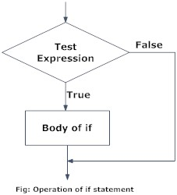 | If test expression1:  Statement(1)  If test expression2:  Statement(2) | num = 3  if num > 0:  print(num‘ is a positive number ’  Output  3 is a positive number
 | If------else | 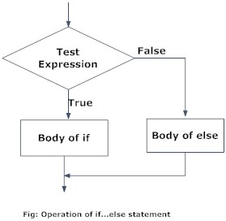 | If test expression:  Statement(s)  else:  body of else | num = 3  if num > 0:  print(num‘ is a positive number’)  else:  print(num‘ is a negative number’)  Output  3 is a positive number
 | If………elif………else | 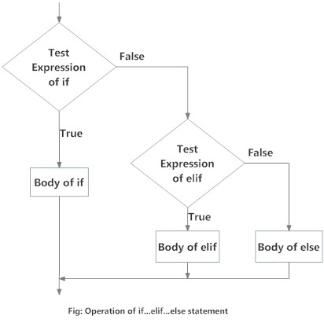 | If test expression:  Statement(1)  elif test expression:  Statement(2)  else:  body of else | num = 3  if num > 0:  print(num‘ is a positive number’)  elif num == 0:  print(num‘ is zero’)  else:  print(num‘ is a negative number’)  Output  3 is a positive number
 | Pass | ------------------------------------- | pass | sequence = {1,2,3,4}  for i in sequence:  pass  Output  no output
 | While loop | 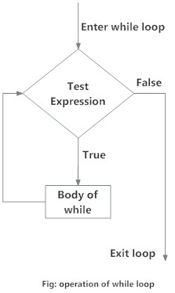 | while test_expression:  Body of while | n = 10  sum = 0  i = 1  while i <= n:  sum = sum + i  i = i+1  print(‘The sum is ‘,sum)  Output  The sum is 55
 | While loop with else | 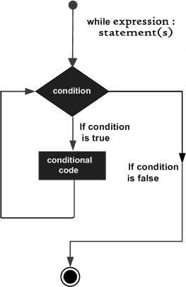 | while test_expression:  Body of while  else:  Body of else | countered = 0  while counter < 3:  print(‘Inside loop’)  counter = counter +1  else:  print(‘Inside else’)  Output  Inside loop  Inside loop  Inside loop  Inside else
 | For loop | 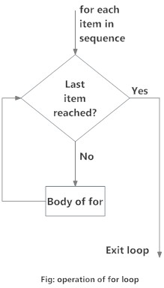 | for val in sequence:  Body of for | numbers = [1,2,3,4,5]  sum = 0  for val in numbers:  sum = sum+val  print(‘The sum is ’ ,sum)  Output  The sum is 15
 | break | 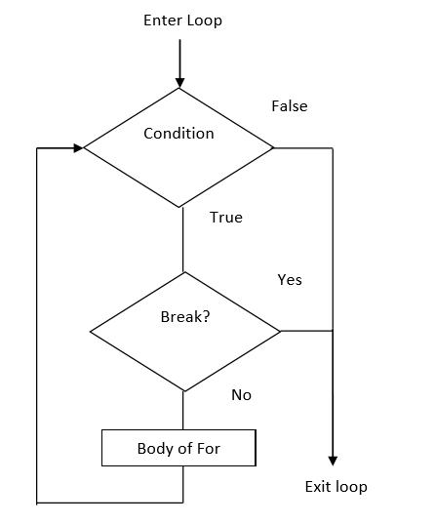 | break | for val in ‘string’:  if val == ‘i’:  break  print(val)  print(‘The end’)  Output  s  t  r  The end
 | Continue | 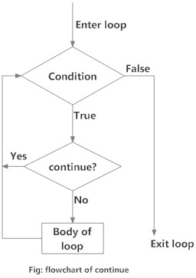 | continue | for val in ‘string’:  if val == ‘i’:  continue  print(val)  print(‘The end’)  Output  s  t  r  n  g  The end

Python Structure Types
S.n | Operations | List | String | Tuple | Set | Dictionary
1. | Create | >>>1  = [1,2,3] | a = ‘programs’ | my_tuple = (1,2,3,4,5,6) | B = Set{1,2,3,} | A = {key:value}
2. | Indexing | It has indexing from 0 to n | It has indexing from 0 to n | It has indexing from 0 to n | Set is a unordered sequence | Set is a unordered sequence
3. | Basic program | Numbers = [1,2,3] | a = ‘programs’ | my_tuple = (1,2,3,4,5,6) | B = Set{1,2,3,} | A = {key1: ‘value1’,key2:’value2}
4. | Access Items | Numbers[0]  Output  >>>1 | a[0]  Output  >>> ‘p’ | my_tuple[0]  Output  >>>1 |  | A[key1]  Output  >>>‘value1’
5. | Add items | Numbers.append(4) | String cannot be modified | Tuples cannot be modified | B.add(4)
6. | Remove Items | pop(4) | String cannot be modified | Tuples cannot be modified | B.remove(4) | A.pop(key2)
7. | Modifying | Numbers[0] = ‘one’ | String cannot be modified | Tuples cannot be modified
8. | Iterating | for i in Numbers:  print(i)  Output  >>>’one’  >>>2  >>>3 | for i in a:  print(i)  Output  >>>p  >>>r  >>>o  >>>g  >>>r  >>>a  >>>m | for i in my_tuple:  print(i)  Output  >>>1  >>>2  >>>3  >>>4  >>>5  >>>6 | for i in B:  print(i)  Output  >>>1  >>>2  >>>3 | for i in A:  print(i)  Output  >>>key
9. | Check the item is exist or not | ‘one’ in Number  Output  >>>True | ‘p’ in a  Output  >>>True | 1 in my_tuple  Output  >>>True | I in B  Output  >>>True | key in A  Output  >>>True
10. | Length | len(number)  Output  >>>3 | len(a)  Output  >>>7 | len(my_tuple)  Output  >>>6 | len(B)  Output  >>>3 | len(A)  Output  >>>1
11. | Copy | Number.copy()  Output  >>>[1,2,3] | b = a  b  ‘programs’ |  | B.copy()  Output  >>>[1,2,3] | A.copy()  Output  >>>{key1:’value1}
12 | Sort and reverse | Number.reverse()  Output  [3, 2, 1]  Number.short()  Output  >>>[1,2,3] | Strings does not support short and reverse | Tuple does not support short and reverse | B.reverse()  Output  {3, 2, 1}  B.short()  Output  >>>{1,2,3} | dictonaries does not support short and reverse

