INHYDRO IoT SOLUTIONS • SYSTEM ENGINEERING
Executive Proposal: Almora Cold Room Controller & HMI System Upgrade
Technical Gap Analysis, System Architecture Diagram, Feature Matrix & Implementation Plan for sensor_monitor2.py
Document Type: Client Proposal & Upgrade Specification | Target System: sensor_monitor2.py (InHydro Cold Room HMI)
Date: July 2026 | Status: Approved Technical Architecture

1. System Architecture & Workflow Diagram
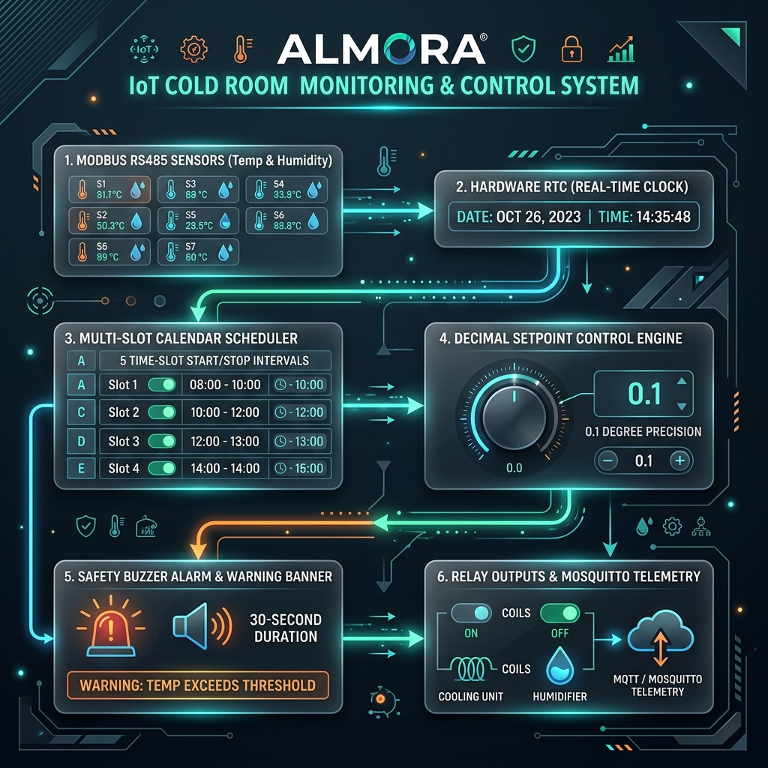
Figure 1: High-Level Industrial System Architecture & Workflow for Almora Controller Upgrade.
2. Executive Summary & Project Scope
This document presents an executive technical analysis and implementation roadmap to upgrade the existing InHydro Cold Room Monitoring Controller (sensor_monitor2.py). Based on the client's Almora specifications and handwritten engineering requirements, the upgraded architecture delivers high-precision decimal setpoint evaluation, hardware Real-Time Clock (RTC) synchronization, multi-slot date-bound calendar scheduling (Settings A to E), and an automated visual and audible alarm safety system.
[EXECUTIVE DIRECTIVE] The proposed upgrade ensures strict compliance with industrial cold storage precision requirements while retaining full backwards compatibility with existing Modbus RS485 sensors and MQTT telemetry gateways.

3. Analysis of Current System (sensor_monitor2.py)
The current sensor_monitor2.py application acts as an edge controller for 7 sensors (S1 to S6 for Cold Rooms, S7 for Greenhouse). Its existing capabilities include:
- Modbus RTU Sensor Sampling: Sequential polling of 7 Modbus sensors over USB RS485 converters.
- Fixed Relay Logic: Dual relay channel mapping per sensor (1 for Cooling Unit/Fan, 1 for Humidifier; 14 channels total).
- Tkinter Fullscreen HMI: 4-column grid display featuring live temperature and humidity with simple color coding.
- Dual MQTT Gateway: Live JSON telemetry streaming over Mosquitto VPS (147.93.106.142) and ThingSpeak cloud logging.
- Local Persistence & Offline Backfill: JSON lines local logging (local_logs/active.jsonl) with automatic cloud sync upon reconnection.
4. Almora Client Requirements vs. Gap Analysis Matrix
The following matrix outlines the functional gap between the baseline sensor_monitor2.py implementation and the new Almora client requirements:
Feature Category | Baseline (sensor_monitor2.py) | Almora Requirement | Engineering Solution
RTC & Clock Display | No clock on GUI header; relies on OS system time | Real-Time Clock display (Date & Time) on HMI screen | Integrate DS3231 I2C RTC hardware + live GUI clock header widget
Setpoint Precision | Standard integer/coarse float inputs | 0.1°C Decimal setpoint precision for temperature | Update setpoint parser and numeric keypad UI for 0.1°C resolution
Target Display | Only live Temp & Humidity displayed on cards | Display Target Setpoints alongside live values | Format widget text: Temp: 21.5°C (Set: 10.0-30.0)
Visual Warning | Widget turns solid red without alert banner | Explicit visual alarm banner on setpoint breach | Add dynamic warning popup header + highlight breaching metrics
Audible Buzzer | No audible alarm trigger | Hardware Buzzer alert for exactly 30 seconds | Implement non-blocking background thread for 30s buzzer relay output
Multi-Slot Schedule | Static T MIN/MAX and H MIN/MAX per sensor | Settings A to E (Calendar dates) + 5 Time Slots / Setting | Restructure setpoints JSON schema & build dynamic time-slot evaluator

5. Technical Implementation Roadmap
Phase 1: Real-Time Clock (RTC) & Screen Timekeeper
• Hardware Setup: Connect DS3231 RTC module via I2C interface (/dev/i2c-1). Sync system clock on boot via `sudo hwclock -s`.
• HMI Header Clock: Add a non-blocking Tkinter clock widget updated every second via root.after(1000, update_clock).
Phase 2: Decimal Setpoint Precision & Enhanced Widget UI
• 0.1°C Setpoint Support: Round float inputs to 1 decimal place. Update numeric keypad to allow decimal point (.) input.
• Setpoint Card UI: Update update_ui() loop to display target threshold ranges directly on live sensor boxes.
Phase 3: Visual Warning Notifications & 30-Second Alarm Buzzer
• Alarm Threading: Implement non-blocking thread to actuate active hardware buzzer relay (Channel 15) for exactly 30 seconds.
• Warning Banner: Render prominent warning header banner on HMI when any sensor reading drifts beyond setpoints.
Phase 4: Multi-Setting Schedule Engine (Settings A to E)
• Schema Upgrade: Extend JSON setpoints configuration to support 5 presets (Setting A through Setting E) with calendar dates.
• 5 Time Slots per Setting: Allow 5 start/stop interval pairs (Start 1-Stop 2, Time 3-4, 5-6, 7-8, 9-10) evaluated dynamically per polling loop.
6. Updated Configuration Schema (JSON)
The upgraded setpoints_{DEVICE_NAME}.json file will adopt the following structured schema:
{
"S1": {
"mode": "SCHEDULED",
"active_setting": "Setting A",
"settings": {
"Setting A": {
"calendar_date": "21 July",
"temp_min": 18.0,
"temp_max": 22.5,
"humi_min": 50.0,
"humi_max": 75.0,
"time_slots": [
{"start": "08:00", "stop": "10:00"},
{"start": "11:00", "stop": "13:00"},
{"start": "14:00", "stop": "16:00"},
{"start": "17:00", "stop": "19:00"},
{"start": "20:00", "stop": "22:00"}
]
},
"Setting B": { "calendar_date": "10 Sep", "..." : "..." }
}
}
}

7. Sign-off & Client Approval
This proposal represents the finalized engineering specification for the Almora Controller upgrade.
Prepared By:  InHydro System Engineering Team  Date: July 2026 | Client Acceptance:  Authorized Signature: ___________________  Date: ___________________

