1. You are converting an existing ASP.NET web application to use the Azure Active Directory (AD) Access Control service for authentication. The application will authenticate users by using their Yahoo account credentials. You need to determine the correct payload for each stage of the authentication process. What should you do? To answer, drag the appropriate payload format to the correct location on the dialog box. Each payload format may be used once, more than once, or not at all. You may need to drag the split bar between panes or scroll to view content.

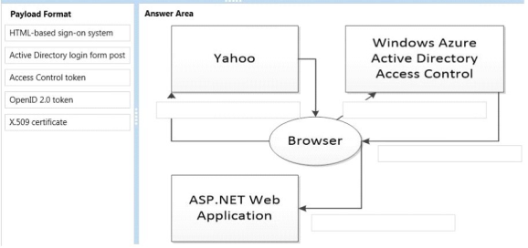

Answer:

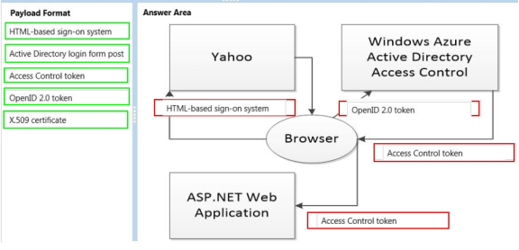

1. sd