1. Drag and Drop Question. You create a web application. You publish the source code of the web application to a GitHub repository by using Microsoft Visual Studio. You create a website by using the Azure management portal. You must continuously deploy the web application from the GitHub repository website to the Azure website. You need to deploy the source code of the web application. Which four actions should you perform in sequence? To answer, move the appropriate actions from the list of actions to the answer area and arrange them in the correct order.

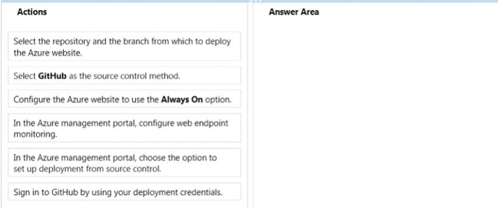

Answer:

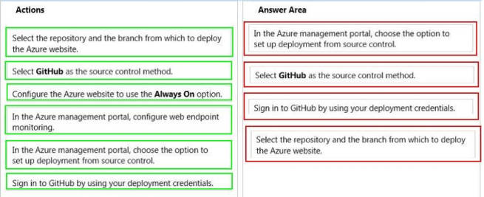

1. A company creates an API and makes it accessible on an Azure website. External partners use the API occasionally. The website uses the Standard web hosting plan. Partners report that the first API call in a sequence of API calls occasionally takes longer than expected to run. Subsequent API calls consistently perform as expected. You need to ensure that all API calls perform consistently. What should you do?
2. Configure the website to use the Basic web hosting plan.
3. Enable Always On support.
4. Configure the website to automatically scale.
5. Add a trigger to the web.config file for the website that causes the website to recycle periodically.

Answer: B

1. Drag and Drop Question. Your team uses a proprietary source control product. You use FTP to manually deploy an Azure website. You must move your source code from the proprietary source control product to a secure onpremises Git versioning system. Instead of deploying the website by using FTP.the website must automatically deploy to Azure each time developers check-in source files. You need to implement the new deployment strategy. Which three actions should you perform in sequence? To answer, move the appropriate actions from the list of actions to the answer area and arrange them in the correct order.

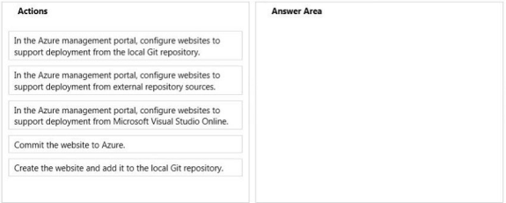

Answer:

