**Case Study 1 - File Tax-Related Document**

**Background**

You are developing an Azure solution that individuals and small businesses will use to prepare and file tax-related documents.

**Business Requirements**

**General**

The solution must provide a way for customers to enter personal and demographic information. Customers must be able to upload income documents and related documents to the solution. The solution must provide reports and summary documents for customers in PDF format.

**Scope and Device Accessibility**

The solution must support two operational modes: On-Peak and Off-Peak. On-Peak is defined as the first quarter of a year. Off-Peak is defined as the other three quarters of a year. Customers must be able to access the solution by using desktop computers, laptop computers, mobile devices, and tablets.

**High Availability and Business Continuity**

The solution must be available at all times. When the solution transitions between Off-Peak mode and On-Peak mode, solution availability must not be affected. Disaster recovery must be established for the customers' stored data.

**Diagnostics**

The solution must log relevant diagnostic data that can be used to troubleshoot the cloud service.

**Scalability**

The solution must scale out while transitioning from Off-Peak mode to On-Peak mode.

**Cost**

The solution must use cloud resources optimally to minimize operating costs.

**Storage and Security**

The solution must be secure to prevent any anonymous access (including read access) to the customers' tax documents.

**Cross-Premises Networking**

The solution must extend the developers' on-premises network into Azure.

**Technical Requirements**

The logical design for the solution is shown in the following exhibit.

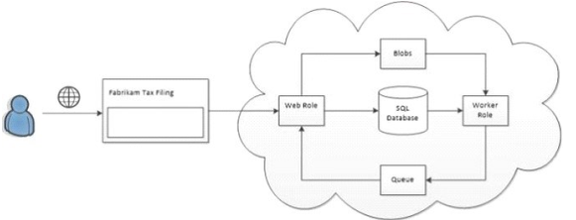

**Platform-as-a-Service (PaaS)**

The solution must have two roles: a web role and worker role. The web interface of the solution uses a web role to accept and send user input and any related documents. The worker role must access the stored data and prepare the tax documents in the background.

**Compute**

The solution must support a minimum of 10 role instances. When the solution is in On- Peak mode, each role instance must be allocated at least 6 GB of memory. The memory can be scaled down to 3 GB when the solution is in Off-Peak mode. The solution must cache documents locally. The cache does not need to be refreshed during the lifecycle of the worker role**.** Role instances that are running should not be affected by topology changes such as an increase in instance count.

**Storage**

The web role must store documents in blob storage. A SQL database is used to store customer information. The worker role must use queues to process the final tax documents.

**Performance and Scalability**

When the solution is in Off-Peak mode, it must support at least 150 concurrent database sessions, and the maximum size of the database is 50 GB. When the solution is in On- Peak mode, it must support 750 concurrent database sessions, and the maximum size of the database is 300 GB. Geo-replication must be enabled and must be configurable by using the Azure management portal.

**Software Prerequisites**

The solution must install the software that is necessary to generate PDF documents on the server. The software will be provided as a Windows Installer package.

**Debugging**

Solution errors and warnings that occur in a web role must be logged. The worker role must log any crash dump files. Detailed information about errors and their context must be collected so that the environment in which errors occurred can be simulated locally.

**Security**

At the time that a customer's tax information and documents are accepted, the solution must send an email to the customer. The email contains a secure hyperlink that the customer can use to upload any additional necessary documents. The customer is asked to upload these documents within 48 hours. If the customer does not upload the documents within 48 hours, the solution should not issue a new hyperlink. The solution must send an email to the customer to remind the customer to use the original hyperlink to upload any additional necessary documents.

**Network Services**

The solution must use a cross-premises secure network. The network must be configurable by using the Azure management portal.

**Social Structure**

Relevant portions of the solution files are shown in the following code segments. Line numbers in the code segments are included for reference only and include a two-character prefix that denotes the specific file to which they belong.



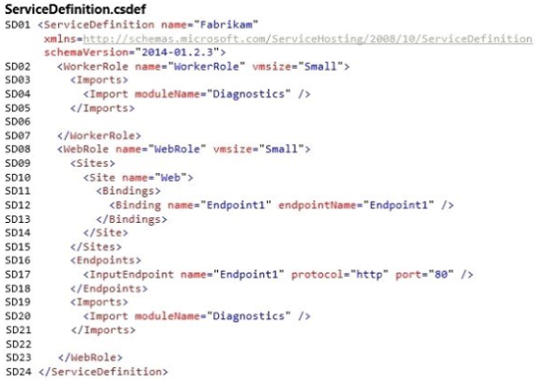

1. You need to configure diagnostics for the Azure solution. Which two types of diagnostic data should you collect? Each correct answer presents part of the solution.
2. Application logs
3. Event logs
4. Crash dumps
5. Infrastructure logs
6. IIS logs
7. Performance counters

Answer: **B, C**

1. You need to configure the virtual network. What are two possible ways to achieve this goal? Each correct answer presents a complete solution.
2. Configure a point-to-site virtual network.
3. Configure a site-to-site virtual network.
4. Configure a multi-site virtual network.
5. Configure a cloud-only virtual network.

Answer: **A, B**

1. You need to configure role instances. Which size should you specify for the VM?
2. Use Small for Off-Peak mode.
3. Use Large for On-Peak mode.
4. Use Extra Large for On-Peak mode.
5. Use Extra Small for Off-Peak mode.

**Answer: B**

1. You need to meet the performance and scalability requirements. Which SQL Database configuration should you use?
2. Use the S1 performance level for On-Peak mode.
3. Use the P2 performance level for On-Peak mode.
4. Use the S2 performance level for On-Peak mode.
5. Use the PI performance level for On-Peak mode.

Answer: D

[Note: S series can have max of 250GB database capacity, but it can support max concurrent sessions from 600 -2400 (S0 to S3). But we need 350 GB storage on-peak time so we can go for premium (P1 to P15). P2 to P6 gives 500GB storage but the max concurrent sessions for P1 is 2400 and P2 is 4800. So we can go for P1 because it is cost effective and meets our requirements. All Standard and Premium tiers give active geo-replication]

1. Drag and Drop Question

You need to insert mark up at line SD22 to install the software that generates PDF documents. How should you complete the relevant mark up? To answer, drag the appropriate code segments to the correct locations. Each code segment may be used once, more than once, or not at all. You may need to drag the split bar between panes or scroll to view content.

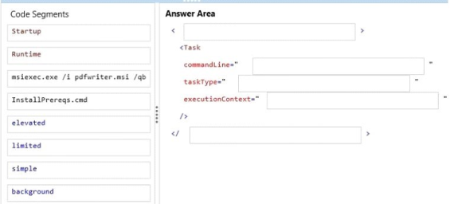

Answer:

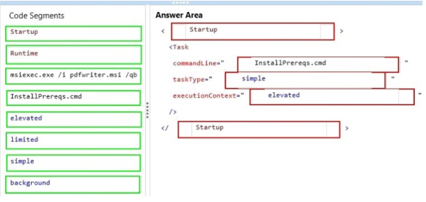

1. You need to insert code at line SB11 to apply the storage access policy.

How should you complete the relevant code segment? To answer, select the appropriate option or options in the answer area

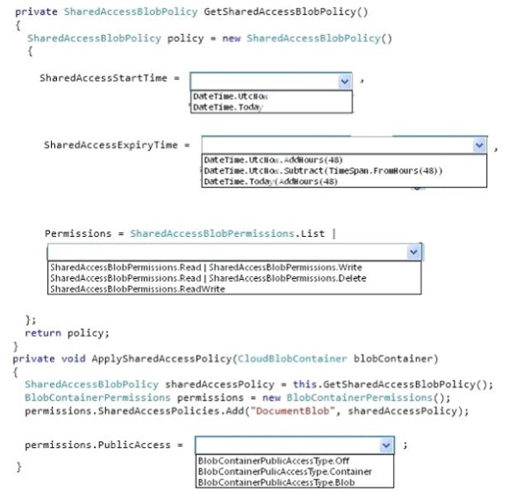

Answer:

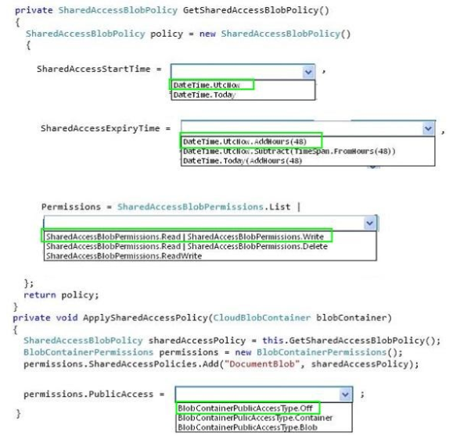

1. You need to debug the Azure solution.

Which tool should you use?

1. Compute emulator
2. Remote debugging
3. Emulator Express
4. IntelliTrace
5. Profiling

Answer: **C**

Note: Debugging requirement says, “So that error occurred can be simulated locally.” Thinking Remote Debugging in this context means debugging production/staging site.

The Full Emulator requires Visual Studio to be started as an administrator while the Emulator Express does not require this. The other big differences are that the Emulator Express cannot use the IIS Web Server and each role is limited to just one instance.

Not A, it requires administrator rights.

Not B, it could make the service unresponsive.

Not E, it is for performance issues.

Not D, Intellitrace must be enabled before running on can’t work.

So its C

1. How should you complete the relevant code? To answer, drag the appropriate code segments to the correct locations. Each code segment may be used once, more than once, or not at all. You may need to drag the split bar between panes or scroll to view content.

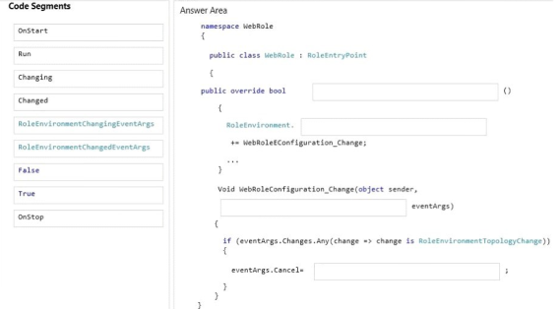

Answer:

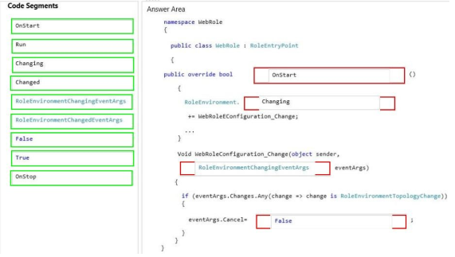

1. Drag and Drop Question

You need to meet the high availability and business continuity requirements. Which three actions should you perform in sequence? To answer, move the appropriate actions from the list of actions to the answer area and arrange them in the correct order.

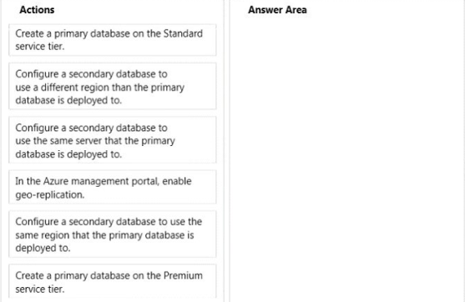

Answer:

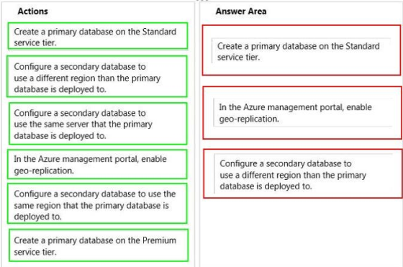

1. Drag and Drop Question

You need to insert code at line SB17 to create the hyperlink that customers use to upload additional necessary documents. How should you complete the relevant code? To answer, drag the appropriate code segments to the correct locations. Each code segment may be used once, more than once, or not at all. You may need to drag the split bar between panes or scroll to view content.

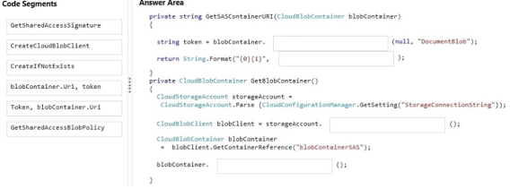

Answer:

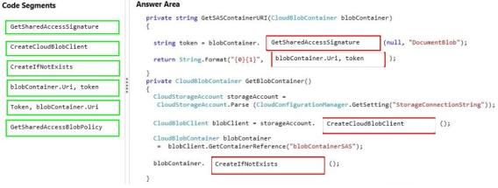

1. You need to insert mark up at line SD06 to cache the client documents. How should you complete the relevant mark up? To answer, select the appropriate option or options in the answer area.

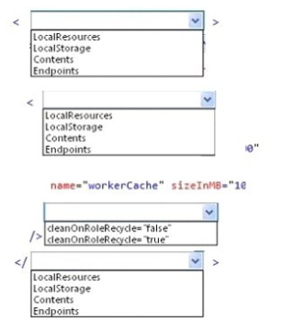

Answer:

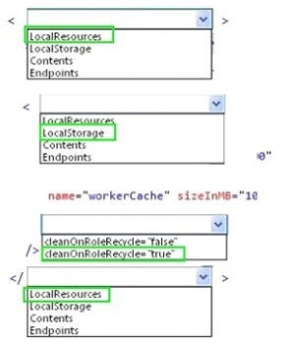

1. You have an ASP.NET application that runs in a cloud service. A new version of the application is ready for release. The new version contains code changes and new SSL certificates. The application consists of six instances of a web role and four instances of a worker role. The application performs at or near full capacity. The cloud service uses the default number of fault domains and upgrade domains. You plan to deploy the new version of the application. The performance and capacity of the web roles must not degrade during the deployment. Temporary degradation of the worker roles is acceptable. The deployment must take a maximum of six hours. You need to deploy the new version of the ASP.NET application to the cloud service. Which two approaches will achieve the goal? Each correct answer presents a complete solution.
2. Increase the number of web role instances to eight, and then deploy the new version of the application by using an in-place update.

Reduce the number of web role instances to six after the upgrade is completed.

1. Deploy the new version of the application by using an in-place update.

Use upgrade domains to ensure that there is sufficient capacity during the upgrade.

1. Deploy the new version of the application into the staging slot for the cloud service.

Then activate the new version of the application by swapping virtual IP (VIP) addresses.

1. Delete the old version of the application, and deploy the new version of the application.

Answers: **B, C**