**Case Study - Contoso, Ltd**

**Background**

Contoso, Ltd. is developing a patient monitoring solution for a hospital. The solution consists of an Azure website and a set of mobile applications that health care providers use to monitor patients remotely. Monitoring devices that run the embedded version of Windows will be attached to patients. The devices will collect information from patients and will transmit real-time continuous data to a service that runs on Azure. The service collects and distributes data. The data that the service provides must be accessible by the website and by the mobile applications.

**Business Requirements**

**Patients**

All patient data must be stored securely on Azure. Data security must meet or exceed Health Insurance Portability and Accountability Act of 1996 (HIPAA) standards in the United States and must meet or exceed ISO/ICE 27002 data security standards in the rest of the world.

**Contractors**

Third-party contractors will develop the mobile applications. All contractors must develop the applications by using virtual machines (VMs) that are hosted on Azure. Only authorized contractors and authorized IP addresses are permitted to access the VMs. The contractors can use Near Field Communication (NFC) tags to launch Remote Desktop (RD) connections to the VMs from NFC enabled devices. For testing purposes, contractors must be able to run multiple instances of mobile applications within the VMs.

**Data Collection and Distribution Service**

The service must monitor the patient data and send out alerts to health care providers when specific conditions are detected. The service must send the alerts to mobile applications and to the website in real time so that doctors, nurses, and caregivers can attend to the patient. Partner organizations and diagnostic laboratories must be able to securely access the data and the website from remote locations.

**Current Issues**

A partner that is testing a prototype of the website reports that after signing in to the website, the partner is redirected to the settings page instead of to the home page. The data from the patient devices is slow to appear on the website and does not always appear. All patient devices online have active connections to the data collection service.

**Technical Requirements**

**Contractors**

All contractors will use virtual machines that are initially configured as size A3. Contractors must sign in to the assigned VM by using IP addresses from a list of preapproved addresses.

**Data Collection and Distribution Service**

- The service runs Node.js in a worker role.

- The service must use at least 2048-bit encryption and must use port 8888.

- All patient information must be encrypted and stored by using a NoSQL data store.

- Data must be stored and retrieved securely by using RESTful endpoints.

- Data must NOT be stored within a virtual machine.

All deployed services must send an alert email to watchguard@contoso.com when any of the following conditions is met:

- The CPU Percentage metric is at or above 85 percent for at least 10 minutes.

- The Network In metric is at or above 2 KB for at least 10 minutes.

- The Network Out metric is at or above 2 KB for at least 10 minutes.

- The Disk Write metric is at or above 1 KB/sec for at least 30 minutes.

- The Disk Read metric is at or above 1 KB/sec for at least 30 minutes.

**Website and Mobile Devices**

The website must be secure and must be accessible only within the hospital's physical grounds.

All mobile applications and websites must be responsive.

All websites must produce error logs that can be viewed remotely.

**Virtual Machines**

- All Azure instances must be deployed and tested on staging instances before they are deployed to production instances.

- All deployed instances must scale up to the next available CPU instance at a CPU usage threshold of 90 percent and scale down when the usage is below 10 percent.

**Application Structure**

Relevant portions of the application files are shown in the following code segments. Line numbers in the code segments are included for reference only and include a two-character prefix that denotes the specific file to which they belong.

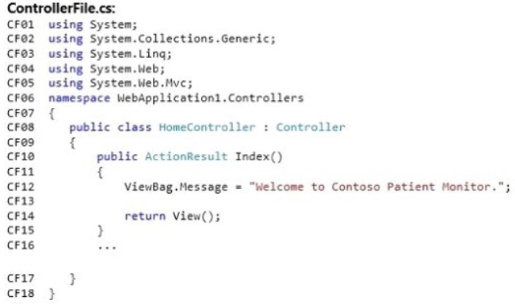

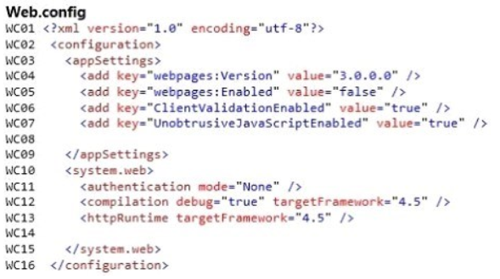

**Questions:**

1. Drag and Drop Question

Contoso, Ltd. reports that hackers have compromised a computer on its network. You need to prevent access to the site from all Contoso, Ltd. computers. How should you complete the relevant Windows PowerShell script? To answer, drag the appropriate Windows PowerShell segment to the correct location. Each Windows PowerShell segment may be used once, more than once, or not at all. You may need to drag the split bar between panes or scroll to view content.

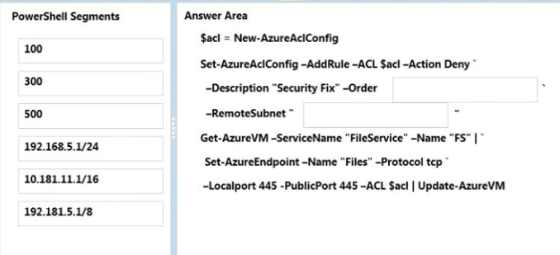

Answer:

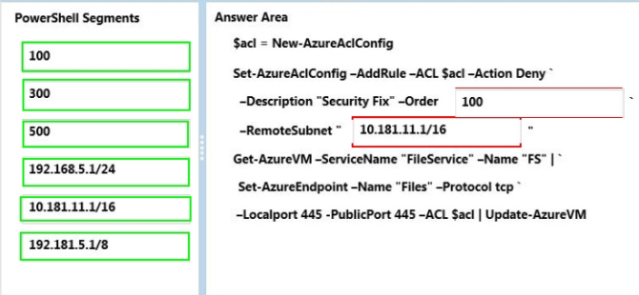

1. Drag and Drop Question

You need to configure a VM for a new contractor. Which three actions should you perform in sequence? To answer, move the appropriate actions from the list of actions to the answer area and arrange them in the correct order.

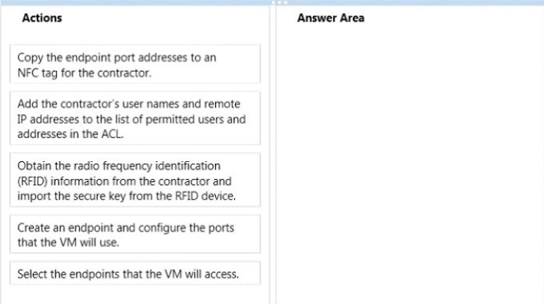

Answer:

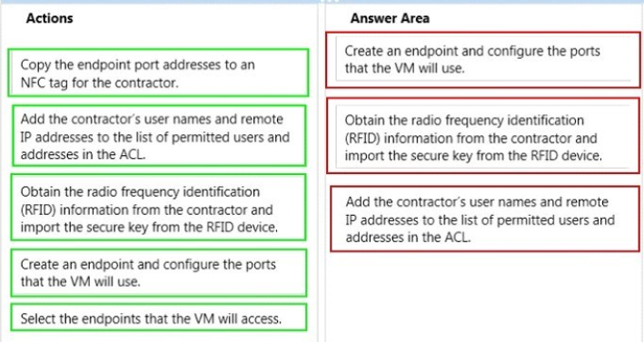

1. You run the following Windows PowerShell script. Line numbers are included for reference only

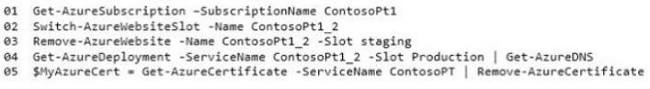

For each of the following statements, select Yes if the statement is true. Otherwise, select No.

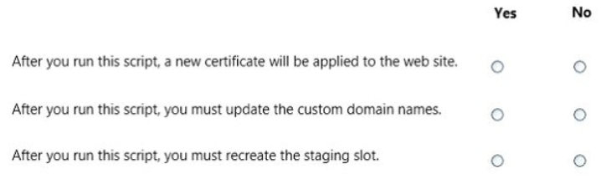

Answer:

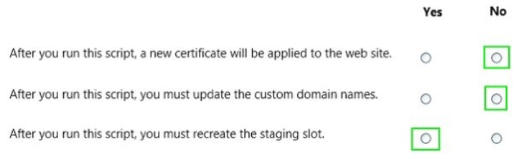

1. The website does not receive alerts quickly enough. You need to resolve the issue.

What should you do?

1. Enable automatic scaling for the website.
2. Manually Increase the instance count for the worker role.
3. Increase the amount of swap memory for the VM instance.
4. Set the monitoring level to Verbose for the worker role.
5. Enable automatic scaling for the worker role.

Answer: B

[Note: The answer is ‘B’. You can’t wait for the auto-scaling to kick in.]

<http://www.aiotestking.com/microsoft/you-need-to-resolve-the-issue/>

1. You need to implement the worker role to support the real-time continuous data-collection service. How should you complete the relevant code? To answer, select the appropriate option or options in the answer area.

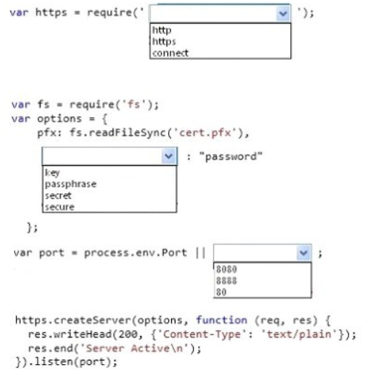

Answer:

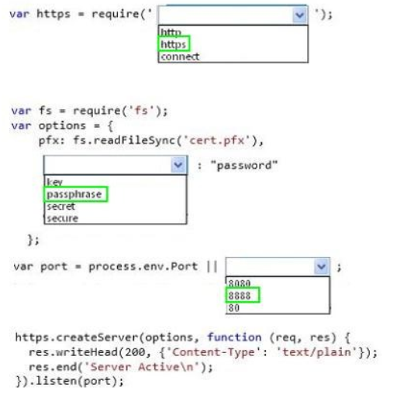

1. You need to implement data storage for patient information. What should you do?
2. Use the Update Entity operation of the Table Service REST API.
3. Use the Put Blob operation of the Blob Service REST API.
4. Use the Put Message operation of the Create Queue REST API.
5. Use the Set Share Metadata operation of the File Service REST API.

Answer: **A**

1. You create a VM named cVM_005 for a newly hired contractor. The contractor reports that the VM runs out of memory when the contractor attempts to test the mobile applications. You need to double the memory that is available for the VM. Which Windows PowerShell command should you use?

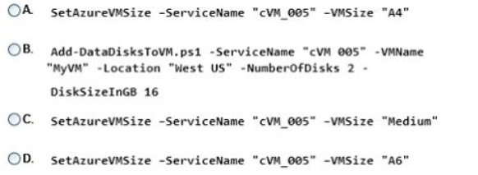

Answer: **A**

[Note: Initial size of the VM is A3 with 7 GB RAM (mentioned in case study). To double the size of RAM he can choose A4 which is coming with 14GB RAM]

1. Users report that after periods of inactivity the website is slow to render pages and to process sign in attempts. You need to ensure that the website is always responsive. What should you do?
2. Add the following markup at line WC14:

<sessionState timeout-"86400" />

1. Add the following markup at line WC08:

<add key="timeout" value="null" />

1. Add the following markup at line WC14:

<sessionState timeout="fl" />

1. In the Azure management portal, enable Always On support for the website.
2. In the Azure management portal, disable Always On support for the website.

Answer: **A**

[Note: It is cloud service application and it does not have AlwaysOn property. Adding a new key with name “timeout” has no effect. And for the session timeout the value must be integer, it cannot be “f1”. So the answer is A]

1. You configure alerts in Azure.

The metrics shown in the following exhibit represent the average values for each five-minute period.

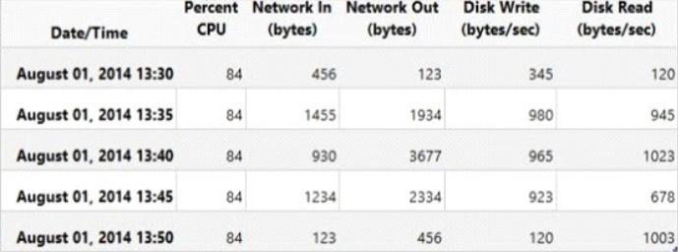

To answer, make the appropriate selections in the answer area.

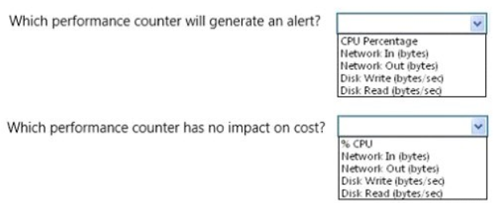

Answer:

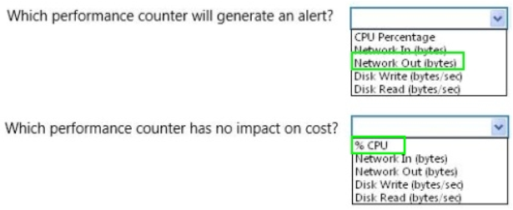

1. You need to implement tracing for the website after the website is deployed. Which code segment should you insert at line CF13?

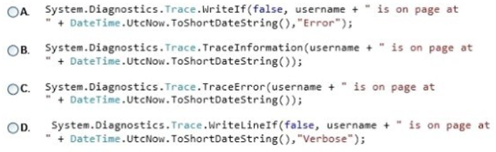

Answer: C

[Note: Under “Websites and Mobile devices” heading it is given “All websites must produce error logs that can be viewed remotely.”. So We must produce an error when the page is loaded that can be traced. So to write an error tracing information answer will be C]