**Case Study - Mortgage Loan**

**Background**

A company is developing a website that supports mortgage loan processing. You use the Azure management portal to create a website. You initially configure the website to use the Basic hosting plan. You register a custom domain for the website with a valid registrar. Customers complete mortgage applications and upload supporting documents to the website. A custom executable named FileProcessor.exe processes all the information received. An on-premises server that runs Windows Server hosts the executable. You create a virtual hard disk (VHD) image of the on-premises server. You plan to use this VHD to replace the on-premises server with a new virtual machine (VM) that is hosted in Azure.

**Business Requirements**

Business stakeholders have identified the following requirements for the mortgage loan processing website:

*- The website must provide a secure mortgage application process for the customer.*

*- Business users must validate new versions of the website before you publish them to the production site. You must be able to revert to the previous version easily when issues arise.*

*- The website must remain available to users while new features and bug fixes are deployed.*

*- Network traffic must be monitored on all ports that the website uses.*

**Technical Requirements**

**General**:

*- You must develop the website by using Microsoft Visual Studio 2013.*

*- The website must be stateless. Subsequent requests from a user might or might not be routed back to the website instance that the user initially connected to.*

**Security**:

You must secure the custom domain and all subdomains by using SSL.

**Storage:**

*- The custom executable must use native file system APIs to share data between different parts of the website*

*- The custom executable must continue to use a network file share to access files.*

**Monitoring**:

The website must use port 6000 with UDP to submit information to another process. This port must be actively monitored by using the same external port number.

**Deployment**:

*- You must deploy the VM and the associated VHD.*

*- You will need to move this VM to a different Azure subscription after deployment.*

*- You must establish a continuous deployment process that uses staged publishing.*

*- The custom domain must handle requests for multiple subdomains.*

*- The custom domain must use a www CNAME record that points to the domain's @A record.*

*- The custom executable must run continuously and must be deployed as an Azure web job named FileProcessor*

*- Application Request Routing (ARR affinity must be disabled for the website.*

**Solution Structure**

The solution structure for the website is shown in the following exhibit.

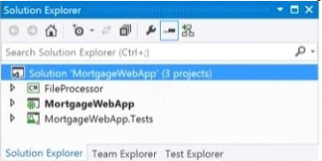

1. You need to implement endpoint monitoring. What should you do? To answer, configure the appropriate options in the dialog box in the answer area.

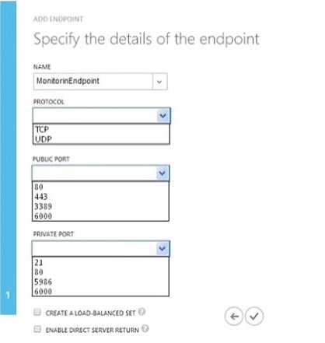

Answer:

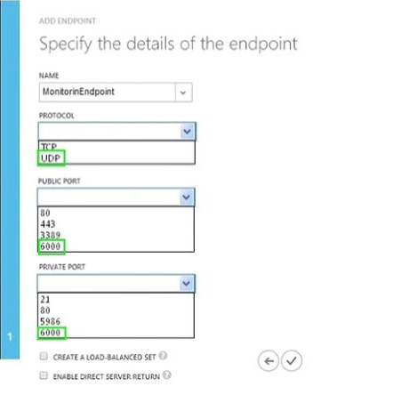

1. You need to debug the website remotely. Which three actions should you take? Each correct answer presents part of the solution.
2. In the Azure management portal, configure a monitoring endpoint.
3. In the Azure management portal, set remote debugging to On and set the Visual Studio version to 2013.
4. Install the Azure SDK for .NET on the computer that runs Visual Studio.
5. In the web.config file for the website, set the debug attribute of the compilation element to true.
6. In the Azure management portal, set the web hosting plan to Standard.

Answer: BCD

1. You need to move the VM. What should you do?
2. Use the Blob Service REST API
3. Use the Service Management REST API
4. Run the Azure PowerShell Convert-VHD cmdlet.
5. Run the Azure PowerShell New-AzureVM cmdlet

Answer: A

1. You need to configure session affinity for the website. Which two actions will achieve the goal? Each correct answer presents a complete solution.

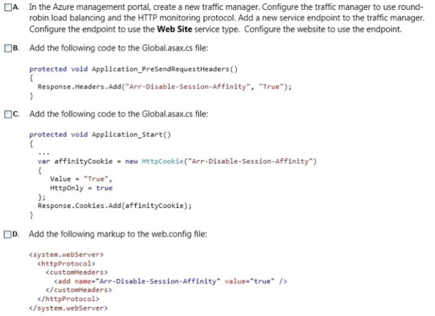

Answers: B, D

1. Drag and Drop Question

You need to complete the domain configuration for the website. Which four actions should you perform in sequence? To answer, move the appropriate actions from the list of actions to the answer area and arrange them in the correct order.

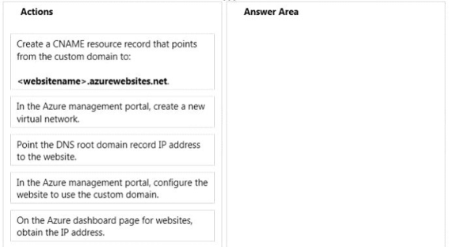

Answer:

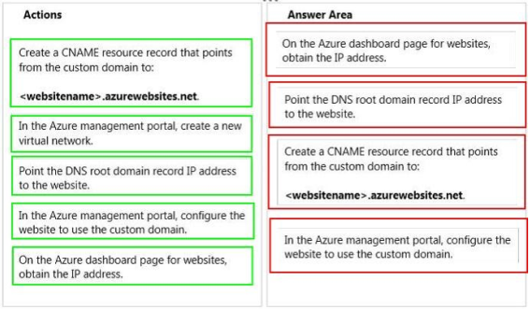

1. You need to implement the web application deployment workflow. In the Azure management portal, what should you do?
2. Set the web hosting plan to Shared. Increase the instance count to 2.

Publish the incremental updates to the new instance.

1. Set the web hosting plan to Standard.

Use Windows PowerShell to create a new deployment slot to publish the incremental updates.

Swap the deployment slot after the business users have validated the updates.

1. Set the web hosting plan to Standard.

Create a new website to host the updated web application.

Create a Windows PowerShell script to move the contents of the new website to the production

website location after the business users have validated the updates.

1. Download the publish profile.

Use Visual Studio to import the publish profile.

Deploy the web application by using the Visual Studio Publish Web wizard after the business users have validated the updates.

Answer: B

1. You need to choose an Azure storage service solution. Which solution should you choose?
2. Queue storage
3. Blob storage
4. File storage
5. Table storage

Answer: C

1. Drag and Drop Question

You need to create the VM to replace the on-premises server. Which three actions should you perform in sequence? To answer, move the appropriate actions from the list of actions to the answer area and arrange them in the correct order.

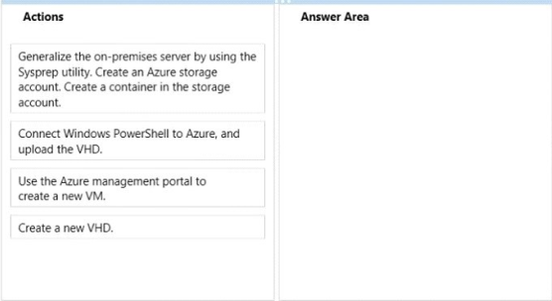

Answer:

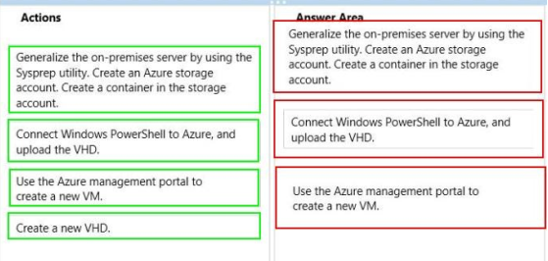

1. Drag and Drop Question

You need to secure the website. Which three actions should you perform in sequence? To answer, move the appropriate actions from the list of actions to the answer area and arrange them in the correct order.

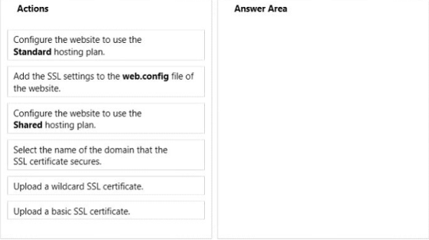

Answer:

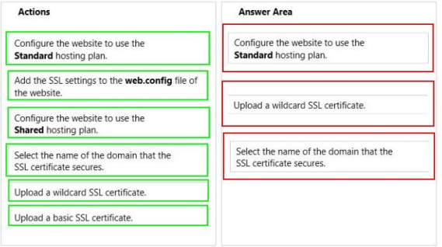

1. You need to deploy the FileProcessor.exe program. How should you update the project configuration file for the program? To answer, select the appropriate option or options in the answer area.

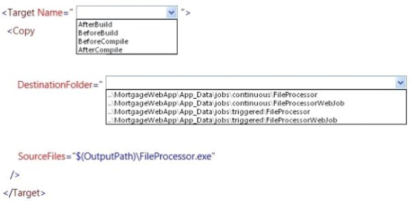

Answer:

