1. You are developing a messaging solution for a financial services company named Adatum. The solution must integrate an application named Enrollment and an application named Activation. The Enrollment application is used to enroll new customers. The Activation application is used to activate accounts for new customers. You need to ensure that each message that the Enrollment application sends is stored in a queue for ten minutes before the Activation application uses the message.

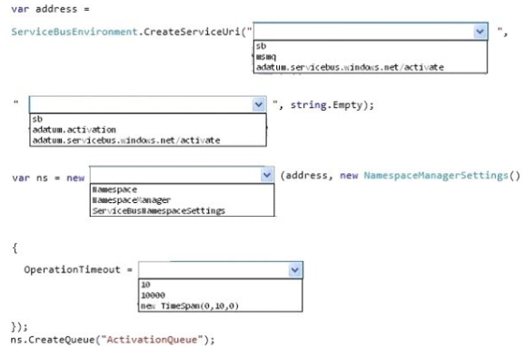

Answer:

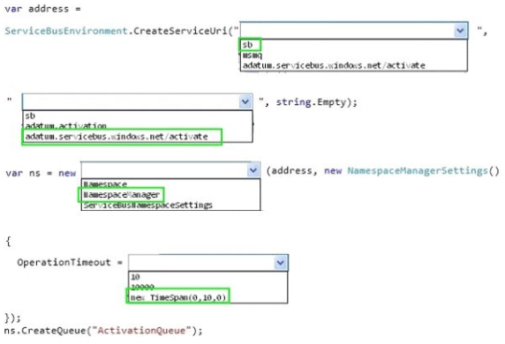

1. An application sends Azure push notifications to a client application that runs on Windows Phone, iOS, and Android devices. Users cannot use the application on some devices. The authentication mechanisms that the application uses are the source of the problem. You need to monitor the number of notifications that failed because of authentication errors. Which three metrics should you monitor?

Each correct answer presents part of the solution.

1. Microsoft Push Notification Service (MPNS) authentication errors
2. External notification system errors
3. Apple Push Notification Service (APNS) authentication errors
4. Channel errors
5. Windows Push Notification Services (WNS) authentication errors
6. Google Cloud Messaging (GCM) authentication errors

Answers: **ACF**

1. d