1. You have an existing server that runs Windows Server.

You plan to create a base image of this server. You will use this base image to prepare several virtual servers for future use. After the base image is prepared, you will capture it by using the Azure management portal. You must use the System Preparation Tool (Sysprep) to prepare the server so that the base image can be captured. You need to prepare the server so that the base image can be captured. What should you do? To answer, configure the appropriate options in the dialog box in the answer area.

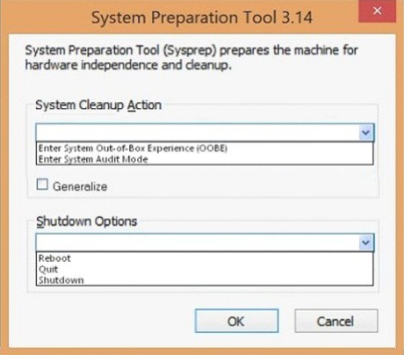

Answer:

Select ‘Enter System Out-of-Box Experience (OOBE)’

Select ‘Generalize’ checkbox

Select ‘Shutdown’ from shutdown options