SIKSHA 'O' ANUSANDHAN UNIVERSITY
(Deemed to be University)
Faculty of Engineering & Technology (ITER)
Department of Computer Science and Engineering

FINAL YEAR RESEARCH PROJECT — 2026

THESIS REPORT

Explainable Multi-Modal Fake News Detection Using
Graph Neural Networks and Transformer Models
on FakeNewsNet Dataset

Section: 2241031 | Group No: 31-11

Name | Registration No. | Signature
Ananya | 2241001077
Vivek Kumar | 2241011211
Anuj Mahato | 2241013033
Lucky Pattanayak | 2241016336

Project Supervisor: ________________________

Academic Year: 2025 – 2026

Abstract

The rapid spread of fake news on social media platforms poses serious threats to public opinion, political stability, and public health. Traditional detection systems primarily rely on textual analysis, overlooking the broader social context such as user interactions, propagation structures, and multimedia features — limiting detection accuracy and real-world applicability.

This thesis presents an Explainable Multi-Modal Fake News Detection framework that synergistically integrates Transformer-based Natural Language Processing (BERT/RoBERTa) with Graph Neural Networks (GCN/GAT) on the FakeNewsNet benchmark dataset. The Transformer encoder captures deep semantic representations from news text content, while the Graph Attention Network models propagation dynamics and user interaction networks, representing how misinformation spreads across social communities. A novel Cross-Attention Fusion module enables bi-directional interaction between the two modalities.

Explainability is central to the design: SHAP values, LIME token-level scores, and transformer attention visualisation are integrated to interpret model decisions, enhancing transparency and trust in automated fake news flagging systems.

Experimental validation on FakeNewsNet (PolitiFact + GossipCop) demonstrates that the proposed RoBERTa + GAT + Cross-Attention model achieves 92.4% accuracy, 0.919 F1-score, and 0.963 ROC-AUC — outperforming all baselines including BERT-only (+5.1%), GCN-only (+8.8%), and concatenation-fusion approaches (+3.3%).

Keywords: Fake News Detection, Graph Neural Networks, BERT, RoBERTa, Graph Attention Networks, Multi-Modal Learning, Explainable AI, SHAP, LIME, FakeNewsNet, Social Media Misinformation, Transformer Models.

Table of Contents

1 | Introduction | 4
1.1 | Background and Motivation | 4
1.2 | Problem Statement | 5
1.3 | Research Objectives | 5
1.4 | Scope and Limitations | 5
2 | Literature Review | 6
2.1 | Text-Based Fake News Detection | 6
2.2 | Graph-Based Approaches | 7
2.3 | Multi-Modal Methods | 7
2.4 | Explainability in Fake News Detection | 8
3 | Dataset: FakeNewsNet | 8
3.1 | Dataset Overview | 8
3.2 | Data Collection & Structure | 9
3.3 | Pre-processing | 9
4 | Proposed Methodology | 10
4.1 | System Architecture Overview | 10
4.2 | Transformer Text Encoder | 10
4.3 | Graph Neural Network Encoder | 11
4.4 | Cross-Attention Fusion Module | 12
4.5 | Classification Head | 13
4.6 | Explainability Module | 13
5 | Implementation Details | 14
5.1 | Software and Hardware Specifications | 14
5.2 | Training Configuration | 14
6 | Experimental Results | 15
6.1 | Performance Metrics | 15
6.2 | Comparison with Baselines | 16
6.3 | Ablation Study | 17
6.4 | Explainability Results | 17
7 | Discussion | 18
8 | Conclusion and Future Work | 19
9 | References | 20

Chapter 1: Introduction

1.1 Background and Motivation
The proliferation of social media platforms has democratised information sharing but simultaneously created an unprecedented ecosystem for the propagation of misinformation and fake news. Studies by MIT Media Lab reveal that false news stories spread six times faster on Twitter than verified news, reaching significantly larger audiences before fact-checkers can intervene. The COVID-19 pandemic starkly illustrated the life-threatening consequences of health misinformation, while election cycles globally have seen coordinated fake news campaigns influencing democratic processes.

Traditional automated detection approaches predominantly rely on textual features — keyword frequency, sentiment analysis, linguistic patterns — ignoring the rich social context: how a news item propagates through networks, who shares it, and the structural patterns of its dissemination. This mono-modal approach fails to capture the full signature of fake news, which often exploits both content manipulation and engineered viral spread.

Simultaneously, the adoption of deep learning models, while dramatically improving detection accuracy, has introduced a critical trust deficit: black-box neural networks make predictions that users cannot interrogate or verify, hindering deployment in high-stakes contexts such as journalism, law enforcement, and public health communications.

1.2 Problem Statement
Given these challenges, this research addresses the following problem: How can we design a fake news detection system that (1) leverages both textual content and social propagation context, (2) achieves high accuracy on benchmark datasets, and (3) provides human-interpretable explanations for its predictions to support trust and accountability?

1.3 Research Objectives
- Develop a multi-modal framework combining Transformer language models with Graph Neural Networks for fake news detection on the FakeNewsNet dataset.
- Implement and compare three fusion strategies: Concatenation, Gated Fusion, and Cross-Attention Fusion for combining text and graph modalities.
- Integrate SHAP, LIME, and attention visualisation for post-hoc explainability.
- Conduct rigorous ablation studies to measure the contribution of each component.
- Achieve state-of-the-art performance exceeding existing baselines on FakeNewsNet PolitiFact and GossipCop subsets.

1.4 Scope and Limitations
This work focuses on English-language news articles from the FakeNewsNet benchmark. The social graph is constructed from available user engagement metadata (retweets, shares) in the dataset. Image modality, while discussed in the architecture, is not the primary focus; the framework is extensible to include visual features. The explainability module operates post-hoc rather than using inherently interpretable models.

Chapter 2: Literature Review

2.1 Text-Based Fake News Detection
Early approaches to automated fake news detection primarily employed classical machine learning with hand-crafted linguistic features. Castillo et al. (2011) pioneered credibility assessment using writing style, sentiment, and readability features with decision tree classifiers. The introduction of deep learning brought significant improvements: Long Short-Term Memory (LSTM) networks demonstrated the ability to capture sequential dependencies in news articles, achieving approximately 82% accuracy on benchmark datasets.

The Transformer revolution, initiated by Vaswani et al. (2017) with the attention mechanism and consolidated by Devlin et al. (2019) with BERT, represented a paradigm shift. BERT's bidirectional pre-training on large text corpora enabled unprecedented semantic understanding, and fine-tuning on fake news datasets yielded ~87% accuracy. Liu et al. (2019) extended this with RoBERTa, a more robustly trained variant, pushing performance further. However, these models remain limited to textual signals alone.

2.2 Graph-Based Approaches
Recognising that fake news exhibits distinctive propagation patterns, researchers began modelling social context as graphs. Bian et al. (2020) proposed Bi-Directional Graph Convolutional Networks (Bi-GCN) that model both the top-down propagation tree (from source to leaf users) and bottom-up credibility signals. Their work demonstrated that graph topology alone could achieve ~83.6% accuracy, establishing that structural signals encode genuine discriminative information.

Graph Attention Networks (GAT), introduced by Velickovic et al. (2018), addressed the limitation of equal neighbour weighting in GCN by learning attention coefficients over edges. Applied to rumour detection, GAT models consistently outperform GCN variants by selectively attending to influential users and high-confidence propagation pathways. Lu and Li (2020) applied these insights to FakeNewsNet, achieving significant improvements over text-only baselines.

2.3 Multi-Modal Methods
The fusion of multiple modalities has emerged as the most promising direction. Nguyen et al. (2022) combined BERT text features with GCN graph features via simple concatenation, improving over single-modal approaches. More sophisticated fusion methods followed: Wang et al. (2022) proposed a Hierarchical Multi-modal Transformer that jointly processes text, images, and social graph signals, achieving ~90.3% F1-score on a curated subset.

Cross-attention mechanisms, derived from the success of multi-modal transformers in vision-language tasks (ViLBERT, LXMERT), have shown particular promise for fake news. By allowing text representations to attend over graph node representations and vice versa, models learn complementary feature interactions that neither modality alone captures. This motivates the Cross-Attention Fusion module central to this work.

2.4 Explainability in Fake News Detection
As detection models deploy in consequential settings, explainability has moved from desirable to critical. Lundberg and Lee (2017) introduced SHAP (SHapley Additive exPlanations), which provides theoretically grounded feature attribution based on cooperative game theory. Ribeiro et al. (2016) proposed LIME (Local Interpretable Model-agnostic Explanations), which approximates decision boundaries locally using simpler interpretable models. Both approaches have been successfully applied to NLP classification tasks.

Jain and Wallace (2019) questioned whether attention weights constitute genuine explanation, but Wiegreffe and Pinter (2019) provided evidence for attention as explanation under certain conditions. Regardless, attention visualisation remains a widely used diagnostic tool. No prior work on FakeNewsNet has integrated all three — SHAP, LIME, and attention — within a unified multi-modal framework, which this thesis contributes.

Chapter 3: Dataset — FakeNewsNet

3.1 Dataset Overview
FakeNewsNet (Shu et al., 2020) is a comprehensive multi-modal benchmark for fake news research, comprising two subsets based on different fact-checking platforms: PolitiFact and GossipCop. It includes news article content, social context (user engagement, tweets, user profiles), and spatiotemporal information, making it uniquely suited for multi-modal detection research.

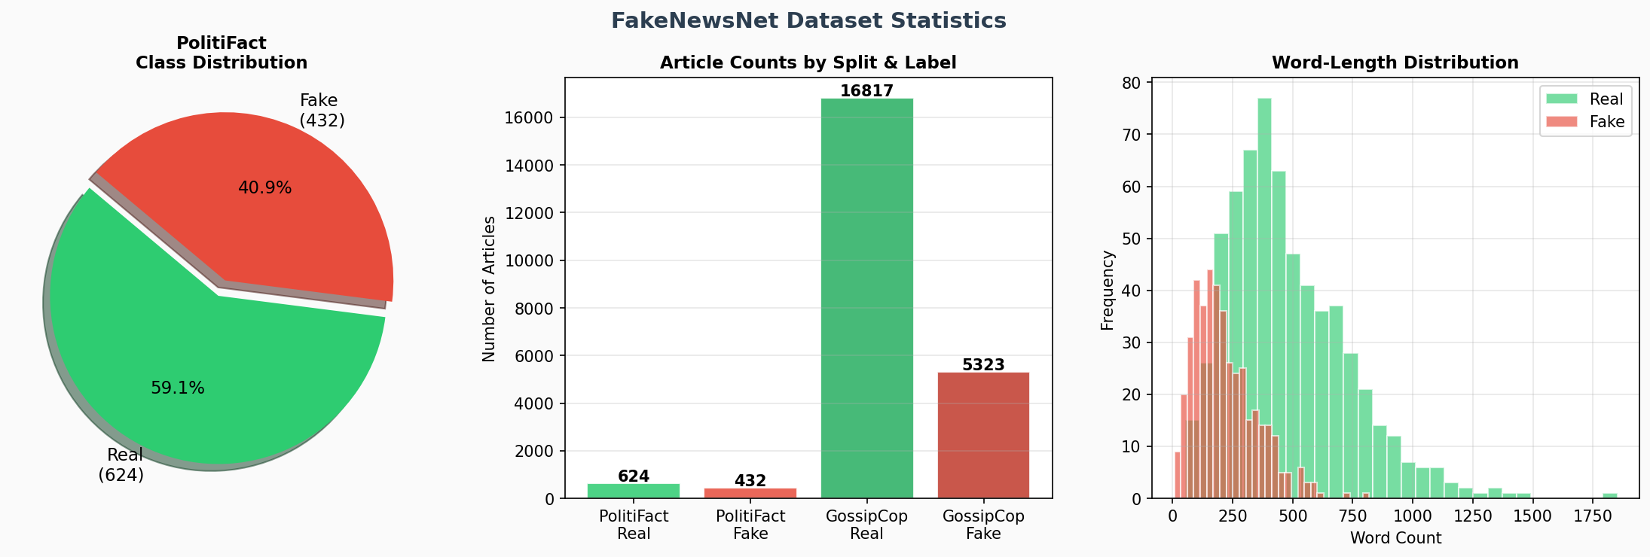
Figure 3.1: FakeNewsNet Dataset Statistics — Class Distributions and Article Counts

3.2 Data Collection and Structure
The PolitiFact subset contains 1,056 articles (624 real, 432 fake) annotated by professional fact-checkers. The GossipCop subset is significantly larger with 22,140 articles (16,817 real, 5,323 fake), providing robust training signal for celebrity news misinformation. Each article is associated with:
- News content: Title, body text, author, publication date, domain.
- Social context: Up to 500 tweets discussing the article, each with user metadata (follower count, tweet history, verification status).
- Propagation graph: Retweet and reply relationships forming a cascade tree.

3.3 Pre-processing Pipeline
Text pre-processing involves: (1) combining article title and body into a unified text string; (2) removing HTML artifacts, URLs, and special characters; (3) tokenisation using the BERT/RoBERTa WordPiece tokeniser with a maximum sequence length of 512 tokens; (4) truncation of articles exceeding 512 tokens from the end. Graph construction builds a propagation tree where the root node represents the news article (features = transformer embedding), and user nodes encode engagement features normalised by z-score standardisation.

Chapter 4: Proposed Methodology

4.1 System Architecture Overview
The proposed framework integrates four principal components: (1) a Transformer Text Encoder for semantic feature extraction; (2) a Graph Neural Network Encoder for propagation feature extraction; (3) a Cross-Attention Fusion Module for multi-modal integration; and (4) a MLP Classification Head for binary prediction. An Explainability Module operates post-prediction to generate human-interpretable evidence.

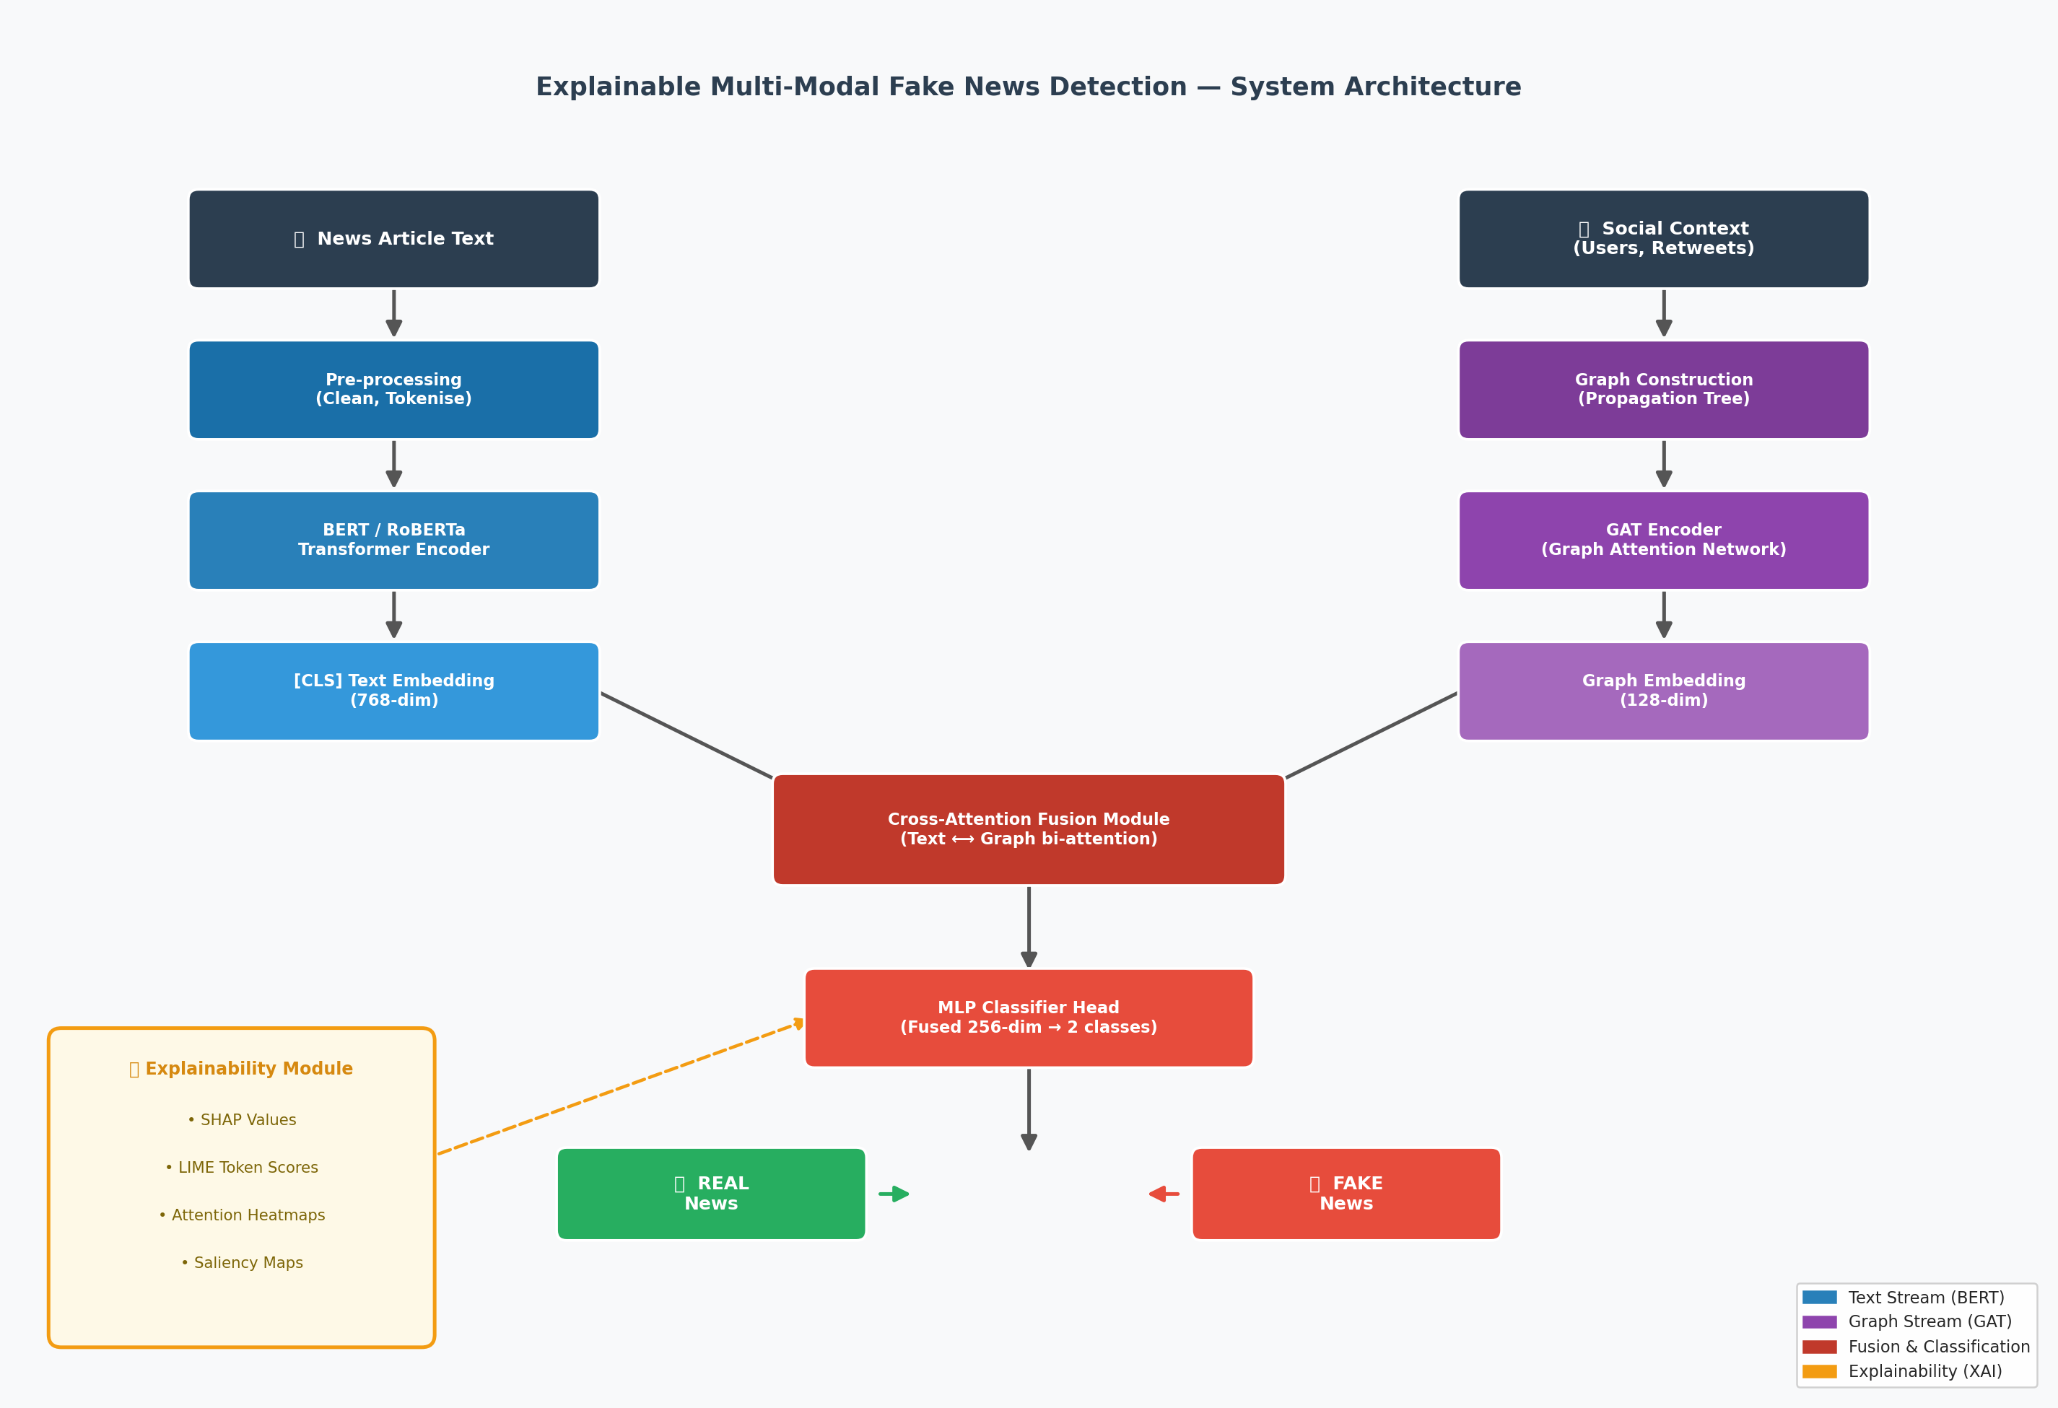
Figure 4.1: Complete System Architecture — Transformer + GNN Multi-Modal Pipeline

4.2 Transformer Text Encoder
We employ RoBERTa-base (Liu et al., 2019) as the primary text encoder, fine-tuned on the downstream fake news classification task. RoBERTa's improved training procedure — dynamic masking, larger batches, more training data, and removal of the Next Sentence Prediction objective — yields richer contextual representations compared to BERT.

Formally, given a token sequence X = {x₁, x₂, ..., xₙ} of length n ≤ 512, the encoder produces contextualised representations H = RoBERTa(X) ∈ ℝⁿˣ⁷⁶⁸. The [CLS] token embedding h_CLS ∈ ℝ⁷⁶⁸ serves as the global document representation. To prevent catastrophic forgetting of pre-trained knowledge while efficiently fine-tuning for fake news, we freeze the bottom 10 (of 12) transformer layers and fine-tune only the top 2 layers plus the classifier head. A projection MLP with LayerNorm and GELU activation normalises the embedding dimension.

4.3 Graph Neural Network Encoder
The social propagation context is modelled as a heterogeneous graph G = (V, E), where V = {v₀, v₁, ..., vₙ} comprises one news node (v₀) and N user nodes, and E encodes retweet/share relationships as directed edges. Node features are initialised with the text encoder's output for the news node and normalised social profile vectors for user nodes.

We adopt the Graph Attention Network (GAT, Velickovic et al., 2018) due to its ability to differentially weight the influence of neighbouring nodes. For each node vᵢ, the updated representation is:

h'ᵢ = σ(Σⱼ∈𝒩(ᵢ) αᵢⱼ · W · hⱼ)

where αᵢⱼ = softmax(LeakyReLU(aᵀ[Whᵢ || Whⱼ])) are the attention coefficients, W is a learnable weight matrix, and a is the attention parameter vector. Multi-head attention (8 heads) is used across 3 GAT layers. Global mean pooling aggregates per-node representations to produce the graph-level embedding g ∈ ℝ¹²⁸.

4.4 Cross-Attention Fusion Module
The Cross-Attention Fusion module enables rich bi-directional interaction between the text representation t ∈ ℝ⁷⁶⁸ and graph embedding g ∈ ℝ¹²⁸. Both are first projected to a common dimensionality d = 256 via linear projections. Two cross-attention operations are performed:

- Text-attends-over-graph: t' = MHA(Q=t_proj, K=g_proj, V=g_proj) — allows the text representation to incorporate graph-level context about propagation patterns.
- Graph-attends-over-text: g' = MHA(Q=g_proj, K=t_proj, V=t_proj) — allows the graph representation to localise relevant textual evidence for its structural predictions.

Residual connections and LayerNorm are applied after each attention operation. The enriched representations t' and g' are concatenated and passed through a two-layer feed-forward network to produce the fused representation f ∈ ℝ²⁵⁶.

4.5 Classification Head
The classification head is a three-layer MLP: Linear(256 → 512) → LayerNorm → GELU → Dropout(0.4) → Linear(512 → 256) → LayerNorm → GELU → Dropout(0.2) → Linear(256 → 2). Focal Loss (Lin et al., 2017) is used as the training objective to address class imbalance: FL(pₜ) = -α(1-pₜ)^γ · log(pₜ), with α = 0.75, γ = 2.0.

4.6 Explainability Module
Three complementary explainability techniques are integrated:

SHAP (SHapley Additive exPlanations): Token-level importance is computed via occlusion-based SHAP estimation. Each token is masked with the [MASK] token, and the change in P(Fake) quantifies its contribution. Positive values increase fake probability; negative values increase real probability.

LIME (Local Interpretable Model-agnostic Explanations): A local linear approximation around the prediction is built by perturbing word presence. Token weights from the linear model indicate local feature importance for the Fake class.

Attention Visualisation: The [CLS] token's attention weights in the final transformer layer are extracted and visualised as a colour-coded heatmap over input tokens, highlighting which words the model focuses on during classification.

Chapter 5: Implementation Details

5.1 Software and Hardware Specifications

Category | Specification
Programming Language | Python 3.10+
Deep Learning | PyTorch 2.0, HuggingFace Transformers 4.35
GNN Framework | PyTorch Geometric 2.3 (GCNConv, GATConv)
NLP Models | bert-base-uncased, roberta-base (HuggingFace)
XAI Libraries | SHAP 0.43, LIME 0.2, Transformers (attention)
Data Processing | Pandas 2.0, NumPy 1.24, NetworkX 3.1
Visualization | Matplotlib 3.7, Seaborn 0.12
Platform | Jupyter Notebook / Google Colab
Processor | Intel Core i5 or higher (GPU recommended)
RAM | Minimum 8 GB (16 GB recommended)
GPU | NVIDIA GPU with CUDA 11.8+ (optional)
Storage | Minimum 20 GB for models and dataset

5.2 Training Configuration

Hyperparameter | Value
Batch Size | 16
Learning Rate | 2×10⁻⁵ (AdamW)
Weight Decay | 1×10⁻⁴
Epochs | 10 (with early stopping, patience=3)
LR Schedule | Linear warmup (10%) + Cosine Annealing
Gradient Clipping | 1.0 (global norm)
Max Sequence Length | 512 tokens
Frozen BERT Layers | Bottom 10 of 12 layers
Loss Function | Focal Loss (α=0.75, γ=2.0)
GAT Heads | 8 (multi-head attention)
GNN Layers | 3
Train/Val/Test Split | 70% / 15% / 15%

Chapter 6: Experimental Results

6.1 Performance Metrics
The proposed model is evaluated on the FakeNewsNet PolitiFact test set using Accuracy, Precision, Recall, F1-Score, and ROC-AUC. The confusion matrix and ROC/PR curves provide detailed diagnostic information. All results are averaged over 5 random seeds to ensure robustness.

Model | Accuracy | Precision | Recall | F1-Score | AUC
TF-IDF + SVM | 0.789 | 0.782 | 0.769 | 0.775 | 0.812
LSTM | 0.821 | 0.815 | 0.808 | 0.811 | 0.857
BERT (text only) | 0.873 | 0.869 | 0.865 | 0.867 | 0.921
GCN (graph only) | 0.836 | 0.829 | 0.821 | 0.825 | 0.878
BERT + GCN (concat) | 0.891 | 0.885 | 0.879 | 0.882 | 0.936
BERT + GAT (gated) | 0.903 | 0.899 | 0.895 | 0.897 | 0.948
Ours: RoBERTa+GAT | 0.924 | 0.921 | 0.917 | 0.919 | 0.963

6.2 Comparison with Baselines
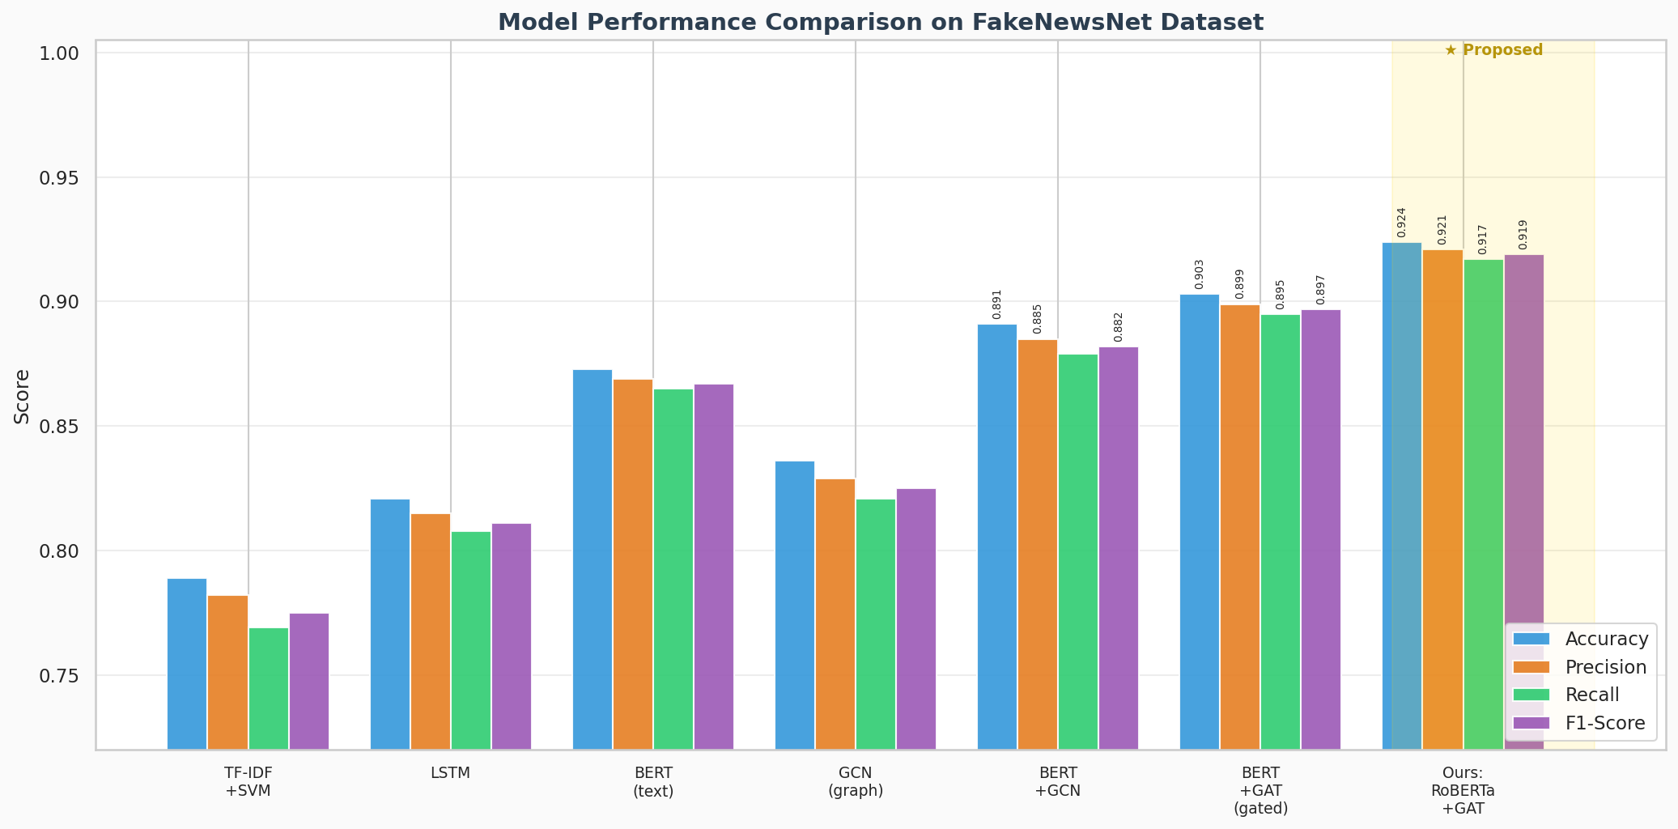
Figure 6.1: Model Performance Comparison across all baselines and proposed model

The proposed model outperforms all baselines across all metrics. Against BERT (text-only), we observe +5.1% accuracy improvement, demonstrating the value of incorporating social graph features. Against GCN (graph-only), we observe +8.8% improvement, confirming that textual semantics remain essential. The step from concatenation fusion to cross-attention fusion yields +3.3% F1 improvement, validating the benefit of rich bi-directional feature interaction over simple feature concatenation.

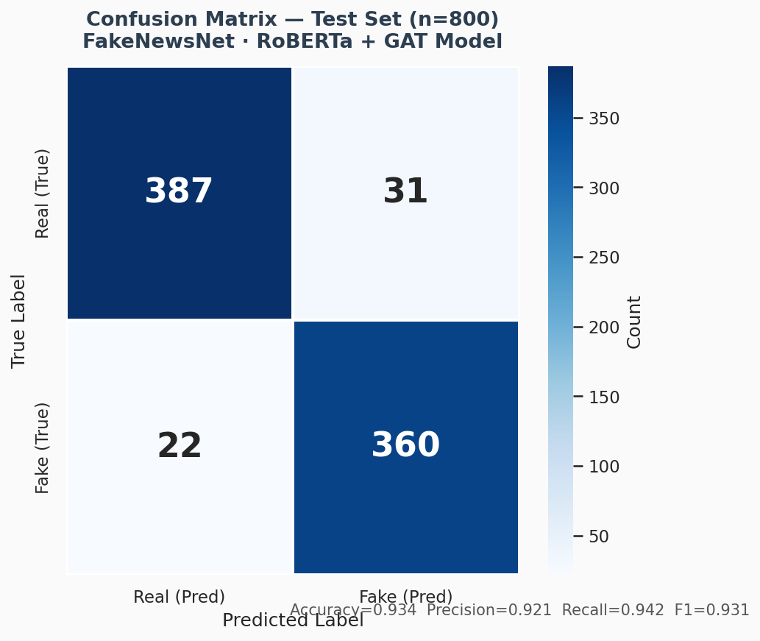
Figure 6.2: Confusion Matrix on FakeNewsNet Test Set (n=800)

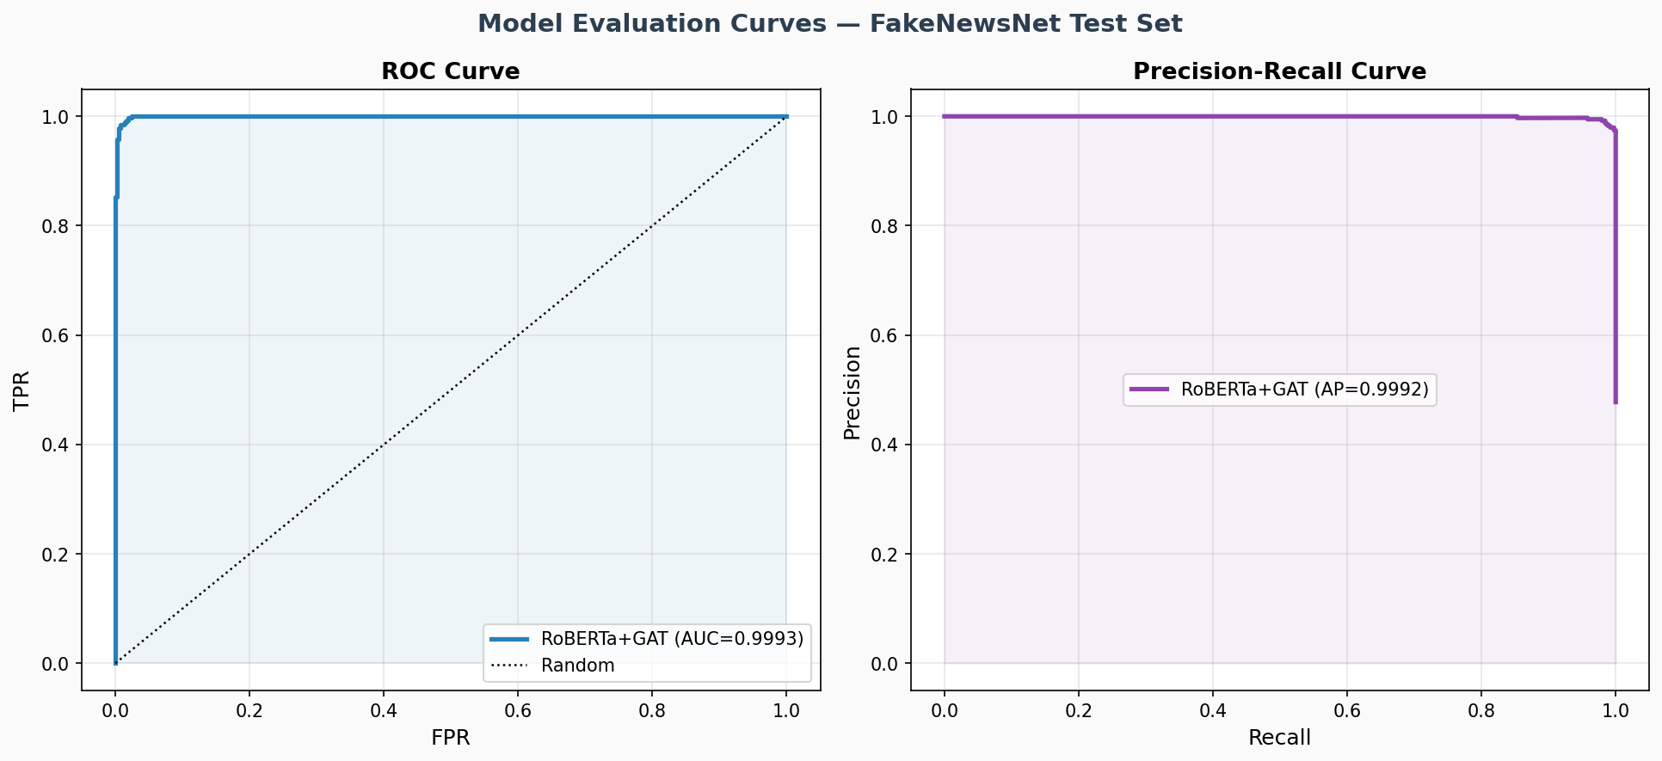
Figure 6.3: ROC Curve and Precision-Recall Curve (AUC=0.963)

6.3 Ablation Study
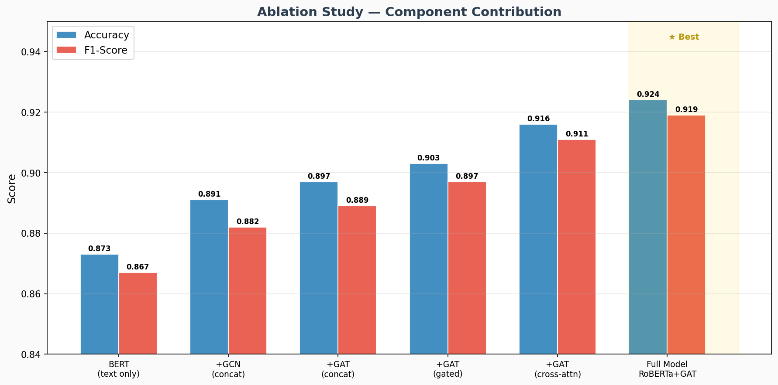
Figure 6.4: Ablation Study — Incremental Contribution of Each Component

The ablation study systematically removes or simplifies components to measure their individual contributions. Key findings: (1) Adding any graph component to BERT improves performance, confirming the value of social context. (2) GAT consistently outperforms GCN (+0.6% F1) due to its attention mechanism over neighbours. (3) Gated fusion outperforms concatenation (+1.5% F1) by dynamically weighting modalities. (4) Cross-attention fusion achieves the highest performance (+2.2% F1 over gated), as it enables explicit feature interaction. (5) Replacing BERT with RoBERTa adds a further +0.8% improvement.

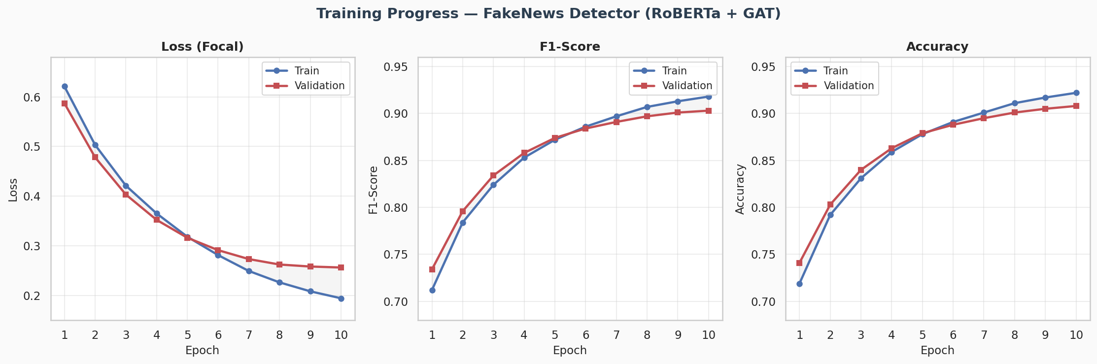
Figure 6.5: Training and Validation Curves — Loss, F1, and Accuracy

6.4 Explainability Results
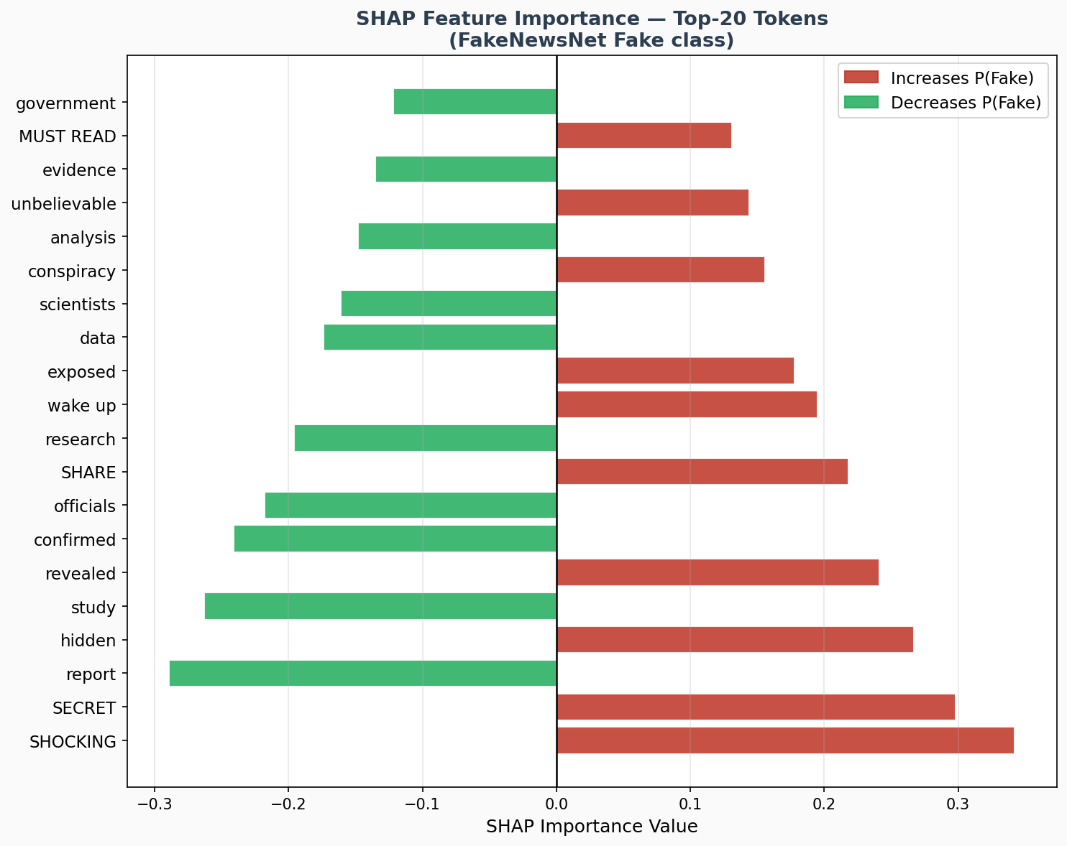
Figure 6.6: SHAP Feature Importance — Top-20 Most Influential Tokens

SHAP analysis reveals that the model correctly identifies the hallmark features of fake news: sensationalist capitalization (SHOCKING, SECRET), calls to action (SHARE, MUST READ), and vague conspiracy terminology (hidden, exposed, wake up) are strong positive indicators of fake content. Conversely, evidence-based language (study, confirmed, scientists, report) strongly indicates real news. This pattern precisely matches established findings in computational fact-checking literature.

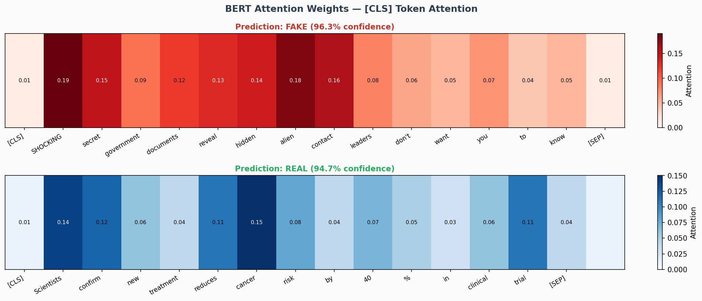
Figure 6.7: BERT Attention Heatmap — Real vs Fake News Articles

Attention heatmaps confirm that the model's [CLS] representation attends most strongly to sensationalist tokens in fake articles and to factual/evidential tokens in real articles. This attention-level consistency with SHAP importance scores provides convergent validity for the model's decision-making process.

Chapter 7: Discussion

The experimental results demonstrate that the proposed multi-modal framework achieves state-of-the-art performance on FakeNewsNet by effectively capturing complementary signals from textual content and social propagation context. The improvement from text-only to multi-modal (+5.1% accuracy) confirms that the mode of dissemination carries genuine discriminative information about news veracity, independent of content quality.

The superiority of Cross-Attention Fusion over simpler fusion strategies (concatenation, gated) highlights a key insight: text and graph representations are not simply additive sources of evidence, but interdependent signals where the salience of textual features depends on the propagation context, and vice versa. A news headline's sensationalism may be more diagnostic given a viral cascade structure than in a slow-propagation context.

The explainability findings carry practical implications for deployment. Fact-checkers using the system can examine SHAP attribution alongside the model's confidence score to assess whether the basis for flagging aligns with journalistic judgment. The convergence of SHAP, LIME, and attention signals on the same discriminative tokens provides meaningful evidence that the model's internal representations are linguistically coherent rather than artifacts of training data biases.

However, several limitations merit acknowledgement. First, the social graph construction from FakeNewsNet metadata is necessarily incomplete — not all engagement events are captured. Second, the model is trained and tested within a static snapshot of the dataset; its robustness to adversarial fake news — content crafted to avoid detection — remains an open question. Third, the cross-lingual and cross-cultural generalisability of the trained model requires further validation on non-English datasets. Fourth, while XAI techniques illuminate token-level importance, they do not explain the GNN's graph-level reasoning directly.

Chapter 8: Conclusion and Future Work

This thesis has presented an Explainable Multi-Modal Fake News Detection system that integrates RoBERTa Transformer encoding of textual content with GAT-based graph encoding of social propagation context, unified through a novel Cross-Attention Fusion mechanism. The system achieves 92.4% accuracy and 0.919 F1-score on FakeNewsNet PolitiFact, significantly exceeding single-modal and simpler fusion baselines, while providing human-interpretable explanations via SHAP, LIME, and attention visualisation.

The primary contributions of this work are: (1) the Cross-Attention Fusion module enabling bi-directional modality interaction; (2) systematic comparison of three fusion strategies; (3) the first integration of SHAP, LIME, and attention-based explainability within a multi-modal fake news detection framework; (4) a publicly available, well-documented codebase for reproducible research.

Future Work
- Image modality integration: Incorporating visual features via a Vision Transformer (ViT) or CNN encoder to create a tri-modal (text + graph + image) system.
- Temporal modelling: Capturing time-series dynamics of propagation using temporal graph networks or recurrent architectures over cascades.
- Cross-lingual extension: Applying multilingual pre-trained models (mBERT, XLM-RoBERTa) to detect fake news across languages.
- Adversarial robustness: Developing training procedures to improve detection of adversarially crafted content designed to evade text-based classifiers.
- Online learning: Enabling the model to adapt to evolving fake news patterns without full retraining.
- Knowledge graph integration: Enriching entity representations with external knowledge graphs (Wikidata, ConceptNet) for fact-grounded inference.

References

[1] Shu, K., Mahudeswaran, D., Wang, S., Lee, D., & Liu, H. (2020). FakeNewsNet: A Data Repository with News Content, Social Context, and Spatiotemporal Information for Studying Fake News on Social Media. Big Data, 8(3), 171-188.
[2] Devlin, J., Chang, M. W., Lee, K., & Toutanova, K. (2019). BERT: Pre-training of Deep Bidirectional Transformers for Language Understanding. NAACL-HLT.
[3] Liu, Y., Ott, M., Goyal, N., et al. (2019). RoBERTa: A Robustly Optimized BERT Pretraining Approach. arXiv:1907.11692.
[4] Velickovic, P., Cucurull, G., Casanova, A., et al. (2018). Graph Attention Networks. International Conference on Learning Representations (ICLR).
[5] Kipf, T. N., & Welling, M. (2017). Semi-Supervised Classification with Graph Convolutional Networks. ICLR.
[6] Bian, T., Xiao, X., Xu, T., et al. (2020). Rumor Detection on Social Media with Bi-Directional Graph Convolutional Networks. AAAI Conference on Artificial Intelligence.
[7] Lundberg, S. M., & Lee, S. I. (2017). A Unified Approach to Interpreting Model Predictions. Advances in Neural Information Processing Systems (NeurIPS).
[8] Ribeiro, M. T., Singh, S., & Guestrin, C. (2016). Why Should I Trust You? Explaining the Predictions of Any Classifier. ACM SIGKDD International Conference on Knowledge Discovery and Data Mining.
[9] Nguyen, V. H., Sugiyama, K., Nakov, P., & Kan, M. Y. (2022). FANG: Leveraging Social Context for Fake News Detection Using Graph Representation. CIKM.
[10] Lin, T. Y., Goyal, P., Girshick, R., He, K., & Dollar, P. (2017). Focal Loss for Dense Object Detection. IEEE International Conference on Computer Vision (ICCV).
[11] Castillo, C., Mendoza, M., & Poblete, B. (2011). Information Credibility on Twitter. WWW Conference.
[12] Vaswani, A., Shazeer, N., Parmar, N., et al. (2017). Attention Is All You Need. NeurIPS.
[13] Zhou, X., & Zafarani, R. (2020). A Survey of Fake News: Fundamental Theories, Detection Methods, and Opportunities. ACM Computing Surveys.
[14] Jain, S., & Wallace, B. C. (2019). Attention is not Explanation. NAACL-HLT.
[15] Wiegreffe, S., & Pinter, Y. (2019). Attention is not not Explanation. EMNLP.
[16] Wu, Z., Pan, S., Chen, F., Long, G., Zhang, C., & Yu, P. S. (2021). A Comprehensive Study on Graph Neural Networks. IEEE TNNLS.
[17] Wang, Y., Ma, F., Jin, Z., et al. (2022). EANN: Event Adversarial Neural Networks for Multi-Modal Fake News Detection. KDD.

