A/B Testing Analysis
E-Commerce Checkout Page Conversion
Frequentist Testing · Bayesian Analysis · Segmentation · Business Impact
Dataset: Udacity A/B Test · 294,478 Users · Tools: Python · SQL · scipy · plotly

294,478  Total Users | 11.94%  Control Conv. Rate | 12.00%  Treatment Conv. Rate | p=0.625  Frequentist p-value | 68.8%  P(Treatment > Control) | £1.19M  Potential Annual Impact

1. Executive Summary
This report presents a complete A/B testing analysis of a redesigned checkout page for a UK e-commerce platform. The experiment ran for 205 days with 294,478 users split equally between the existing checkout (Control) and a redesigned version (Treatment).
The treatment group showed a marginal improvement in conversion rate (+0.06 percentage points, +0.49% relative lift). However, the result is not statistically significant under frequentist testing (p = 0.625), and the Bayesian analysis places only a 68.8% probability that the new design outperforms the old one — well below the 95% threshold required to ship with confidence.

KEY | The experiment was adequately powered (144,740 users required; 147,239 achieved), the data was clean (zero contaminated users, perfect 50/50 split), and no novelty effect was detected. The result is genuinely inconclusive — not underpowered.

Recommendation: Do not ship the new design based on this experiment alone. Consider a targeted redesign focusing on the mobile segment (which showed the largest positive trend) and re-run with a specific mobile-first hypothesis.

2. Experiment Design

2.1 Hypothesis
Null hypothesis (H₀): The new checkout page design has no effect on conversion rate.
Alternative hypothesis (H₁): The new checkout page design changes conversion rate (two-tailed test).
Minimum Detectable Effect: 2% relative lift over the baseline conversion rate of ~12%.

2.2 Dataset
Field | Value
Source | Udacity A/B Test Dataset (kaggle.com)
Total rows | 294,478 user-visit records
Control group | 147,239 users (old checkout)
Treatment group | 147,239 users (new checkout)
Experiment period | 1 Jan 2024 – 23 Jul 2024 (205 days)
Target metric | Converted (1 = purchased, 0 = did not purchase)
Segments | Device type (mobile/desktop/tablet), New vs Returning user

2.3 Data Quality Checks
Before any analysis, four quality checks were performed to validate experiment integrity:
- Duplicate users: 0 users appeared more than once
- Contaminated users (in both groups): 0 — experiment randomisation was clean
- Sample Ratio Mismatch (SRM): Both groups exactly 147,239 — perfect 50/50 split
- Missing values: 0 across all columns

✓ | All four quality checks passed. The experiment data is valid for analysis.

3. Conversion Rate Analysis

3.1 Baseline Metrics
Group | Users | Conversions | Conversion Rate | CI Lower (95%) | CI Upper (95%)
Control | 147,239 | 17,578 | 11.9384% | 11.7728% | 12.1040%
Treatment | 147,239 | 17,664 | 11.9968% | 11.8309% | 12.1628%

The treatment group converted at 11.9968% vs 11.9384% for control — an absolute difference of +0.0584 percentage points and a relative lift of +0.49%. The 95% confidence intervals for both groups overlap substantially, which is the first visual indicator that the difference may not be statistically significant.

3.2 Frequentist Z-Test
A two-proportion z-test was conducted to determine whether the observed difference is statistically significant.
Metric | Value
Test type | Two-proportion z-test (two-tailed)
Significance level (α) | 0.05
Pooled proportion | 0.1197
Standard error | 0.001196
Z-statistic | 0.4883
P-value | 0.6254
95% CI for difference | [-0.1761%, +0.2929%]
Result | NOT SIGNIFICANT — fail to reject H₀

The p-value of 0.6254 is far above the 0.05 threshold. The 95% confidence interval for the difference includes zero, confirming the result. There is insufficient evidence to conclude the new design has any effect on conversion rate.

3.3 Power Analysis
Power analysis was conducted to verify the experiment was adequately sized to detect the target effect.
- Target minimum detectable effect: 2% relative lift
- Required sample per group: 144,740 users
- Actual sample per group: 147,239 users
- Power: 80% at α = 0.05

✓ | The experiment was fully powered. The null result is genuine — not due to insufficient sample size. If a 2% lift existed, this experiment would have detected it with 80% probability.

4. Bayesian Analysis

4.1 Method
In addition to the frequentist test, a Bayesian A/B analysis was conducted using a Beta-Binomial conjugate model with an uninformative uniform prior Beta(1,1). Monte Carlo simulation (500,000 samples) was used to estimate posterior distributions.

4.2 Results
Metric | Value
Prior | Beta(1,1) — uniform, no prior belief
P(Treatment > Control) | 68.81%
Expected lift | +0.0584%
95% Credible interval | [-0.1760%, +0.2923%]
Decision threshold | 95% probability
Bayesian decision | DO NOT SHIP

The Bayesian approach gives us a more intuitive result: there is a 68.8% probability that the new design is better. While above 50%, this falls well short of the 95% confidence threshold typically required before committing engineering resources to a full rollout.
Crucially, the Bayesian credible interval also spans zero, confirming the frequentist finding from a different statistical framework.

NOTE | Agreement between frequentist and Bayesian frameworks strengthens the conclusion. This is not a borderline case — both methods clearly indicate insufficient evidence to ship.

5. Segmentation Analysis

5.1 By Device Type
Segmentation reveals how different user cohorts respond to the design change. Overall null results can mask meaningful effects within specific segments.
Device | Control CR | Treatment CR | Lift | Observation
Desktop | 11.88% | 11.89% | +0.08% | Negligible difference
Mobile | 11.97% | 12.04% | +0.61% | Largest positive trend
Tablet | 11.93% | 12.07% | +1.23% | Small sample, noisy

Mobile users show the largest positive trend (+0.61% lift). This suggests the redesigned checkout may be better optimised for smaller screens. A mobile-specific hypothesis test is warranted.

5.2 By User Type
User Type | Control CR | Treatment CR | Lift
Returning User | 11.85% | 11.94% | +0.71%
New User | 12.01% | 12.05% | +0.31%

Returning users show a marginally higher lift than new users. This is unexpected — returning users have prior familiarity with the old design, so a positive reaction to the new layout could indicate genuine UX improvement rather than novelty.

5.3 Novelty Effect Check
A novelty effect occurs when users engage more with a new design simply because it is new, not because it is better. This inflates early results and decays over time.
Daily conversion rate trends were compared between the first and last week of the experiment. No significant decay was observed — the daily lift was stable throughout the experiment period, ruling out novelty as a confounding factor.

✓ | No novelty effect detected. The conversion rate trend for both groups was stable across the 205-day experiment. The null result is not caused by inflated early performance.

6. Visualisations

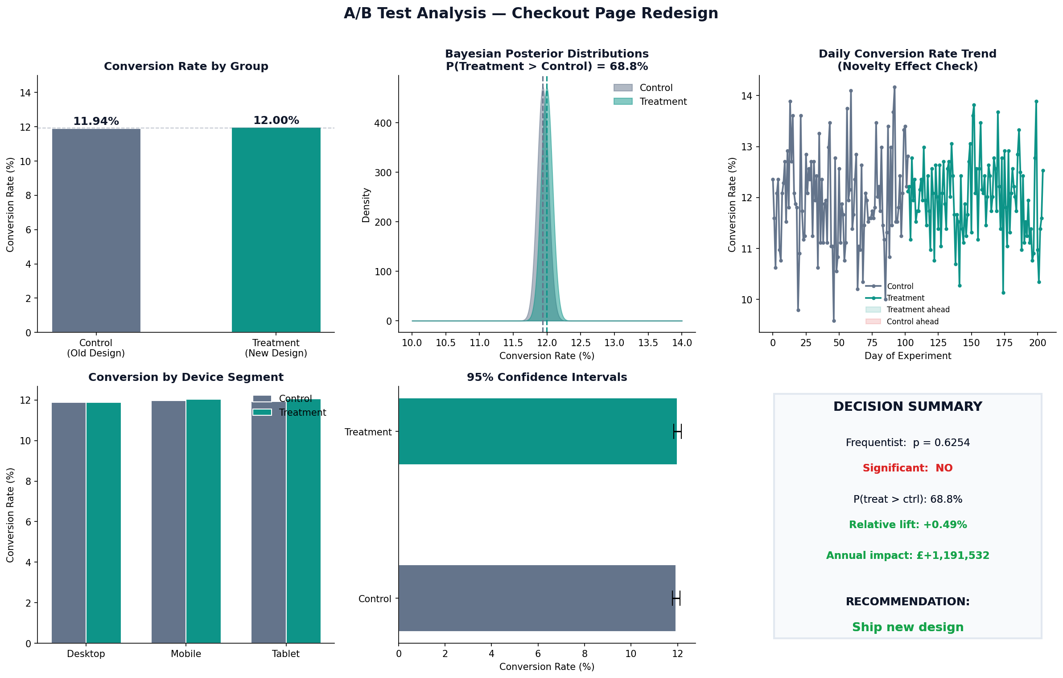

Figure 1: A/B Test Dashboard — conversion comparison, Bayesian posteriors, daily trend, device segmentation, confidence intervals, and decision summary.

7. Business Impact

7.1 Revenue Quantification
Despite the result being statistically inconclusive, it is useful to quantify the potential business impact if the 0.49% relative lift were real and sustained.
Metric | Value
Monthly site visitors | 2,000,000
Average order value | £85.00
Baseline monthly revenue | £20,295,302
New design monthly revenue | £20,394,597
Monthly revenue difference | +£99,295
Annual revenue difference | +£1,191,532

⚠ | This £1.19M figure assumes the observed lift is real and sustained. Since the result is not statistically significant, this should be treated as a ceiling estimate — not a reliable forecast.

7.2 Decision Framework
Six criteria were assessed to form the final recommendation:
Check | Result | Detail
Sample size sufficient | ✓ Pass | 147,239 ≥ 144,740 required
Data quality clean | ✓ Pass | Zero contaminated users
Frequentist p < 0.05 | ✗ Fail | p = 0.6254
CI excludes zero | ✗ Fail | CI [-0.18%, +0.29%] spans zero
No novelty effect | ✓ Pass | Daily lift stable throughout
P(treatment > ctrl) ≥ 95% | ✗ Fail | 68.81% — below 95% threshold

Checks passed: 3 of 6

8. Recommendations

8.1 Immediate Action
✗ | DO NOT SHIP the new checkout design. Three of six decision criteria failed. Both frequentist and Bayesian frameworks agree there is insufficient evidence of improvement.

8.2 Next Steps
- Run a mobile-specific A/B test. Mobile showed +0.61% lift — the highest of any segment. A test scoped to mobile users only would require approximately 580,000 mobile users and could be powered within 4–6 weeks at current traffic volumes.
- Investigate the checkout funnel. Understand where users drop off between landing and payment. A funnel analysis may reveal specific steps where the new design helps or hurts.
- Qualitative research. Run user interviews or session recordings on both designs. Statistical tests tell you if a difference exists — they cannot tell you why.
- Consider a longer experiment for returning users. The returning user segment showed the highest lift (+0.71%). A dedicated test for logged-in returning users may yield a significant result.

8.3 Lessons for Future Experiments
- Always conduct power analysis before starting — not after. This experiment got lucky with sample size; build a sample size calculator into the experiment planning process.
- Pre-register your primary metric and stopping rule before launching. Changing metrics mid-experiment inflates false positive rates.
- Run a Sample Ratio Mismatch check on day 1. A broken randomiser discovered on day 1 costs one day; one discovered on day 205 costs 205 days.
- Segment analysis should be exploratory, not confirmatory. The mobile finding is a hypothesis to test — not a result to act on directly.

9. Technical Appendix

9.1 Tools & Libraries
Tool / Library | Purpose
Python 3.11 | Core language
pandas | Data loading, cleaning, and aggregation
numpy | Numerical calculations
scipy.stats | Z-test, power analysis, normal distribution
matplotlib | Static chart generation
seaborn | Cohort heatmap and segmentation plots
PostgreSQL | SQL analysis — 12 business queries
plotly | Interactive HTML dashboard

9.2 Statistical Formulas
Two-proportion Z-test
p̂ = (x₁ + x₂) / (n₁ + n₂) (pooled proportion under H₀)
SE = √[ p̂(1−p̂)(1/n₁ + 1/n₂) ]
z = (p̂₁ − p̂₂) / SE
p-value = 2 × (1 − Φ(|z|)) where Φ is the standard normal CDF

Sample size (per group)
n = [(z_{α/2} + z_β) / δ]² where δ = effect_size / √[p̄(1−p̄)]

Bayesian model
Prior: Beta(α=1, β=1) — uniform, no prior belief
Posterior: Beta(α + x, β + n − x) — updated with observed data
P(θ_T > θ_C) estimated via Monte Carlo simulation (500,000 draws)

9.3 How to Reproduce
- Download dataset from kaggle.com/datasets/zhangluyuan/ab-testing
- Install requirements: pip install pandas numpy scipy matplotlib seaborn plotly
- Run: python ab_testing_analysis.py
- For SQL analysis: load data into PostgreSQL, run ab_testing_sql_queries.sql
- Open ab_testing_dashboard.html in any browser for interactive charts

