Anuj Joshi

CT14061

Git Assignment 2

1. Continuing from the previous assignment, make sure that there are no files in the staging area & that the remote repository contains files f1.txt and f2.txt with some content.

1. Create 3 new files named f3.txt, f4.txt and f5.txt respectively.

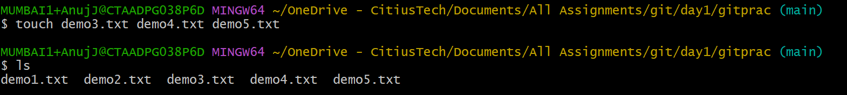

1. Commit the changes. (do not push)

1. Add some text again in f1.txt and save the changes.

1. Stage the changes made to f1.txt.

1. Use the commit –amend command to undo the last commit.

1. Push the changes to the remote repo finally. Go to the remote repo and check the results.

1. Create a new branch named branch1.



1. Switch to this branch.



1. Add some lines in the file f1.txt and save the changes.



1. Stage and commit. (do not push).

1. Check the contents of the file.

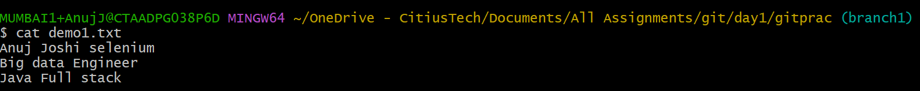

1. Switch back to the master branch.



1. Add some lines in the file f1.txt and save the changes.



1. Stage and commit. (do not push)

1. Check the contents of the file.



1. From the master branch, push the changes to the remote repository. Go to the remote repo and check the contents of the f1.txt file.

