Data-Dependent Selection of 6-bit MX/BFP Formats
CS611 Assignment 1 · Group 8 · Dataset C · 6-bit element width
[TO CONFIRM] Group member names and roll numbers.

Summary
We select a 6-bit format for the weight matrix W_C ∈ R^(100×100) from the candidates MXFP6 E3M2, MXFP6 E2M3, MXFP6 E4M1, MXINT6 and BFP6. We use the output error ‖(W − Q(W))X‖² as the quality metric. We then propose a histogram-based predictor that estimates this error for every format without quantizing W or multiplying by X.
- Q1 (best format): MXFP6 E2M3. Output SQNR 30.2 dB (3.1% relative output error), 2.4 dB ahead of MXINT6.
- Q2 (efficient selection): the predictor reproduces the exhaustive ranking on W_C (Spearman 1.0, error within 0.22 dB). It also picks the exhaustive winner in 90/90 synthetic matrices from nine distribution families, using about 750× fewer operations than exhaustive output-error evaluation.
- Q3 (data effects): heavy tails favour E2M3 over INT, and uniform or very sparse data flip the choice to MXINT6. Per-block scaling absorbs row and column scale variation. Formats whose maximum value falls below the shared-scale binade (E3M2, E4M1) lose accuracy to clipping.

1. Problem and data
Given W (FP32, 100×100) and a calibration input X_cal (FP32, 100×256), choose the element format that best preserves Y = W·X at 6 bits per element. A separate X_test is used for grading, so the method must not overfit X_cal.
Statistic | W_C | X_cal
shape | 100 × 100 | 100 × 256
mean / std | 0.0047 / 1.000 | −0.0003 / 0.100
min / max | −5.70 / 5.59 | −0.41 / 0.40
excess tail (kurtosis, Gaussian = 3) | 5.76 | 3.02
entries beyond 4σ | 0.45% | 0.008%
exact zeros | 0 | 0
negative entries | 49.5% | 50.1%

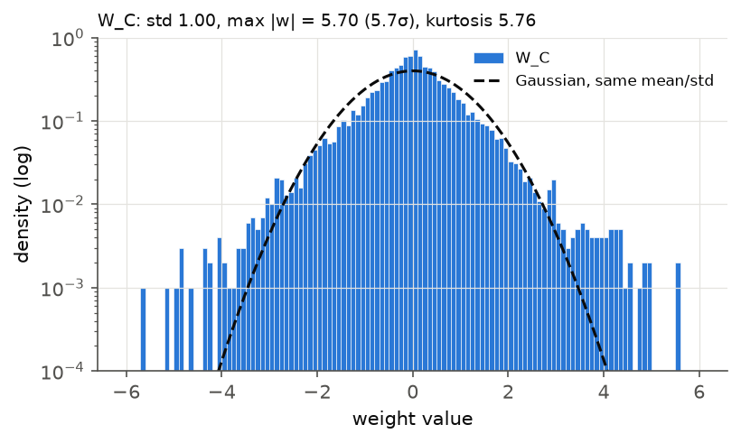
Figure 1. W_C is close to Gaussian in the bulk but has clearly heavier tails (log scale).
W_C has no sparsity to exploit. Its row max |w| ranges from 1.9 to 5.7 and its row std from 0.78 to 1.26, so scale variation is moderate. X_cal is close to white Gaussian, so XXᵀ is close to a scaled identity.

2. Format definitions and conventions
[TO CONFIRM] Replace with the exact classroom conventions. The values below follow the OCP MX v1.0 specification where it defines a format; E4M1, MXINT6 and BFP6 are our assumptions.
Format | Element encoding | Bias | Max |element| | Min subnormal | Shared scale
MXFP6 E3M2 | 1s + 3e + 2m | 3 | 28 | 0.0625 | E8M0, 2^(⌊log2 amax⌋ − 4)
MXFP6 E2M3 | 1s + 2e + 3m | 1 | 7.5 | 0.125 | E8M0, 2^(⌊log2 amax⌋ − 2)
MXFP6 E4M1 | 1s + 4e + 1m | 7 (assumed) | 384 (assumed) | 2^−7 | E8M0, 2^(⌊log2 amax⌋ − 8)
MXINT6 | sign + 5-bit magnitude, k/16 | – | 31/16 | 1/16 | E8M0, 2^⌊log2 amax⌋
BFP6 | sign + 5-bit mantissa | – | 31·scale | scale | 2^⌈log2(amax/31)⌉ (no clipping)

- Block size 32 along the reduction dimension (columns of W). 100 = 3·32 + 4, so each row has a final 4-element block with its own scale.
- Rounding: round-to-nearest, ties-to-even. Overflow: saturate to ±max. Values below half the smallest subnormal round to zero.
- FP6 formats have no Inf/NaN encodings. A NaN shared scale (E8M0 = 0xFF) is never produced by finite FP32 input.
- Storage: 6 bits per element + 8 bits per block = 6.32 bits/element for W_C (the 4-element tail block raises this from the ideal 6.25).
No candidate is ineligible: W_C is finite, signed, and inside every format's range after scaling.

3. Method

3.1 Quality metric
What matters is the effect of quantization on the layer output, not on the weights themselves. With ΔW = W − Q(W) and H = X Xᵀ:
E_out(f) = ‖ΔW·X‖²_F = Σ_i ΔW_i · H · ΔW_iᵀ ≈ Σ_ij E[ΔW_ij²] · H_jj
The approximation assumes rounding errors are uncorrelated across columns. It holds well here because X_cal is nearly white, and it lets input statistics weight each column of W. We report output SQNR = 10·log10(‖WX‖² / E_out).

3.2 Scale optimisation
The default shared exponent comes from the block maximum. For each block we also try exponent shifts of −2…+2 and keep the one that minimises the block's error, using either weight MSE or the output-aware error ΔW_b·H_bb·ΔW_bᵀ. This changes only the scale value, not the format definition.

3.3 Histogram predictor (selection without quantizing)
Every MX/BFP candidate scales a block by a power of two tied to the block maximum, s_f = 2^(e_b − emax_f) with e_b = ⌊log2 amax_b⌋. Normalise every weight by its block binade:
u = |w| / 2^(e_b) ∈ (0, 2)
Then the squared error that format f makes on w is 2^(2e_b)·g_f(u). Here g_f depends only on the format (Figure 2):
- uniform rounding noise step_f(u)²/12 inside the representable range,
- clipping error (u − max_f)² above the format's maximum,
- flush-to-zero error u² below half the smallest step.
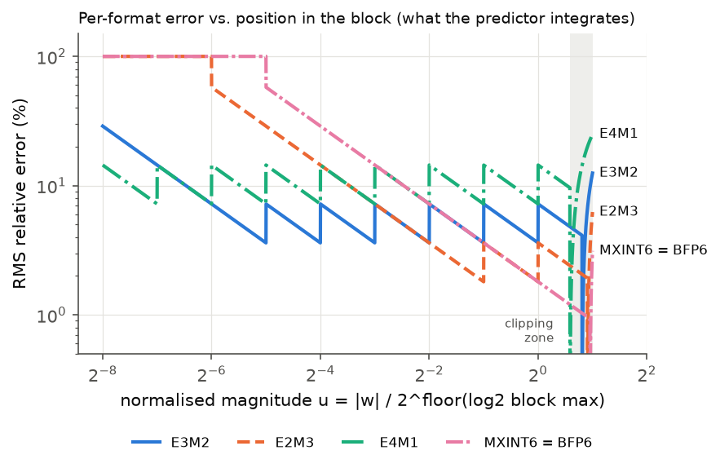
Figure 2. Relative error of each format against position within the block. E2M3 is most accurate where most weights lie. E3M2 and E4M1 clip the top of every binade (u > 1.75 and u > 1.5).
Combining this with the metric of Section 3.1, all data dependence collapses into a single format-independent histogram of u, where weight w_ij contributes 2^(2e_b)·H_jj:
- Statistics pass (once, shared by all formats): compute block maxima and normalised magnitudes u, and accumulate the weighted histogram over 512 log-spaced bins. The block maximum itself is stored separately (one value per block): it carries the most weight and its error is deterministic. One flag per block records whether u_max > 31/16, which BFP6's exponent rule needs.
- Scoring (per format): P_f = Σ_bins hist·g_f(u_bin) + Σ_blocks weight·exact_err_f(u_max).
- Selection: f* = argmin_f P_f.
Cost: one pass over W, then O(#bins + #blocks) per format, independent of the number of columns of X. Exhaustive evaluation needs, per format, a full quantization of W plus a 100×100×256 matrix product.

4. Results

4.1 Exhaustive evaluation (ground truth)
Format | Weight SQNR (dB) | Output SQNR (dB) | Rel. output error | After scale search (dB) | Clipped elements
MXFP6 E2M3 | 30.22 | 30.23 | 3.08% | 30.29 | 0.43%
MXINT6 | 27.91 | 27.86 | 4.05% | 28.19 | 0.20%
BFP6 | 27.67 | 27.60 | 4.17% | 28.19 | 0%
MXFP6 E3M2 | 25.32 | 25.29 | 5.44% | 25.62 | 0.96%
MXFP6 E4M1 | 19.13 | 19.10 | 11.09% | 19.85 | 2.45%

Scale search helps most where the default scale clips (E4M1, E3M2) or wastes range (BFP6), but it never changes the ranking. Output-aware search gives the same result as weight-MSE search, as expected for a nearly white X. Tuning on half of the X_cal columns and testing on the other half gives the same gains, so there is no sign of overfitting to X_cal.

4.2 Predictor vs. exhaustive
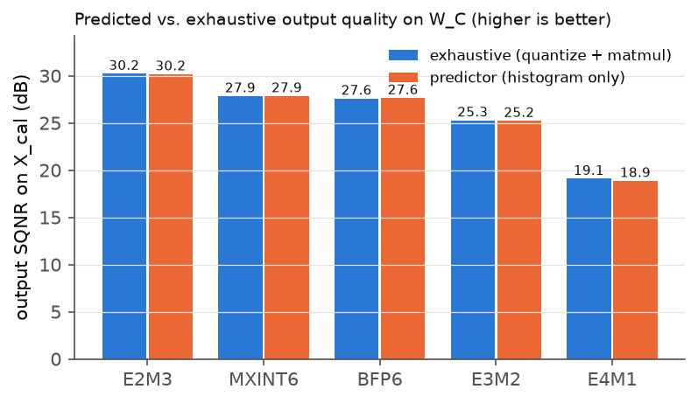
Figure 3. Predicted and exhaustive output SQNR on W_C.
Test set | Top-1 agreement | Mean regret (dB) | Spearman ρ | Exhaustive winners
W_C | 1/1 | 0 | 1.00 | E2M3
Gaussian | 10/10 | 0 | 1.00 | E2M3
Laplace | 10/10 | 0 | 1.00 | E2M3
Student-t ν=3 | 10/10 | 0 | 1.00 | E2M3
Student-t ν=6 | 10/10 | 0 | 1.00 | E2M3
Uniform | 10/10 | 0 | 1.00 | MXINT6
90% sparse | 10/10 | 0 | 1.00 | MXINT6
20 outliers ×50 | 10/10 | 0 | 0.96 | E2M3 ×6, E3M2 ×4
Row-scaled 1e±2 | 10/10 | 0 | 1.00 | E2M3
Shuffled W_C | 10/10 | 0 | 1.00 | E2M3

Ablation: when block maxima are left inside the histogram instead of being scored exactly, agreement on the outlier family drops to 6/10 (mean regret 0.24 dB). A single extreme value per block dominates that block's error, and the averaged noise model cannot capture it.

4.3 Cost
 | Exhaustive (output error) | Predictor
work per format | 10,000 roundings + 2.56 M MACs | 1,028 bin evaluations + 400 roundings
shared work | – | 10,000 binning operations
total (5 formats) | ≈ 12.9 M operations | ≈ 17 k operations

Against exhaustive weight-MSE evaluation, which needs no matrix product, the saving is only about 3×. The predictor's advantage is that the per-format cost does not depend on the matrix size or on X, and it adds the output-awareness of H at no extra cost.

5. Effect of outliers, sparsity and scale variation
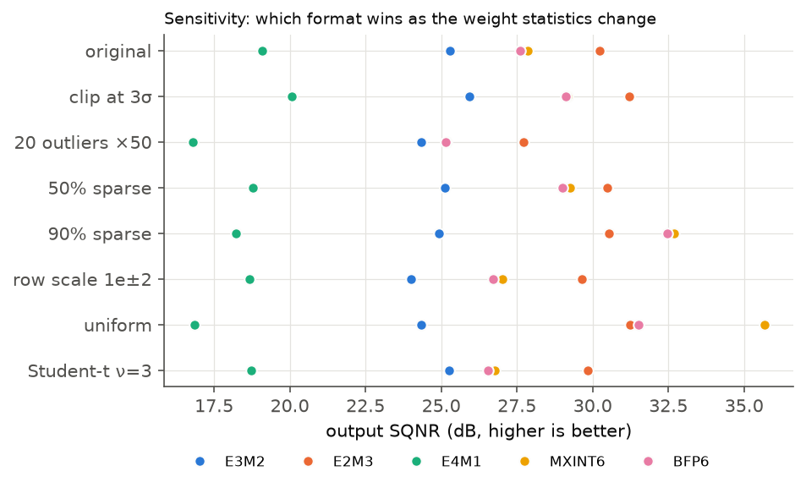
Figure 4. Output SQNR of every format under controlled perturbations of W_C.
- Outliers. Inside a 32-element block, the largest value sets the scale and the others share the remaining levels. E2M3 spends its levels near the top of the binade (fine relative steps from 1 to 8), so it degrades gracefully. Clipping W_C at 3σ improves every format by about 1 dB but does not change the winner. Extreme outliers (×50) shrink E2M3's lead, and in 4 of 10 synthetic trials E3M2's range wins.
- Sparsity. W_C has no zeros. With synthetic sparsity, blocks contain a few non-zeros whose magnitudes are close to the block max, so a uniform grid fits them better. At 90% sparsity MXINT6 overtakes E2M3. Exact zeros are representable in every format.
- Scale variation. Per-block power-of-two scaling absorbs row or column scale differences of up to 10^±2 with almost no change in SQNR. Within-block variation (outliers) is what matters.
- Distribution shape. Uniform data favours MXINT6 by more than 4 dB. Gaussian, Laplace and Student-t data favour E2M3. This is consistent with the INT-vs-FP analyses of Kuzmin et al. and van Baalen et al.

6. Recommendation
Use MXFP6 E2M3 (block 32, E8M0 shared scale) for W_C. It gives the lowest output error (30.2 dB SQNR, 3.1% relative error) at 6.32 bits/element, and the histogram predictor selects it without quantizing any candidate. MXINT6/BFP6 are the runner-up. E4M1 should not be used for this data: it has too little mantissa precision and clips 2.45% of the weights under the default scale.

7. Limitations
- Conventions for E4M1, MXINT6 and BFP6 are assumptions until checked against the classroom definitions.
- The predictor ignores off-diagonal terms of XXᵀ. This is fine for a near-white X but should be revisited for strongly correlated inputs.
- The uniform-noise model is an average. Exact scoring of block maxima corrects the worst case (outliers), but small blocks with few distinct values can still deviate.
- Only one weight matrix is available. The synthetic families are used to test generality.

8. Reproducibility
python3 validate_predictor.py · python3 explore.py · python3 make_figures.py (numpy; matplotlib for figures)

References
- Open Compute Project, OCP Microscaling Formats (MX) Specification v1.0, 2023.
- B. D. Rouhani et al., Microscaling Data Formats for Deep Learning, arXiv:2310.10537, 2023.
- B. D. Rouhani et al., With Shared Microexponents, A Little Shifting Goes a Long Way, ISCA 2023.
- A. Kuzmin et al., FP8 Quantization: The Power of the Exponent, NeurIPS 2022.
- M. van Baalen et al., FP8 versus INT8 for Efficient Deep Learning Inference, arXiv:2303.17951, 2023.
- Y. Zhang et al., Integer or Floating Point? New Outlooks for Low-Bit Quantization on LLMs, arXiv:2305.12356, 2023.
- V. Egiazarian et al., Bridging the Gap Between Promise and Performance for Microscaling FP4 Quantization, ICLR 2026.

