**GANPAT UNIVERSITY**

**U. V. PATEL COLLEGE OF ENGINEERING**

**B.Tech CE/IT Semester IV**

**2CEIT404: Python Programming**

**Practical-2: Basic Python Programming**

|  |
| --- |
|  |

1. Write a python program to print “Welcome to UVPCE”.

Code:

print("welcome to uvpce")

output:

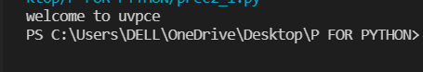

1. Write a python program which takes student information such as Name, Enrollment Number, Branch, Age, Email and Mobile number from user and print as following:

|  |
| --- |
| “===========================”  Your Name  Your Enrollment No.  Branch: CE/IT  Age:XX years  Email:your mail ID  Mobile No: your No.  “===========================” |

Code:

name=input("Enter your name:")

enroll_no=input("Enter your Enroll_NO:")

branch=input("Enter your branch:")

age=input("Enter your Age:")

email=input("Enter your Email_id:")

mobile_no=input("Enter your Mobile_NO:")

print("*************************************")

print("Name = "+name)

print("Enroll_no = "+enroll_no)

print("Branch = "+branch)

print("Age = "+age)

print("Email = "+email)

print("Mobile_No = "+mobile_no)

Output:

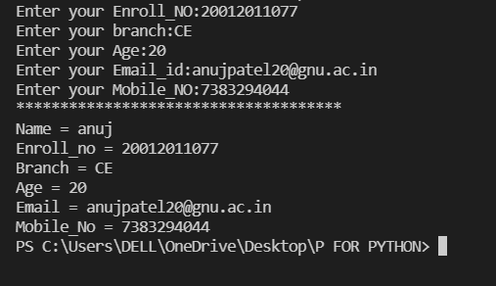

1. Write python programs to evaluate the following expressions to demonstrate the use of operator precedence and associativity.

**12 + 3 - 4 / 2 < 3 + 1**

**X = (10 * 2) % 2 << 4++**

**Code:**

a=10

b=8.6

c="Anuj"

d=[1,2,3,4,5]

e=(77,"Anuj")

print(type(a))

print(type(b))

print(type(c))

print(type(d))

print(type(e))

print(type(20>25))

**output:**

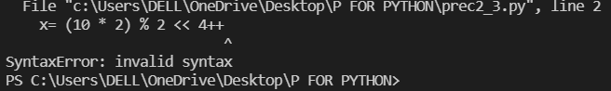

1. Write a python program to display data types of different variables.

Code:

a=10

b=8.6

c="Anuj"

d=[1,2,3,4,5]

e=(77,"Anuj")

print(type(a))

print(type(b))

print(type(c))

print(type(d))

print(type(e))

print(type(20>25))

output:

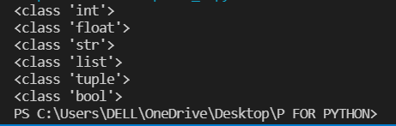

1. Write a python program to check given character is a vowel or not.

Code:

ch = input("Enter a character:")

if (ch=='A' or ch=='a' or ch=='E' or ch=='e' or ch=='I' or ch=='i'

    or ch=='O' or ch=='o' or ch=='U' or ch=='u'):

    print("This character is vowel.")

else:

    print("This character is consonant.")

output:



1. Write a python program to for library charges a fine for books returned late. Following are the fines:

First five days: 40 paisa per day.

Six to ten day: 65 paisa per day.

Above ten days: 80 paisa per day

Code:

day = int(input("Enter the number of days:"))

if(day<=0):

    print("you have to pay 0 rupees...")

elif(day > 0 and day<=5):

    f=day*0.40

    print("Fine = ""{0:.2f}".format(f),"Rupees")

elif(day > 5 and day<=10):

    f=day*0.60

    print("Fine = ""{0:.2f}".format(f),"rupees")

else:

    f=day*0.80

    print("Fine = ""{0:2f}".format(f),"Rupees")

output:

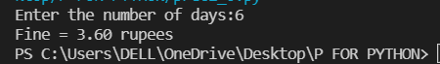

1. Write a python program to count odd numbers from given three numbers and display maximum odd number.

Code:

import opcode

a=int(input("enter 1st no:"))

b=int(input("enter 2nd no:"))

c=int(input("enter 3rd no:"))

odd_count=0

x,y,z=0,0,0

if(a%2!=0):

    odd_count+=1

    x=a

if(b%2!=0):

    odd_count+=1

    y=b

if(c%2!=0):

    odd_count+=1

    z=c

print("\n NO of odd count=",odd_count)

if(odd_count==0):

    print("no odd nos.")

else:

    if(x>y and x>z):

        print(x,"is maximum odd no.")

    elif(y>z):

        print(y,"is maximum odd no.")

    else:

        print(z,"is maximum odd no.")

output:

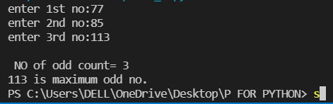

1. Enter the following statements into the interpreter and note which ones produce an error, give reason for error:
2. str1 = “welcome”

print (str1*2)

2) 15 % 12

3) print (18.0 // 4)

4) 7<=7

5) -1<>-1.0

6) -5 is -5.0

7) print( ‘Steve's “ Laptop”’)

Code:

str1 ="welcome"

print(str1*2)

print(15%12)

print(18.0//4)

print(7<=7)

print(-5 is -5.0)

print("Steve's Laptop")

output:

