1. 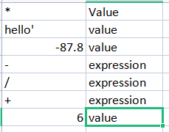
2. Strings are the values and variables are the reference names used for locating the Strings

**3.** A) Integer - These are the integral numerical values

1. Boolean - These consist of True /False values
2. Float - It consists of decimal numbers

**4.**Expressions are the combination of operators and operands. All expressions result in some value after calculation the mathematical operations

1. A statement directly assign a value to a variable and does not contain an operator but a single value whereas the expression contains both operator and operand(value).
2. 23
3. ‘spamspamspam’ and ‘spamspamspam’
4. ‘eggs’ is a valid variable as it adheres to the naming convention of variables but ‘100’ does not as variable name cannot start with a digit
5. Int() , float() , str()
6. It causes an error as “99” is not in string. To make it work , we need to convert “99” into a string as below

‘I have eaten’ + str(99) + ‘burritos’