1 . # this is a comment

Print(“Learning Python”)

2. ‘’’ this is a multiline comment ’’’

a=1,b=2,c=3,d=4

Print(a)

Print(b)

Print(c)

Print(d)

3. a=30 , b=True , c=”Python” , d=5.46 , e=3+54j

Print(type(a))

Print(type(b))

Print(type(c))

Print(type(d))

Print(type(e))

4. a=3242

b=24232

print(id(a))

print(id(b))

5. a=434 , b=24+43j , c=False , d=”Anuj”

Print(a)

Print(b)

Print(c)

Print(d)

Print(type(a))

Print(type(b))

Print(type(c))

Print(type(d))

Print(type(e))

Print(id(a))

Print(id (b))

Print(id (c))

Print(id (d))

Print(id (e))

6. import keyword

print(keyword.kwlist)

7. 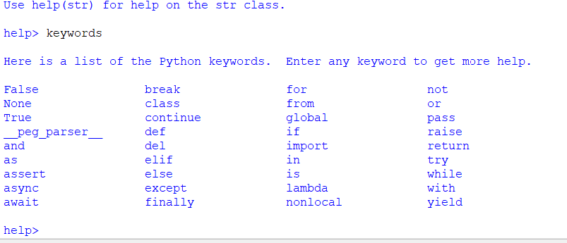

8.

10.

import datetime

b=datetime.datetime.now()

print(b)

from datetime import datetime

dt=datetime.today()

print(dt)