1. Build a simple webpage that displays text as shown in the below image.

Answer:- <!DOCTYPE html>

<html lang="en">

<head>

<meta charset="UTF-8">

<meta name="viewport" content="width=device-width, initial-scale=1.0">

<title>Document</title>

</head>

<body>

<p><b>text will be bolded</b> </p>

<br>

<p><i>text will be Italic</i></p>

<br>

<p><ins>this txt will be undeline</ins></p>

<br>

<p><mark>this text will be highligted</mark>

</p>

<br>

<p>this is normal text <sup>this text will be subcripted</sup> this is normal again</p>

<br>

<p>this is normal text <sub>this text will be subscripted</sub></p>

<br>

<p>NORMAL TEXT <small>Small text</small></p>

<br>

<p><del>this text will be deleted</del></p>

</body>

</html>

2. Build a simple webpage that helps users navigate different web development-related websites. Note: On clicking the hyperlink the web pages should open in a new tab. Below is a reference image.

Answer:- <!DOCTYPE html>

<html lang="en">

<head>

<meta charset="UTF-8">

<meta name="viewport" content="width=device-width, initial-scale=1.0">

<title>Document</title>

</head>

<body>

<h1><B>Navigate me</B></h1>

<br>

<P>Take me to <a href="http://www.youtube.com" target="_blank">youtube</a> to watch a vidios</P>

<br>

<p>Take me to <a href="http://www.wikipedia.org" target="_blank">wikipedia</a> to know about everything</p>

<br>

<p>Take me to <a href="http://lab.pwskills.com" target="_blank">pw skills lab</a> to practice live coding </p>

</body>

</html>

3. Build a simple blog web page with o pages home, web development, and web design. Each page must contain hyperlinks to other pages in the top, a heading of the page topic and a paragraph of information. For the home page you can add some information about yourself.

Answer:-

Calling page HTML doc:-

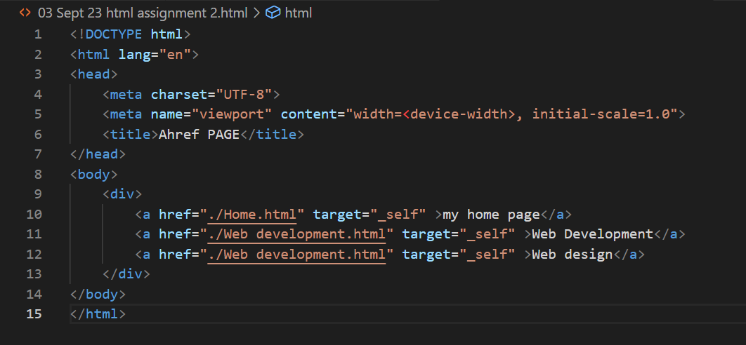

Home page

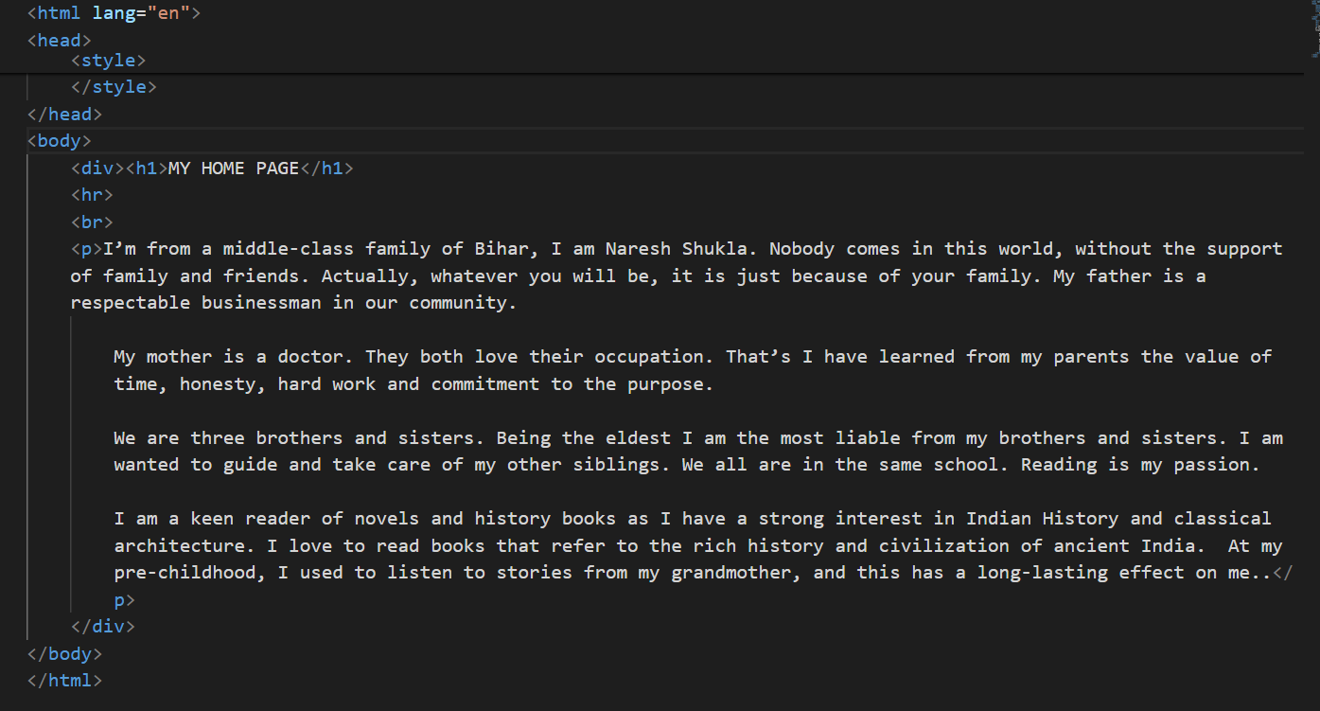

Web Development 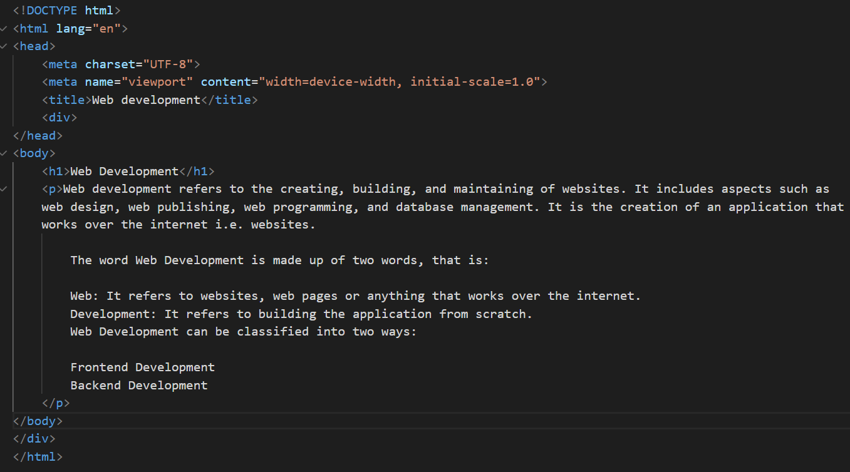

Web design

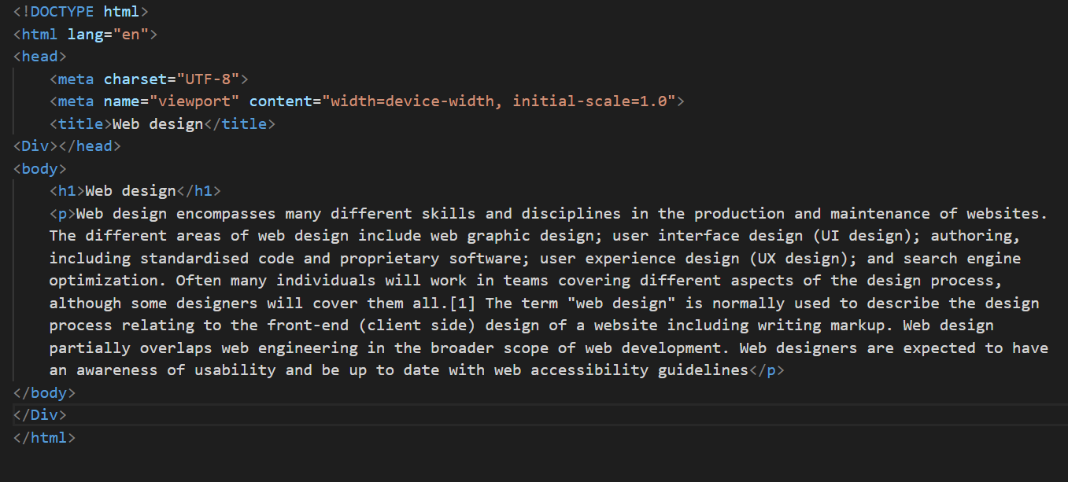

Full code:-

<!DOCTYPE html>

<html lang="en">

<head>

<meta charset="UTF-8">

<meta name="viewport" content="width=device-width, initial-scale=1.0">

<title>Document</title>

</head>

<body>

<div>

<a href="./Home.html" target="_self" >my home page</a>

<a href="./Web development.html" target="_self" >Web Development</a>

<a href="./Web development.html" target="_self" >Web design</a>

</div>

</body>

home page

<body>

<div><h1>MY HOME PAGE</h1>

<hr>

<br>

<p>I’m from a middle-class family of Bihar, I am Naresh Shukla. Nobody comes in this world, without the support of family and friends. Actually, whatever you will be, it is just because of your family. My father is a respectable businessman in our community.

My mother is a doctor. They both love their occupation. That’s I have learned from my parents the value of time, honesty, hard work and commitment to the purpose.

We are three brothers and sisters. Being the eldest I am the most liable from my brothers and sisters. I am wanted to guide and take care of my other siblings. We all are in the same school. Reading is my passion.

I am a keen reader of novels and history books as I have a strong interest in Indian History and classical architecture. I love to read books that refer to the rich history and civilization of ancient India. At my pre-childhood, I used to listen to stories from my grandmother, and this has a long-lasting effect on me..</p>

</div>

</body>

web development page

<body>

<h1>Web Development</h1>

<p>Web development refers to the creating, building, and maintaining of websites. It includes aspects such as web design, web publishing, web programming, and database management. It is the creation of an application that works over the internet i.e. websites.

The word Web Development is made up of two words, that is:

Web: It refers to websites, web pages or anything that works over the internet.

Development: It refers to building the application from scratch.

Web Development can be classified into two ways:

Frontend Development

Backend Development

</p>

</body>

web design

<Div></head>

<body>

<h1>Web design</h1>

<p>Web design encompasses many different skills and disciplines in the production and maintenance of websites. The different areas of web design include web graphic design; user interface design (UI design); authoring, including standardised code and proprietary software; user experience design (UX design); and search engine optimization. Often many individuals will work in teams covering different aspects of the design process, although some designers will cover them all.[1] The term "web design" is normally used to describe the design process relating to the front-end (client side) design of a website including writing markup. Web design partially overlaps web engineering in the broader scope of web development. Web designers are expected to have an awareness of usability and be up to date with web accessibility guidelines</p>

</body>

</Div>

</html>

4. Create an ordered list of HTML tags. Each list item must include the tag name and some information about The tag.

Answer:- <!DOCTYPE html>

<html lang="en">

<head>

<meta charset="UTF-8">

<meta name="viewport" content="width=device-width, initial-scale=1.0">

<title>Document</title>

</head>

<body>

<h1>ordered list </h1>

<ol>

<li><a> :- Defines a hyperlink</li>

<li><b> :- Defines bold text</li>

<li>br :- Defines a single line break</li>

<li>dd:- Defines a description/value of a term in a description list</li>

<li>div :- Defines a section in a document</li>

<li>h1 :- Defines HTML headings</li>

<li>hr :- Defines a thematic change in the content</li>

<li>ins:- Defines a text that has been inserted into a document</li>

</ol>

</body>

</html>

5. Create a description list of full stack web development tech stack, using the <dlH tag. Each term should be a tech stack name and each description should be a brief explanation of what the tech stack is used for.

Answer:-

<!DOCTYPE html>

<html lang="en">

<head>

<meta charset="UTF-8">

<meta name="viewport" content="width=device-width, initial-scale=1.0">

<title>Document</title>

</head>

<body>

<h1>Full Stack Development</h1>

<dl>

<dt >HTML</dt>

<dd >HTML is a standard language that is used to create the structure of our website using tags.</dd>

<dt >CSS</dt>

<dd>CSS is the very next step in this guide for Full Stack Developer Roadmap. </dd>

<dt>JavaScript</dt>

<dd>This is the programming language of the web. This is the language that our browser understands, from here our main Development starts, it is used to make our content dynamic and more interactive.</dd>

<dt>node .js </dt>

<dd>Node.js is an open-source, cross-platform, JavaScript runtime

environment that executes JavaScript code outside of a browser.</dd>

<dt>express.js</dt>

<dd>Express.js is a web application framework for Node.js designed for

building web applications and APIs.</dd>

<dt>Mongo db</dt>

<dd>MongoDB is a NoSQL document-oriented database program that uses

JSON-like documents with optional schemas.</dd>

<dt>react.js</dt>

<dd>React.js is a JavaScript library for building user interfaces or UI

components.</dd>

</dl>

</body>

</html>

6. Create an ordered list of the full stack web development tech stack HTML, CSS, and JS. For each tech stack, create a table that lists the tech stack name, its primary use cases, and some key features or benefits. Below is a reference image.

Answer:-

<!DOCTYPE html>

<html lang="en">

<head>

<meta charset="UTF-8">

<meta name="viewport" content="width=device-width, initial-scale=1.0">

<title>Document</title>

</head>

<body>

<ol type="1">

<li>

<h1>HTML</h1>

<table>

<tr>

<th>Primary Use cases</th>

<th>Key freature/benefits</th>

</tr>

<tr>

<td>Building the structue of web pages

</td>

<td>

<ul>

<li>Simple and easy to learn</li>

<li>Compatible with all web browser </li>

<li>allows for semantic markup</li>

</ul>

</td>

</tr>

</table>

</li>

<li>

<h1>CSS</h1>

<table>

<tr>

<th>Primary Use cases</th>

<th>Key freature/benefits</th>

</tr>

<tr>

<td>Styling web pages

</td>

<td>

<ul>

<li>control the appearance and layout of HTML</li>

<li>enhance user experience by using one code to style multiple pages </li>

<li>It can add various effects, such as colors, fonts, backgrounds,</li>

</ul>

</td>

</tr>

</table>

</li>

<li>

<h1>JS</h1>

<table>

<tr>

<th>Primary Use cases</th>

<th>Key freature/benefits</th>

</tr>

<tr>

<td>to create all types of applications </td>

<td>

<ul>

<li>Light Weight</li>

<li>Case Sensitive </li>

<li>Large Browser Control</li>

</ul>

</td>

</tr>

</table></li></ol>

</body>

</html>

7. Build a complex nested list structure representing a multi-level table of contents. Use unordered lists (<ul>) and list items (<li>) with inline-block styling to create a structured layout. Apply formatting tags to enhance the presentation of list items.

Answer:-

<!DOCTYPE html>

<html lang="en">

<head>

<meta charset="UTF-8">

<meta name="viewport" content="width=device-width, initial-scale=1.0">

<title>Document</title>

</head>

<body>

<h1>Table of Contents</h1>

<ul>

<li><a href="#">Part 1: Introduction</a></li>

<li><a href="#">Part 2: Getting Started</a>

<ul>

<li><a href="#">2.1 Installing the Software</a></li>

<li><a href="#">2.2 Creating a New Project</a>

<ul>

<li><a href="#">2.2.1 Project Templates</a></li>

<li><a href="#">2.2.2 Customizing Settings</a></li>

</ul>

</li>

<li><a href="#">2.3 Exploring the Interface</a>

<ul>

<li><a href="#">2.3.1 Toolbar Features</a></li>

<li><a href="#">2.3.2 Panel Layout</a>

<ul>

<li><a href="#">2.3.2.1 Docking Panels</a></li>

<li><a href="#">2.3.2.2 Tabbed Interface</a></li>

</ul>

</li>

</ul>

</li>

</ul>

</li>

<li><a href="#">Part 3: Advanced Topics</a>

<ul>

<li><a href="#">3.1 Working with Plugins</a>

<ul>

<li><a href="#">3.1.1 Installing Plugins</a></li>

<li><a href="#">3.1.2 Plugin Configuration</a></li>

</ul>

</li>

<li><a href="#">3.2 Customizing the UI</a>

<ul>

<li><a href="#">3.2.1 Changing Themes</a></li>

<li><a href="#">3.2.2 Configuring Shortcuts</a></li>

</ul>

</li>

<li><a href="#">3.3 Optimizing Performance</a>

<ul>

<li><a href="#">3.3.1 Caching Strategies</a></li>

<li><a href="#">3.3.2 Resource Minification</a></li>

</ul>

</li>

</ul>

</li>

<li><a href="#">Part 4: Conclusion</a></li>

</ul>

</body>

</html>

8. Build a complex nested list structure representing a multi-level table of contents. Use unordered lists (<ul>) and list items (<li>) with inline-block styling to create a structure( layout. Apply formatting tags to enhance the presentation of list items.

Answer:-

<!DOCTYPE html>

<html lang="en">

<head>

<meta charset="UTF-8">

<meta name="viewport" content="width=device-width, initial-scale=1.0">

<title>Document</title>

<style>

table, th, td {

border:1px solid black;

}

</style>

</head>

<body>

<h1>Conference Schedule</h1>

<table cellpadding="10">

<thead>

<tr>

<th>Time</th>

<th>Room 1</th>

<th>Room 2</th>

<th>Room 3</th>

<th>Room 4</th>

</tr>

</thead>

<tbody>

<tr>

<td rowspan="3">9:00 AM - 10:00 AM</td>

<td rowspan="2">Keynote</td>

<td>Session A</td>

<td>Session B</td>

<td rowspan="3">Session C</td>

</tr>

<tr>

<td>Session D</td>

<td>Session E</td>

</tr>

<tr>

<td>10:30 AM - 11:30 AM</td>

<td colspan="2">Session F</td>

</tr>

<tr>

<td>12:00 PM - 1:00 PM</td>

<td colspan="4">Lunch Break</td>

</tr>

<tr>

<td rowspan="2">1:00 PM - 2:00 PM</td>

<td>Session G</td>

<td rowspan="2">Session H</td>

<td>Session I</td>

<td>Session J</td>

</tr>

<tr>

<td>Session K</td>

<td>Session L</td>

<td>Session M</td>

</tr>

</tbody>

</table>

</body>

</html>