Creating and connecting Linux instance

Screenshots

Instance Details

AMI, Instance Type, Listing your Instances, Termination Protection and screenshot of error failed to terminate

Then terminate the instance and show state.

Challenge task: Creating Windows machine

RDP/All traffic anywhere

Creating and connecting Linux instance:

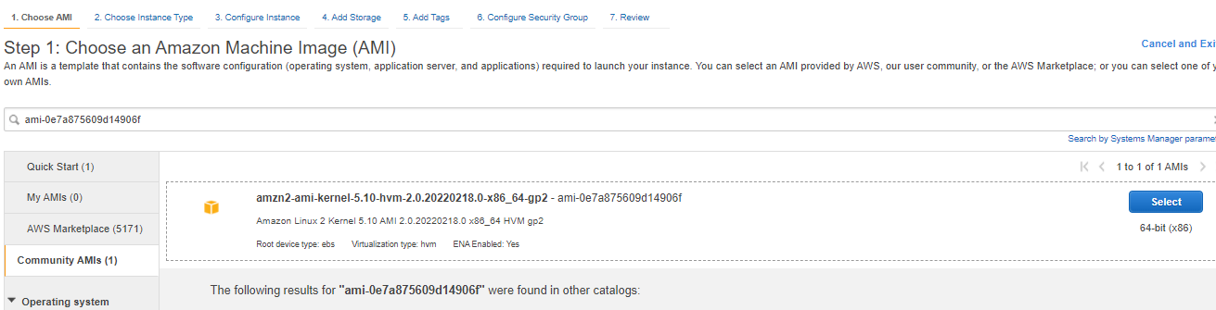

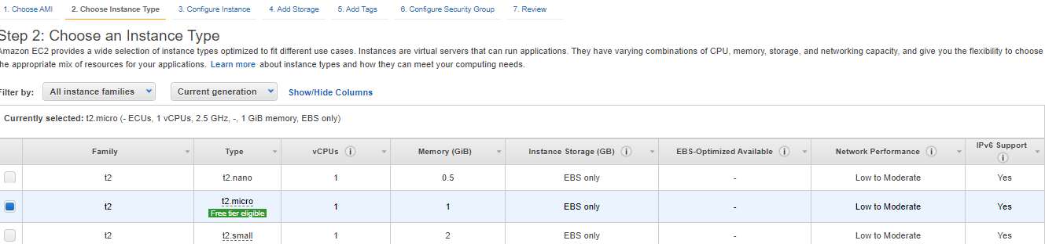

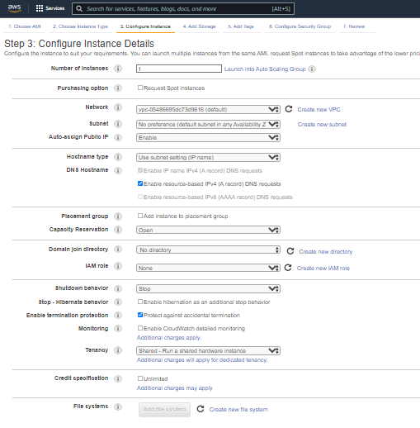

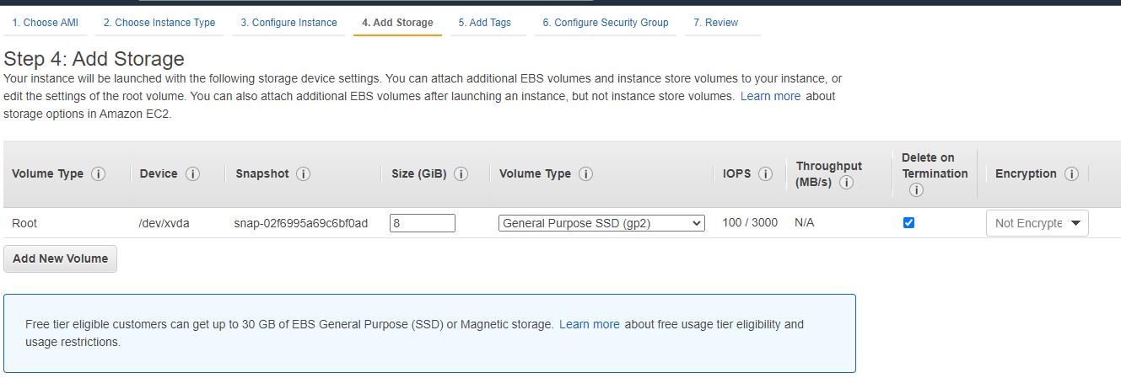

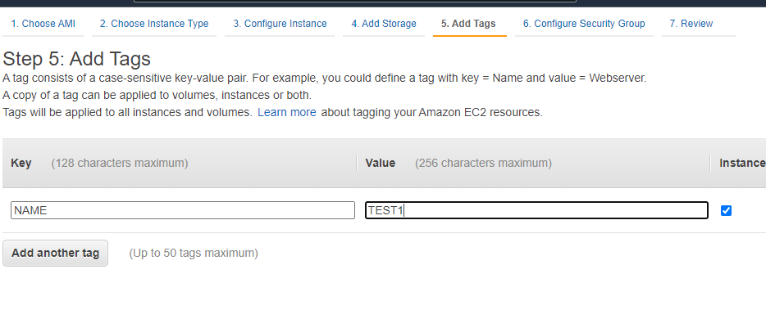

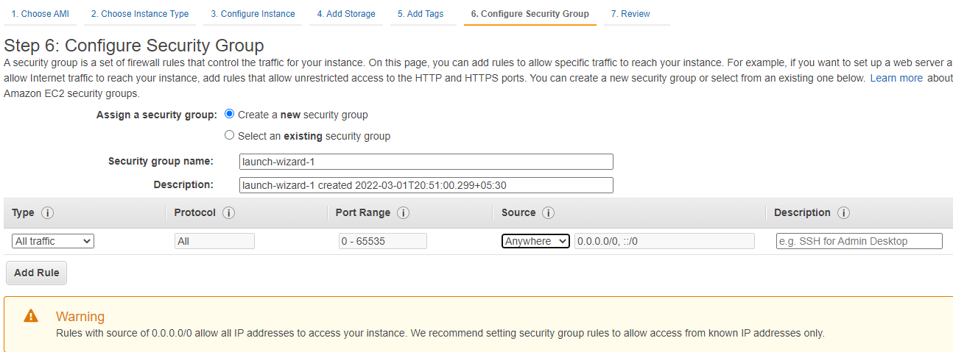

Instance Details:

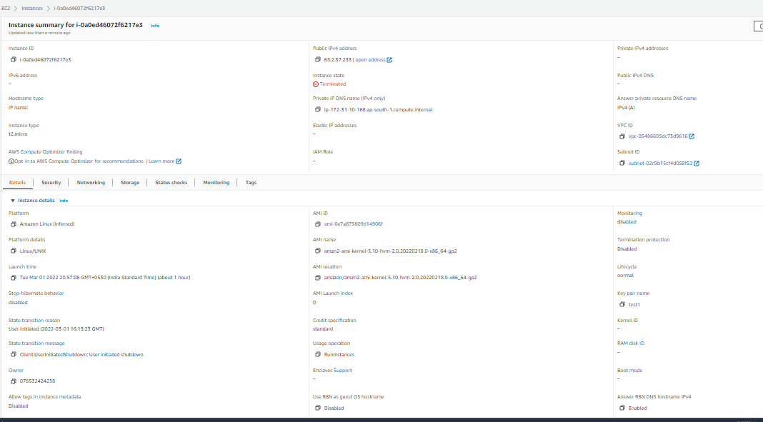

AMI Details:

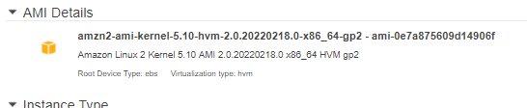

Instance Type:

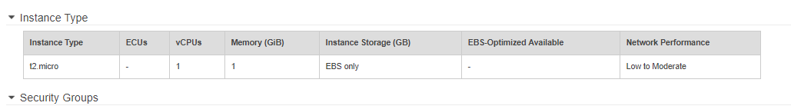

Listing your Instances:

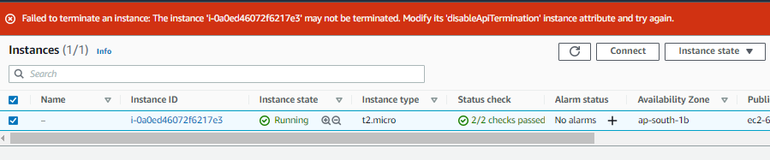

Termination Protection and Screenshot of error failed to terminate:



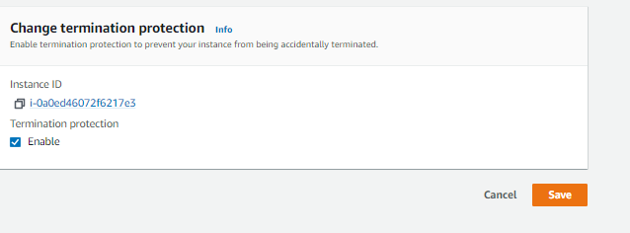

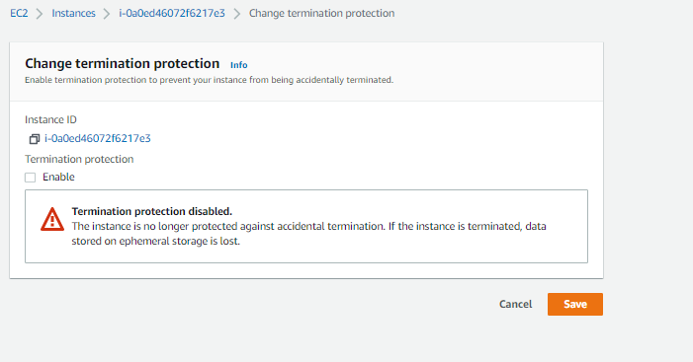



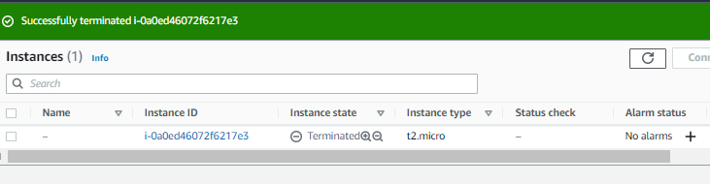

Challenge task: Creating Windows machine

RDP/All traffic anywhere

