Creating EBS volume

Show difference between available and in use ebs status

Attaching an ebs volume to ec2 instance

Snapshot of EBS volume details page

Create an AMI from snapshot.

Deregister an AMI then delete the snapshot.

Detach and delete ebs volume

Clean up resources

Creating EBS volume:

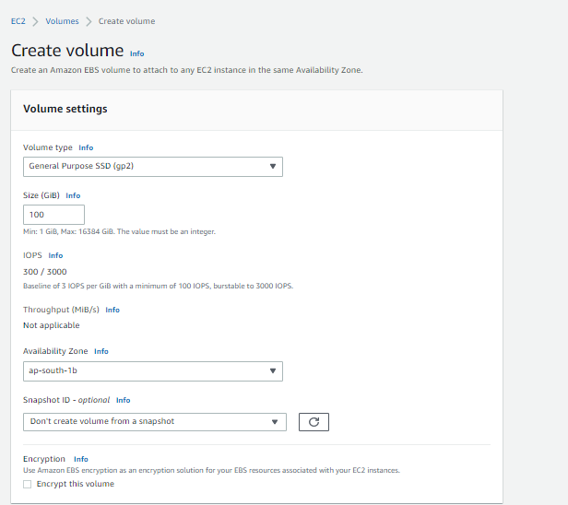

Show difference between available and in use ebs status:

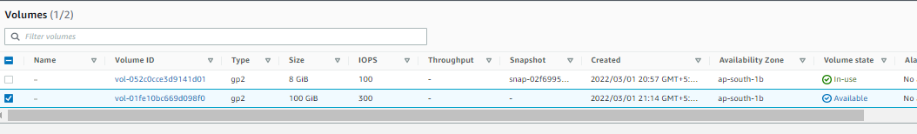

Attaching an ebs volume to ec2 instance:

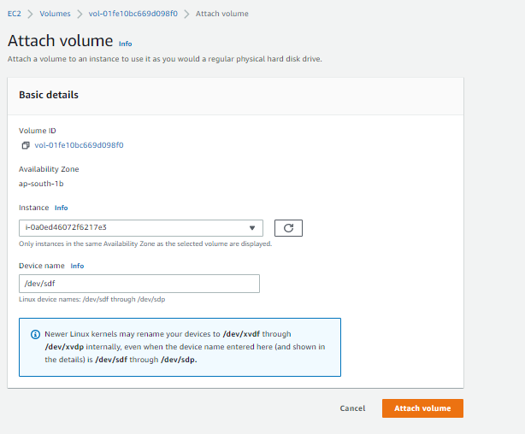

Snapshot of EBS volume details page:

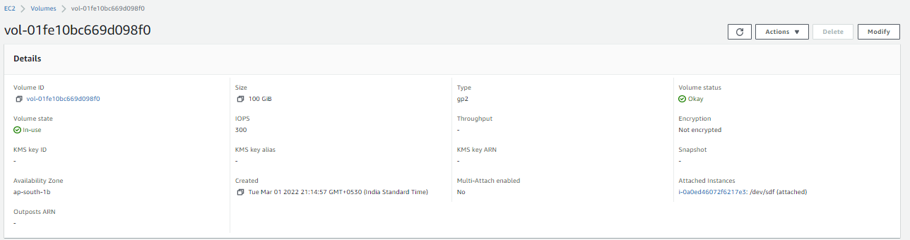

Create an AMI from snapshot:

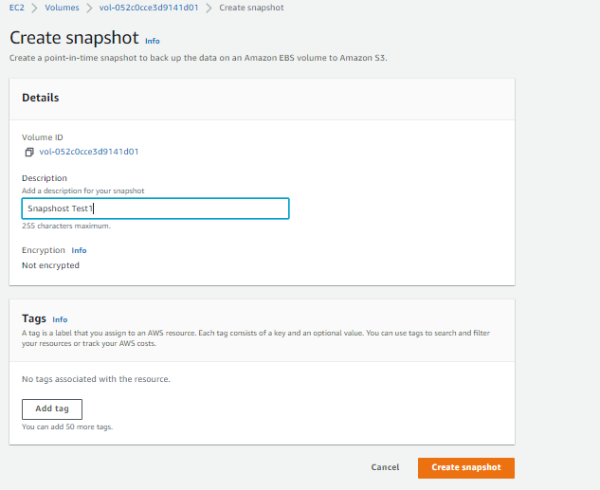

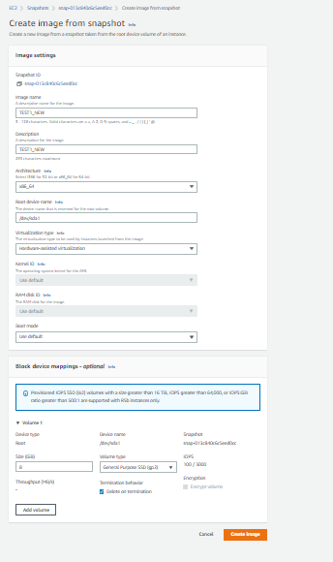

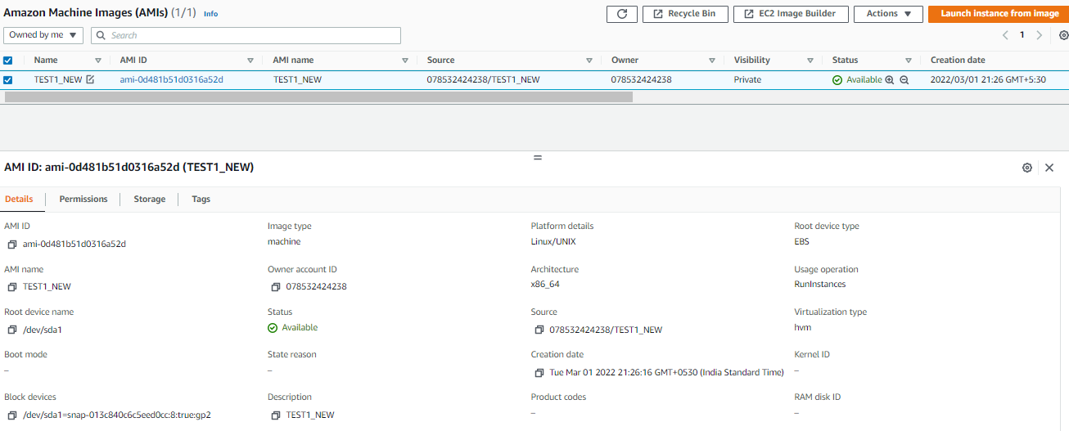

Detach and delete ebs volume:

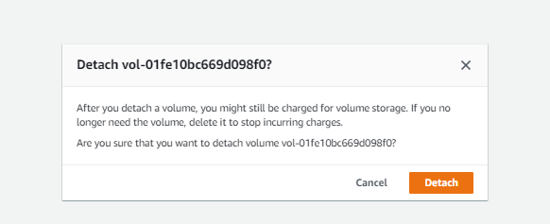

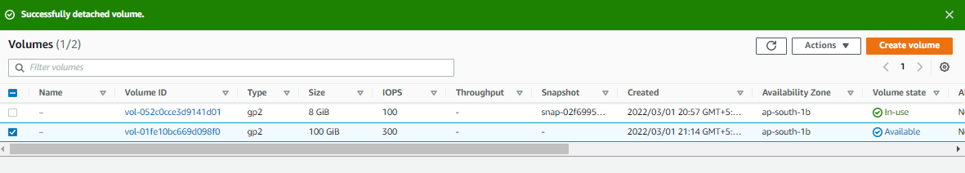

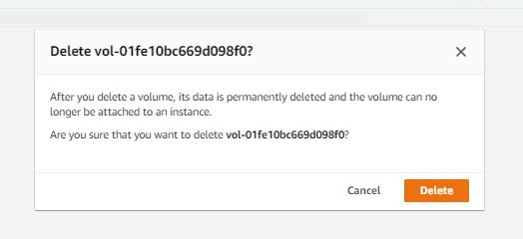

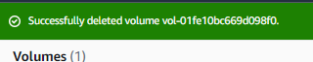

Deregister an AMI then delete the snapshot:

