PROJECT REPORT
PROJECT TITLE: RAIN ALARM CIRCUIT

1. HARDWARE REQUIREMENTS
- Copper Clad Board
- Soldering Gun
- Connecting Wires
- 9V Battery

2. COMPONENTS REQUIRED
Sr. No. | Component | Quantity
1 | 555 Timer IC | 1
2 | Rain Sensor | 1
3 | BC547 NPN Transistor | 1
4 | 10µF Capacitor | 1
5 | Buzzer | 1
6 | Bright Red LED | 1
7 | 100 kΩ Resistor | 2
8 | 470 Ω Resistor | 1
9 | 1 kΩ Resistor | 1
10 | 4.7 kΩ Resistor | 1

3. SOFTWARE REQUIREMENTS
Proteus Design Suite
- Used for circuit design, simulation, PCB layout generation, and 3D visualization.

4. CIRCUIT DIAGRAM
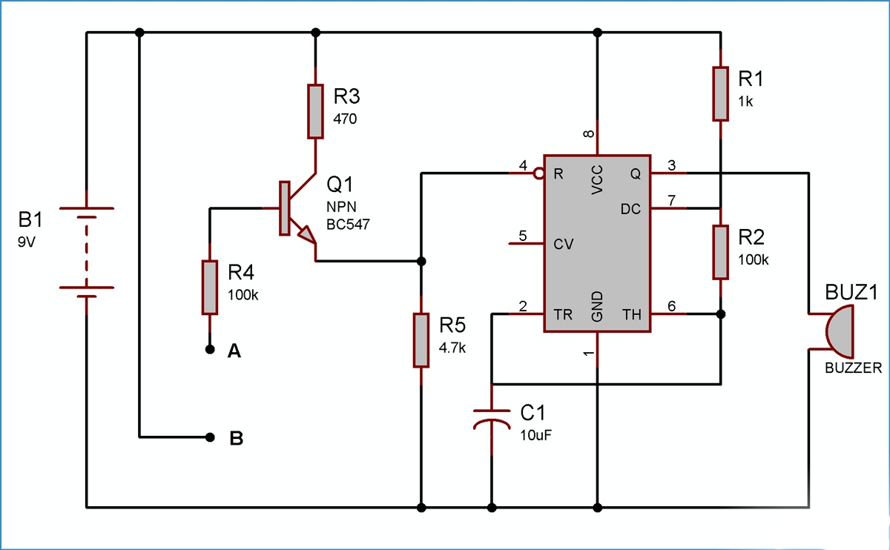

5. PROJECT DESCRIPTION
The Rain Alarm Circuit is a simple and cost-effective electronic system designed to detect rainfall and provide an audible and visual alert. The project uses a rain sensor to sense the presence of water droplets. When rainwater falls on the sensor surface, the conductivity between the sensor tracks increases, generating a trigger signal.
This trigger signal is applied to a 555 Timer IC configured in astable mode. The timer activates a buzzer and LED through a BC547 transistor, thereby producing both sound and light indications whenever rain is detected.
The system can be used in homes, agricultural fields, industries, automobiles, and weather-monitoring applications to provide early notification of rainfall. The project aims to develop a reliable rain detection system at a low cost while enhancing practical knowledge of electronic circuit design and PCB fabrication.

6. WORKING PRINCIPLE
- The rain sensor continuously monitors the presence of water droplets.
- Under dry conditions, the sensor remains inactive and the buzzer remains OFF.
- When rainwater falls on the sensor, it creates a conductive path between the sensor tracks.
- This signal triggers the 555 Timer IC.
- The BC547 transistor amplifies the output signal.
- The buzzer starts producing an alarm sound and the LED glows.
- Once the sensor becomes dry, the circuit returns to its normal state and the alarm stops.
7. BLOCK DIAGRAM
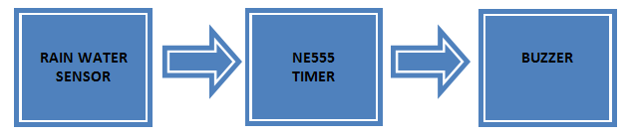

8. SIMULATION OUTPUT
The circuit was successfully designed and simulated using Proteus software. The simulation verified that whenever the rain sensor detected moisture, the LED glowed and the buzzer produced an audible alarm.
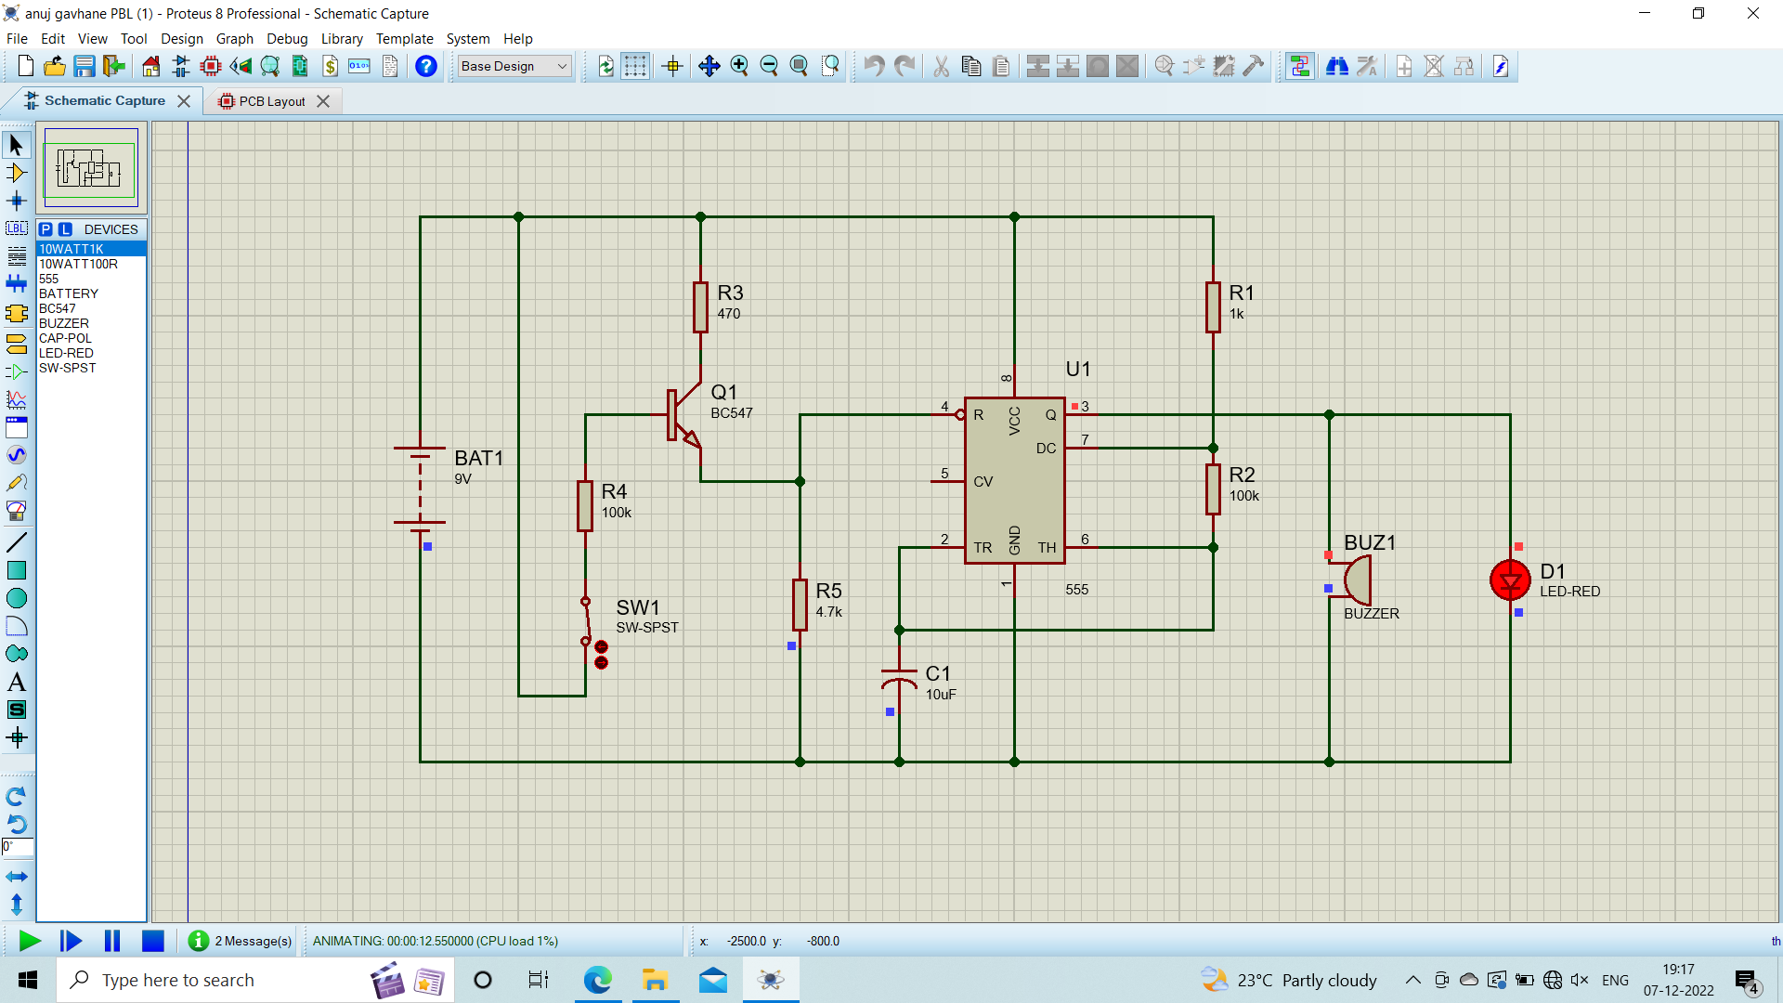

9. PCB LAYOUT
The PCB layout was designed using Proteus software. Proper component placement and routing were performed to ensure reliable operation and ease of fabrication.
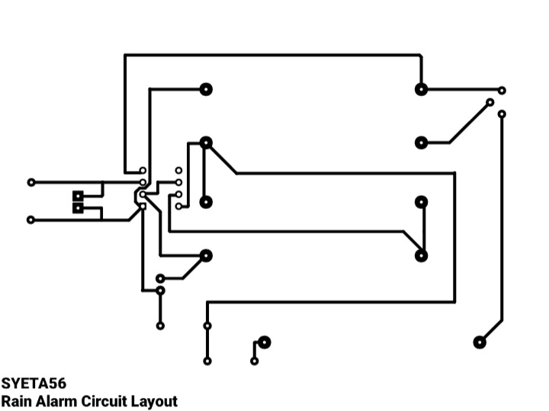

10. BILL OF MATERIALS (BOM)
Component | Cost (₹)
Copper Clad Board | 60
Ferric Chloride | 40
Layout Print on Photo Paper | 20
9V Battery | 20
555 Timer IC | 10
Rain Sensor | 20
BC547 NPN Transistor | 10
10µF Capacitor | 5
Connecting Wires | 5
Buzzer | 25
Bright Red LED | 2
Resistors (5 Nos.) | 10
Total Cost | ₹227
11. FINAL OUTPUT
The hardware prototype was successfully implemented on a custom-designed PCB. During testing, water droplets placed on the rain sensor activated both the LED and buzzer, confirming proper operation of the rain alarm system.

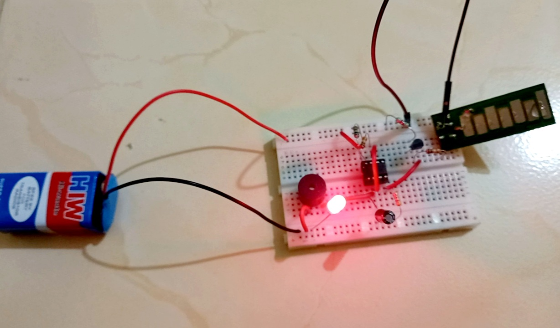

12. 3D VISUALIZATION
The 3D PCB model generated in Proteus was used to verify component placement and overall board appearance before fabrication.
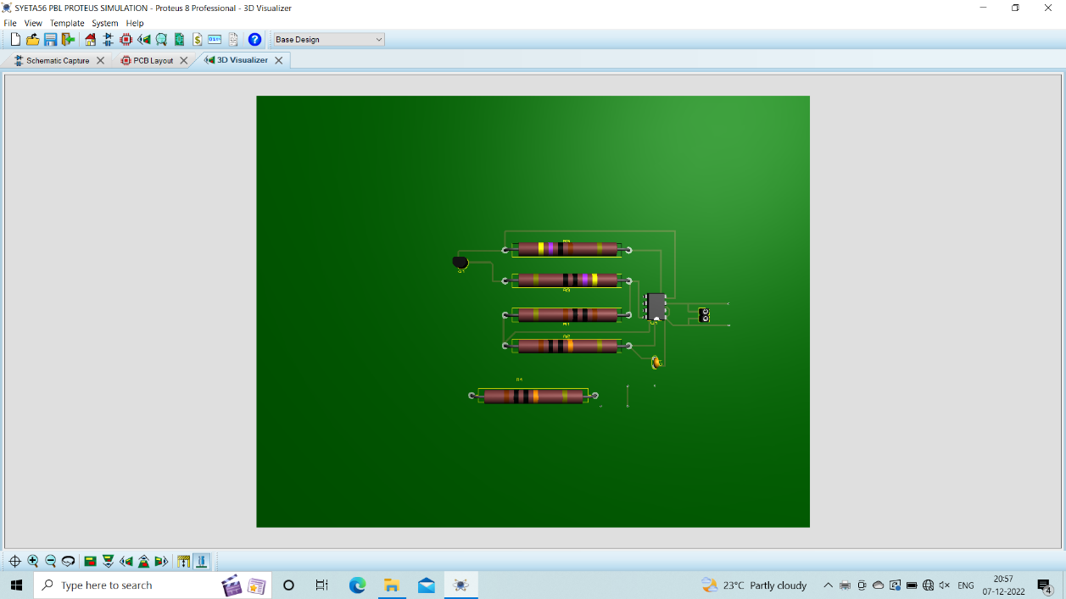

13. OBSERVATIONS
- Designed and simulated the Rain Alarm Circuit using Proteus software.
- Generated PCB layout and analyzed the 3D model of the circuit.
- Fabricated the PCB using copper clad board and etching process.
- Assembled and soldered all components on the PCB.
- Tested the circuit successfully on a breadboard and PCB.
- Observed that when water droplets fall on the rain sensor, the buzzer sounds and the LED glows immediately.

14. APPLICATIONS
- Rainwater harvesting systems
- Agricultural irrigation monitoring
- Home automation systems
- Weather monitoring stations
- Automobile rain detection systems
- Industrial safety and monitoring systems

15. ADVANTAGES
- Low-cost implementation
- Simple circuit design
- Easy to install and maintain
- Provides immediate rain detection
- Low power consumption
- Suitable for multiple applications

16. CONCLUSION
This project successfully demonstrated the design and implementation of a Rain Alarm Circuit using a rain sensor, 555 Timer IC, BC547 transistor, LED, and buzzer. The circuit effectively detects the presence of rainwater and provides immediate audio-visual alerts.
Through this project, practical knowledge of electronic circuit design, Proteus simulation, PCB layout generation, PCB fabrication, soldering techniques, and hardware testing was gained. The project achieved its objective of developing a simple, reliable, and economical rain detection system suitable for real-world applications.

