Methodology
The proposed system follows a risk-aware, RAG-based LLM cybersecurity incident-response pipeline. The methodology is designed to convert structured security incidents into validated response playbooks while keeping risk assessment independent from the language model and requiring human approval before simulated execution.
Overall Workflow
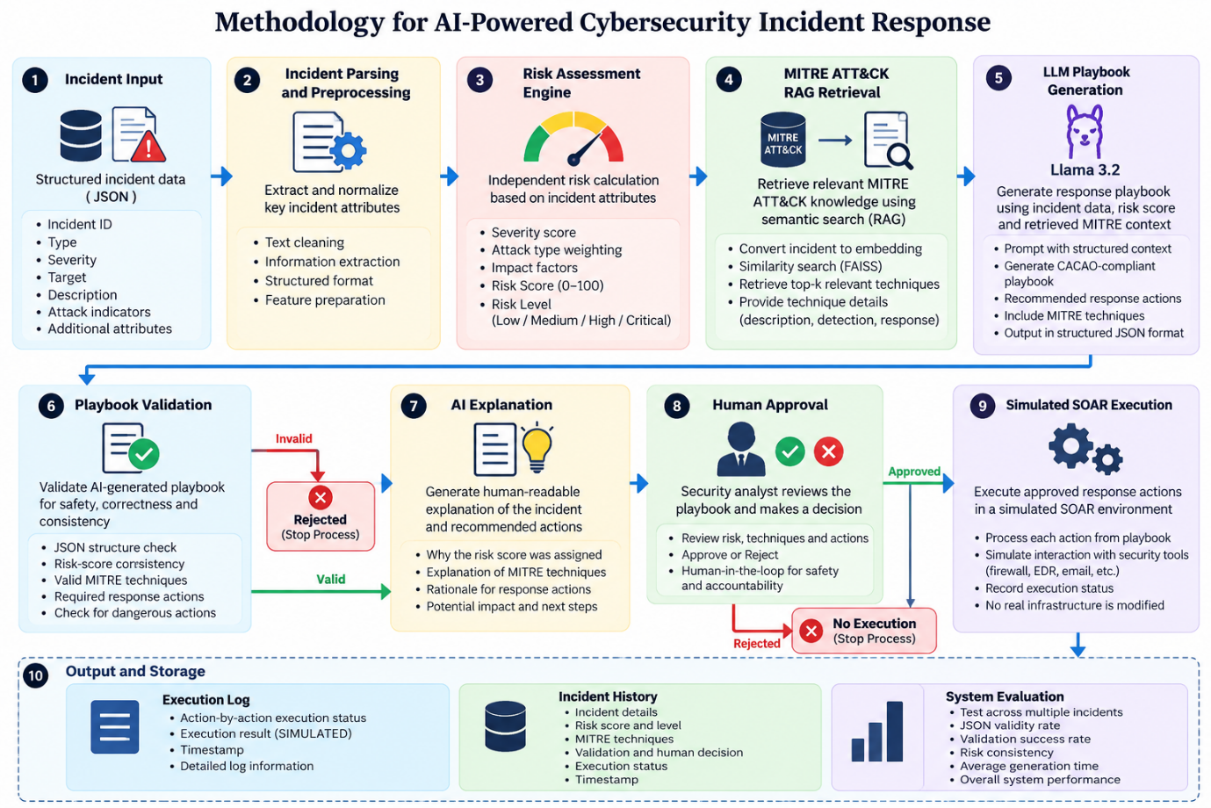
3.1 Incident Input and Preprocessing
The system accepts structured cybersecurity incident information in JSON format. Each incident contains attributes such as incident ID, attack type, severity, source IP, target, failed attempts, and incident description.
The incident data is parsed and converted into a standardized representation. The relevant attributes are then combined to create a retrieval query for the knowledge-retrieval stage.

3.2 Independent Risk Assessment
Before involving the LLM, the system calculates an independent risk score using a deterministic risk engine.
The risk score considers factors such as:
- Incident severity
- Number of failed attempts
- Target importance
- Attack characteristics
The resulting score is normalized to a 0–100 scale and mapped to a risk level:
0–24 → Low
25–49 → Medium
50–74 → High
75–100 → Critical
For example, the demonstrated brute-force incident receives:
Risk Score: 90/100
Risk Level: Critical
The calculated risk is supplied to the LLM as an external constraint. This prevents the LLM from independently changing the system's risk assessment.

3.3 MITRE ATT&CK Knowledge Retrieval
The system uses a Retrieval-Augmented Generation (RAG) approach to provide cybersecurity-specific knowledge to the LLM.
The MITRE ATT&CK knowledge base contains information about attack techniques, including:
- Technique ID
- Technique name
- Description
- Detection information
- Response information
The incident query is converted into a semantic embedding using the all-MiniLM-L6-v2 sentence-transformer model. Similarity search is then used to retrieve the most relevant MITRE ATT&CK techniques.
For example, a brute-force incident can retrieve:
T1110 Brute Force
T1110.001 Password Guessing
The retrieved knowledge is inserted into the LLM prompt as contextual information.

3.4 LLM-Based Playbook Generation
The retrieved MITRE knowledge, incident information, and independently calculated risk assessment are provided to a local LLM.
The current implementation supports models such as:
- Llama 3.2
- Qwen3 4B
Additional local models can be evaluated using the same pipeline.
The LLM generates a structured response playbook containing:
Incident ID
Incident Type
Risk Score
Risk Level
MITRE Techniques
Response Actions
Reasons for Actions
The system instructs the model to produce individual defensive actions rather than combining multiple activities into one action.

3.5 Playbook Validation
The generated playbook is passed through an independent validation layer before it can reach the execution stage.
The validator checks:
- JSON structure
- Required fields
- Risk-score consistency
- Risk-level consistency
- Presence of MITRE techniques
- Presence of response actions
- Action/reason structure
- Potentially dangerous actions
If validation fails, the workflow is stopped and the playbook is not executed.
This creates a safety boundary between LLM generation and response execution.

3.6 AI Explanation
After successful validation, the system generates a human-readable explanation of the generated response.
The explanation describes:
- Why the incident received its risk level
- Why the incident is significant
- Why particular MITRE techniques are relevant
- Why the recommended response actions were selected
This improves the interpretability of the generated playbook for a security analyst.

3.7 Human Approval
The system follows a human-in-the-loop approach.
The security analyst reviews:
- Risk score
- Risk level
- MITRE techniques
- Generated response actions
- Validation result
- AI explanation
The analyst can either:
APPROVE → Continue to simulated SOAR
REJECT → Stop execution
This prevents the LLM from directly triggering response actions without human review.

3.8 Simulated SOAR Execution
After approval, the playbook is passed to the simulated SOAR layer.
SOAR stands for Security Orchestration, Automation and Response.
In this project, the SOAR layer does not modify real infrastructure. Instead, it simulates the execution of each approved response action and records the result.
For example:
Action:
Lock affected account

Status:
SIMULATED

Result:
Action successfully simulated
This allows the complete incident-response workflow to be demonstrated safely.

3.9 Logging and Incident History
The system stores important information from every analyzed incident, including:
- Incident ID
- Incident type
- Risk score
- Risk level
- MITRE techniques
- Number of actions
- Validation status
- Human decision
- Execution status
- Timestamp
Execution information is also stored in an execution log.
This provides traceability across the complete response process.

3.10 Multi-LLM Comparative Evaluation
To study the effect of model selection, the same incident set can be processed using different LLMs.
The experimental setup keeps the following components constant:
Same incidents
+
Same risk engine
+
Same RAG knowledge
+
Same prompt structure
+
Same validator
↓
Different LLMs
↓
Comparable results
The models can be compared using:
- JSON validity
- MITRE technique F1
- Risk consistency
- Validation pass rate
- Response-action quality
- Average generation time
- Number of generated actions
This allows the project to evaluate not only whether an LLM can generate a playbook, but also how different compact LLMs behave under the same cybersecurity response conditions.

