jQuery Assignment

jQuery-- 1. Query is a fast, small, and feature-rich JavaScript library.
2. It makes things like HTML document traversal and manipulation, event handling, animation, and Ajax much simpler with an easy-to-use API that works across a multitude of browsers.

Ques. 1 Console "Hello Word" in document.ready function
Ans 1. document.ready function-- A page can't be manipulated safely until the document is "ready." jQuery detects this state of readiness for you. Code included inside $( document ).ready() will only run once the page Document Object Model (DOM) is ready for JavaScript code to execute.

Code--
<!DOCTYPE html>
<html>
<head>
<title></title>
</head>
<script type="text/javascript">

</script>
<script src="https://ajax.googleapis.com/ajax/libs/jquery/3.3.1/jquery.min.js"></script>
<script>
$(document).ready(function()
{
console.log("hello world")
});

</script>
<body>
<p></p>
</body>
</html>
Output-- Browser Window is empty since we are printing the output is displayed on the console.
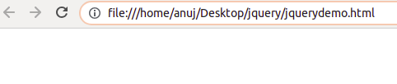
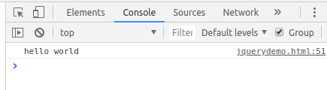

Console window

Ques 2. Select a ID name "#test" and add class "load" when DOM is loaded
Ans 2. DOM-- Document Object Model
DOM is basically the heirarchy in html.
Code-- <!DOCTYPE html>
<html>
<head>
<title></title>
</head>
<script type="text/javascript">
</script>
<script src="https://ajax.googleapis.com/ajax/libs/jquery/3.3.1/jquery.min.js"></script>
<script>
$(document).ready(function()
{
$("#test").addclass("load")
});

</script>
<body>
<p id="test">CALL FUNCTION</p>
<p>NEW CLASS NAMED "LOAD" IS ADDED BY USING TEST ID</p>////
</body>
</html>
Output--
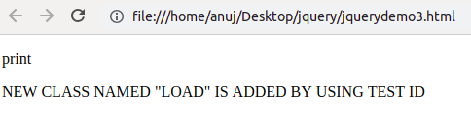

Ques 3. Change the color of element which class name end with "-new"
Ans 3. In this ques we have used hover functionality to change the the color of the class.
Hover-- The hover() method specifies two functions to run when the mouse pointer hovers over the selected elements.

Code--
<!DOCTYPE html>
<html>
<head>

<script type="text/javascript" src="https://ajax.googleapis.com/ajax/libs/jquery/3.1.1/jquery.min.js"></script>
<script type="text/javascript">
$(document).ready(function(){
$(".sdnew").hover(function(){
$(this).css("background-color", "yellow");
}, function(){
$(this).css("background-color", "blue");
});
});
</script>
<title>Question 2</title>
<style type="text/css">
.sdnew{
background-color: blue;
color: white;
}
</style>
</head>
<body>
<div class="sdnew">
<p>this is a paragraph</p>
</div>
</body>
</html>

Before hover--
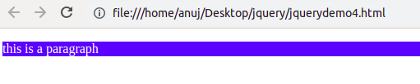
After hover--
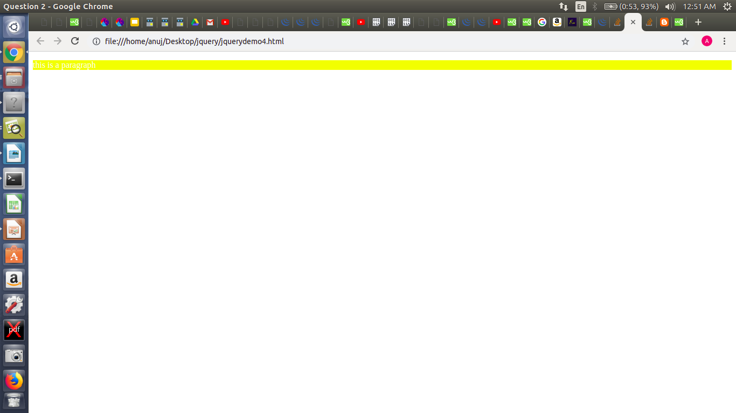

Ques 4. Disable submit button using jquery attr method
Ans 4. attr() method-- The attr() method sets or returns attributes and values of the selected elements.
When this method is used to return the attribute value, it returns the value of the FIRST matched element.
When this method is used to set attribute values, it sets one or more attribute/value pairs for the set of matched elements.
Code--
<!DOCTYPE html>
<html>
<head>
<title></title>
</head>
<script type="text/javascript">

</script>
<script src="https://ajax.googleapis.com/ajax/libs/jquery/3.3.1/jquery.min.js"></script>
<script>
$(document).ready(function(){
$("button").click(function()
{
alert("disable this alert");
$("#abc1").attr('disabled','disabled');
});
});
</script>
<body>
<button id="abc1" type="button">Tap this Button to disable</button>
</body>
</html>
Before disabling the button
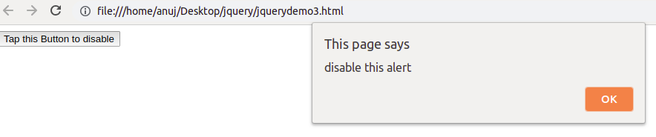
After disabling the switch
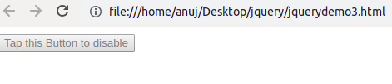

Ques 5.--Change the font size of ".target" which has parent element with id name "#main"
Ans 5.
Code--
<!DOCTYPE html>
<html>
<head>
<title></title>
</head>
<script type="text/javascript">

</script>
<script src="https://ajax.googleapis.com/ajax/libs/jquery/3.3.1/jquery.min.js"></script>
<script>
$(document).ready(function(){
{
$("#main").css("font-size","+=10")
$(".target").text(size+=10)
}
});

</script>
<body>
<div id="main">
<p class="target">This is paragraph.</p>
</div>
</body>
</html>
Output-- Before changing the font size.
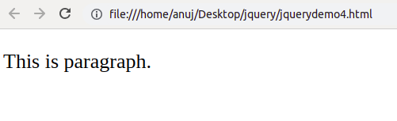
After changing the font-size
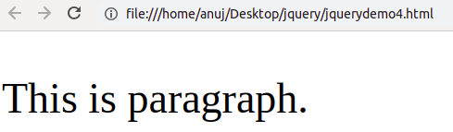

Ques 6. After page load change the HTML of div element with "p" element
Ans 6. We will use replacewith method in this question.
Replacewith()-- the replaceWith() method replaces selected elements with new content.
Code--
<!DOCTYPE html>
<html>
<head>
<script src="https://ajax.googleapis.com/ajax/libs/jquery/3.3.1/jquery.min.js"></script>
<script>
$(document).ready(function(){
$("button").click(function(){
$("div:first").replaceWith("DIVISION REPLACED WITH PARAGRAPH");
});
});
</script>
</head>
<body>
<div style="width: 50%;height: 20px;background-color: blue;">PARAGRAPH TO BE REPLACED</div><br>
<button>Replace the first p element with new text</button>
</body>
</html>
Output--
Before replacing--
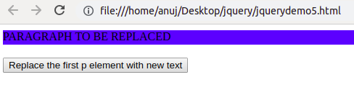

After replacing-- When you click the specified button content will change.
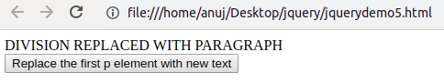

Ques 7. Bind a click function to an "click" element and append next "click" next to it.
Ans 7. Append-- The append()method inserts the specified content as the last child of each element in the jQuery collection.

Code-- <!DOCTYPE html>
<html>
<head>
<script src="https://ajax.googleapis.com/ajax/libs/jquery/3.3.1/jquery.min.js"></script>
<script>
$(document).ready(function(){
$("#btn1").click(function(){
$("body").append(" <button>Appended Button</button>");
});
});
</script>
</head>
<body>
<p>This is a paragraph.</p>
<button id="btn1" type="button" onclick="function()">insert</button>
</body>
</html>

Output-- Before pressing button.
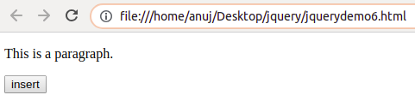

After pressing button it appends a click button next to it.
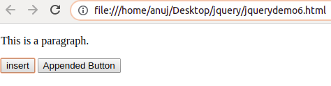

Ques 8. Click event not working on element which added dynamicly or via script, make it work using .on method
Ans 8.
Code-- <html>
<head>
<script
src="https://code.jquery.com/jquery-3.3.1.js">
</script>
<script type="text/javascript">
$(document).ready(function()
{
$("body").append(" <b>Click Here</b>.").on("click", function(){ alert("Clicking this you have got alert using on method");
});
});
</script>
</head>
<body>
</body>
</html>
Output--
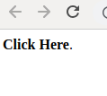
Click this text to get alert--->

Here on clicking text we got the alert box
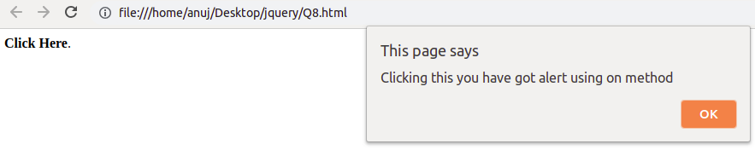
Ques 9. Get ropdown selected value on onchanage event and append in div container
Ans 9.
Code--
<!DOCTYPE html>
<html>
<head>
<head>
<script src="https://ajax.googleapis.com/ajax/libs/jquery/3.1.1/jquery.min.js">
</script>
</head>
<body>
<select id="selector">
<option value="Linux">Linux</option>
<option value="Git">Git</option>
<option value="Database">Database</option>
<option value="HTML & CSS">HTML & CSS</option>
</select>
<div id="container"></div>
<script>
$('#selector').on('change', function() {
var el = "<p>" + $("#selector").val() + "</p>";
$("#container").append(el);
});
</script>
</body>
</html>
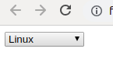
Output--

Drop down select option---->

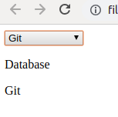

When any option selected its
new div is created and ----------->
option is displayed

Ques 10. Create a dropdown menu using hover method in jquery
Ans 10.
Code-- <!DOCTYPE html>
<html>
<head>
<script src="https://ajax.googleapis.com/ajax/libs/jquery/3.3.1/jquery.min.js"></script>
</head>
<body>
Operating System:<br>
<select class="abc1" style="border-color: #66ff99;background-color: #66ff99;border-radius: 4px;"> <option value="Windows XP">Windows XP</option>
<option value="Windows 8.1">Windows 8.1</option>
<option value="Windows 10">Windows 10</option>
<option value="Mac">Mac</option>
<option value="Linux">Linux</option>
</select><br><br>
<script>
$(".abc1").hover(function()
{
var a=$(".abc1")[0].options.length;
$(".abc1")[0].size=a;
},function(){
$(".abc1")[0].size=0;
});
</script>
</body>
</html>
Output--
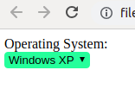
Without Hover---->

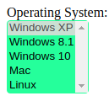

With hover ----->

Ques 11. On clicking on "google" tag. It is taking us to google home page. Stop it from happening.
Ans 11. Using event.preventDefault function()-- It prevents the default functioning of an event performed by any function
For eg-- If there is any anchor link which takes you to the specified URL then to prevent it doing so we use event.preventDefault() .
Code--
<!DOCTYPE html>
<html>
<head>
<title></title>
</head>
<script type="text/javascript">

</script>
<script src="https://ajax.googleapis.com/ajax/libs/jquery/3.3.1/jquery.min.js"></script>
<script>
$(document).ready(function(){
$(".abc1").click(function()
{

event.preventDefault();
$("p").text("Disabled button")
});
});
</script>
<body>
<a class="abc1" href="http://www.google.com">Google</a>
<p></p>
</body>
</html>
Output--
Before clicking the tag--
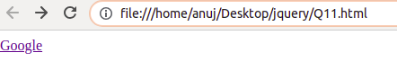

After clicking the tag it will display the message that tag is disabled--
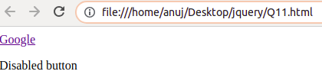

Ques 12. We have bind a click funtion to parent div but we want stop it from performing when user clicks on its child.
Ans 12.
Code-- <!DOCTYPE html>
<html>
<head>
<title></title>
</head>
<script type="text/javascript">

</script>
<script src="https://ajax.googleapis.com/ajax/libs/jquery/3.3.1/jquery.min.js"></script>
<script>
$(document).ready(function(){

$("#abc1").click(function(){
alert("disable this alert");
$("#abc2").attr('disabled','disabled');
});
$("#abc2").click(function(){
alert("disable this alert");
});
});
</script>
<body>
<button id="abc1" type="button"> Parent
<button id="abc2" type="button"> Child </button>
</button>
</body>
</html>
Output-- We have created two buttons first button is parent and other is its child button
If we click on parent button it wil disable its child button and if we click its child button then it has some functionality.

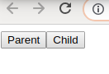

We have two buttons--->

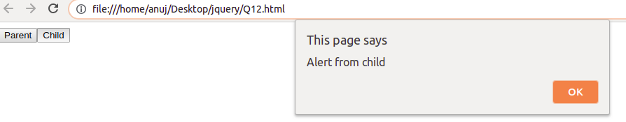

When we clicked on child button
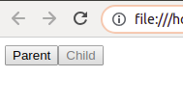
it displays some message. ------------->

when we clicked on parent button it
disabled the child button.---------------->

Ques 13. Get the max height of elements using jquery each method
Ans 13. We are using height method to get maximum height of the div.
Each method-- The each() method specifies a function to run for each matched element
Code-- <!DOCTYPE html>
<html>
<head>
<title></title>
</head>
<script type="text/javascript">

</script>
<script src="https://ajax.googleapis.com/ajax/libs/jquery/3.3.1/jquery.min.js"></script>
<script>
$(document).ready(function(){
var h=0
$(".line1").each(function(){
h=h>$(this).height() ? h : $(this).height()
});
console.log(h);
});
</script>
<body>
<div class="line1"> <br>
line1
<div class="line1"><br>
line2
line2
<div class="line1"><br>
line3
line3
line3
<div class="line1"><br>
line4
line4
line4
line4
<div class="line1"><br>
line5
line5
line5
line5
line5
line5
</div>
</div>
</div>
</div>
</div>
</body>
</html>

Output---
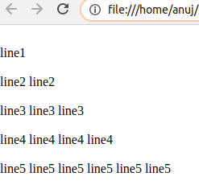

Lines present in different --->
div

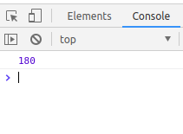

max_height displayed on the --->
console

Ques. 14 Chagne color of every cell which has numberl larger than 10.
Ans 14.
Code-- <!DOCTYPE html>
<html>
<head>
<title></title>
</head>
<script type="text/javascript"> </script>
<script src="https://ajax.googleapis.com/ajax/libs/jquery/3.3.1/jquery.min.js"></script>
<body>
<script>
$(document).ready(function ()
{
$(".line").each(function()
{
var el = $(this);
var value = parseFloat(el.text());
if (value > 10)
{
el
.css("font-weight", "bold")
.css("color", "red");
}
else
{
el.css("font-weight", "normal");
}
});
});
</script>
<div class="line">4</div>
<div class="line">34</div>
<div class="line">4</div>
<div class="line">3</div>
<div class="line">14</div>
<div class="line">364</div>
</body>
</html>

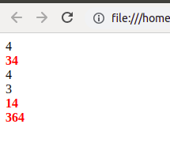
Output--

Number greater than 10 are red in color ----->

Ques 15. Retrive the data from server using ajax get call
Ans 15. AJAX-- Update a web page without reloading the page
Request data from a server - after the page has loaded
Receive data from a server - after the page has loaded
Send data to a server - in the background
Server used-- https://reqres.in/--- It is host which provides the data from any ajax call.
Code-- <!DOCTYPE html>
<html>
<head>
</head>
<body>
<script src="https://ajax.googleapis.com/ajax/libs/jquery/3.3.1/jquery.min.js"></script>
<script>
$(document).ready(function(){
$(".abc").click(function() {
// data path
$.ajax({type: "GET", url: "https://www.reqres.in/api/users/2", success: function(result) {
// get Result
console.log(result)
var el = "<p>" +"Id=" +result.data.id +"<br>"+ "Name="+ result.data.first_name + " " +result.data.last_name +"<br>"+ "Avatar="+result.data.avatar +"</p>";
$(".xyz").append(el);
}});
});
});
</script>
<button class="abc">Click here to fetch data</button>
<div class="xyz"></div>
<br><br>
</body>
</html>

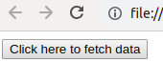
Output--
Click this button to get the data from reqres server. ---->

After clicking the button we have recieved the data from server.
