**WEEK1**

Q1) Write a simple poem and represent it as a web page. Give a title for the poem.

Make rhyming words in the poem as bold.

Code:

<!DOCTYPE html>

<html lang="en">

<head>

<meta charset="UTF-8">

<meta name="viewport" content="width=device-width, initial-scale=1.0">

<title>question 1</title>

</head>

<body>

<p style="text-align: center">

<span display="inline-block" width= "200px" white-space="normal" >

Beneath the sky so bright and <b>blue</b>,<br>

The flowers bloom with morning <b>dew</b>.<br>

The birds take flight, their songs in <b>tune</b>,<br>

As golden rays chase away the <b>moon</b>.<br><br>

The world awakens, calm and <b>clear</b>,<br>

A peaceful world, so full of <b>cheer</b>.<br>

With every step, the day feels <b>new</b>,<br>

A perfect start for me and <b>you.</b>

</span>

</p>

</body>

</html>

Snippet:

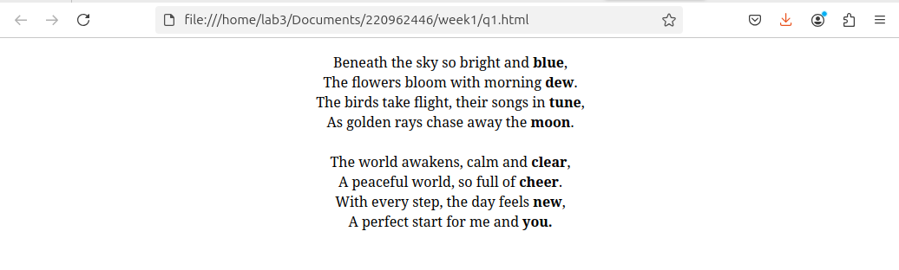

Q2). Assume you have brought a new car. Write down the list of additional

accessories you need for the car as an unordered list in HTML. Also, list the

travel plans on the car as an ordered list.

Code:

<!DOCTYPE html>

<html lang="en">

<head>

<meta charset="UTF-8">

<meta name="viewport" content="width=device-width, initial-scale=1.0">

<title>Question 2</title>

</head>

<body>

<div style="display: flex; gap:20px">

<div>

<h2>Addtional Accessories</h2>

<ul>

<li>Seat cover</li>

<li>Fake exhaust</li>

<li>Car cover</li>

</ul>

</div>

<div>

<h2>Travel Plans</h2>

<ol>

<li>Beach Trip</li>

<li>Hillstation visit</li>

<li>WaterPark trip</li>

</ol>

</div>

</div>

</body>

</html>

Snippet:

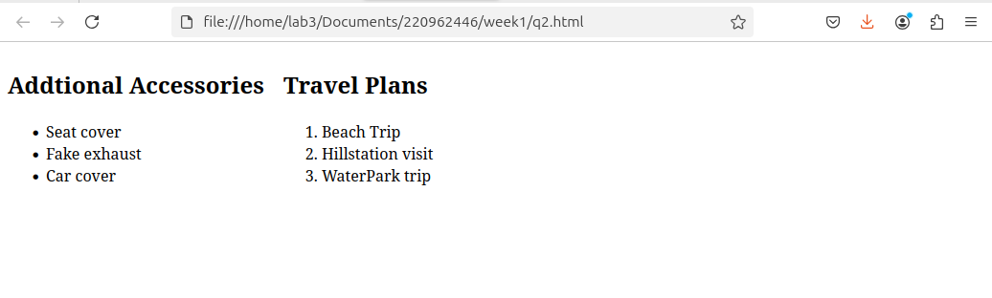

Q3) Complete the following website name “Share your Winter Vacation Videos”.

The required video files are located inside the compressed folder “Week 1

Assignment Files/Media/”.

Code:

<!DOCTYPE html>

<html lang="en">

<head>

<meta charset="UTF-8">

<meta name="viewport" content="width=device-width, initial-scale=1.0">

<title>Question 3</title>

</head>

<body style="font-family: 'Brush Script MT', cursive;color:white">

<div style="background: linear-gradient(to bottom, blue 20%, white 80%); ">

<nav style=" background-image: url('../../../Downloads/nav_bg.jpeg');">

<h1>Share your Winter Vacation Videos</h1>

</nav>

<div style=" padding-left:50px;">

<h3>HTML Video</h3>

<figure style="display:flex; justify-content: center; gap:20px;">

<video src="../../../Downloads/vid1.mp4" width="320" height="240" controls></video>

<video src="../../../Downloads/vid2.mp4" width="320" height="240" controls></video>

<video src="../../../Downloads/vid3.mp4" width="320" height="240" controls></video>

</figure>

</div>

</div>

</body>

</html>

Snippet:

