**Week 3 – 220962446**

Question 1)Write a JavaScript program to perform an online quiz

Code 1)

<!DOCTYPE html>

<html>

<head>

<title>Online Quiz</title>

<style>

body {

font-family: Arial, sans-serif;

background-color: lightblue;

text-align: center;

}

.question {

background-color: white;

margin: 10px;

padding: 15px;

border-radius: 10px;

}

#resultDiv {

display: none;

background-color: #f0f0f0;

padding: 20px;

margin-top: 20px;

}

</style>

</head>

<body>

<h1>Online Quiz</h1>

<form id="quizForm">

<div class="question">

<p>1. Is water wet?</p>

<label>

<input type="radio" name="water_question" value="yes"> Yes

</label>

<label>

<input type="radio" name="water_question" value="no"> No

</label>

</div>

<div class="question">

<p>2. What is 18 + 35?</p>

<input type="number" name="math_question" id="math_answer">

</div>

<div class="question">

<p>3. The world is flat.</p>

<label>

<input type="radio" name="world_question" value="true"> True

</label>

<label>

<input type="radio" name="world_question" value="false"> False

</label>

</div>

<button type="button" onclick="submitQuiz()">Submit Quiz</button>

<button type="reset">Reset</button>

</form>

<div id="resultDiv">

<h2>Quiz Results</h2>

<p id="scoreDisplay"></p>

<p id="feedbackDisplay"></p>

</div>

<script>

function submitQuiz() {

const form = document.getElementById('quizForm');

const resultDiv = document.getElementById('resultDiv');

const scoreDisplay = document.getElementById('scoreDisplay');

const feedbackDisplay = document.getElementById('feedbackDisplay');

const correctAnswers = {

water_question: 'yes',

math_question: 53,

world_question: 'false'

};

let score = 0;

const waterAnswer = form.querySelector('input[name="water_question"]:checked');

if (waterAnswer && waterAnswer.value === correctAnswers.water_question) {

score++;

}

const mathAnswer = document.getElementById('math_answer').value;

if (parseInt(mathAnswer) === correctAnswers.math_question) {

score++;

}

const worldAnswer = form.querySelector('input[name="world_question"]:checked');

if (worldAnswer && worldAnswer.value === correctAnswers.world_question) {

score++;

}

scoreDisplay.textContent = `Your Score: ${score} out of 3`;

if (score === 3) {

feedbackDisplay.textContent = "Excellent! Perfect Score!";

feedbackDisplay.style.color = 'green';

} else if (score >= 2) {

feedbackDisplay.textContent = "Good job! You're almost there.";

feedbackDisplay.style.color = 'blue';

} else {

feedbackDisplay.textContent = "You need more practice. Try again!";

feedbackDisplay.style.color = 'red';

}

resultDiv.style.display = 'block';

}

</script>

</body>

</html>

Output 1)

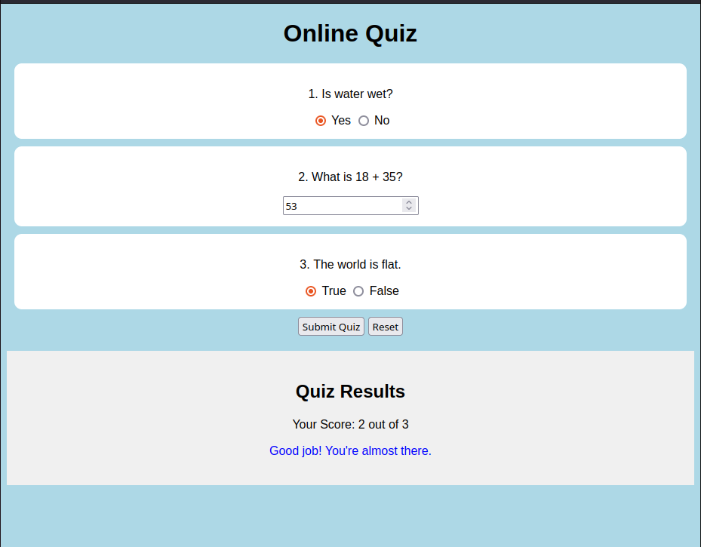

Question 2) Write a JavaScript program to Wish a user at different hours of a day. Use

appropriate dialog boxes for wishing the user. Display the dynamic clock on the

web page. Make use of CSS and HTML5 elements for creative and attractive

design.

Code 3)

<!DOCTYPE html>

<html>

<head>

<title>Dynamic Time Wisher</title>

<style>

body {

font-family: Arial, sans-serif;

display: flex;

flex-direction: column;

align-items: center;

justify-content: center;

height: 100vh;

background-color: #f0f0f0;

}

.clock {

font-size: 3rem;

color: #333;

margin-bottom: 20px;

}

.wish {

font-size: 2rem;

font-weight: bold;

padding: 15px;

border-radius: 10px;

text-align: center;

}

.morning { background-color: #e6f2ff; color: #0066cc; }

.afternoon { background-color: #fff2e6; color: #ff9900; }

.evening { background-color: #e6ffe6; color: #009900; }

.night { background-color: #f0e6ff; color: #6600cc; }

</style>

</head>

<body>

<div class="clock" id="clockDisplay"></div>

<div id="wishMessage" class="wish"></div>

<script>

function startTime() {

const now = new Date();

const h = now.getHours();

const m = now.getMinutes();

const s = now.getSeconds();

const formattedTime = [h, m, s]

.map(time => time < 10 ? `0${time}` : time)

.join(':');

document.getElementById('clockDisplay').textContent = formattedTime;

let wishMessage = '';

let wishClass = '';

if (h >= 4 && h < 12) {

wishMessage = 'Good Morning!';

wishClass = 'morning';

} else if (h >= 12 && h < 16) {

wishMessage = 'Good Afternoon! ';

wishClass = 'afternoon';

} else if (h >= 16 && h < 20) {

wishMessage = 'Good Evening!';

wishClass = 'evening';

} else {

wishMessage = 'Good Night!';

wishClass = 'night';

}

const wishElement = document.getElementById('wishMessage');

wishElement.textContent = wishMessage;

wishElement.className = `wish ${wishClass}`;

setTimeout(startTime, 1000);

}

window.onload = startTime;

</script>

</body>

</html>

Output 2)



Question 3) Write the java script program to display the grade [A, B,C,D] based on the marks

entered by student(take the input into text boxes). Enter the marks of 4 subjects and

calculate the average( using button). If the avg>90 then A, avg>80 then B, if avg>70

then C, if avg>60 then D.

Code 3)

<!DOCTYPE html>

<html>

<head>

<title>Online Quiz</title>

<style>

body {

font-family: Arial, sans-serif;

background-color: lightblue;

text-align: center;

}

.question {

background-color: white;

margin: 10px;

padding: 15px;

border-radius: 10px;

}

#resultDiv {

display: none;

background-color: #f0f0f0;

padding: 20px;

margin-top: 20px;

}

</style>

</head>

<body>

<h1>Online Quiz</h1>

<form id="quizForm">

Enter marks for these subjects

<div class="question">

<p>Mathematics</p>

<input type="number" name="math" id="marks1">

</div>

<div class="question">

<p>General Science</p>

<input type="number" name="science" id="marks2">

</div>

<div class="question">

<p>Machine Learning</p>

<input type="number" name="ml" id="mark3">

</div>

<div class="question">

<p>English</p>

<input type="number" name="english" id="mark4">

</div>

<button type="button" onclick="submitQuiz()">Submit Quiz</button>

<button type="reset">Reset</button>

</form>

<div class="question">

<p>Average Score</p>

<p id="average"></p>

</div>

<div id="resultDiv">

<h2>Quiz Results</h2>

<p id="scoreDisplay"></p>

<p id="feedbackDisplay"></p>

</div>

<script>

function submitQuiz() {

const form = document.getElementById('quizForm');

const resultDiv = document.getElementById('resultDiv');

const scoreDisplay = document.getElementById('scoreDisplay');

const feedbackDisplay = document.getElementById('feedbackDisplay');

const averageDisplay = document.getElementById('average');

let avg = 0;

const mark1 = Number(document.getElementById('marks1').value);

const mark2 = Number(document.getElementById('marks2').value);

const mark3 = Number(document.getElementById('mark3').value);

const mark4 = Number(document.getElementById('mark4').value);

avg = (mark1 + mark2 + mark3 + mark4) / 4.0;

averageDisplay.textContent = avg.toFixed(2);

scoreDisplay.textContent = `Average Score: ${avg.toFixed(2)}`;

let score = "";

if (avg >= 90) {

feedbackDisplay.textContent = "Grade: A (Excellent!)";

feedbackDisplay.style.color = 'green';

} else if (avg >= 80) {

feedbackDisplay.textContent = "Grade: B (Very Good)";

feedbackDisplay.style.color = 'blue';

} else if (avg >= 70) {

feedbackDisplay.textContent = "Grade: C (Good)";

feedbackDisplay.style.color = 'blue';

} else if (avg >= 60) {

feedbackDisplay.textContent = "Grade: D (Average)";

feedbackDisplay.style.color = 'orange';

} else {

feedbackDisplay.textContent = "Grade: F (Need Improvement)";

feedbackDisplay.style.color = 'red';

}

resultDiv.style.display = 'block';

}

</script>

</body>

</html>

Output 3)

