Week 4: 220962446

Question 1) Write a web page which contains table with 3 X 3 dimensions (fill some data) and one

image. Style the rows with alternate color. Move the table and image together from

right to left when button is clicked.

Solution 1)

<!DOCTYPE html>

<html lang="en">

<head>

<meta charset="UTF-8">

<meta name="viewport" content="width=device-width, initial-scale=1.0">

<title>Document</title>

<style>

table, td, tr {

border: 2px solid black;

}

#container {

display: flex;

justify-content: flex-end;

align-items: center;

align-content: center;

height: 500px;

position: relative;

}

#table, #img {

position: relative;

right: 0;

}

/\* Alternate row colors \*/

tr:nth-child(even) {

background-color: yellow;

}

tr:nth-child(odd) {

background-color: red;

}

button {

margin-top: 20px;

padding: 10px;

cursor: pointer;

}

</style>

<script src="https://code.jquery.com/jquery-3.6.0.min.js"></script>

<script type="text/javascript">

$(document).ready(function () {

$("button").click(function(){

$("#table, #img").animate({right: '60%'}, 1000);

});

});

</script>

</head>

<body>

<div id="container">

<table id="table">

<tr>

<td>1</td>

<td>2</td>

<td>3</td>

</tr>

<tr>

<td>4</td>

<td>5</td>

<td>6</td>

</tr>

<tr>

<td>7</td>

<td>8</td>

<td>9</td>

</tr>

</table>

<img id="img" src="/home/lab3/Documents/220962446/week4/trump.jpeg" alt="Trump Image">

</div>

<button>Click Here</button>

</body>

</html>

Output 1)

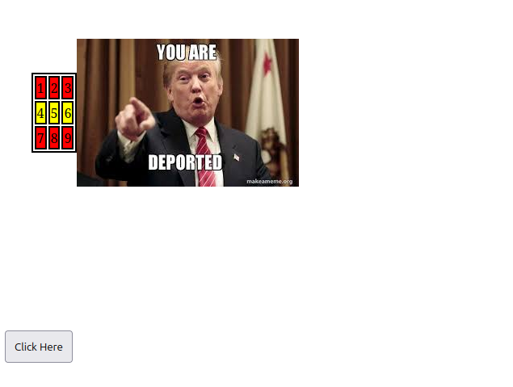

Question 2) Design a calculator to perform basic arithmetic operations. Use textboxes and buttons

to design web page.

Solution 2)

<!DOCTYPE html>

<html lang="en">

<head>

<meta charset="UTF-8">

<meta name="viewport" content="width=device-width, initial-scale=1.0">

<title>Single Input Calculator</title>

<style>

body {

font-family: Arial, sans-serif;

display: flex;

justify-content: center;

align-items: center;

height: 100vh;

background-color: #f4f4f4;

}

.calculator {

background: white;

padding: 20px;

border-radius: 10px;

box-shadow: 0 0 10px rgba(0, 0, 0, 0.1);

text-align: center;

}

input {

width: 200px;

height: 40px;

font-size: 20px;

text-align: right;

margin-bottom: 10px;

padding: 5px;

border: 1px solid #ccc;

}

.buttons {

display: flex;

gap: 10px;

justify-content: center;

}

button {

width: 50px;

height: 50px;

font-size: 18px;

cursor: pointer;

border: none;

background: orange;

color: white;

border-radius: 5px;

}

button.equal {

background: green;

}

button.AC{

background: blue;

}

</style>

</head>

<body>

<div class="calculator">

<input type="text" id="display" placeholder="0" >

<div class="buttons">

<button class="operator" data-op="+">+</button>

<button class="operator" data-op="-">-</button>

<button class="AC">AC</button>

</div>

<div class="buttons">

<button class="operator" data-op="\*">x</button>

<button class="operator" data-op="/">/</button>

<button class="equal">=</button>

</div>

</div>

<script src="https://code.jquery.com/jquery-3.6.0.min.js"></script>

<script>

let expression = "";

$(document).ready(function() {

$('#display').focus();

$('.operator').click(function() {

let operator = $(this).data('op');

setOperation(operator);

});

$('.AC').click(function() {

AC();

});

$('.equal').click(function() {

calculate();

});

});

function AC() {

expression = "";

$('#display').val("");

$('#display').attr("placeholder", "0");

$('#display').focus();

}

function setOperation(operator) {

let displayVal = $('#display').val();

if (displayVal === "") return;

if (expression !== "") calculate();

expression = displayVal + " " + operator + " ";

$('#display').val("");

$('#display').attr("placeholder", displayVal + " " + operator);

$('#display').focus();

}

function calculate() {

try {

expression += $('#display').val();

let result = eval(expression);

$('#display').val(result);

expression = result.toString();

} catch {

$('#display').val("Error");

expression = "";

}

$('#display').focus();

}

</script>

</body>

</html>

Output 2)

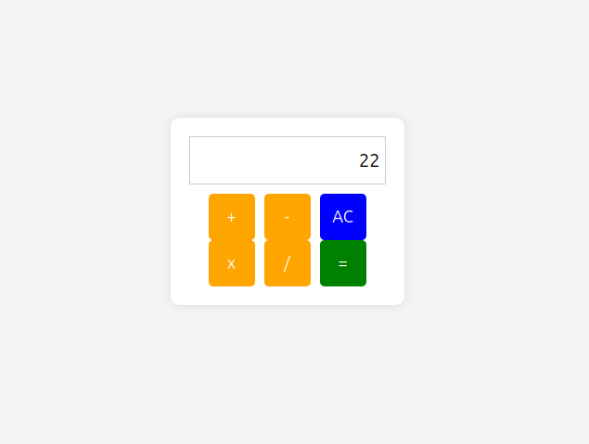

Question 3) Create a web page to design a birthday card shown below.

Solution 3)

<!DOCTYPE html>

<html lang="en">

<head>

<meta charset="UTF-8">

<meta name="viewport" content="width=device-width, initial-scale=1.0">

<title>Custom Styling</title>

<style>

.big-container {

display: flex;

height: 100vh;

}

.container1 {

background-color: rgb(235, 235, 126);

width: 50%;

padding: 20px;

box-sizing: border-box;

display: flex;

flex-direction: column;

justify-content: flex-start;

}

.container2 {

width: 50%;

padding: 20px;

display: flex;

flex-direction: column;

justify-content: center;

align-items: center;

transition: all 0.3s ease;

}

.greetings {

text-align: center;

font-size: 2rem;

margin-bottom: 20px;

}

.image {

display: flex;

justify-content: center;

margin-top: 20px;

}

label, select, textarea, button {

margin: 10px 0;

font-size: 1rem;

}

button {

padding: 10px 20px;

background-color: #4CAF50;

color: white;

border: none;

cursor: pointer;

font-size: 1rem;

}

button:hover {

background-color: #45a049;

}

textarea {

width: 100%;

height: 100px;

padding: 10px;

font-size: 1rem;

border-radius: 5px;

border: 1px solid #ccc;

}

</style>

<script src="https://code.jquery.com/jquery-3.6.0.min.js"></script>

<script type="text/javascript">

$(document).ready(function () {

$('#btnSubmit').click(function (event) {

event.preventDefault();

var bgcolor = $('#colors').val();

var font = $('#fonts').val();

var border = $('input[name="border-style"]:checked').val();

var pictureChecked = $('#addPicture').prop('checked');

$('.container2').css('background-color', bgcolor);

$('.greetings').css('font-family', font);

if (border) {

$('.container2').css('border', `5px ${border} black`);

} else {

$('.container2').css('border', 'none');

}

if (pictureChecked) {

$('.image').html('<img src="/home/lab3/Documents/220962446/week4/cake.jpeg" alt="Default Picture">');

} else {

$('.image').html('');

}

var greetingText = $('#greets').val();

$('.greetings').html('<p>' + greetingText + '</p>');

});

});

</script>

</head>

<body>

<div class="big-container">

<div class="container1">

<form style="display: flex; flex-direction: column;">

<label for="colors">Choose a background color</label>

<select name="colors" id="colors">

<option value="yellow">Yellow</option>

<option value="green">Green</option>

<option value="blue">Blue</option>

</select>

<br>

<label for="fonts">Choose a font</label>

<select name="fonts" id="fonts">

<option value="Verdana">Verdana</option>

<option value="Calibri">Calibri</option>

<option value="Roboto">Roboto</option>

</select>

<br>

<label>Choose a border style:</label>

<label><input type="radio" name="border-style" id="None" value="None"> None</label>

<label><input type="radio" name="border-style" id="Double" value="Double"> Double</label>

<label><input type="radio" name="border-style" id="Solid" value="Solid"> Solid</label>

<br>

<label><input type="checkbox" name="add-picture" id="addPicture"> Add the Default picture</label>

<br>

<label for="greets">Enter the greeting text below:</label><br>

<textarea id="greets"></textarea>

<br>

<button type="submit" id="btnSubmit">Update</button>

</form>

</div>

<div class="container2">

<div class="greetings"></div>

<div class="image"></div>

</div>

</div>

</body>

</html>

Output 3)

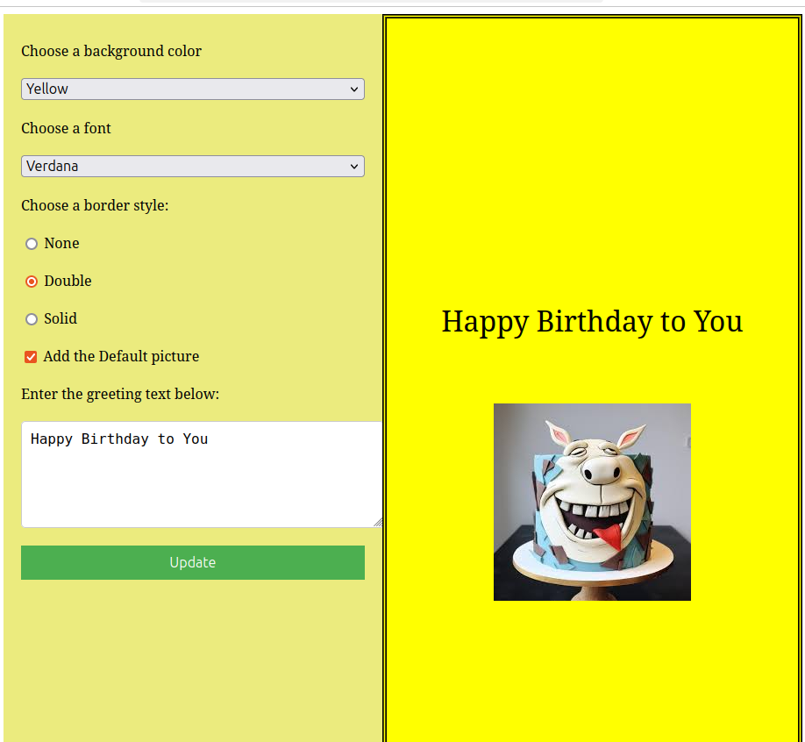

Question 4) Design a webpage. The page contains:

• Dropdown list with HP, Nokia, Samsung, Motorola, Apple as items.

• Checkbox with Mobile and Laptop as items. Textbox where you enter quantity.

• There is a button with text as ‘Produce Bill’.

On Clicking Produce Bill button, alert should be displayed with total amount.

Solution 4)

<!DOCTYPE html>

<html lang="en">

<head>

<meta charset="UTF-8">

<meta name="viewport" content="width=device-width, initial-scale=1.0">

<title>Produce Bill</title>

<style>

.big-container {

display: flex;

height: 100vh;

}

.container1 {

background-color: rgb(235, 235, 126);

width: 110%;

padding: 20px;

box-sizing: border-box;

display: flex;

flex-direction: column;

justify-content: flex-start;

}

label, select, input, button {

margin: 10px 0;

font-size: 1rem;

}

button {

padding: 10px 20px;

background-color: #4CAF50;

color: white;

border: none;

cursor: pointer;

font-size: 1rem;

}

button:hover {

background-color: #45a049;

}

input[type="text"] {

width: 100%;

padding: 10px;

font-size: 1rem;

border-radius: 5px;

border: 1px solid #ccc;

}

</style>

<script src="https://code.jquery.com/jquery-3.6.0.min.js"></script>

<script type="text/javascript">

$(document).ready(function () {

$('#btnSubmit').click(function (event) {

event.preventDefault();

var phoneBrand = $('#phones').val();

var quantity = parseInt($('#quantity').val(), 10);

var mobileChecked = $('#mobile').prop('checked');

var laptopChecked = $('#laptop').prop('checked');

var priceList = {

'HP': 300,

'Nokia': 200,

'Samsung': 400,

'Motorola': 250,

'Apple': 800

};

var laptopPriceList = {

'HP': 1000,

'Nokia': 800,

'Samsung': 1200,

'Motorola': 950,

'Apple': 2000

};

var totalAmount = 0;

if (mobileChecked) {

totalAmount += priceList[phoneBrand] \* quantity;

}

if (laptopChecked) {

totalAmount += laptopPriceList[phoneBrand] \* quantity;

}

if (totalAmount > 0) {

alert("Total Amount: $" + totalAmount);

} else {

alert("Please select at least one item and enter quantity.");

}

});

});

</script>

</head>

<body>

<div class="big-container">

<div class="container1">

<form style="display: flex; flex-direction: column;">

<label for="phones">Choose a phone brand</label>

<select name="phones" id="phones">

<option value="HP">HP</option>

<option value="Nokia">Nokia</option>

<option value="Samsung">Samsung</option>

<option value="Motorola">Motorola</option>

<option value="Apple">Apple</option>

</select>

<br>

<label><input type="checkbox" name="mobile" id="mobile"> Mobile</label>

<label><input type="checkbox" name="laptop" id="laptop"> Laptop</label>

<br>

<label for="quantity">Enter quantity:</label>

<input type="text" id="quantity" placeholder="Enter quantity" />

<br>

<button type="submit" id="btnSubmit">Produce Bill</button>

</form>

</div>

</div>

</body>

</html>

Output 4)

