**WEEK5 – Developing Web Application using Django-Part I 220962446**

Question 1)Create a web form which allows the teacher to enter the student details like name,

date of birth, address, contact number, email id and marks of English, Physics and

Chemistry. After filling all the information and on clicking submit button, details

should be added to a textarea displayed on the same page. Display the total

percentage of marks obtained in a label.

Code 1)

**base.html**

<!DOCTYPE html>

<html>

<head>

<title>Student Details Form</title>

</head>

<body>

<h1>Enter Student Details</h1>

<form method="POST">

{% csrf_token %}

{{ form.as_p }}

<button type="submit">Submit</button>

</form>

{% if student_info %}

<h2>Student Details:</h2>

<textarea rows="10" cols="50">

Name: {{ student_info.name }}

Date of Birth: {{ student_info.dob }}

Address: {{ student_info.address }}

Contact Number: {{ student_info.contact_number }}

Email: {{ student_info.email }}

Marks in English: {{ student_info.english_marks }}

Marks in Physics: {{ student_info.physics_marks }}

Marks in Chemistry: {{ student_info.chemistry_marks }}

Total Marks: {{ student_info.total_marks }}

Percentage: {{ total_percentage }}%

</textarea>

<br>

<label for="percentage">Total Percentage: {{ total_percentage }}%</label>

{% endif %}

</body>

</html>

**form.py**

from django import forms

class StudentForm(forms.Form):

name = forms.CharField(label="Name", max_length=100)

dob = forms.DateField(label="Date of Birth", widget=forms.DateInput(attrs={'type': 'date'}))

address = forms.CharField(label="Address", widget=forms.Textarea(attrs={'rows': 4, 'cols': 40}))

contact_number = forms.CharField(label="Contact Number", max_length=15)

email = forms.EmailField(label="Email ID")

english_marks = forms.IntegerField(label="Marks in English", min_value=0, max_value=100)

physics_marks = forms.IntegerField(label="Marks in Physics", min_value=0, max_value=100)

chemistry_marks = forms.IntegerField(label="Marks in Chemistry", min_value=0, max_value=100)

**views.py**

from django.shortcuts import render

from django.http import HttpResponse

from .forms import StudentForm

def index(request):

return HttpResponse("<H2>HEY! Welcome to Edureka! </H2>")

def student_details(request):

total_percentage = None

student_info = None

if request.method == 'POST':

form = StudentForm(request.POST)

if form.is_valid():

name = form.cleaned_data['name']

dob = form.cleaned_data['dob']

address = form.cleaned_data['address']

contact_number = form.cleaned_data['contact_number']

email = form.cleaned_data['email']

english_marks = form.cleaned_data['english_marks']

physics_marks = form.cleaned_data['physics_marks']

chemistry_marks = form.cleaned_data['chemistry_marks']

total_marks = english_marks + physics_marks + chemistry_marks

percentage = (total_marks / 300) * 100

total_percentage = round(percentage, 2)

student_info = {

'name': name,

'dob': dob,

'address': address,

'contact_number': contact_number,

'email': email,

'english_marks': english_marks,

'physics_marks': physics_marks,

'chemistry_marks': chemistry_marks,

'total_marks': total_marks,

'percentage': total_percentage,

}

else:

form = StudentForm()

return render(request, 'base.html', {'form': form, 'student_info': student_info, 'total_percentage': total_percentage})

**Output 1)**

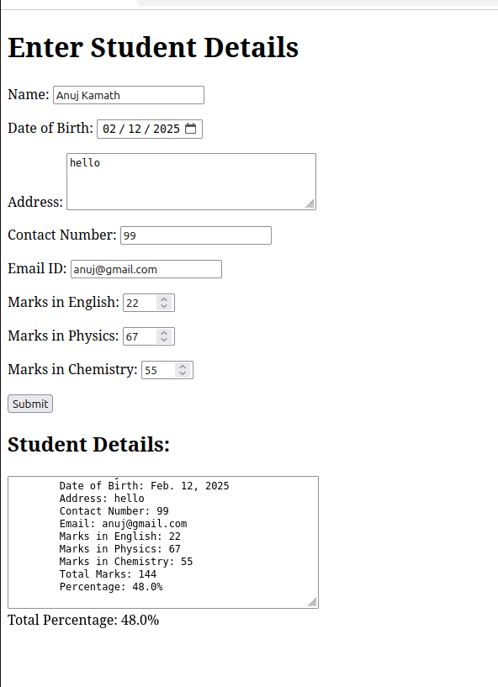

**Question 2) Create a web form with employee ids in dropdown list. Use a textbox for accepting**

**date of joining. Add a button named “Am I Eligible for Promotion”. On clicking**

**the button, if he has more than 5 years of experience, then display “YES” else**

**“NO” in the label control.**

**Code 1)**

**base.html**

<!DOCTYPE html>

<html>

<head>

<title>Employee Details Form</title>

</head>

<body>

<h1>Enter Employee Details</h1>

<form method="POST">

{% csrf_token %}

{{ form.as_p }}

<button type="submit">“Am I Eligible for Promotion:</button>

</form>

<!-- {% if employee_info %}

<label for="result"><h1>{{ result }}</h1></label>

{% endif %} -->

{% if result %}

<h2>Eligibility Result:</h2>

<p>Employee ID: {{ employee_info.employee_id }}</p>

<p>Date of Joining: {{ employee_info.doj }}</p>

<p>Eligibility for Promotion: {{ result }}</p>

{% endif %}

</body>

</html>

**forms.py**

**f**rom django import forms

EMPLOYEE_IDS = [

('101', 'Employee 101'),

('102', 'Employee 102'),

('103', 'Employee 103'),

('104', 'Employee 104'),

]

class EmployeeForm(forms.Form):

employee_id = forms.ChoiceField(label="Employee ID", choices=EMPLOYEE_IDS)

doj = forms.CharField(label="Date of Joining", max_length=100)

views.py

from django.shortcuts import render

from django.http import HttpResponse

from .forms import EmployeeForm

from datetime import date,datetime

def index(request):

return HttpResponse("<H2>HEY! Welcome to Edureka! </H2>")

def employee_details(request):

result = None

employee_info = None

if request.method == 'POST':

form = EmployeeForm(request.POST)

if form.is_valid():

employee_id = form.cleaned_data['employee_id']

doj = form.cleaned_data['doj']

today = date.today()

try:

date_of_joining = datetime.strptime(doj, "%d-%m-%Y").date()

except ValueError:

date_of_joining = None

difference_in_years = (today - date_of_joining).days / 365.25 # Dividing by 365.25 accounts for leap years

if difference_in_years > 5:

result = "Yes"

else:

result = "No"

# year = int(year)

# month = int(month)

# date1 = int(date1)

employee_info = {

'employee_id': employee_id,

'doj':doj,

}

else:

form = EmployeeForm()

return render(request, 'base.html', {'form': form, 'employee_info': employee_info, 'result': result})

**Output 2)**

