**Week 8 – 220962446**

Question 1) Develop a web application using Django framework to demonstrate the transfer of

multiple parameters between web pages. User should be presented with a dropdown

list containing car manufacturers, a text box which takes model name of the

manufacturer and a submit button. On submitting the web page, the user is forwarded

to a new page. This new page should display the selected car manufacturer name and

the model name.

Code 1)

**base.html**

<!DOCTYPE html>

<html lang="en">

<head>

<meta charset="UTF-8">

<meta name="viewport" content="width=device-width, initial-scale=1.0">

<title>Car Information</title>

<link href="https://maxcdn.bootstrapcdn.com/bootstrap/4.5.2/css/bootstrap.min.css" rel="stylesheet">

</head>

<body>

<div class="container mt-5">

<h1 class="text-center mb-4">Enter Car Information</h1>

<form method="POST" class="form-group">

{% csrf_token %}

<div class="form-group">

<label for="car_brand">Car Manufacturer</label>

{{ form.car_brand }}

</div>

<div class="form-group">

<label for="car_model">Car Model Name</label>

{{ form.car_model }}

</div>

<button type="submit" class="btn btn-primary btn-block">Submit</button>

</form>

</div>

<script src="https://code.jquery.com/jquery-3.5.1.slim.min.js"></script>

<script src="https://cdn.jsdelivr.net/npm/bootstrap@4.5.2/dist/js/bootstrap.bundle.min.js"></script>

</body>

</html>

**Result.html**

<!DOCTYPE html>

<html lang="en">

<head>

<meta charset="UTF-8">

<meta name="viewport" content="width=device-width, initial-scale=1.0">

<title>Car Information Result</title>

<link href="https://maxcdn.bootstrapcdn.com/bootstrap/4.5.2/css/bootstrap.min.css" rel="stylesheet">

</head>

<body>

<div class="container mt-5">

<h1 class="text-center mb-4">Selected Car Information</h1>

<div class="card">

<div class="card-body">

<h5 class="card-title">Car Manufacturer: {{ car_brand }}</h5>

<p class="card-text">Car Model: {{ car_model }}</p>

</div>

</div>

<a href="/" class="btn btn-secondary mt-3">Go Back</a>

</div>

<script src="https://code.jquery.com/jquery-3.5.1.slim.min.js"></script>

<script src="https://cdn.jsdelivr.net/npm/bootstrap@4.5.2/dist/js/bootstrap.bundle.min.js"></script>

</body>

</html>

**views.py**

from django.shortcuts import render, redirect

from django.http import HttpResponse

from .forms import CarForm

def car_form(request):

if request.method == 'POST':

form = CarForm(request.POST)

if form.is_valid():

car_brand = form.cleaned_data['car_brand']

car_model = form.cleaned_data['car_model']

return redirect(f'/result/?car_brand={car_brand}&car_model={car_model}')

else:

form = CarForm()

return render(request, 'base.html', {'form': form})

def result(request):

car_brand = request.GET.get('car_brand', '')

car_model = request.GET.get('car_model', '')

return render(request, 'result.html', {'car_brand': car_brand, 'car_model': car_model})

**forms.py**

from django import forms

class CarForm(forms.Form):

CAR_BRANDS = [

('Mahindra', 'Mahindra'),

('Tata', 'Tata'),

('Volkswagon', 'Volkswagon'),

]

car_brand = forms.ChoiceField(label='Car Manufacturer', choices=CAR_BRANDS)

car_model = forms.CharField(label='Car Model Name', max_length=100)

**webapp/urls.py**

from django.urls import path

from . import views

urlpatterns = [

path('', views.car_form, name='car_form'),

path('result/', views.result, name='result'),

]

**Output 1)**

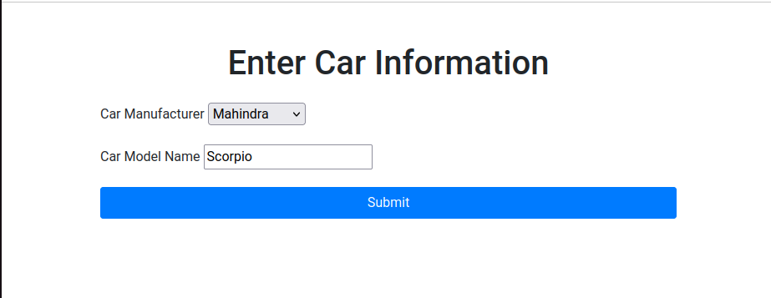

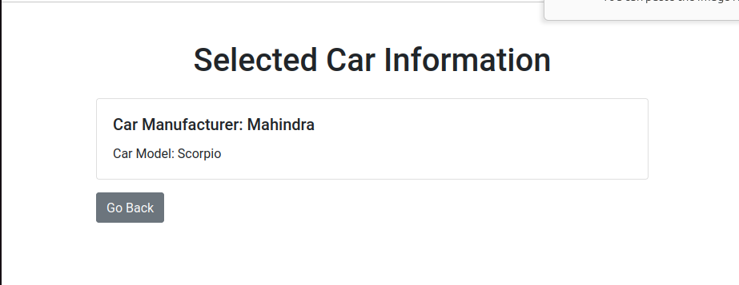

**Question 2)** Create a page firstPage.html with two TextBoxes [Name, Roll], DropDownList

[Subjects], and a button. Create another page secondPage.html with a label and a

button. When the user clicks the button in first Page, he should be sent to the second

page and display the contents passed from first page in the label. The button in second

page should navigate the user back to firstPage. Use Django sessions to transfer

information.

**Code 2)**

**firstPage.html**

<!DOCTYPE html>

<html lang="en">

<head>

<meta charset="UTF-8">

<meta name="viewport" content="width=device-width, initial-scale=1.0">

<title>First Page</title>

<link href="https://maxcdn.bootstrapcdn.com/bootstrap/4.5.2/css/bootstrap.min.css" rel="stylesheet">

</head>

<body>

<div class="container mt-5">

<h1 class="text-center mb-4">Enter Your Information</h1>

<form method="POST" class="p-4 border rounded shadow-sm">

{% csrf_token %}

<div class="form-group">

<label for="name">Name:</label>

<input type="text" name="name" id="name" class="form-control" required>

</div>

<div class="form-group">

<label for="roll">Roll No:</label>

<input type="text" name="roll" id="roll" class="form-control" required>

</div>

<div class="form-group">

<label for="subject">Subject:</label>

<select name="subject" id="subject" class="form-control">

<option value="Math">Math</option>

<option value="Science">Science</option>

<option value="English">English</option>

</select>

</div>

<button type="submit" class="btn btn-primary btn-block">Submit</button>

</form>

</div>

<script src="https://code.jquery.com/jquery-3.5.1.slim.min.js"></script>

<script src="https://cdn.jsdelivr.net/npm/bootstrap@4.5.2/dist/js/bootstrap.bundle.min.js"></script>

</body>

</html>

**secondPage.html**

<!DOCTYPE html>

<html lang="en">

<head>

<meta charset="UTF-8">

<meta name="viewport" content="width=device-width, initial-scale=1.0">

<title>Second Page</title>

<link href="https://maxcdn.bootstrapcdn.com/bootstrap/4.5.2/css/bootstrap.min.css" rel="stylesheet">

</head>

<body>

<div class="container mt-5">

<h1 class="text-center mb-4">Student Information</h1>

<div class="card shadow-sm">

<div class="card-body">

<h5 class="card-title">Name: {{ name }}</h5>

<p class="card-text">Roll No: {{ roll }}</p>

<p class="card-text">Subject: {{ subject }}</p>

</div>

</div>

<form method="POST" class="mt-4">

{% csrf_token %}

<button type="submit" class="btn btn-secondary btn-block">Go Back to First Page</button>

</form>

</div>

<script src="https://code.jquery.com/jquery-3.5.1.slim.min.js"></script>

<script src="https://cdn.jsdelivr.net/npm/bootstrap@4.5.2/dist/js/bootstrap.bundle.min.js"></script>

</body>

</html>

**views.py**

from django.shortcuts import render, redirect

from django.http import HttpResponse

def first_page(request):

if request.method == 'POST':

name = request.POST.get('name')

roll = request.POST.get('roll')

subject = request.POST.get('subject')

request.session['name'] = name

request.session['roll'] = roll

request.session['subject'] = subject

return redirect('second_page')

return render(request, 'firstPage.html')

def second_page(request):

name = request.session.get('name', 'Not available')

roll = request.session.get('roll', 'Not available')

subject = request.session.get('subject', 'Not available')

context = {

'name': name,

'roll': roll,

'subject': subject,

}

if request.method == 'POST':

return redirect('first_page')

return render(request, 'secondPage.html', context)

**Output 2)**

