WEEK9 – 220962446

Form Processing using Django – Part II

**Question 1) Create a Register page and Success page with the following requirements:**

* **Register page should contain four input TextBoxes for UserName, Password, Email id and Contact Number and also a button to submit. Make the username as compulsory field and other fields as optional.**
* **On button click, Success page is displayed with message "Welcome {UserName}" and also his Email and Contact Number has to be displayed.**
* **Use secure technique to send details to the Success page (Hint: use csrftoken) 4)**

**Design a website with two pages.**

**Code 1)**

**forms.py**

from django import forms

class RegisterForm(forms.Form):

username = forms.CharField(max_length=100, required=True, label="User Name")

password = forms.CharField(widget=forms.PasswordInput, required=False, label="Password")

email = forms.EmailField(required=False, label="Email ID")

contact_number = forms.CharField(max_length=15, required=False, label="Contact Number")

**views.py**

from django.shortcuts import render

from django.http import HttpResponseRedirect

from django.urls import reverse

from .forms import RegisterForm

def register_view(request):

if request.method == "POST":

form = RegisterForm(request.POST)

if form.is_valid():

username = form.cleaned_data['username']

email = form.cleaned_data['email']

contact_number = form.cleaned_data['contact_number']

request.session['username'] = username

request.session['email'] = email

request.session['contact_number'] = contact_number

return HttpResponseRedirect(reverse('success'))

else:

form = RegisterForm()

return render(request, 'register_page.html', {'form': form})

def success_view(request):

username = request.session.get('username')

email = request.session.get('email')

contact_number = request.session.get('contact_number')

return render(request, 'success_page.html', {

'username': username,

'email': email,

'contact_number': contact_number,

})

**urls.py**

from django.urls import path

from . import views

urlpatterns = [

path('', views.register_view, name='register'),

path('success/', views.success_view, name='success'),

]

**register_page.html**

<!DOCTYPE html>

<html lang="en">

<head>

<meta charset="UTF-8">

<meta name="viewport" content="width=device-width, initial-scale=1.0">

<title>Register</title>

<link href="https://stackpath.bootstrapcdn.com/bootstrap/4.5.2/css/bootstrap.min.css" rel="stylesheet">

</head>

<body>

<div class="container mt-5">

<h2 class="text-center">Register</h2>

<div class="card p-4 shadow-lg">

<form method="POST">

{% csrf_token %}

<div class="form-group">

<label for="username">User Name</label>

<input type="text" class="form-control" id="username" name="username" required>

</div>

<div class="form-group">

<label for="password">Password</label>

<input type="password" class="form-control" id="password" name="password" ">

</div>

<div class="form-group">

<label for="email">Email</label>

<input type="email" class="form-control" id="email" name="email" ">

</div>

<div class="form-group">

<label for="contact_number">Contact Number</label>

<input type="text" class="form-control" id="contact_number" name="contact_number" >

</div>

<button type="submit" class="btn btn-primary btn-block">Submit</button>

</form>

</div>

</div>

<script src="https://code.jquery.com/jquery-3.5.1.slim.min.js"></script>

<script src="https://cdn.jsdelivr.net/npm/@popperjs/core@2.5.4/dist/umd/popper.min.js"></script>

<script src="https://stackpath.bootstrapcdn.com/bootstrap/4.5.2/js/bootstrap.min.js"></script>

</body>

</html>

**success_page.html**

<!DOCTYPE html>

<html lang="en">

<head>

<meta charset="UTF-8">

<meta name="viewport" content="width=device-width, initial-scale=1.0">

<title>Success</title>

<link href="https://stackpath.bootstrapcdn.com/bootstrap/4.5.2/css/bootstrap.min.css" rel="stylesheet">

</head>

<body>

<div class="container mt-5">

<div class="card p-4 shadow-lg">

<h2 class="text-center">Welcome, {{ username }}!</h2>

<p class="lead text-center">Here are your details:</p>

<div class="list-group">

<div class="list-group-item">

<strong>Email:</strong> {{ email }}

</div>

<div class="list-group-item">

<strong>Contact Number:</strong> {{ contact_number }}

</div>

</div>

<div class="text-center mt-3">

<a href="{% url 'register' %}" class="btn btn-secondary">Back to Register</a>

</div>

</div>

</div>

<script src="https://code.jquery.com/jquery-3.5.1.slim.min.js"></script>

<script src="https://cdn.jsdelivr.net/npm/@popperjs/core@2.5.4/dist/umd/popper.min.js"></script>

<script src="https://stackpath.bootstrapcdn.com/bootstrap/4.5.2/js/bootstrap.min.js"></script>

</body>

</html>

**Output 1)**

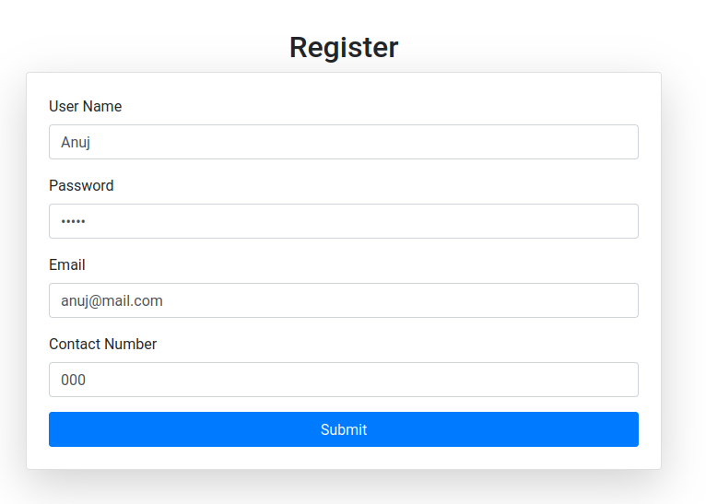

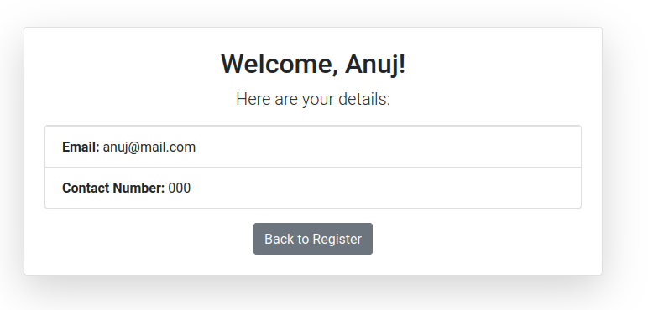

**Question 2) “How is the book ASP.NET with c# by Vipul Prakashan?” Give the user three choice : i) Good**

**ii) Satisfactory iii) Bad. Provide a VOTE button. After user votes, present the result in**

**percentage using labels next to the choices**

**Code 2)**

**views.py**

from django.shortcuts import render, redirect

from .forms import VoteForm

from .models import Vote

def vote_view(request):

if request.method == 'POST':

form = VoteForm(request.POST)

if form.is_valid():

user_choice = form.cleaned_data['choice']

vote, created = Vote.objects.get_or_create(choice=user_choice)

vote.count += 1

vote.save()

return redirect('vote')

else:

form = VoteForm()

votes = Vote.objects.all()

total_votes = sum(vote.count for vote in votes)

if total_votes == 0:

percentages = {'Good': 0, 'Satisfactory': 0, 'Bad': 0}

else:

percentages = {

vote.choice: round((vote.count / total_votes) * 100)

for vote in votes

}

return render(request, 'base.html', {

'form': form,

'percentages': percentages,

})

**forms.py**

from django import forms

class VoteForm(forms.Form):

CHOICE_OPTIONS = [

('Good', 'Good'),

('Satisfactory', 'Satisfactory'),

('Bad', 'Bad'),

]

choice = forms.ChoiceField(choices=CHOICE_OPTIONS, widget=forms.RadioSelect)

**urls.py**

from django.urls import path

from . import views

urlpatterns = [

path('', views.vote_view, name='vote'),

]

**models.py**

from django.db import models

class Vote(models.Model):

CHOICES = [

('Good', 'Good'),

('Satisfactory', 'Satisfactory'),

('Bad', 'Bad'),

]

choice = models.CharField(max_length=20, choices=CHOICES)

count = models.IntegerField(default=0)

def __str__(self):

return self.choice

**base.html**

<!DOCTYPE html>

<html lang="en">

<head>

<meta charset="UTF-8">

<meta name="viewport" content="width=device-width, initial-scale=1.0">

<title>Vote for Book Review</title>

<link href="https://cdn.jsdelivr.net/npm/bootstrap@5.3.0-alpha1/dist/css/bootstrap.min.css" rel="stylesheet">

</head>

<body>

<div class="container my-4">

<h1 class="text-center mb-4">How is the book "ASP.NET with C# by Vipul Prakashan?"</h1>

<form method="post">

{% csrf_token %}

<div class="form-group" style="display: flex;">

<div>

<div>

<label>

<input type="radio" name="choice" value="Good" {% if form.choice.value == 'Good' %}checked{% endif %}>

Good

</label>

</div>

<div>

<label>

<input type="radio" name="choice" value="Satisfactory" {% if form.choice.value == 'Satisfactory' %}checked{% endif %}>

Satisfactory

</label>

</div>

<div>

<label>

<input type="radio" name="choice" value="Bad" {% if form.choice.value == 'Bad' %}checked{% endif %}>

Bad

</label>

</div>

</div>

<div style="padding-left:20px">

{% if percentages %}

<div>{{ percentages.Good }}%</div>

{% endif %}

{% if percentages %}

<div>{{ percentages.Satisfactory }}%</div>

{% endif %}

{% if percentages %}

<div>{{ percentages.Bad }}%</div>

{% endif %}

</div>

</div>

<button type="submit" class="btn btn-primary w-100">Vote</button>

</form>

</div>

</body>

</html>

**Output 2)**

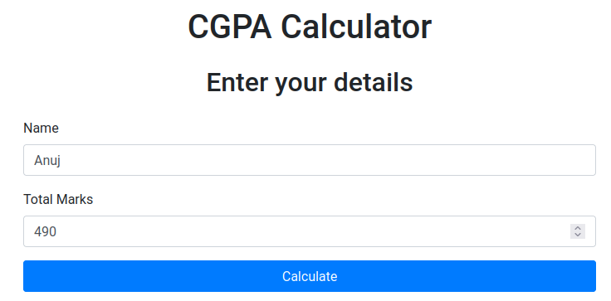

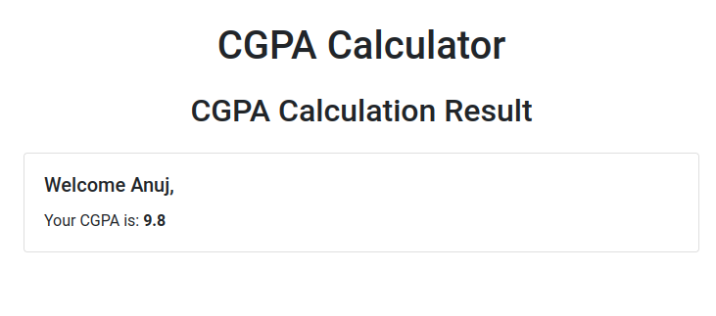

**Question 3) Create a website with two pages. Page 1 has two TextBoxes (name and total marks)**

**and one ‘Calculate’ Button as shown in the figure. On clicking the ‘Calculate’ Button,**

**CGPA (total marks/50) along with the name should be displayed in the Page 2. Use**

**Django sessions to store the information.**

**Code 3)**

**views.py**

from django.shortcuts import render

from .forms import CGPACalculatorForm

def home(request):

if request.method == 'POST':

form = CGPACalculatorForm(request.POST)

if form.is_valid():

name = form.cleaned_data['name']

total_marks = form.cleaned_data['total_marks']

cgpa = total_marks / 50

request.session['name'] = name

request.session['cgpa'] = cgpa

return render(request, 'result.html', {'name': name, 'cgpa': cgpa})

else:

form = CGPACalculatorForm()

return render(request, 'home.html', {'form': form})

def result(request):

name = request.session.get('name', 'Guest')

cgpa = request.session.get('cgpa', 0)

return render(request, 'result.html', {'name': name, 'cgpa': cgpa})

**forms.py**

from django import forms

class CGPACalculatorForm(forms.Form):

name = forms.CharField(max_length=100, label="Name")

total_marks = forms.IntegerField(label="Total Marks")

**urls.py**

from django.urls import path

from . import views

urlpatterns = [

path('', views.home, name='home'),

path('result/', views.result, name='result'),

]

**base.html**

<!DOCTYPE html>

<html lang="en">

<head>

<meta charset="UTF-8">

<meta name="viewport" content="width=device-width, initial-scale=1.0">

<title>CGPA Calculator</title>

<link href="https://stackpath.bootstrapcdn.com/bootstrap/4.5.2/css/bootstrap.min.css" rel="stylesheet">

</head>

<body>

<div class="container my-4">

<h1 class="text-center mb-4">CGPA Calculator</h1>

{% block content %}

{% endblock %}

</div>

<script src="https://code.jquery.com/jquery-3.5.1.slim.min.js"></script>

<script src="https://cdn.jsdelivr.net/npm/@popperjs/core@2.5.4/dist/umd/popper.min.js"></script>

<script src="https://stackpath.bootstrapcdn.com/bootstrap/4.5.2/js/bootstrap.min.js"></script>

</body>

</html>

**home.html**

{% extends 'base.html' %}

{% block content %}

<h2 class="text-center mb-4">Enter your details</h2>

<form method="post">

{% csrf_token %}

<div class="mb-3">

<label for="id_name" class="form-label">Name</label>

<input type="text" name="name" class="form-control" id="id_name" value="{{ form.name.value }}">

</div>

<div class="mb-3">

<label for="id_total_marks" class="form-label">Total Marks</label>

<input type="number" name="total_marks" class="form-control" id="id_total_marks" value="{{ form.total_marks.value }}">

</div>

<button type="submit" class="btn btn-primary w-100">Calculate</button>

</form>

{% endblock %}

**result.html**

{% extends 'base.html' %}

{% block content %}

<h2 class="text-center mb-4">CGPA Calculation Result</h2>

<div class="card">

<div class="card-body">

<h5 class="card-title">Welcome {{ name }},</h5>

<p class="card-text">Your CGPA is: <strong>{{ cgpa }}</strong></p>

</div>

</div>

{% endblock %}

**Output 3)**

