WEEK 2 - 220962446
Question 1) Design the student bio-data form using button, label, textbox, radio button, table and
checkbox using CSS.

Code1)
<!DOCTYPE html>
<html lang="en">
<head>
<meta charset="UTF-8">
<meta name="viewport" content="width=device-width, initial-scale=1.0">
<title>Document</title>
<link rel="stylesheet" href="https://maxcdn.bootstrapcdn.com/bootstrap/3.4.1/css/bootstrap.min.css">
<script src="https://maxcdn.bootstrapcdn.com/bootstrap/3.4.1/js/bootstrap.min.js"></script>
<style>
label {
min-width: 120px;
margin-right: 20px;
}
.container2 {
display: flex;
gap: 30px;
}
td, th {
border: 2px solid black;
padding: 5px;
}
.vertical{
display: flex;
flex-direction: column;
}
</style>
</head>
<body class="container">

<h1 class="text-center">Student Bio Data</h1>

<form>
<div class="panel panel-default">
<div class="panel-heading">
<h3 class="panel-title">Personal Information</h3>
</div>
<div class="panel-body">
<div class="container2">
<div class="vertical">
<label for="name">Full Name:</label>
<label for="reg_no">Registration No:</label>
<label for="address">Address:</label>
</div>
<div class="vertical">
<input id="name" class="form-control" type="text">
<input id="reg_no" class="form-control" type="number" pattern="\d{10}">
<textarea id="address" class="form-control" name="Address"></textarea>
</div>
</div>
</div>
</div>

<div class="panel panel-default">
<div class="panel-heading">
<h3 class="panel-title">College Information</h3>
</div>
<div class="panel-body">
<table class="table table-bordered">
<thead>
<tr>
<th>Category</th>
<th>College Fees</th>
</tr>
</thead>
<tbody>
<tr>
<td>General</td>
<td>Rs 4,00,000</td>
</tr>
<tr>
<td>NRI</td>
<td>Rs 8,00,000</td>
</tr>
<tr>
<td>Others</td>
<td>Rs 2,00,000</td>
</tr>
</tbody>
</table>

<h4>Enter your Category</h4>
<div class="container2">
<div class="vertical">
<label for="general">General</label>
<label for="NRI">NRI</label>
<label for="Others">Others</label>
</div>
<div class="vertical">
<input id="general" name="category" type="radio">
<input id="NRI" name="category" type="radio">
<input id="Others" name="category" type="radio">
</div>
</div>
</div>
</div>

<div class="panel panel-default">
<div class="panel-heading">
<h3 class="panel-title">Interested Domains</h3>
</div>
<div class="panel-body">
<div class="container2">
<div class="vertical">
<label for="Machine Learning">Machine Learning</label>
<label for="Development">Development</label>
</div>
<div class="vertical">
<input id="Machine Learning" type="checkbox">
<input id="Development" type="checkbox">
</div>
</div>
</div>
</div>

<button type="submit" class="btn btn-primary">Submit</button>
<button type="reset" class="btn btn-primary">Reset</button>

</form>

</body>
</html>

Screenshot

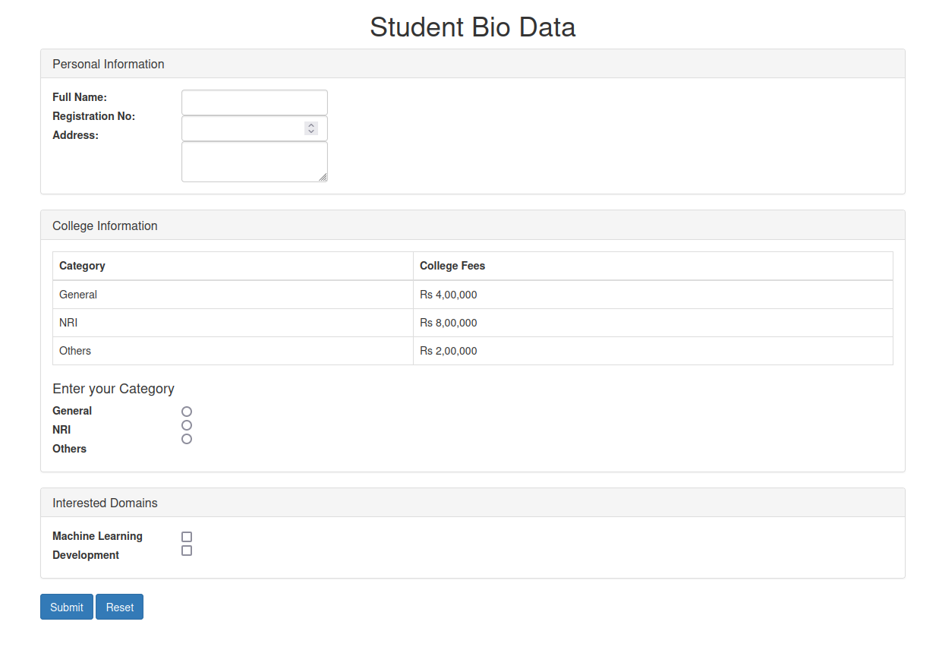
.

Question 3) Create a web page using bootstrap as mentioned. Divide the page in to 2 parts top and
bottom, then divide the bottom into 3 parts and design each top and bottom part using
different input groups, input, badges, buttons and button groups. Make the design more
attractive using bootstrap.

Solution 3)
<!DOCTYPE html>
<html lang="en">
<head>
<meta charset="UTF-8">
<meta name="viewport" content="width=device-width, initial-scale=1.0">
<title>Bootstrap Page</title>
<link rel="stylesheet" href="https://maxcdn.bootstrapcdn.com/bootstrap/3.4.1/css/bootstrap.min.css">
<script src="https://ajax.googleapis.com/ajax/libs/jquery/3.5.1/jquery.min.js"></script>
<script src="https://maxcdn.bootstrapcdn.com/bootstrap/3.4.1/js/bootstrap.min.js"></script>
</head>
<body>

<div class="container">
<div class="row">
<div class="col-md-12 text-center">
<h1>Welcome to My Page</h1>
</div>
</div>

<div class="row" style="margin-top: 20px;">
<div class="col-md-12">
<div class="input-group">
<span class="input-group-addon">Username</span>
<input type="text" class="form-control" placeholder="Enter your username">
</div>
</div>
</div>

<div style="margin-top: 40px;display:flex;gap:20px">
<div >
<h3>Section 1</h3>
<button class="btn btn-primary">Primary Button</button>
<button class="btn btn-success">Success Button</button>
</div>
<div >
<h3>Section 2</h3>
<div class="input-group">
<span class="input-group-addon">@</span>
<input type="text" class="form-control" placeholder="Enter email">
</div>
</div>
<div >
<h3>Section 3</h3>
<span class="badge">New</span>
<span class="badge badge-danger">Warning</span>
</div>
</div>

</div>

</body>
</html>

Screenshot)
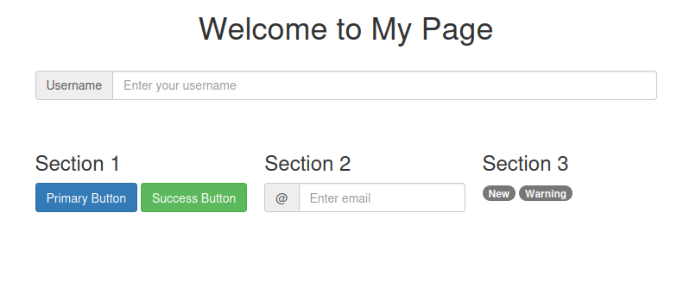
.

Question 4) Design your class timetable using bootstrap table and carousel.
Code 4)
<!DOCTYPE html>
<html lang="en">
<head>
<meta charset="UTF-8">
<meta name="viewport" content="width=device-width, initial-scale=1.0">
<title>Document</title>
<style>
td,th{
border:2px solid black;
}
</style>
<link rel="stylesheet" href="https://maxcdn.bootstrapcdn.com/bootstrap/3.4.1/css/bootstrap.min.css">
<script src="https://maxcdn.bootstrapcdn.com/bootstrap/3.4.1/js/bootstrap.min.js"></script>
<script src="https://ajax.googleapis.com/ajax/libs/jquery/3.5.1/jquery.min.js"></script>
<script src="https://maxcdn.bootstrapcdn.com/bootstrap/3.4.1/js/bootstrap.min.js"></script>
<script>
$(document).ready(function(){
$('#myCarousel').carousel();
});
</script>
</head>
<body>
<h1>Class TimeTable</h1>
<div id="myCarousel" class="carousel slide" data-ride="carousel">
<ol class="carousel-indicators">
<li data-target="#myCarousel" data-slide-to="0" class="active"></li>
<li data-target="#myCarousel" data-slide-to="1"></li>
<li data-target="#myCarousel" data-slide-to="2"></li>
</ol>

<div class="carousel-inner" style="justify-items: center;">
<div class="item active">
<div class="day" style="justify-items: center;">
<h3>Monday</h3>
<table class="table table-bordered table-striped mx-auto" style="width: 80%;">
<tr>
<th></th>
<th>8-9</th>
<th>9-10</th>
<th>10:30-11:30</th>
</tr>
<tr>
<th>Subjects</th>
<td>Web Programming</td>
<td>Deep Learning</td>
<td>EEFM</td>
</tr>
<tr>
<th>Teachers</th>
<td>Ms Ancilla</td>
<td>Ms Ashalatha</td>
<td>Mr Sunith</td>
</tr>
</table>
</div>

</div>

<div class="item">
<div class="day">
<h3>Tuesday</h3>
<table class="table table-bordered table-striped mx-auto" style="width: 80%;">
<tr>
<th></th>
<th>8-9</th>
<th>9-10</th>
<th>10:30-11:30</th>
</tr>
<tr>
<th>Subjects</th>
<td></td>
<td>Program Elective I</td>
<td>PCAP</td>
</tr>
<tr>
<th>Teachers</th>
<td></td>
<td>Ms Jashma Suresh</td>
<td>Ms Jyothi</td>
</tr>
</table>
</div>
</div>

<div class="item">
<div class="day">
<h3>Wednesday</h3>
<table class="table table-bordered table-striped mx-auto" style="width: 80%;">
<tr>
<th></th>
<th>8-9</th>
<th>9-10</th>
<th>10:30-11:30</th>
</tr>
<tr>
<th>Subjects</th>
<td>Program Elective II</td>
<td>Open Electives</td>
<td>PCAP</td>
</tr>
<tr>
<th>Teachers</th>
<td></td>
<td>Mr Ashwath</td>
<td>Mr Someone</td>
</tr>
</table>
</div>
</div>
</div>

<a class="left carousel-control" href="#myCarousel" data-slide="prev">
<span class="glyphicon glyphicon-chevron-left"></span>
<span class="sr-only">Previous</span>
</a>
<a class="right carousel-control" href="#myCarousel" data-slide="next">
<span class="glyphicon glyphicon-chevron-right"></span>
<span class="sr-only">Next</span>
</a>
</div>
</body>
</html>
Screenshot)

